

REQUEST FOR CLARIFICATION OR INTERPRETATION

Date: September 30, 2010
Requester Name: Tony Roza
Company: GXS
Phone, Fax, E-mail: Voice: 949-838-1020, FAX: 939-838-1058, tony.roza@gxs.com

NAESB Standard Number: NAESB 1.9 Internet Electronic Transport Related Standards
Clarification or interpretation request:
- Page 32. Use of data element server-id.
- Page 35. Use of data elements refnum and refnum-orig.
- Pages 39, 41, 43. Typo in examples: version and DUNS numbers.
- Page 47. Errors in sample PGP signed document (RFC2015/3156). Question about supporting RFC 4880 (Section 7) Cleartext PGP signature.
- Page 48. Mandated elements in Error Notification.
- Pages 50, 51. Errors in sample: Error Notification.
Possible interpretations or clarifications, if known:
See below.

Comments on the
NAESB 1.9
INTERNET ELECTRONIC TRANSPORT RELATED STANDARDS
of September 30, 2009.

GXS has recently completed our implementation of the NAESB 1.9 protocol for the GXS BizManager product line. During the implementation, several issues were noted about the specification. Issues involve interpretation of the specification and/or errors in the specification. I am providing this information to NAESB in hope that they can provide clarification on these issues.
Tony Roza
Senior Software Engineer
GXS
18300 Von Karman Av, Suite 800
Irvine, CA 92612
tony.roza@gxs.com
Voice: 949-838-1020
FAX: 939-838-1058

- Server-id data element. There is some confusion on the use of server-id data element described on page 32. One interpretation is that the server-id must be the same for the HTTP Response and a subsequent error notification. However, we have noticed that some implementations do not do that. Issue: BizManager uses the server-id, time-c, and trans-id to tie an error notification back to the original outbound send operation in our audit trail. Some implementations use more than one server so that the HTTP response may read “server-id=a.example.com* time-c=20100921122841* trans-id=6032*” while the error notification reads “server-id=b.example.com* time-c=20100921122841* trans-id=6032*”. Hence, we have trouble linking the outbound operation to the received error notification. Does the specification require the server-id specified in the HTTP Response must match the server-id in the error notification?
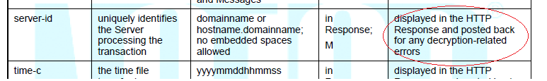

- Refnum and refnum-orig data elements. Refer to pages 31, 32, and 34. Some confusion remains with the refnum and refnum-orig elements. Is the intention to assign a unique number to the payload (aka package)? If so, the refnum-orig can be used to detect duplicate transmissions.

Illustration of hypothetical event caused by a brief proxy or firewall outage: EDI document “X” is sent from party A to party B. Party A attempts 3 sends but receives gibberish for the response (Note that the verbiage on page 34 of the specification says a “NAESB response” but it does not say a VALID response). An operator at party A intervenes and retransmits document “X”— (the 4th send) and it is received successfully. After that, an operator at party “B” contacts party A and asks for document “X” to be sent again (the 5th send). What REFNUM-ORIG should be used on this 5th transmission? It is clear that each send attempt must use a unique REFNUM. However, should all transmissions use the same REFNUM-ORIG or should a new REFNUM-ORIG be assigned on the manual start and after successful receipt? By the way, the examples for refnum/refnum-orig on pages 34 and 35 were very helpful.
Transmission | refnum | refnum-orig
1 send / receipt is gibberish | 100001 | 100001
1st resend / receipt is gibberish | 100002 | 100001
2nd resend / receipt is gibberish | 100003 | 100001
3rd resend - manual / good receipt | 100004 | Should 10001 or 10004 be used?
4th resend - manual / good receipt | 100005 | Should 10001 or 10005 be used?

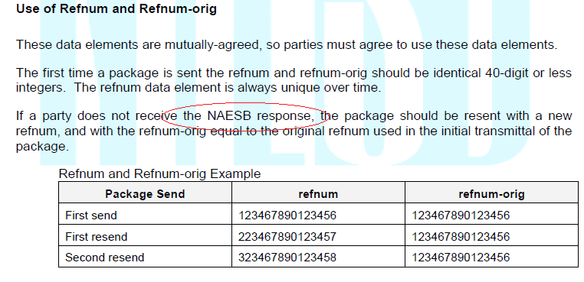
- Version number and DUNS typos. There are several typos in version and receipt-disposition-to.

Page 39: Invalid version number. The receipt-disposition-to field contains an invalid character in the DUNS number element.

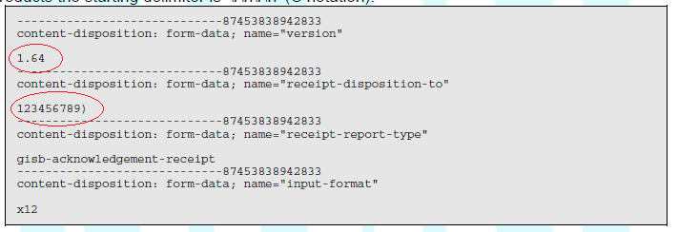

Page 41. Invalid version number.

Page 43. Invalid version number.
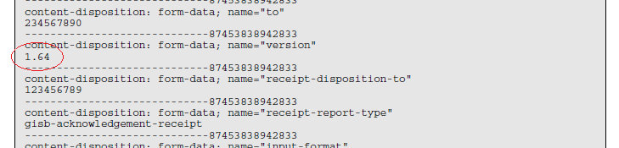

- Errors in sample PGP signed document. See page 47 (reference RFC 2015 and RFC 3156 PGP).
Note 1: Line 5 should not be a blank line. Each multipart section contains a header and body—separated by a blank line. Since line 4 is the boundary, line 5 is the start of the signed text. Yet, line 5 is blank meaning the next line is the body of the document. Since there are no headers, the content-type defaults to “text/plain” rather than “multipart/report”.
Reference: RFC 2045
http://tools.ietf.org/search/rfc2045

5.2. Content-Type Defaults

Default RFC 822 messages without a MIME Content-Type header are taken
by this protocol to be plain text in the US-ASCII character set,
which can be explicitly specified as:

Content-type: text/plain; charset=us-ascii

Note 2: The boundary on line 40 “----boundary2--20030909001—“ is incorrect. The closing boundary must end in two dashes but instead ends in a single elongated dash (probably from a cut and paste from a word processor such as Microsoft Word). The lack of a correct closing boundary invalidates the multipart/signed message.

Reference: RFC 1341 section 7.2.1
http://www.w3.org/Protocols/rfc1341/7_2_Multipart.html

The encapsulation boundary following the last body part is a distinguished delimiter that indicates that no further body parts will follow. Such a delimiter is identical to the previous delimiters, with the addition of two more hyphens at the end of the line:

--gc0p4Jq0M2Yt08jU534c0p--

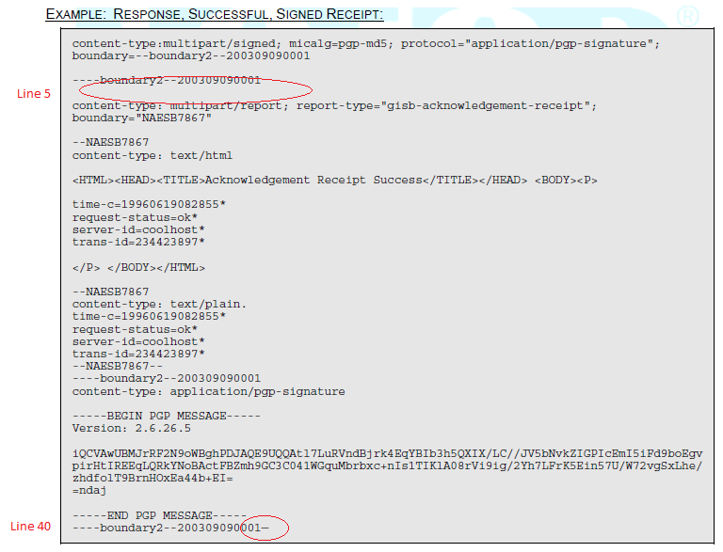
Note 3: The signature example above uses the RFC2015/RFC3156 “multipart/signed, application/pgp-signature”. There is an alternative signature defined in RFC 4880 Section 7. Cleartext Signature Framework as illustrated below. This style would probably be sent using “content-type: text/plain”. What is the NAESB position on supporting this format? I did not find RFC4880 mentioned in the NAESB 1.9 specification.

-----BEGIN PGP SIGNED MESSAGE-----

time-c=20100921122841*
time-c-qualifier=-08*
request-status=ok*
server-id=71.140.242.201*
trans-id=128509732146032*

-----BEGIN PGP SIGNATURE-----
Version: PGP SDK 3.5.4

iQCVAwUATJkHaXWvepV1HI9zAQFLSQP9HG04UFT81dwWDnNMUWUGTPVKj8vWyL9d
ZjtjarJZ5vb0I+PZUj7z+c29zZPqfP7Dt/T28U1LEJbzfJHDbw0fIdAP5LiRNnEH
=vqQX
-----END PGP SIGNATURE-----

- Mandated elements in Error Notification. Page 48 states that Error Notifications must include the “to”, “from”, and “input-format” elements. However, pages 32 to 33 list additional mandatory elements (such as “version” and “receipt-security-selection”) and mutually agreed upon elements (such as “refnum-orig”). These two sections appear to be in conflict (signed signatures are indicated as mandatory per page 32 but are not listed as required per page 48). Are error notifications exempt from the mandatory element requirements on pages 32 and 33?

- Errors in sample: Error Notification. The error notification on pages 50 and 51 contains several errors.
- Page 50, line 5 in the example: The version number says 1.6 rather than 1.9.
- Page 50, line 9 in the example: There needs to be a blank line after the Content-Length to indicate the end of the headers.
- Page 50, line 64 in the example: There is a boundary ending with “833—“ (long dash). It must be “833--“ (two short dashes).
- The text “Signed Error Notification” beginning at line 66 appears to have been appended from a word processor. It should have replaced the unsigned form (marked with a blue rectangle) with the signed receipt (the signed receipt begins on page 50 line 68 and continues to the end of the example on page 51).
- Page 51, line 35 in the example. There needs to be a blank line after the Content-Type to indicate the end of the pgp-signature header and the start of the signature body.

From page 50 of the NAESB 1.9 Specification.

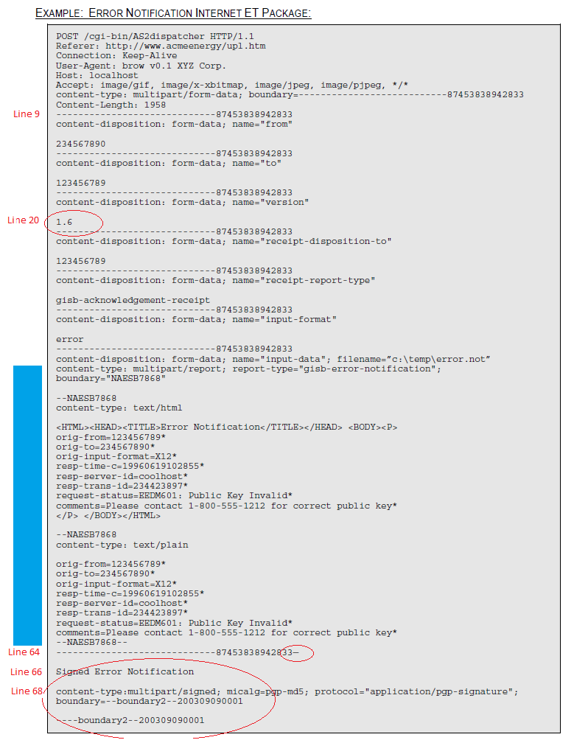

From page 51 of the NAESB 1.9 Specification.

