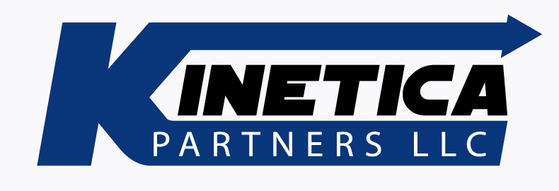

August 14, 2014

NAESB

RE: Request For Comment on Annual Plan Item 11.c Recommendation

Kinetica welcomes this opportunity to comment on this recommendation regarding the FERC’s Notice of Proposed Rulemaking (“NOPR”) on the coordination of scheduling processes for Natural Gas Pipelines and Public Utilities. The NOPR touches on several critical areas that will affect gas pipeline and electric utility operations.

Kinetica does not support the NOPR and urges NAESB in the strongest terms to reconsider its position on the NOPR and its recommendations in Item 11.c. While we have several areas of disagreement, our primary concern is that the NOPR is attempting to impose incompatible requirements on gas pipeline operations in an attempt to solve supply issues in the electrical generation sector.

The incompatibility is the result of some fundamental differences between gas transportation systems and electric transportation systems. Electricity is used the instant it is generated and cannot be easily stored. Gas can take several days to transport from the wellhead to the burner tip and can be stored in various ways, including in the pipeline delivering it by increasing pressure and line pack. Kinetica’s position is that the current requirements for the start of the gas day and intraday deadlines are the most appropriate for pipeline operations.

Kinetica does not agree with or support the open-ended time standard set forth in Standard No 1.3.1. We urge NAESB to be proactive in proposing an appropriate and workable starting time for the gas day rather than relying upon the FERC. NAESB has the expertise to make such a recommendation and there is no reason to not exercise that expertise in the NOPR proceeding.

Kinetica also does not agree with the proposed times set forth in Standard No 1.3.2 because NAESB has not specified an appropriate time in Standard No 1.3.1. Kinetica’s position is that Standard No 1.3.1 is an essential prerequisite to determining subsequent deadlines and nomination cycles. Furthermore, it is essential that intraday cycle deadlines be evenly spaced and not occur past 9:00PM. The truncated time, only one half of an hour, proposed between Confirmations and Scheduling in Standard No 1.3.2 is not enough time for Kinetica to make necessary operational decisions to appropriately schedule its pipeline.

Kinetica does not agree that there is any need to introduce an Intraday 3 nomination cycle. We especially do not agree with the 10 PM scheduling deadline with an effective time of 10:00 PM.

For the same reasons as set out above, Kinetica does not agree with the proposed changes to Standard No. 1.3.4. Specifically, we do not agree with the 10:00 PM time for scheduled flow when the Gas Day time has not been defined.

And finally, Kinetica and many other pipelines have no direct connections to electric generating stations. Although, we recognize that scheduling coordination may benefit operations between pipelines and local distribution companies, the standards must be workable across the industry. Kinetica does not use line pack and storage in direct response to the electric market, and it would be not be an appropriate option for many pipelines. We cannot sacrifice the reliability of the operations of gas pipelines in an attempt to solve a challenge for one industry among the many relying upon the efficient and reliable delivery of natural gas.

