Minor Correction Request

Quadrant: Wholesale Electric Quadrant (WEQ)
Business Practice: Correction to Diagram for Meter Before/Meter After Definition (WEQ-000)
Submitted By: Ed Skiba
Date: March 22, 2011

Midwest ISO is requesting that the WEQ Executive Committee address a diagram error in the definition of Meter Before/Meter After as a minor correction. We believe that correcting the graphic so that it is consistent with the textual definition of Meter Before/Meter meets the criteria of a minor correction under item (d) below.

According to the NASB Operating Practices Minor Corrections include:
(a) clarifications or corrections made by a regulatory agency to standards that are of a jurisdictional nature, or by the American National Standards Institute or its successor;
(b) clarifications or corrections to the format, appearance, or descriptions of standards in standards documentation;
(c) clarifications or corrections to add code values to tables; and
(d) clarifications and corrections that do not materially change a standard.

Background Information:
The Meter Before/Meter After diagram has an error in the location of the Meter After bracket. The diagram indicates the Meter After is the period after returning to Normal Operations. However, the textual description on Meter Before/Meter After indicates that comparison is between a period of time prior to deployment (Meter Before) and similar readings during the Sustained Response Period (Meter After). Based on the textual description the diagram should have the Meter After period from Reduction Deadline to Release/Recall. The current diagram and a corrected diagram are included for Executive Committee consideration.
Current Version of Graphic
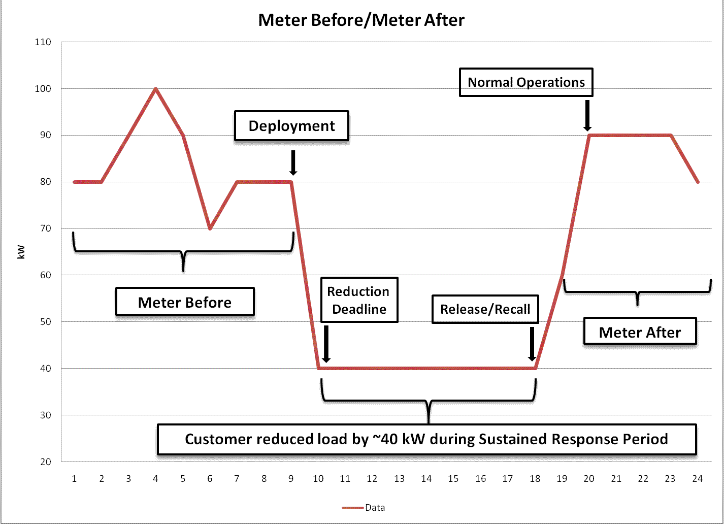

Corrected Version of Graphic
