1. RECOMMENDED ACTION: EFFECT OF EC VOTE TO ACCEPT RECOMMENDED ACTION:
 | Accept as requested |  | Change to Existing Practice
 | Accept as modified below | X | Status Quo
X | Decline
2. TYPE OF DEVELOPMENT/MAINTENANCE
Per Request: |  | Per Recommendation:
 | Initiation |  | Initiation
X | Modification |  | Modification
 | Interpretation |  | Interpretation
 | Withdrawal |  | Withdrawal
 | Principle |  | Principle
 | Definition |  | Definition
 | Business Practice Standard |  | Business Practice Standard
 | Document |  | Document
 | Data Element |  | Data Element
 | Code Value |  | Code Value
 | X12 Implementation Guide |  | X12 Implementation Guide
 | Business Process Documentation |  | Business Process Documentation

3. RECOMMENDATION

SUMMARY:

WEQ 2014 Annual Plan Item 1.i (Coordinate with NERC on NERC Project 2012-08 Glossary Updates) coordinates the definitions for Transmission Operator and Generator Operator. The other definitions provided in Project 2012-08 are not used in the NAESB WEQ Business Practice Standards.

FERC Order No. 788 issued on November 21, 2013, provides the following justifications to meet specific FERC directives:

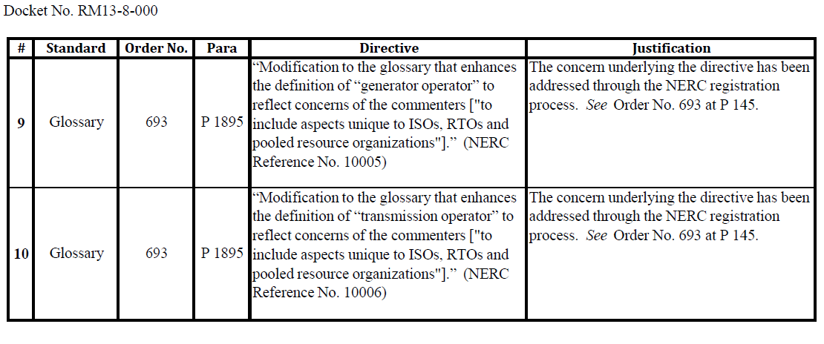
Recommended Standards:
No changes to existing standards are required.

4. SUPPORTING DOCUMENTATION

a. Description of Request:
Develop, modify or delete definitions to support NERC activities related to NERC Project 2012-08.
b. Description of Recommendation:
No changes are required to the NAESB WEQ Business Practice Standards since the FERC directives have been addressed through the NERC registration process.

c. Business Purpose:
The intent of the WEQ Annual Plan item is to stay coordinated with NERC on definitions. Since the NERC project related to glossary updates has been addressed through the NERC registration process, there is no coordination work required by NAESB.

d. Commentary/Rationale of Subcommittee(s)/Task Force(s):
None

Reference Documents:
FERC Order No. 788, Docket No. RM13-8-000 (November 21, 2013)
NERC Reliability Standards Development Plan 2013-2015

