Additions & Revisions to Existing Business Practice Standard WEQ-013
(OASIS Implementation Guide)

Revisions to Existing Business Practice Standard WEQ-013
(OASIS Implementation Guide)

Applicability

1) Eligible Transmission Customer including Affiliate, Assignee, Financially Obligated Transmission Customer (FOTC), Native Load Customer, Reseller, Seller, Transmission Customer, Network Customer, and 2) Transmission Provider including ISO, RTO

Additions to Existing Business Practice Standard WEQ-013
(OASIS Implementation Guide)

013-101 GENERAL NETWORK INTEGRATION TRANSMISSION SERVICE APPLICATION AND MODIFICATION OF SERVICE PROCESSING REQUIREMENTS

013-101.1 NETWORK INTEGRATION TRANSMISSION SERVICE APPLICATION AND MODIFICATION OF SERVICE PROCESSING

The basic NITS Application and modification of service process for NITS on OASIS is described below. This Implementation Guide also contains additional requirements and provides guidance for processing business transactions in the implementation of NITS on OASIS. Note that the Transmission Provider may, but is not limited to, interact with OASIS using the applicable NITS templates or the user interface. Transmission Providers also may also implement OASIS functions on back-end systems, and are not required to perform all transaction processing on an OASIS Node proper, provided that the results of all transaction processing are correctly posted on OASIS as required by the tariff, regulation, or other established Business Practices.

013-101.2 OVERALL NETWORK INTEGRATION TRANSMISSION SERVICE APPLICATION AND MODIFICATION OF SERVICE PROCESSING

The overall NITS Application and modification of service request must be submitted on OASIS, and is composed of a NewNITSRequest NITS OASIS INPUT Template, and multiple related NITS OASIS REQUEST Templates, as described in this Implementation Guide. Some of these NITS OASIS REQUEST Templates provide general customer and agent information, while other NITS OASIS REQUEST Templates provide information specific to a portion of the overall NITS Application or modification of service. Each NITS OASIS REQUEST Template will contain one or more NITS OASIS DATA Templates conveying the specific information related to the action being requested by the Eligible Customer or Transmission Customer. The list of NITS OASIS INPUT, REQUEST, and DATA Templates and associated Data Elements for NITS on OASIS, can be found in Business Practice Standard WEQ-002-101.3. An example of this process is found in Business Practice Standard WEQ-013 Appendix X, Example xx2.

013-101.3 NETWORK INTEGRATION TRANSMISSION SERVICE APPLICATION AND MODIFICATION OF SERVICE TEMPLATES

A summary of the NITS Application and modification of service NITS OASIS Templates used to execute a NITS Application and modification of service transaction on OASIS can be found in Business Practice Standard WEQ-002-101.3. Note that the OASIS Business Practice Standards require all template functionality to be provided through a user interface. While this section focuses on template execution, all actions must be supported through a browser-based user interface. Detailed examples of the transaction process and description of the business logic to be implemented on the Transmission Provider’s OASIS or through other back-end transaction support services are provided in subsequent sections of this OASIS Implementation Guide.

The applicable NITS OASIS Templates shall be used by the Eligible Customer to submit a request for NITS. All pertinent application-specific information must be provided in the appropriate template. The initial submission, and progress through evaluation and ultimate approval or denial of each request comprising the full NITS Application or modification of service, is tracked through the use of the STATUS Data Element.

013-101.4 NETWORK INTEGRATION TRANSMISSION SERVICE APPLICATION AND MODIFICATION OF SERVICE STATUS
3/8/12 accepted

The following are the defined values that may appear in the STATUS Data Element associated with a new NITS Application or a request for modification of service:

PRESUBMITTED - assigned by OASIS prior to submission by the Eligible Customer or Transmission Customer in a workspace to be saved while developing a NITS Application or request for modification of service such that the NITS Application or request for modification of service can be submitted at a later date.

QUEUED - initial status assigned by the TSIP on receipt of "Transmission Customer services purchase request” or “Eligible Customer or Transmission Customer NITS Application request”.

INVALID - assigned by the TSIP or Transmission Provider indicating an invalid field in the request, such as improper POR, POD, SOURCE, SINK, etc. or that the request does not meet minimum information or data requirements (Final state).

RECEIVED - assigned by the Transmission Provider or Reseller (PTP only) to acknowledge QUEUED requests and indicate the service request is being evaluated, including for completing the required ancillary services.

DEFICIENT - assigned by the Transmission Provider to indicate that a correctable deficiency in the NITS Application or request for modification of service, such as missing, incomplete, or inconsistent information.

REEVALUATE - assigned by the Eligible Customer or Transmission Customer during the NITS Application or request for modification of service process indicating that deficiencies have been corrected, and the revised NITS Application or request for modification of service is ready for review.

COMPLETED - assigned by the Transmission Provider to indicate that there are no deficiencies or all deficiencies in the NITS Application or request for modification of service have been met.

STUDY - assigned by the Transmission Provider or Reseller (PTP only) to indicate some level of study is required or being performed to evaluate service request.

REBID - assigned by the Eligible Customer or Transmission Customer to indicate that a new value for BID_PRICE (PTP only) and/or CAPACITY_REQUESTED over time is being proposed.

COUNTEROFFER - assigned by Transmission Provider or Reseller (PTP only) to indicate that a new OFFER_PRICE and/or CAPACITY_GRANTED over time is being proposed in the negotiation of requested service (i.e., offering of Partial Service or negotiation of price).

CR_COUNTEROFFER - assigned by Transmission Provider or Reseller (PTP only) to indicate that a new OFFER_PRICE and/or CAPACITY_GRANTED over time is being proposed in the negotiation of requested service for Coordinated Request (i.e., offering of Partial Service or negotiation of price

ACCEPTED - assigned by the Transmission Provider or Reseller (PTP only) to indicate the service request at the designated BID_PRICE and CAPACITY_REQUESTED has been approved/accepted. Depending upon the type of ancillary services required, the Seller may or may not require all ancillary service reservations to be completed before accepting a request.

CR_ACCEPTED - assigned by the Transmission Provider or Reseller (PTP only) to indicate the Coordinated Request at the designated BID_PRICE and CAPACITY_REQUESTED has been approved/accepted. Depending upon the type of ancillary services required, the Seller may or may not require all ancillary service reservations to be completed before accepting a Coordinated Request.

DECLINED - assigned by the Transmission Provider or Reseller (PTP only) to indicate that the terms and conditions of the request, such as the BID_PRICE, are unacceptable and that negotiations are terminated or that contractual terms have not been met or the Eligible Customer or Transmission Customer has failed to respond to a deficiency within an established time frame. (Final state).

SUPERSEDED - assigned by the Transmission Provider or Reseller (PTP only) when a request which has not yet been confirmed is preempted by another reservation request. (Final state).

RETRACTED - assigned by the Transmission Provider or Reseller (PTP only) when the Eligible Customer or Transmission Customer fails to confirm or withdraw the request within the required time period. (Final state).

REFUSED - assigned by Transmission Provider or Reseller (PTP only) to indicate service request has been denied due to lack of ATC. (Final state)

CONFIRMED - assigned by the Eligible Customer or Transmission Customer in response to the Transmission Provider or Reseller (PTP only) posting "ACCEPTED", “CR_ACCEPTED”, “COUNTEROFFER”, or “CR_COUNTEROFFER” status, to confirm service or the NITS Application. Once a request has been "CONFIRMED", a Transmission Service reservation exist or the NITS Application is completed. (Final state, unless overridden by DISPLACED or ANNULLED state).

WITHDRAWN - assigned by the Eligible Customer or Transmission Customer during a request evaluation to withdraw the request from any further action. (Final state).

DISPLACED - (PTP and Secondary Network Transmission Service only) - assigned by the Transmission Provider or Reseller when a "CONFIRMED" reservation from a Eligible Customer or Transmission Customer is displaced by a higher priority reservation, and the Eligible Customer or Transmission Customer is not offered or has not exercised right of first refusal (i.e. refused to match terms of new request). (Final state).

ANNULLED - assigned by the Seller when, by mutual agreement with the Eligible Customer or Transmission Customer, a confirmed reservation, NITS Application, or pre-confirmed request is to be voided or assigned unilaterally by the Transmission Provider when a Resale reservation is to be voided or NITS Application is to be voided. (Final state).

DELETED – assigned by the Eligible Customer or Transmission Customer to permanently remove a PRESUBMITTED request from the Pre-submittal Workspace. (Final state)

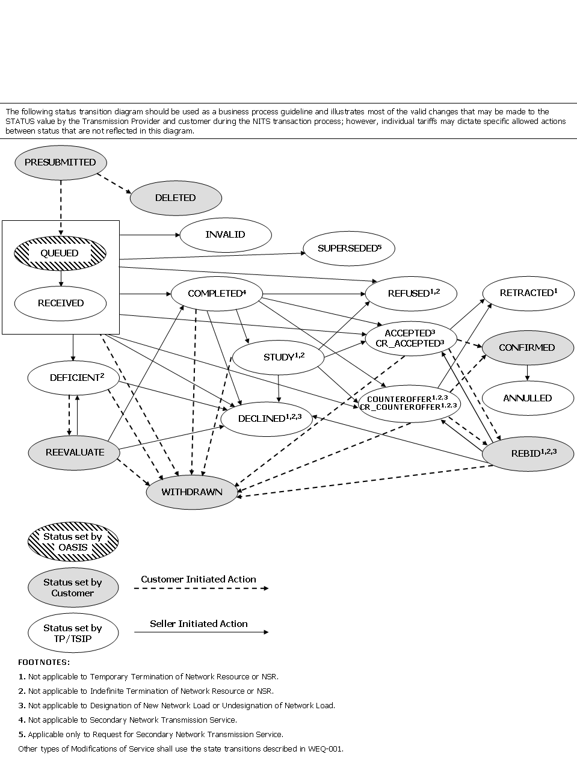

Exhibit 101 - Status Diagram for NITS Application & Modification of Service Processes

013-101.5 ACCEPTED OR CR_ACCEPTED STATUS RESTRICTIONS

OASIS shall block a request from being set to a status of ACCEPTED or CR_ACCEPTED by the Transmission Provider if the value for CAPACITY_GRANTED does not exactly match the corresponding value for CAPACITY_REQUESTED over every START_TIME/STOP_TIME interval. This ensures that both parties to the transaction are in agreement to the terms of the request.

If the request is flagged as PRECONFIRMED=YES and CG_STATUS is null, OASIS shall immediately set the request STATUS to CONFIRMED when it is accepted.

If the request is flagged as PRECONFIRMED=YES and CG_STATUS is non-null, i.e., it is a Coordinated Request, OASIS shall not set the request STATUS to CONFIRMED until after expiration of the Transmission Customer confirmation time limit (RESPONSE_TIME_LIMIT), specified in Business Practice Standard WEQ-001-105.1.5 Table 105-A,

013-101.6 CONFIRMED STATUS RESTRICTIONS

OASIS shall block a request from being set to a status of CONFIRMED by the Eligible Customer if the value for CAPACITY_REQUESTED does not exactly match the corresponding value for CAPACITY_GRANTED over every START_TIME/STOP_TIME interval. This ensures that both parties to the transaction are in agreement to the terms of the request.

013-101.7 NETWORK INTEGRATION TRANSMISSION SERVICE APPLICATION AND MODIFICATION OF SERVICE PROCESSING

A new NITS Application or a request for modification of service, shall be submitted by the Eligible Customer or Transmission Customer on OASIS via the NewNITSRequest NITS OASIS INPUT Template.

OASIS should screen submitted requests to validate proper use of NITS OASIS INPUT and REQUEST Templates.

Once the new NITS request has been successfully submitted on OASIS, the Transmission Provider may take any of the following actions:

• Acknowledge receipt by setting the STATUS to RECEIVED, COMPLETED, DEFICIENT or STUDY
• Deny the request by setting the STATUS to INVALID, SUPERSEDED, DECLINED, RETRACTED, or REFUSED
• Approve the request by setting the STATUS to ACCEPTED, CR_ACCEPTED, COUNTEROFFER, or CR_COUNTEROFFER

At any time during the processing of a request, the Eligible Customer or Transmission Customer may set the status to WITHDRAWN to remove the request from further consideration by the Transmission Provider.

Prior to NITS Application being completed, the Eligible Customer or Transmission Customer may take any of the following actions via the UpdateNITSRequest NITS OASIS INPUT Template:

• WITHDRAW the request
• Provide information to resolve deficiencies in the request and setting the STATUS to REEVALUATE

Once the Transmission Provider has approved the request, the Eligible Customer or Transmission Customer may take any of the following actions via the UpdateNITSRequest NITS OASIS INPUT Template:

• WITHDRAW the request
• Continue negotiation of the request by setting the STATUS to REBID
• Complete the request by setting the status to CONFIRMED

Prior to final confirmation by the Eligible Customer or Transmission Customer, the Transmission Provider may override their approval of the request as follows:

• Retract approval based on exceeding the Eligible Customer confirmation time limits and/or scheduling deadlines or other criteria established by the Transmission Provider by setting the status to RETRACTED

Once CONFIRMED on OASIS by the Eligible Customer or Transmission Customer a NITS Application or reservation shall be deemed to exist. The Transmission Provider may make the following status changes to a CONFIRMED NITS Application or reservation:

- Nullify the NITS Application or reservation for cause by setting the status to ANNULLED
- Displace the Secondary Network Transmission Service reservation in-whole to accommodate a higher priority competing request by setting the STATUS to DISPLACED

The Transmission Provider shall provide a reason in the SELLER_COMMENTS whenever a NITS Application or service request is set to the status of INVALID, SUPERSEDED, REFUSED, DECLINED, RETRACTED, ANULLED, or DISPLACED. The Transmission Provider, when not acting as the Seller, shall provide a reason in the PROVIDER_COMMENTS whenever a service request is set to the STATUS of ANNULLED or DISPLACED.

013-102 NETWORK INTEGRATION TRANSMISSION SERVICE APPLICATION PROCESSING

The following Business Practice Standard identifies specific OASIS processing requirements that must be implemented by OASIS and/or associated back-end support systems. Before the NITS Application has been submitted, the results of all NITS Application processing shall be viewable by the requesting Eligible Customer or Transmission Customer via the QueryNITSRequest NITS OASIS QUERY Template and corresponding NITS OASIS REQUEST Templates.

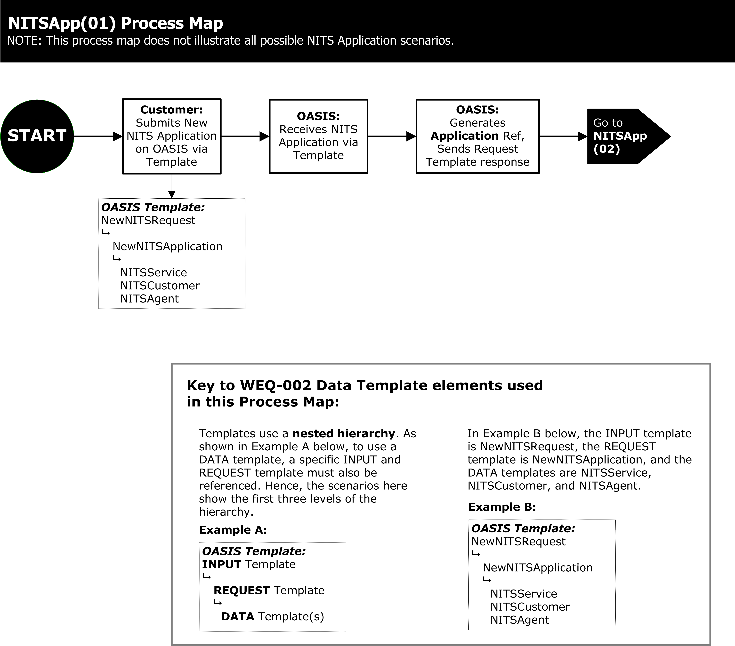
Exhibit 102 – APPLICATION PROCESS

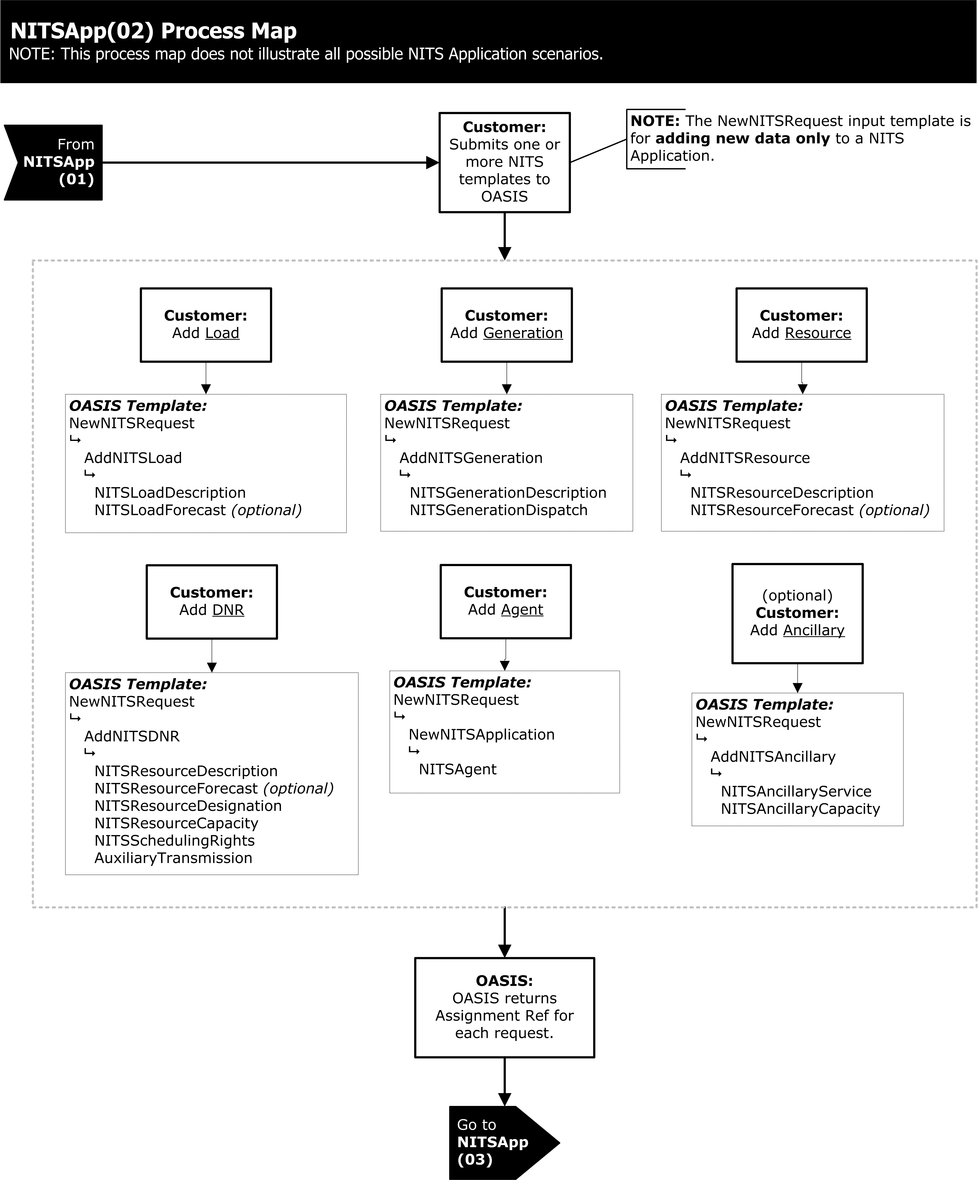
Exhibit 103 – APPLICATION PROCESS
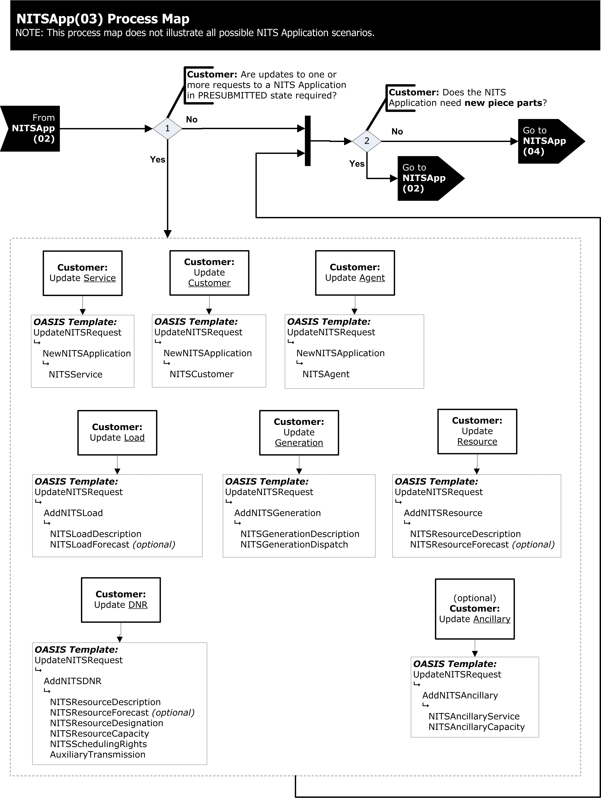
Exhibit 104 – APPLICATION PROCESS

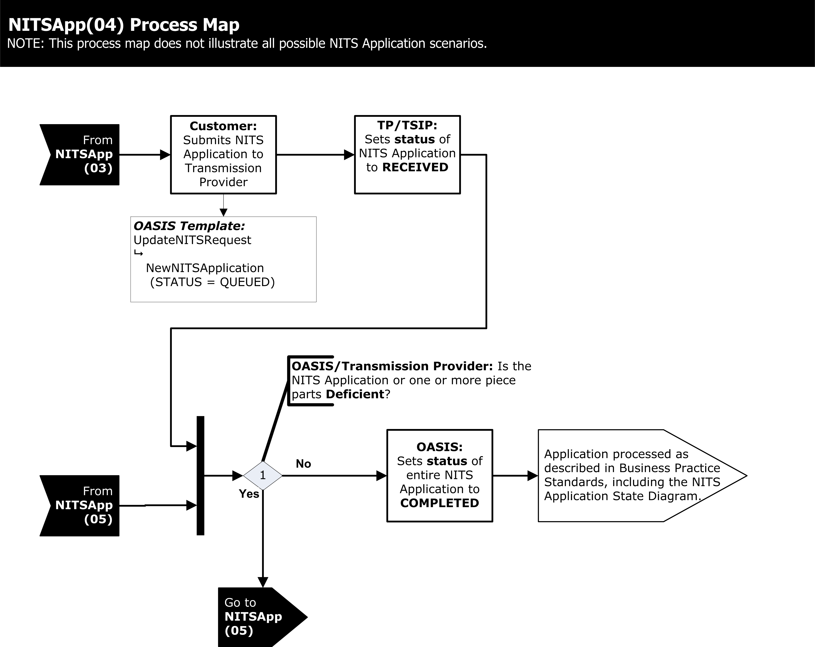
Exhibit 105 – APPLICATION PROCESS

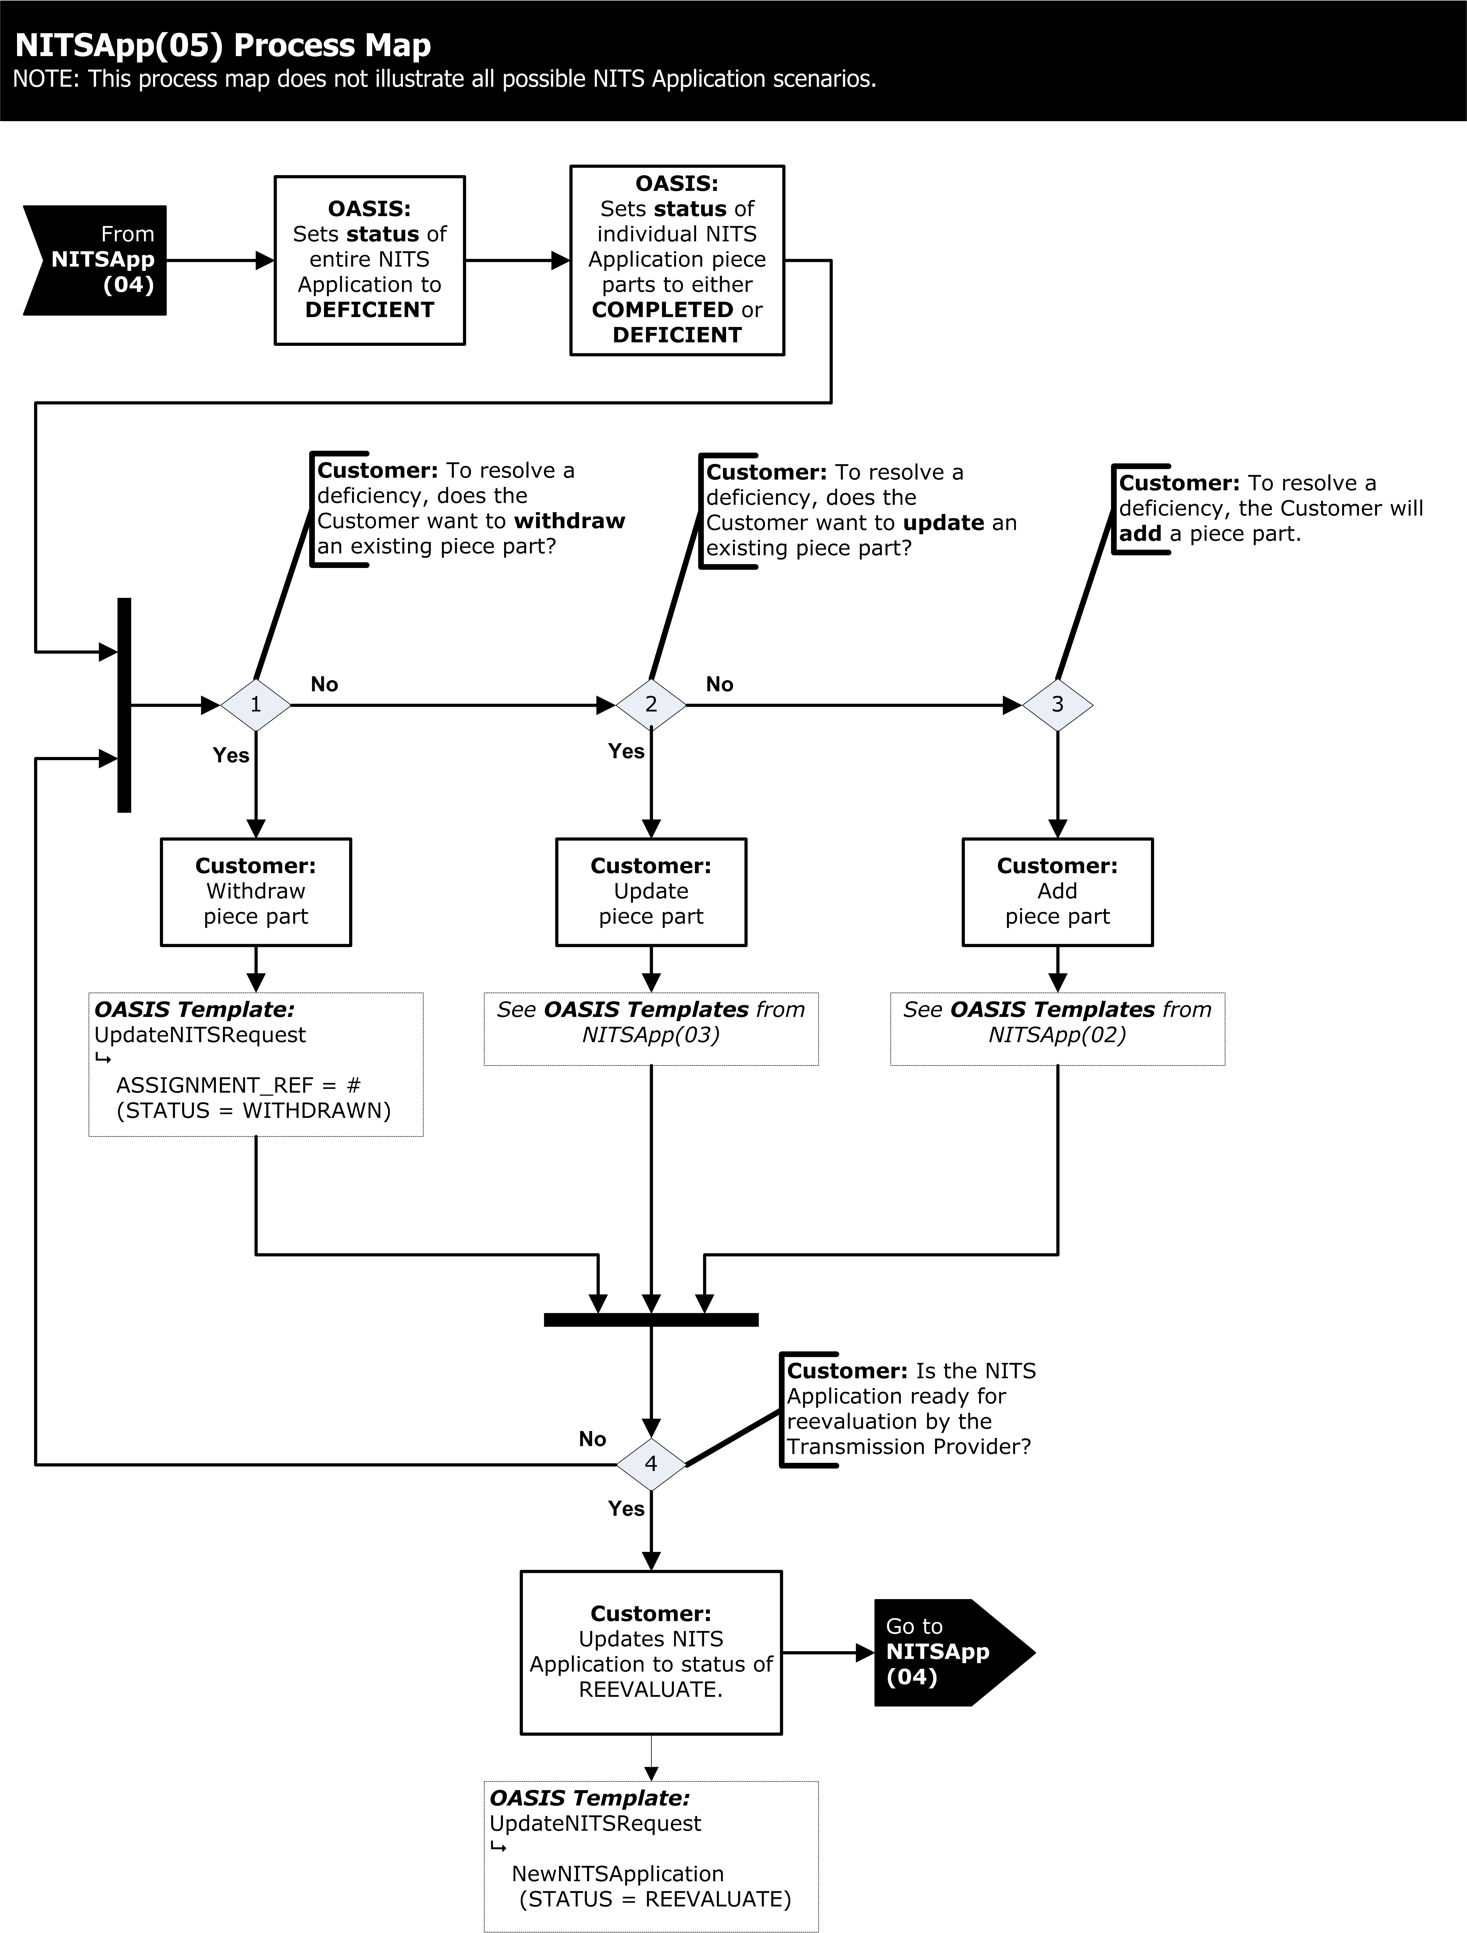
Exhibit 106 – APPLICATION PROCESS
013-102.1 PRE-SUBMITTED NETWORK INTEGRATION TRANSMISSION SERVICE APPLICATION PROCESS

The pre-submitted NITS Application process, as shown in Business Practice Standard WEQ-013-102 Exhibit 102-105, should be used as a business process guideline and illustrates the valid changes that may be made to the process by the Transmission Provider and the Eligible Customer during the pre-submitted NITS Application process; however, individual tariffs may dictate specific allowed actions between statuses that are not reflected in this diagram.

Pre-submitted NITS Application requests may be developed by the Eligible Customer or developed on OASIS using the Transmission Provider’s Pre-submittal Workspace to arrange for a new NITS Application, Transmission Service or ancillary service with the Transmission Provider.

013-102.2 PRE-SUBMITTED NETWORK INTEGRATION TRANSMISSION SERVICE APPLICATION

Pre-submitted NITS Applications shall be submitted by the Eligible Customer to arrange for a new NITS Application on OASIS. The following are requirements for the NITS Application request associated with pre-submittal of the new NITS Application using the NewNITSRequest NITS OASIS INPUT Template.

NewNITSRequest NITS OASIS INPUT Template may be used to open a new OASIS Pre-submittal Workspace and begin the process for submitting a new NITS Application. Along with this NITS OASIS INPUT Template a single NITS OASIS REQUEST Template NewNITSApplication with the NITS OASIS DATA Templates NITSService, NITSCustomer, and NITSAgent (optional) must also be submitted for a new NITS Application.

Data structures for the NITS OASIS INPUT, REQUEST, and DATA Templates are defined in Business Practice Standards WEQ-002-100.

To create the Pre-submittal Workspace the Eligible Customer must submit the request with the STATUS of PRESUBMITTED. OASIS will then create the Pre-submittal Workspace and assign a unique application reference number (APPLICATION_REF) for the NITS Application as a whole and a unique request reference number (ASSIGNMENT_REF) used to identify the NewNITSApplication NITS OASIS REQUEST Template itself. The OASIS will return a request response to the Eligible Customer indicating the success/failure of the NewNITSApplication NITS OASIS REQUEST Template request.

Once the Pre-submittal Workspace has been created for the new NITS Application, the Eligible Customer may add all required information associated with the initial NITS Application through the submission of the appropriate NITS OASIS INPUT, REQUEST and DATA Templates. Minimum information requirements that must be submitted in the initial application for NITS are subject to the Transmission Provider’s Business Practices.

013-102.3 ADD INFORMATION TO THE PRE-SUBMITTED NETWORK INTEGRATION TRANSMISSION SERVICE APPLICATION

To add information to the pre-submitted NITS Application process, as shown in Business Practice Standard WEQ-013-102 Exhibit 102-106, should be used as a business process guideline and illustrates the valid changes that may be made to the process by the Eligible Customer during the pre-submitted stage of the NITS Application; however, individual tariffs may dictate specific allowed actions between statuses that are not reflected in this diagram.

The NewNITSRequest NITS OASIS INPUT Template is used to add additional requests and information to the pre-submitted NITS Application. The specific NITS Application that the additional requests will be added to must be identified by its unique APPLICATION_REF identifier returned by OASIS with the NewNITSApplication NITS OASIS REQUEST Template request.

Along with the NewNITSRequest NITS OASIS INPUT Template, NITS OASIS REQUEST Templates AddNITSLoad, AddNITSGeneration, AddNITSResource, AddNITSDNR, and AddNITSAncillary may be submitted to add the required information to the NITS Application. The specific NITS OASIS DATA Templates associated with each specific NITS OASIS REQUEST Template are defined in Business Practice Standards WEQ-002-101.3.

When adding requests to the Pre-submittal Workspace the Eligible Customer must submit each request with the STATUS of PRESUBMITTED. OASIS will then add the information to the Pre-submittal Workspace and return a request response to the Eligible Customer indicating the success/failure of submitted information along with a unique ASSIGNMENT_REF identifier to be used in any subsequent request to update information or STATUS associated with that specific request.

013-102.4 UPDATING INFORMATION TO THE PRE-SUBMITTED OR COMPLETED NETWORK INTEGRATION TRANSMISSION SERVICE APPLICATION

To update information in the pre-submitted or completed NITS Application process, as shown in Business Practice Standard WEQ-013-102 Exhibit 102-106, should be used as a business process guideline and illustrates the valid changes that may be made to the application by the Transmission Provider and the Eligible Customer during the pre-submitted or completed NITS Application process; however, individual tariffs may dictate specific allowed actions between statuses that are not reflected in this diagram.

The UpdateNITSRequest NITS OASIS INPUT Template is used to update existing information in a request associated with a pre-submitted or completed NITS Application. The specific NITS request to be updated must be identified by its NITS OASIS REQUEST Template name and unique APPLICATION_REF and ASSIGNMENT_REF identifiers assigned when the request was initially submitted on OASIS. Along with the UpdateNITSRequest NITS OASIS INPUT Template NITS OASIS REQUEST Templates NewNITSApplication, AddNITSLoad, AddNITSGeneration, AddNITSResource, AddNITSDNR, and AddNITSAncillary may be submitted to modify information with any of the existing requests present in the pre-submitted or completed NITS Application. The specific NITS OASIS DATA Templates associated with each specific NITS OASIS REQUEST Template are defined in Business Practice Standards WEQ-002-101.3.

To update the Pre-submittal Workspace, the Eligible Customer must submit the update request with the STATUS of PRESUBMITTED. OASIS will then modify the information in the Pre-submittal Workspace and return a request response to the Eligible Customer indicating the success/failure of the update.

To remove a request from the pre-submitted NITS Application in its entirety, the Eligible Customer may submit the UpdateNITSRequest NITS OASIS INPUT Template with the NITS OASIS REQUEST Template identifying the specific request to be removed and updating the STATUS to DELETED. OASIS will disassociate that request from the pre-submitted NITS Application and return a request response to the Eligible Customer indicating the success/failure of the update.

013-102.5 SUBMITTING THE NETWORK INTEGRATION TRANSMISSION SERVICE APPLICATION

As shown in Business Practice Standard WEQ-013-102 Exhibit 102-106, should be used as a business process guideline for completing the process and illustrates the valid changes that may be made to the application by the Transmission Provider and the Eligible Customer during the pre-submitted NITS Application process; however, individual tariffs may dictate specific allowed actions between statuses that are not reflected in this diagram.

UpdateNITSRequest NITS OASIS INPUT Template is used to complete the information in the pre-submitted NITS Application and submit the NITS Application to the Transmission Provider. The Eligible Customer must submit the UpdateNITSRequest NITS OASIS INPUT Template along with the NewNITSApplication NITS OASIS REQUEST Template to set the pre-submitted NITS Application STATUS to QUEUED. OASIS will set NewNITSApplication NITS OASIS REQUEST Template request, as well as all existing requests associated with that NITS Application by APPLICATION_REF that have a status of PRESUBMITTED, to the STATUS of QUEUED and update the TIME_QUEUED to the time the NITS Application is updated to the STATUS of QUEUED.

OASIS will then return a request response to the Eligible Customer indicating the success or failure of the update. The Transmission Provider will then make the appropriate STATUS changes.

013-102.6 COMPLETING THE NETWORK INTEGRATION TRANSMISSION SERVICE APPLICATION

Once the NITS Application is submitted by the Eligible Customer the Transmission Provider shall acknowledge its receipt by setting the STATUS of the NewNITSApplication NITS OASIS REQUEST Template request to RECEIVED.

The Transmission Provider will then review the NITS Application for the specified minimum information requirements. If the information has not been provided the Transmission Provider shall set the STATUS of the NewNITSApplication NITS OASIS REQUEST Template request to INVALID or DEFICIENT.

The Transmission Provider shall then determine if each of the individual requests (e.g., AddNITSResource NITS OASIS REQUEST Template) and associated information required in a NITS Application are sufficient (i.e. consistent with the Transmission Provider’s OATT requirements for a Completed Application). The Transmission Provider shall set the STATUS of each such individual request to COMPLETED. If not deemed sufficient, the Transmission Provider shall set the STATUS of each such individual request to INVALID or DEFICIENT.

The Eligible Customer must take the appropriate actions to remove all deficiencies identified by the Transmission Provider in the NITS Application. Once all the individual requests considered part of the NITS Application have been set to the STATUS of COMPLETED, the Transmission Provider shall set the overall NewNITSApplication NITS OASIS REQUEST Template request to the STATUS of COMPLETED and the process can continue with the evaluation of the completed NITS Application.

013-102.7 DEFICIENT PROCESSING

As shown in Business Practice Standard WEQ-013-102 Exhibit 102-106, should be used as a business process guideline for deficiency processing and illustrates the valid changes that may be made to the application by the Transmission Provider and the Eligible Customer during the submitted NITS Application process; however, individual tariffs may dictate specific allowed actions between statuses that are not reflected in this diagram.

Deficient processing to the submitted NITS Application shall be submitted by the Eligible Customer to remedy the deficient information to the NITS Application on OASIS. The following are requirements for NITS Application request associated with remedying the deficient NITS Application using the UpdateNITSRequest and/or NewNITSRequest NITS OASIS INPUT Templates.

The UpdateNITSRequest NITS OASIS INPUT Template structure is used to remedy deficient information to the submitted NITS Application by updating or adding additional information to the NITS OASIS DATA Templates associated with the specific request(s) that have been marked DEFICIENT. The applicable NITS OASIS DATA Templates associated with each NITS OASIS REQUEST Template, and any restrictions on the information that may be updated in the existing request are set forth in Business Practice Standard WEQ-002-101.3.

If the deficiency can be remedied by updating the information associated with a given DEFICIENT request, the Eligible Customer can use the UpdateNITSRequest NITS OASIS INPUT Template structure to submit the updated information and reset the request STATUS to REEVALUATE for reconsideration by the Transmission Provider.

If the deficiency cannot be remedied by updating the information associated with a given DEFICIENT request, the Eligible Customer can use the UpdateNITSRequest NITS OASIS INPUT Template structure to set the request STATUS to WITHDRAWN to remove that request from further consideration by the Transmission Provider. New information can then be added to the NITS Application by submission of one or more new NITS request using the NewNITSRequest NITS OASIS INPUT Template.

The NewNITSRequest NITS OASIS INPUT Template is used to add additional requests to the NITS Application to remedy deficiencies by using the process as described in Business Practice Standard WEQ-013-102.1. New requests may be added to the Pre-submittal Workspace and updated prior to submission for consideration by the Transmission Provider, or the requests may be submitted directly with the STATUS of QUEUED to be considered by the Transmission Provider as part of the NITS Application.

Any new or updated NITS requests that are QUEUED or set to REEVALUATE may be set to a STATUS of INVALID, DECLINED, or DEFICIENT if the Transmission Provider determines that the Eligible Customer has failed to meet any of the terms and conditions for the provision of service (e.g., failure to provide a required deposit, execute a study agreement, etc.). If the new or updated information has remedied the deficiency for that portion of the NITS Application, the Transmission Provider shall set the STATUS of associated request to COMPLETED.

Once the Eligible Customer has remedied all the deficiencies to a submitted NITS Application the Eligible Customer must update the overall NITS Application with the STATUS of REEVALUATE using the UpdateNITSRequest NITS OASIS INPUT Template and the NewNITSApplication NITS OASIS REQUEST Template structure.

The Transmission Provider will then continue the processing in accordance with Business Practice Standard WEQ-013-102.7 until all deficiencies are resolved and the Transmission Provider sets the NewNITSApplication NITS OASIS REQUEST Template request STATUS of the entire NITS Application to COMPLETED.

013-103 EVALUATION OF NETWORK INTEGRATION TRANSMISSION SERVICE APPLICATION

As shown in Business Practice Standard WEQ-013-101.4 Exhibit 101 should be used as a business process guideline and illustrates the valid changes that may be made to the STATUS value by the Transmission Provider and the Eligible Customer during the NITS Application process; however, individual tariffs may dictate specific actions allowed between statuses that are not reflected in this diagram.

013-103.1 Review of Completed NETWORK INTEGRATION TRANSMISSION SERVICE Application

The completed NITS Application will be reviewed by the Transmission Provider prior to the NITS Application STATUS being set to CONFIRMED. The following are requirements for a NITS Application request associated with confirming the submitted NITS Application.

If the Transmission Provider determines that some level of study is required or is being performed, the Transmission Provider shall set the overall NITS Application STATUS to STUDY from COMPLETED,

If the Transmission Provider determines that the Eligible Customer has failed to meet any of the terms and conditions for the provision of service (e.g., failure to provide a required deposit, execute a study agreement, etc.), the Transmission Provider shall set the overall NITS Application STATUS to DECLINED from STUDY,.

If the Transmission Provider determines that a specific requested service cannot be provided due to insufficient transfer capability consistent with the Transmission Provider’s tariff requirements, shall set the STATUS of that request to REFUSED from STUDY,.

If the Transmission Provider determines that a specific request is to be granted only in part as specified in the NITS Application shall set the STATUS of that request to COUNTEROFFER or CR_COUNTEROFFER from STUDY

If the Transmission Provider determines that a specific request is to be granted in full as specified in the NITS Application shall set the STATUS of that request to ACCEPTED or CR_ACCEPTED from STUDY

If the Transmission Provider determines that all specific requests in the NITS Application is to be granted as specified, the Transmission Provider shall set the overall NITS Application STATUS to ACCEPTED from STUDY,. Prior to setting the overall NITS Application to ACCEPTED the Transmission Provider shall update the status of all associated requests in the completed NITS Application to ACCEPTED or CR_ACCEPTED. Otherwise the Transmission Provider shall set the overall NITS Application STATUS to COUNTEROFFER to reflect that one or more specific requests in the NITS Application have not been granted in full.

Once the NITS Application has been set to the STATUS of ACCEPTED or COUNTEROFFER, the Eligible Customer must set the STATUS of the overall NITS Application to CONFIRMED or WITHDRAWN according to the time limits specified in the Transmission Provider’s tariff for execution of a service agreement or for requesting filing of an unexecuted service agreement using the UpdateNITSRequest NITS OASIS INPUT Template and the NewNITSApplication NITS OASIS REQUEST Template structure.

The NewNITSRequest NITS OASIS INPUT Template structure may be used to submit administrative changes or other requests to modify service under a pending NITS Application. If the request is not an administrative change, the Transmission Provider has the discretion to allow the requested change or may set the STATUS of the request to DECLINED.

If the Eligible Customer has not set the STATUS to CONFIRMED or WITHDRAWN according to the time limits specified in the Transmission Provider’s tariff for execution of a service agreement or for requesting filing of an unexecuted service agreement, the Transmission Provider shall set the STATUS of the overall NITS Application and all requests of the NITS Application that are not already in a final state to RETRACTED from ACCEPTED or COUNTEROFFER.

Once the overall NITS Application has been set to the STATUS of CONFIRMED, any changes to the NITS Application will be made in accordance with Business Practice Standard WEQ-013-105.
Once the overall NITS Application has been set to the STATUS of CONFIRMED, if the Transmission Provider and Transmission Customer mutually agree to void the NITS Application, the Transmission Provider shall set the status of the overall NITS Application and all requests of the NITS Application that are CONFIRMED to ANNULLED.

013-105 NETWORK INTEGRATION TRANSMISSION SERVICE MODIFICATION OF SERVICE PROCESSING

The following Business Practice Standard identifies specific OASIS processing requirements that must be implemented by OASIS and/or associated back-end support systems. Before the modification of service has been submitted, the results of all modification of service processing shall be viewable by the requesting Eligible Customer or Transmission Customer via the QueryNITSRequest NITS OASIS QUERY Template and corresponding NITS OASIS REQUEST Templates.

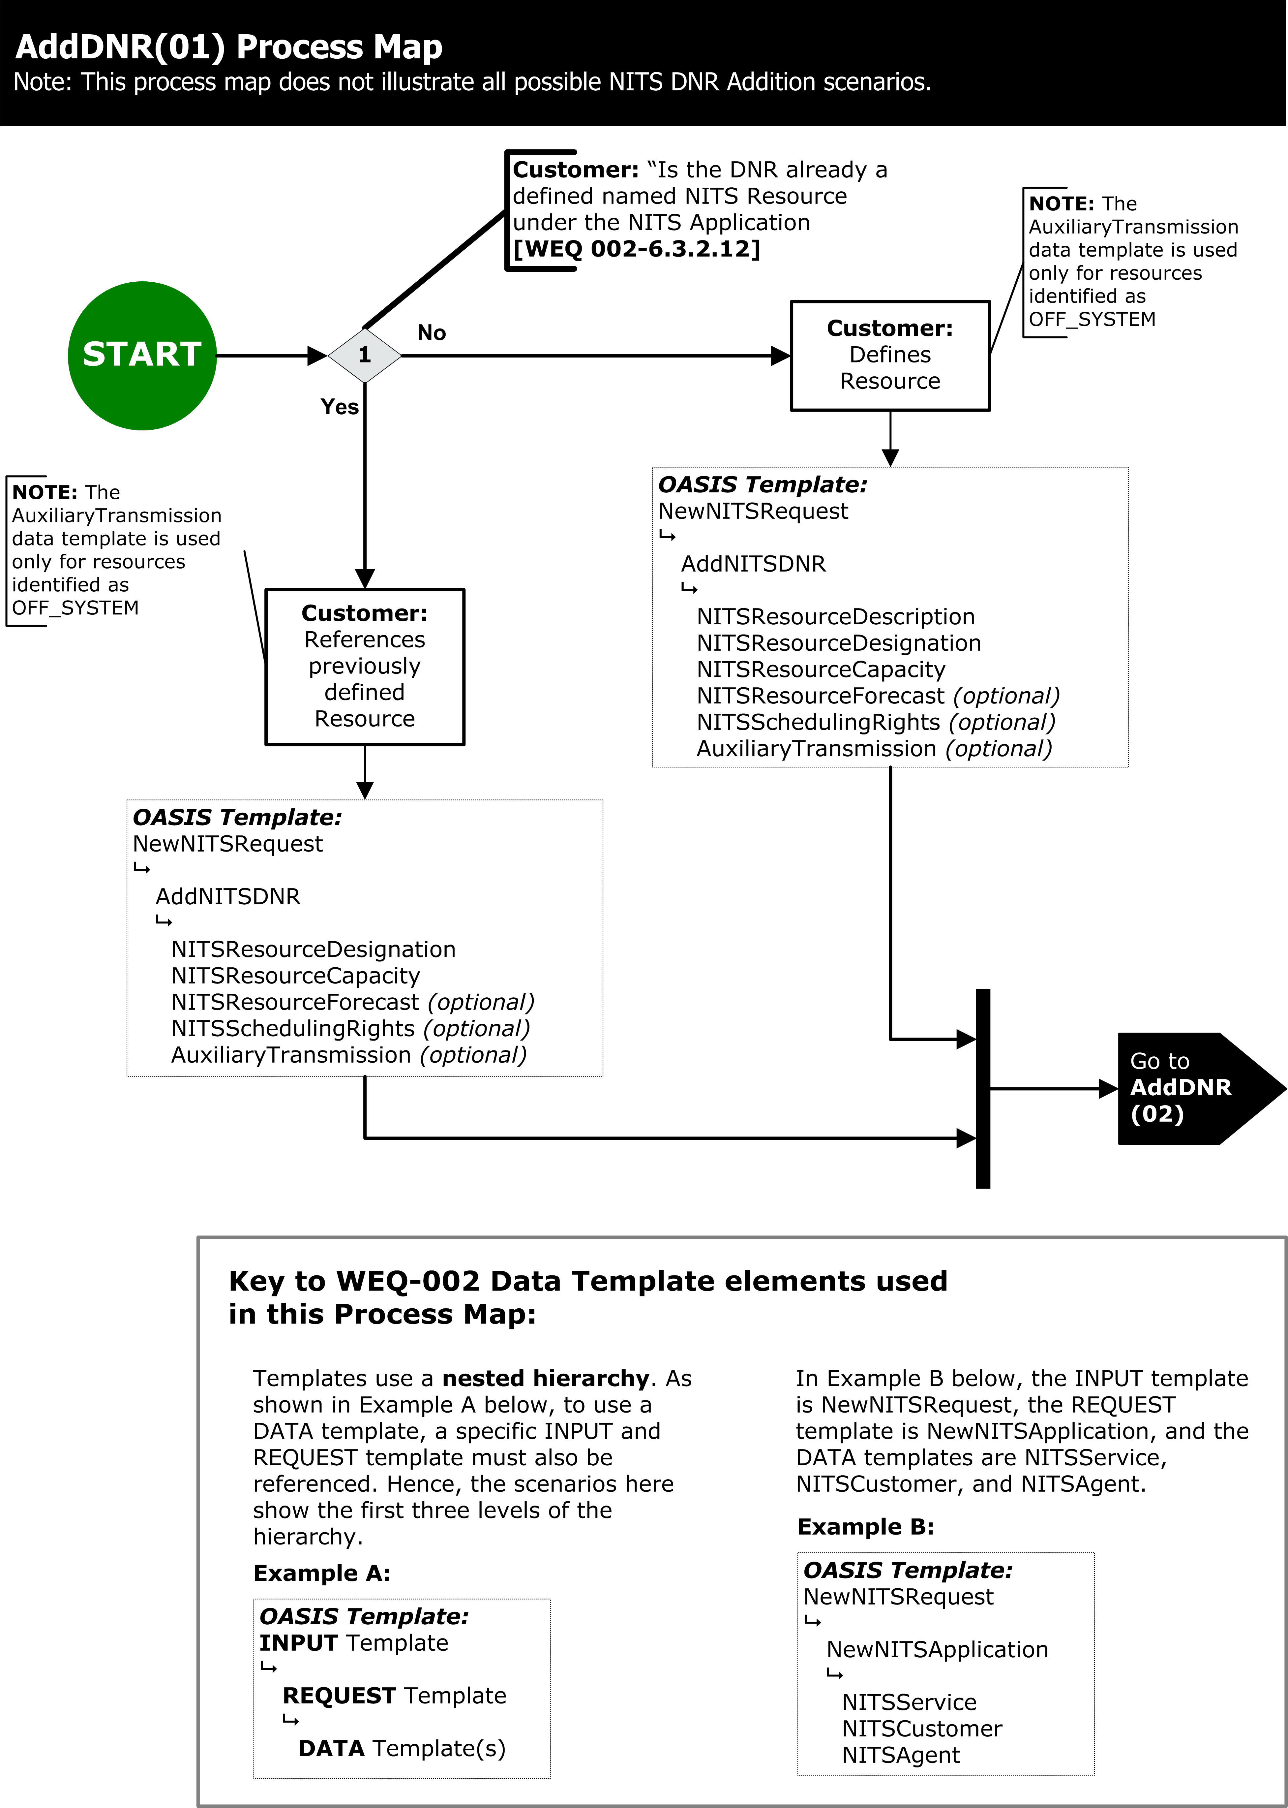Exhibit 107 – ADD DNR PROCESS

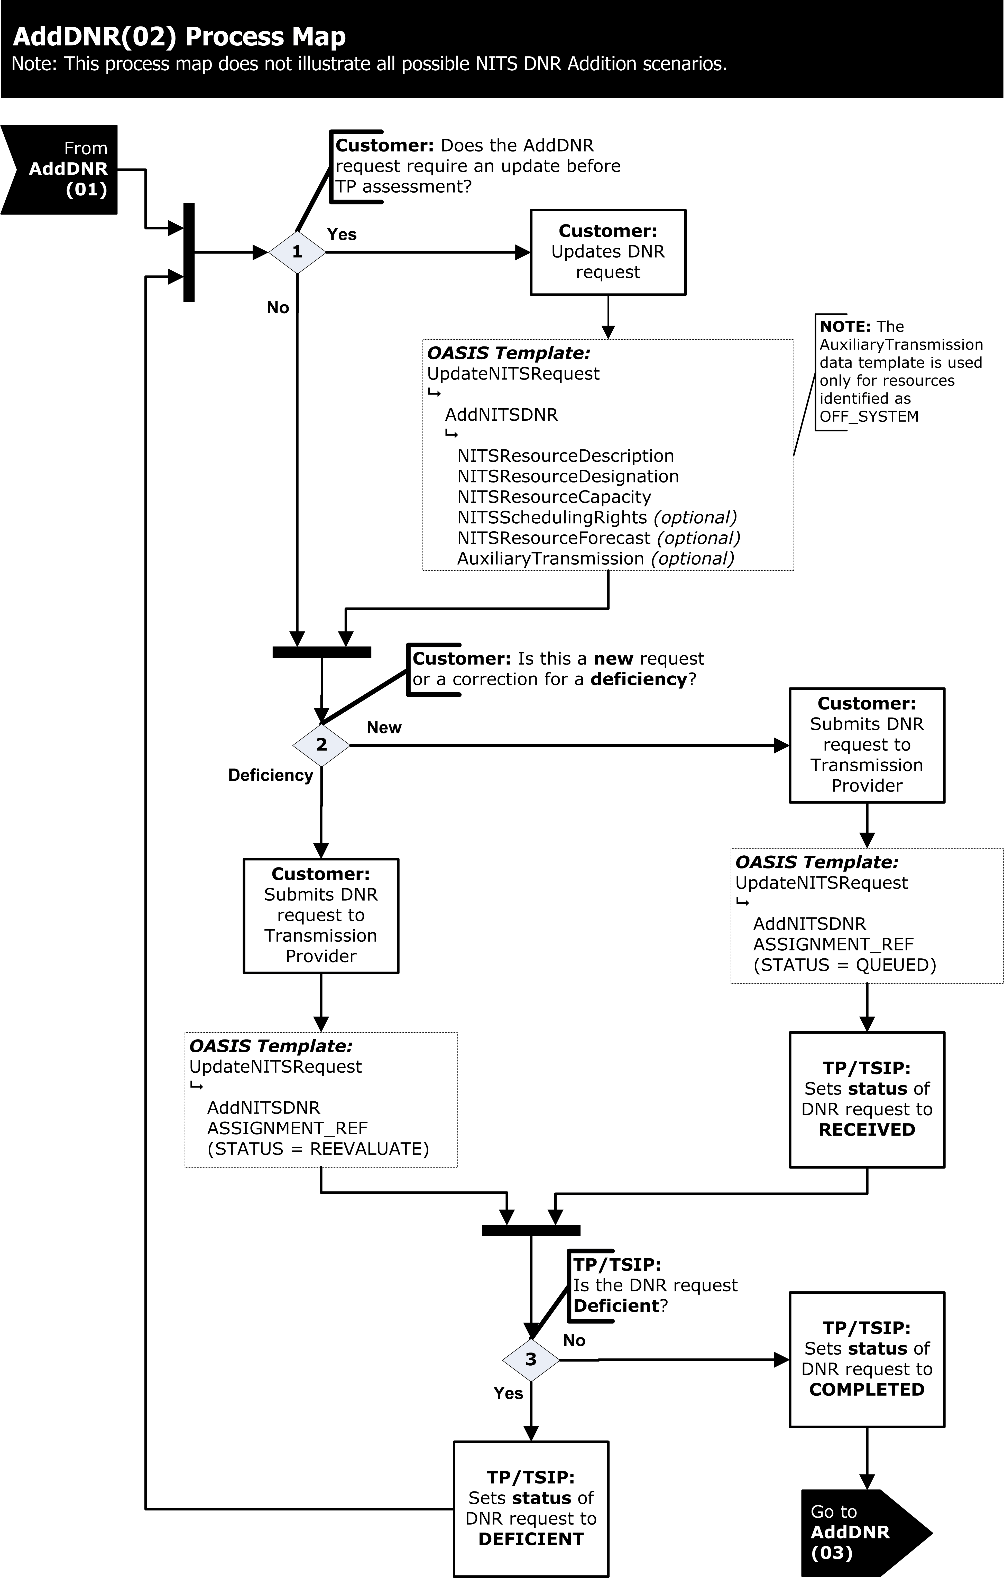
Exhibit 108 – ADD DNR PROCESS
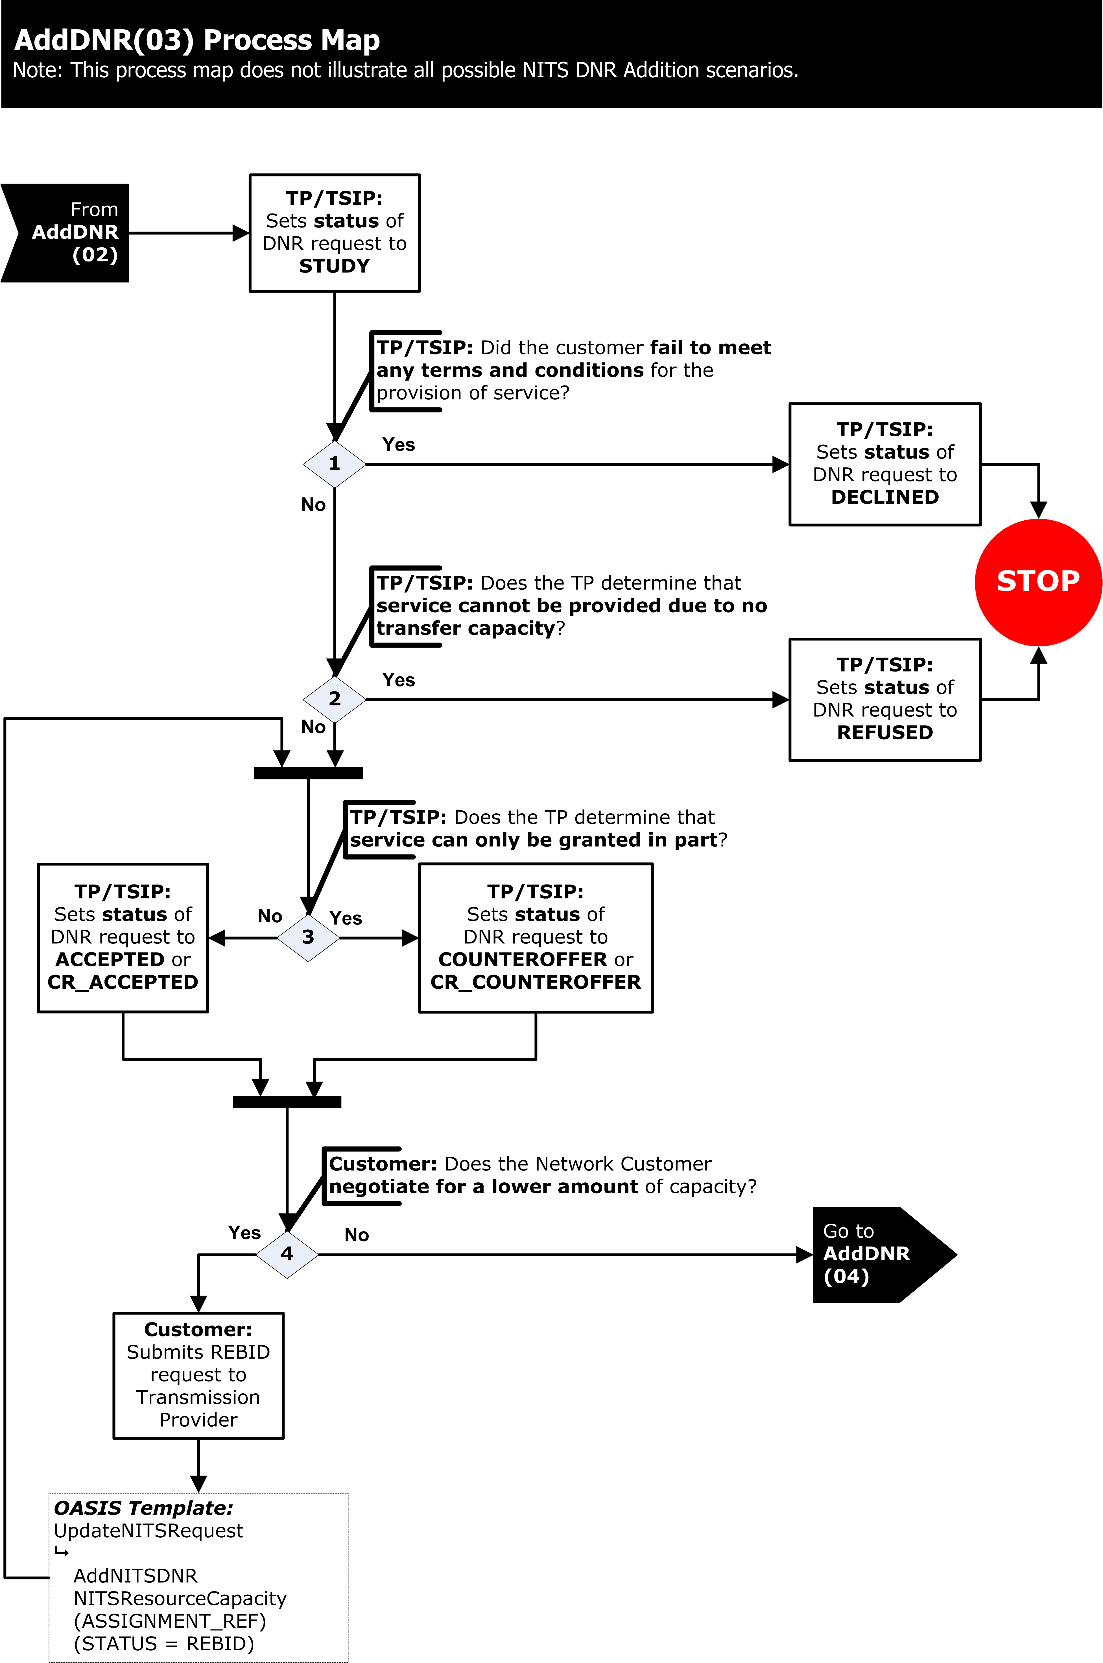
Exhibit 109 – ADD DNR PROCESS

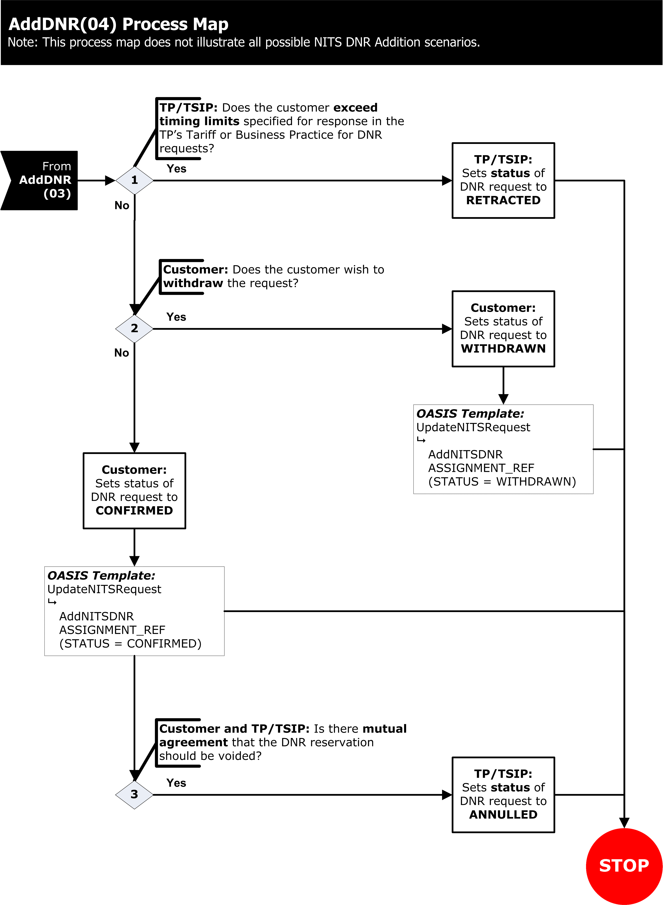
Exhibit 110 – ADD DNR PROCESS
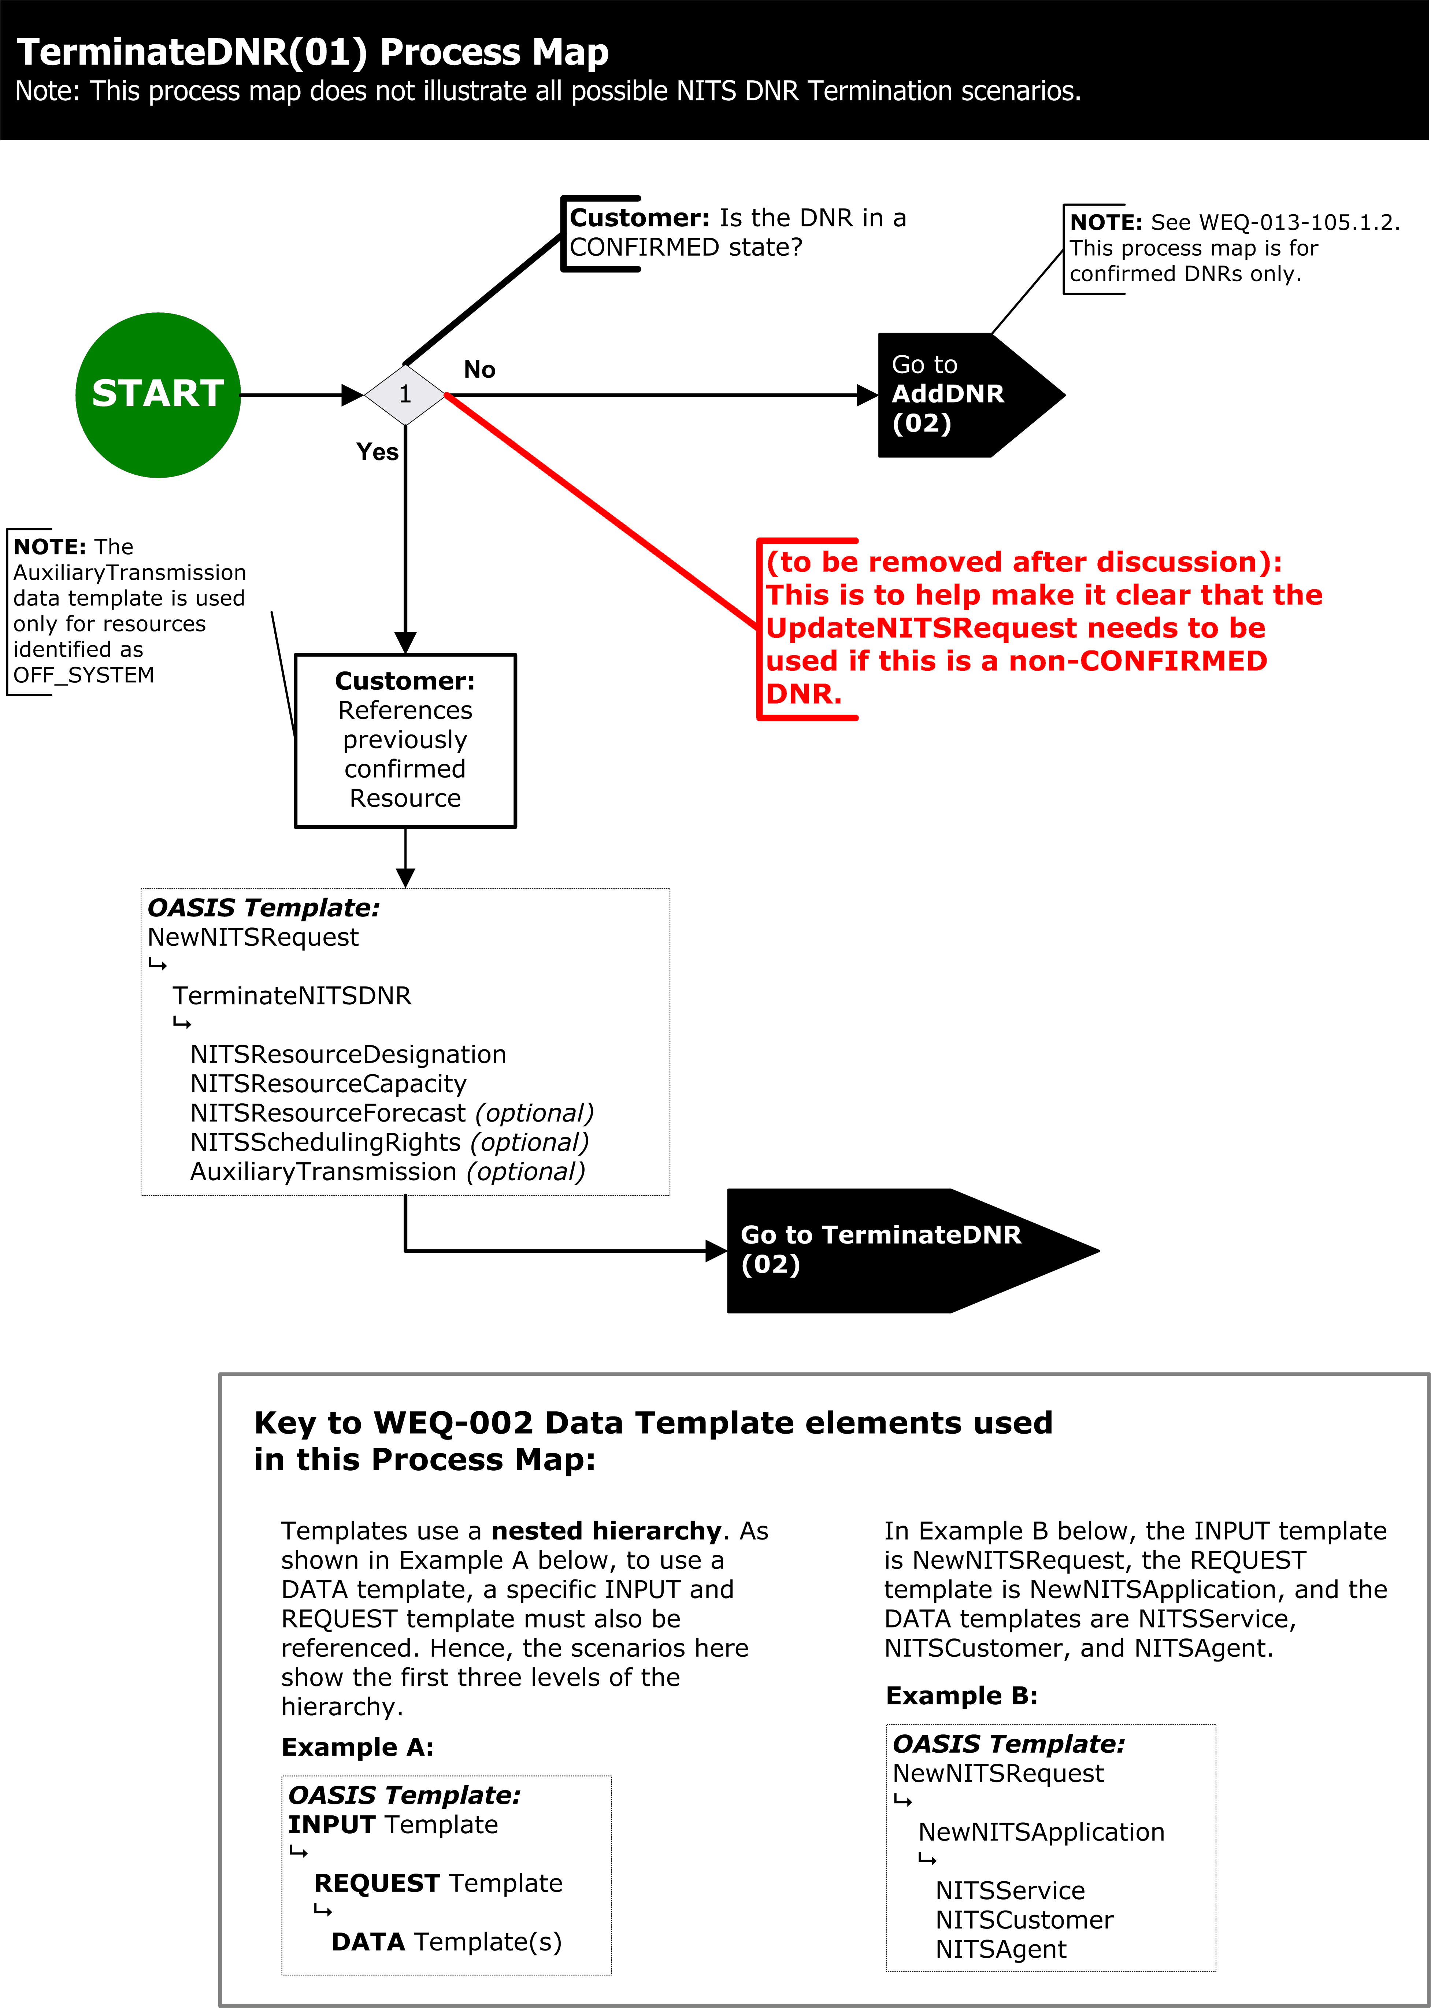
Exhibit 111 – TERMINATE DNR PROCESS

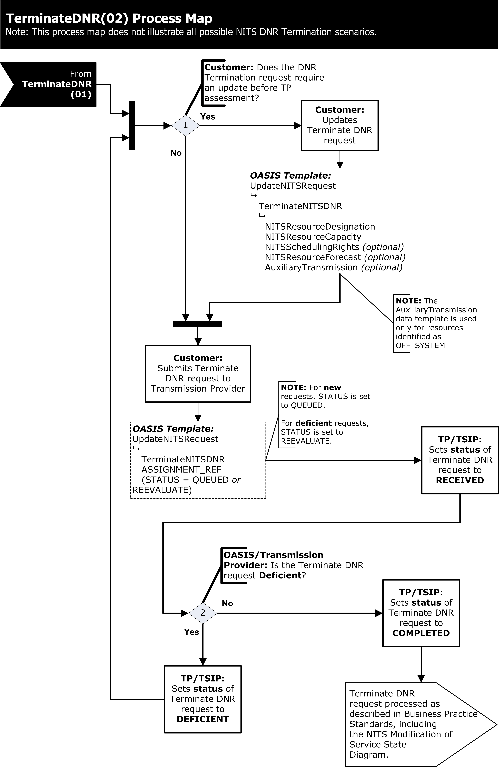
Exhibit 112 – TERMINATE DNR PROCESS

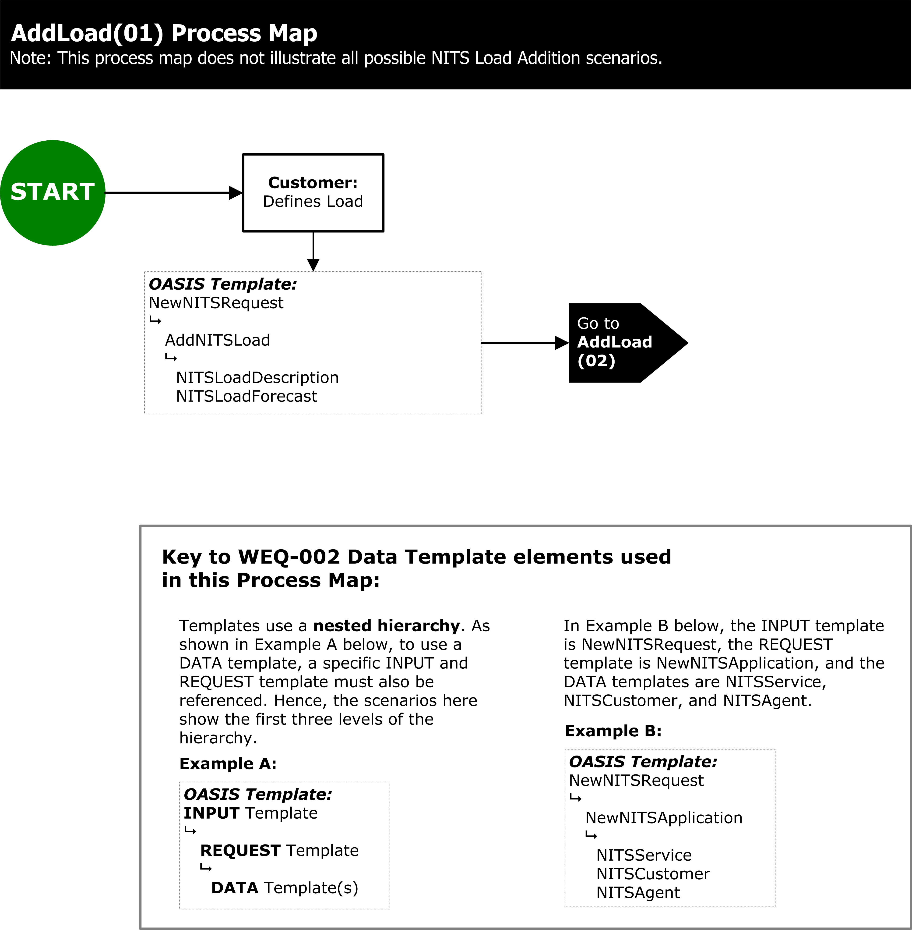
Exhibit 113 – ADD LOAD PROCESS

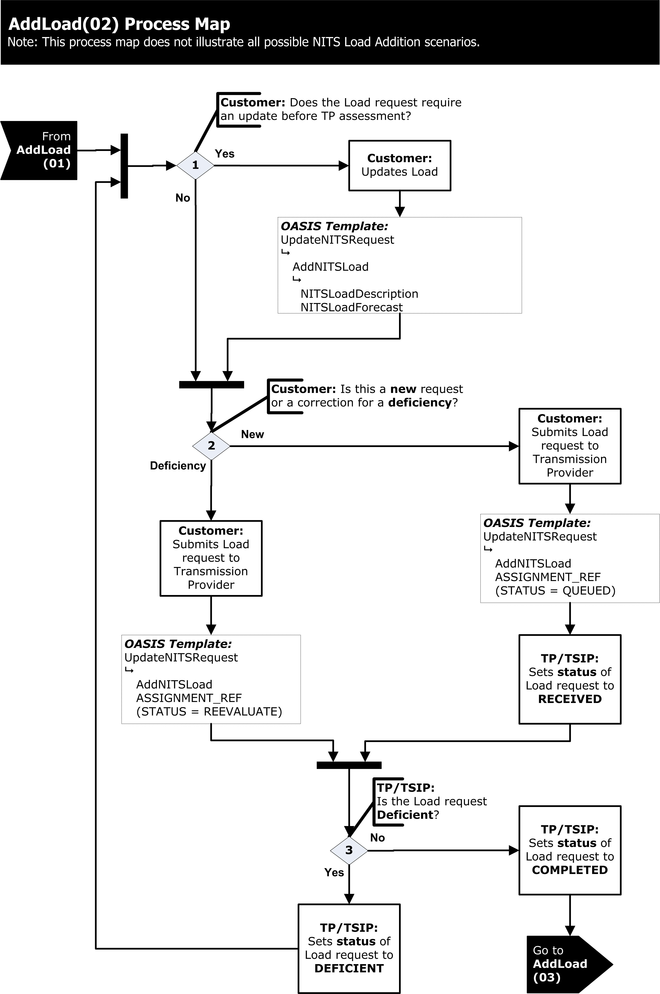
Exhibit 114 – ADD LOAD PROCESS

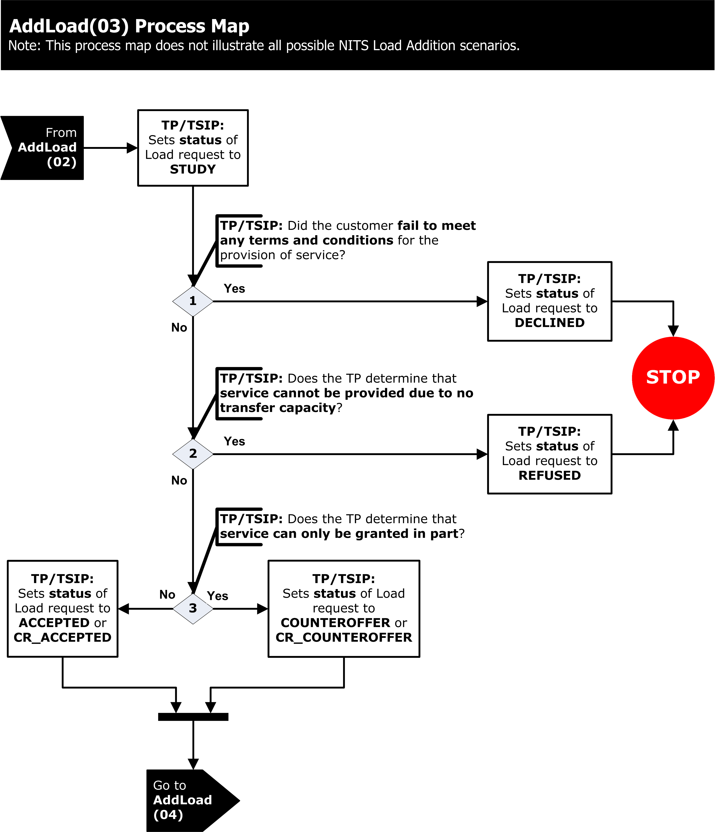
Exhibit 115 – ADD LOAD PROCESS

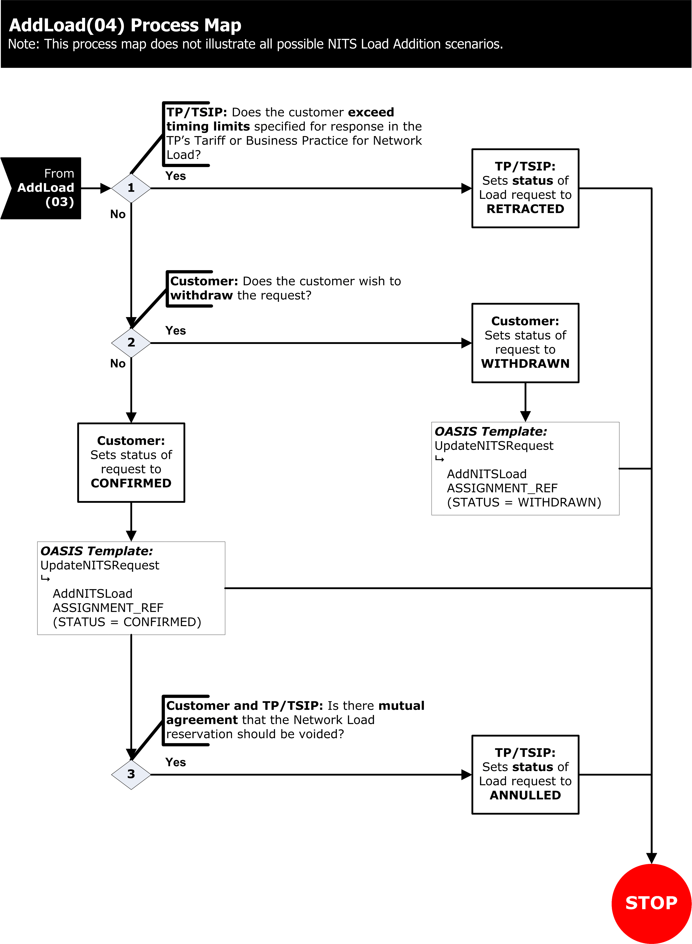
Exhibit 116 – ADD LOAD PROCESS

013-105.1 DESIGNATED NETWORK RESOURCE PROCESSING

The DNR processing, as shown in Business Practice Standard WEQ-013-105 Exhibit 107-110, of pre-submitted or confirmed NITS Application should be used as a business process guideline and illustrates the valid changes that may be made to the process by the Transmission Provider, the Eligible Customer or the Transmission Customer during the pre-submitted or confirmed NITS Application process; however, individual tariffs may dictate specific allowed actions between statuses that are not reflected in this diagram.

Pre-submitted modification of service requests may be developed by the Eligible Customer or Transmission Customer offline or developed on OASIS using the Transmission Provider’s Pre-submittal Workspace to arrange for modification of service with the Transmission Provider.

013-105.1.1 PRE-SUBMITTED DESIGNATED NETWORK RESOURCE

Pre-submitted DNRs shall be submitted by the Eligible Customer or Transmission Customer to arrange for a new or modified DNR on OASIS. The following are requirements for the DNR request associated with pre-submittal of the DNR using the NewNITSRequest NITS OASIS INPUT Template.

NewNITSRequest NITS OASIS INPUT Template may be used to open a new OASIS Pre-submittal Workspace and begin the process for submitting a new or modification DNR. Along with this NITS OASIS INPUT Template a single NITS OASIS REQUEST Template AddNITSDNR with the NITS OASIS DATA Templates NITSResourceDescription, NITSResourceForecast, NITSResourceDesignation, NITSResourceCapacity, NITSSchedulingRights, and AuxillaryTransmission must also be submitted for a new or modification DNR.

Data structures for the NITS OASIS INPUT, REQUEST, and DATA Templates are defined in Business Practice Standards WEQ-002-100.

To create the Pre-submittal Workspace, the Eligible Customer or Transmission Customer must submit the request with the STATUS of PRESUBMITTED, along with the required APPLICATION_REF Data Elements. OASIS will then create the Pre-submittal Workspace and use the inputted reference numbers assigned for making addition(s) or modification(s) to the NITS Application. OASIS will return a request response to the Eligible Customer or Transmission Customer, indicating the success/failure of the NewNITSRequest NITS OASIS REQUEST Template request including the ASSIGNMENT_REF if successful.

Once the Pre-submittal Workspace has been created for the DNR, the Eligible Customer or Transmission Customer may add all required information associated with the DNR through the submission of the appropriate NITS OASIS INPUT, REQUEST and DATA Templates. Minimum information requirements for submission of the DNR are subject to the Transmission Provider’s Business Practices.

If the Eligible Customer or Transmission Customer does not wish to create a Pre-submittal Workspace, then the Eligible Customer or Transmission Customer must submit the request with the STATUS of QUEUED along with the required APPLICATION_REF Data Elements in the appropriate NITS OASIS DATA Templates. Minimum information requirements that must be submitted in the DNR are subject to the Transmission Provider’s Business Practices.

013-105.1.2 ADD INFORMATION TO THE PRE-SUBMITTED DESGINATED NETWORK RESOURCE

To add information in the pre-submitted DNR process, as shown in Business Practice Standard WEQ-013-105 Exhibit 107-110, should be used as a business process guideline and illustrates the valid changes that may be made to the process by the Eligible Customer or Transmission Customer during the pre-submitted stage of the DNR; however, individual tariffs may dictate specific permissible actions between statuses that are not reflected in the following diagram.

013-105.1.3 UPDATING INFORMATION TO THE PRE-SUBMITTED OR COMPLETED DESIGNATED NETWORK RESOURCE
To update information in the pre-submitted or completed DNR process is defined in accordance to Business Practice Standard WEQ-013-102.1.3 for update DNR; however, individual tariffs may dictate specific allowed actions between statuses that are not reflected in Business Practice Standard WEQ-013-105 Exhibit 107-110.

013-105.1.4 SUBMITTING THE DESIGNATED NETWORK RESOURCE
As shown in Business Practice Standard WEQ-013-105 Exhibit 107-110, should be used as a business process guideline for completing the process and illustrates the valid changes that may be made to the application by the Transmission Provider and the Eligible Customer or Transmission Customer during the pre-submitted DNR; however, individual tariffs may dictate specific allowed actions between statuses that are not reflected in Business Practice Standard WEQ-013-105 Exhibit 107-110.

013-105.1.5 COMPLETING THE DESIGNATED NETWORK RESOURCE

Once submitted by the Eligible Customer or Transmission Customer the Transmission Provider shall acknowledge receipt of the NITS Application by setting the STATUS of the AddNITSDNR NITS OASIS REQUEST Template request to RECEIVED.

The Transmission Provider will then review the DNR for the specified minimum information requirements. If the minimum information has not been provided the Transmission provider shall set the STATUS of the AddNITSDNR NITS OASIS REQUEST Template request to INVALID or DEFICIENT.

The Transmission Provider shall determine if each of the individual requests (e.g., AddNITSResource NITS OASIS REQUEST Template), and associated information required in a DNR can be deemed sufficient (i.e. consistent with the Transmission Provider’s OATT requirements for a Completed Application). If sufficient, the Transmission Provider shall set the STATUS of each such individual request to COMPLETED. If insufficient, the Transmission Provider shall set the STATUS of each such individual request to INVALID or DEFICIENT.

The Eligible Customer or Transmission Customer must take the appropriate actions required to remedy all deficiencies identified by the Transmission Provider in the DNR. Once all the individual requests considered as part of the DNR have been set to the STATUS of COMPLETED, the Transmission Provider shall set the overall AddNITSDNR NITS OASIS REQUEST Template request to the STATUS of COMPLETED and the process can continue with the evaluation of the completed DNR.

013-105.1.6 DEFICIENT PROCESSING

Deficient information processing of the submitted DNR shall be submitted by the Eligible Customer or Transmission Customer to remedy the deficiency. The following are requirements for DNR request associated with remedying the deficient DNR using the UpdateNITSRequest NITS OASIS INPUT Templates.

The UpdateNITSRequest NITS OASIS INPUT Template structure is used to remedy deficient information to the submitted DNR by updating or adding additional information to the NITS OASIS DATA Templates associated with the specific request(s) that have been marked DEFICIENT. The applicable NITS OASIS DATA Templates associated with each NITS OASIS REQUEST Template, and any restrictions on the information that may be updated in the existing request, are set forth in Business Practice Standard WEQ-002-101.3.

If the deficiency can be remedied by updating the information associated with a given DEFICIENT request, the Eligible Customer or Transmission Customer can use the UpdateNITSRequest NITS OASIS INPUT Template structure to submit the updated information and reset the request’s STATUS to REEVALUATE for reconsideration by the Transmission Provider.

If the deficiency cannot be remedied by updating the information associated with a given DEFICIENT request, the Eligible Customer or Transmission Customer can use the UpdateNITSRequest NITS OASIS INPUT Template structure to set the request’s STATUS to WITHDRAWN and remove that request from further consideration by the Transmission Provider. A NewNITSRequest NITS OASIS INPUT Template can be used to submit an AddNITSDNR NITS OASIS REQUEST Template to replace the deficient request. The new DNR request will be given a new queue time reflecting the time the AddNITSDNR request is submitted.

Any new or updated DNR requests that are QUEUED or set to REEVALUATE may be set to the STATUS to INVALID, DECLINED, DEFICIENT if the Transmission Provider determines that the Eligible Customer or Transmission Customer has failed to meet any of the terms and conditions for the provision of service (e.g., failure to provide a required deposit, execute a study agreement, etc.). If the new or updated information has remedied the deficiency for that portion of the DNR, the Transmission Provider shall set the STATUS of associated request to COMPLETED.

The Transmission Provider will then continue the processing using the process in accordance with Business Practice Standard WEQ-013-105 Exhibit 107-110 until all deficiencies are resolved and the Transmission Provider sets the AddNITSDNR NITS OASIS REQUEST Template request STATUS of the entire DNR to COMPLETED.

013-105.1.7 EVALUATION OF DESIGNATED NETWORK RESOURCE

As shown in Business Practice Standard WEQ-013-101.4 Exhibit 101 should be used as a business process guideline and illustrates the valid changes that may be made to the STATUS value by the Transmission Provider, the Eligible Customer, or Transmission Customer during the DNR process; however, individual tariffs may dictate specific actions allowed between statuses that are not reflected in Business Practice Standard WEQ-013-105 Exhibit 107-110.

013-105.1.8 REVIEW OF COMPLETED DESIGNATED NETWORK RESOURCE

The completed DNR will be reviewed by the Transmission Provider prior to the DNR request being confirmed. The following are requirements for the DNR request(s) associated with confirming the submitted DNR.

If the Transmission Provider determines that some level of study is required or is being performed, the Transmission Provider shall set the STATUS to STUDY from COMPLETED.

If the Transmission Provider determines that the Eligible Customer or Transmission Customer has failed to meet any of the terms and conditions for the provision of service (e.g., failure to provide a required deposit, execute a study agreement, etc.), the Transmission Provider shall set the STATUS to DECLINED from STUDY.

If the Transmission Provider determines that the requested service cannot be provided due to insufficient transfer capability consistent with the Transmission Provider’s tariff requirements, the Transmission Provider shall set the STATUS to REFUSED from STUDY.

If the Transmission Provider determines that the DNR is to be granted only in part as requested in the DNR request, the Transmission Provider shall set the STATUS of that request to COUNTEROFFER or CR_COUNTEROFFER from STUDY.

If the Transmission Provider determines that a specific request is to be granted in full as specified in the DNR request, the Transmission Provider shall set the STATUS of that request to ACCEPTED or CR_ACCEPTED from STUDY,.

Once the DNR has been set to the STATUS of ACCEPTED, CR_ACCEPTED, COUNTEROFFER, or CR_COUNTEROFFER the Eligible Customer or Transmission Customer must set the STATUS of the DNR request to CONFIRMED or WITHDRAWN according to the timing limits specified in Business Practice WEQ-001-105.1.5 Table 105-A using the UpdateNITSRequest NITS OASIS INPUT Template and the AddNITSDNR NITS OASIS REQUEST Template structure.

If the Eligible Customer or Transmission Customer has not set the STATUS to CONFIRMED or WITHDRAWN according to the timing limits specified in Business Practice WEQ-001-105.1.5 Table 105-A, the Transmission Provider may update the request STATUS to RETRACTED from ACCEPTED, CR_ACCEPTED, COUNTEROFFER, or CR_COUNTEROFFER.

Once the DNR request has been set to the STATUS of CONFIRMED the DNR reservation is incorporated into the NITS Application and added to the list of current DNRs.

If the Transmission Provider and Transmission Customer mutually agree to void the DNR reservation, the Transmission Provider shall set the status of the DNR reservation from CONFIRMED to ANNULLED and remove the DNR from the list of current DNRs under the NITS Application.

013-105.2 PRE-SUBMITTED TERMINATION OF DESIGNATED NETWORK RESOURCE

The termination processing, as shown in Business Practice Standard WEQ-013-105 Exhibit 111-112, to terminate (temporary or indefinite) of DNRs should be used as a business process guideline and illustrates the valid changes that may be made to the process by the Transmission Provider, the Eligible Customer or the Transmission Customer during the termination process; however, individual tariffs may dictate specific allowed actions between statuses that are not reflected in the following diagram.

013-105.2.1 PRE-SUBMITTED TERMINATION

Pre-submitted termination (temporary or indefinite) requests may be developed by the Eligible Customer or Transmission Customer offline or developed on OASIS using the Transmission Provider’s Pre-submittal Workspace to arrange for termination (temporary or indefinite) with the Transmission Provider.

Pre-submitted termination shall be submitted by the Eligible Customer or Transmission Customer to arrange for the termination of the DNR on OASIS. The following are requirements for the termination request associated with pre-submittal of the termination using the NewNITSRequest NITS OASIS INPUT Template.

NewNITSRequest NITS OASIS INPUT Template may be used to open a new OASIS Pre-submittal Workspace and begin the process for submitting a termination request. Along with this NITS OASIS INPUT Template a single NITS OASIS REQUEST Template TerminateNITSDNR with the NITS OASIS DATA Templates NITSResourceDesignation and NITSResourceCapacity must also be submitted for a termination.

Data structures for the NITS OASIS INPUT, REQUEST, and DATA Templates are defined in Business Practice Standards WEQ-002-100.

To create the Pre-submittal Workspace the Eligible Customer or Transmission Customer must submit the request with the STATUS of PRESUBMITTED along with the required APPLICATION_REF and RESOURCE_NAME Data Elements. OASIS will then create the Pre-submittal Workspace and use the inputted reference number assigned for making addition or modification to the NITS Application. The OASIS will return a request response to the Eligible Customer or Transmission Customer indicating the success/failure of the NewNITSRequest NITS OASIS REQUEST Template request including the ASSIGNMENT_REF if successful..

Once the Pre-submittal Workspace has been created for the termination request, the Eligible Customer or Transmission Customer may add or update all required information associated with the termination through the submission of the appropriate NITS OASIS INPUT, REQUEST and DATA Templates. Minimum information requirements that must be submitted for the termination are subject to the Transmission Provider’s Business Practices.

If the Eligible Customer or Transmission Customer does not wish to create a Pre-submittal Workspace then the Eligible Customer or Transmission Customer must submit the TerminateNITSDNR request with the STATUS of QUEUED along with the required APPLICATION_REF and RESOURCE_NAME Data Elements in the appropriate NITS OASIS DATA Templates. Minimum information requirements that must be submitted in the termination are subject to the Transmission Provider’s Business Practices.

013-105.2.2 COMPLETING THE TERMINATION

The process to complete the pre-submitted termination request is defined in accordance to Business Practice Standard WEQ-013-105 Exhibit 111-112 for update DNR; however, individual tariffs may dictate specific allowed actions between statuses that are not reflected in this diagram.

Once submitted by the Eligible Customer or Transmission Customer the Transmission Provider shall acknowledge receipt of the NITS Application by setting the STATUS of the TerminateNITSDNR NITS OASIS REQUEST Template request to RECEIVED.

The Transmission Provider will then review the termination request for the specified minimum information requirements as required. If the information has not been provided the Transmission provider shall set the STATUS of the TerminateNITSDNR NITS OASIS REQUEST Template request to INVALID or DEFICIENT (temporary termination only).

The Transmission Provider shall then determine if the termination requests (e.g., TerminateNITSDNR NITS OASIS REQUEST Template) and associated information required in the termination can be deemed sufficient (i.e. consistent with the Transmission Provider’s OATT requirements for a termination). If deemed sufficient, the Transmission Provider shall set the STATUS of the termination request to COMPLETED. If not deemed sufficient, the Transmission Provider shall set the STATUS of the termination request to INVALID or DEFICIENT (temporary termination only).
The Eligible Customer or Transmission Customer must take the appropriate actions required to remove all deficiencies identified by the Transmission Provider in the termination request. Once the termination request has been reviewed, the Transmission Provider shall set the STATUS to COMPLETED and the process can continue with the evaluation of the completed termination.
The general process flow for remedying DNR deficiencies is described in Business Practice Standard WEQ-013-105.1.6.

013-105.2.3 EVALUATION OF TERMINATION

As shown in Business Practice Standard WEQ-013-101.4 Exhibit 101 should be used as a business process guideline and illustrates the valid changes that may be made to the STATUS value by the Transmission Provider, the Eligible Customer, or Transmission Customer for the termination request; however, individual tariffs may dictate specific actions allowed between statuses that are not reflected in this diagram.

The completed termination request will be reviewed by the Transmission Provider prior to the termination request being confirmed. Unless provided for in the TP BP the termination request shall be granted in full by the TP setting the termination request STATUS to ACCEPTED.

UpdateNITSRequest NITS OASIS INPUT Template is used to set the status of the TerminateNITSDNR NITS OASIS REQUEST Template. No NITS OASIS DATA Templates are required as the STATUS Data Element being updated is included in the NITS OASIS REQUEST Template Header Record.

Once the termination has been set to the STATUS of ACCEPTED, the Eligible Customer or Transmission Customer must set the STATUS of the overall termination to CONFIRMED or WITHDRAWN according to the time limits specified in the Transmission Provider’s tariff for execution of a termination using the UpdateNITSRequest NITS OASIS INPUT Template and the TerminateNITSDNR NITS OASIS REQUEST Template structure.

If the Eligible Customer or Transmission Customer has not set the STATUS to CONFIRMED or WITHDRAWN according to the timing limits specified in Business Practice WEQ-001-105.1.5 Table 105-A, the Transmission Provider may update the request STATUS to RETRACTED from ACCEPTED

013-105.3 NETWORK LOAD PROCESSING

The Network Load processing, as shown in Business Practice Standard WEQ-013-105 Exhibit 113-116, of pre-submitted or confirmed NITS Application should be used as a business process guideline and illustrates the valid changes that may be made to the process by the Transmission Provider, the Eligible Customer or the Transmission Customer during the pre-submitted or confirmed NITS Application process; however, individual tariffs may dictate specific allowed actions between statuses that are not reflected in this diagram.

Pre-submitted modification of service requests may be developed by the Eligible Customer or Transmission Customer offline or developed on OASIS using the Transmission Provider’s Pre-submittal Workspace to arrange for modification of service with the Transmission Provider.

013-105.3.1 PRE-SUBMITTED NETWORK LOAD

Pre-submitted Network Load shall be submitted by the Eligible Customer or Transmission Customer to arrange for a new or modified Network Load on OASIS. The following are requirements for the Network Load request associated with pre-submittal of the Network Load using the NewNITSRequest NITS OASIS INPUT Template.

NewNITSRequest NITS OASIS INPUT Template may be used to open a new OASIS Pre-submittal Workspace and begin the process for submitting a new or modification Network Load. Along with this NITS OASIS INPUT Template a single NITS OASIS REQUEST Template AddNITSLoad with the NITS OASIS DATA Templates NITSLoadDescription and NITSLoadForecast must also be submitted for a new or modification Network Load.

Data structures for the NITS OASIS INPUT, REQUEST, and DATA Templates are defined in Business Practice Standards WEQ-002-100.

To create the Pre-submittal Workspace the Eligible Customer or Transmission Customer must submit the request with the STATUS of PRESUBMITTED along with the required APPLICATION_REF Data Elements. OASIS will then create the Pre-submittal Workspace and use the inputted reference numbers assigned for making addition(s) or modification(s) to the NITS Application. OASIS will return a request response to the Eligible Customer or Transmission Customer indicating the success/failure of the NewNITSRequest NITS OASIS REQUEST Template request including the ASSIGNMENT_REF if successful.

Once the Pre-submittal Workspace has been created for the Network Load, the Eligible Customer or Transmission Customer may add all required information associated with the Network Load through the submission of the appropriate NITS OASIS INPUT, REQUEST and DATA Templates. Minimum information requirements that must be submitted for the Network Load are subject to the Transmission Provider’s Business Practices.

If the Eligible Customer or Transmission Customer does not wish to create a Pre-submittal Workspace then the Eligible Customer or Transmission Customer must submit the request with the STATUS of QUEUED along with the required APPLICATION_REF Data Elements in the appropriate NITS OASIS DATA Templates. Minimum information requirements that must be submitted in the Network Load are subject to the Transmission Provider’s Business Practices.

013-105.3.2 ADD INFORMATION TO THE PRE-SUBMITTED NETWORK LOAD

To add additional information to the pre-submitted Network Load process, as shown in Business Practice Standard WEQ-013-105 Exhibit 113-116, should be used as a business process guideline and illustrates the valid changes that may be made to the process by the Eligible Customer or Transmission Customer during the pre-submitted stage of the Network Load; however, individual tariffs may dictate specific allowed actions between statuses that are not reflected in the following diagram.

013-105.3.3 UPDATING INFORMATION TO THE PRE-SUBMITTED OR COMPLETED NETWORK LOAD
To update information in the pre-submitted or completed Network Load process is defined in accordance to Business Practice Standard WEQ-013-105 Exhibit 113-116 for update Network Load; however, individual tariffs may dictate specific allowed actions between statuses that are not reflected in the following diagram.

013-105.3.4 SUBMITTING THE NETWORK LOAD
As shown in Business Practice Standard WEQ-013-105 Exhibit 113-116, should be used as a business process guideline for completing the process and illustrates the valid changes that may be made to the application by the Transmission Provider and the Eligible Customer or Transmission Customer during the pre-submitted Network Load; however, individual tariffs may dictate specific allowed actions between statuses that are not reflected in the following diagram.

013-105.3.5 COMPLETING THE NETWORK LOAD

Once submitted by the Eligible Customer or Transmission Customer the Transmission Provider shall acknowledge receipt of the Network Load by setting the STATUS of the AddNITSLoad NITS OASIS REQUEST Template request to RECEIVED.

The Transmission Provider will then review the Network Load for the specified minimum information requirements as required. If the information has not been provided the Transmission provider shall set the STATUS of the AddNITSLoad NITS OASIS REQUEST Template request to INVALID or DEFICIENT.

The Transmission Provider shall then determine if each of the individual requests (e.g., AddNITSLoad NITS OASIS REQUEST Template) and associated information required in a Network Load can be deemed sufficient (i.e. consistent with the Transmission Provider’s OATT requirements for a Completed Application). If deemed sufficient, the Transmission Provider shall set the STATUS of each such individual request to COMPLETED. If not deemed sufficient, the Transmission Provider shall set the STATUS of each such individual request to INVALID or DEFICIENT.
The Eligible Customer or Transmission Customer must take the appropriate actions required to remove all deficiencies identified by the Transmission Provider in the Network Load. Once all the individual requests to be considered part of the Network Load for evaluation have been set to the STATUS of COMPLETED, the Transmission Provider shall set the overall AddNITSLoad NITS OASIS REQUEST Template request to the STATUS of COMPLETED and the process can continue with the evaluation of the completed Network Load.

013-105.3.6 DEFICIENT PROCESSING

Deficient processing to the submitted Network Load shall be submitted by the Eligible Customer or Transmission Customer to remedy the deficiency. The following are requirements for Network Load request associated with remedying the deficient Network Load using the UpdateNITSRequest NITS OASIS INPUT Templates.

The UpdateNITSRequest NITS OASIS INPUT Template structure is used to remedy deficient information to the submitted Network Load by updating or adding additional information to the NITS OASIS DATA Templates associated with the specific request(s) that have been marked DEFICIENT. The applicable NITS OASIS DATA Templates associated with each NITS OASIS REQUEST Template, and any restrictions on the information that may be updated in the existing request are set forth in Business Practice Standard WEQ-002-101.3.

If the deficiency can be remedied by updating the information associated with a given DEFICIENT request, the Eligible Customer or Transmission Customer can use the UpdateNITSRequest NITS OASIS INPUT Template structure to submit the updated information and reset the request’s STATUS to REEVALUATE for reconsideration by the Transmission Provider.

If the deficiency cannot be remedied by updating the information associated with a given DEFICIENT request, the Eligible Customer or Transmission Customer can use the UpdateNITSRequest NITS OASIS INPUT Template structure to set the request’s STATUS to WITHDRAWN and remove that request from further consideration by the Transmission Provider. A NewNITSRequest NITS OASIS INPUT Template can be used to submit an AddNITSLoad NITS OASIS REQUEST Template to replace the deficient request. The new Network Load request will be given a new queue time reflecting the time the AddNITSLoad request is submitted.

Any new or updated Network Load requests that are QUEUED or set to REEVALUATE may be set to the STATUS to INVALID, DECLINED, DEFICIENT if the Transmission Provider determines that the Eligible Customer or Transmission Customer has failed to meet any of the terms and conditions for the provision of service (e.g., failure to provide a required deposit, execute a study agreement, etc.). If the new or updated information has remedied the deficiency for that portion of the Network Load, the Transmission Provider shall set the STATUS of associated request to COMPLETED.

The Transmission Provider will then continue the processing using the process in accordance with Business Practice Standard WEQ-013-102.4 until all deficiencies are resolved and the Transmission Provider sets the AddNITSLoad NITS OASIS REQUEST Template request STATUS of the entire Network Load to COMPLETED.

013-105.3.7 EVALUATION OF NETWORK LOAD

As shown in Business Practice Standard WEQ-013-101.4 Exhibit 101 should be used as a business process guideline and illustrates the valid changes that may be made to the STATUS value by the Transmission Provider, the Eligible Customer, or Transmission Customer during the Network Load process; however, individual tariffs may dictate specific actions allowed between statuses that are not reflected in this diagram.

013-105.3.8 REVIEW OF COMPLETED NETWORK LOAD

The completed Network Load will be reviewed by the Transmission Provider prior to the Network Load request being confirmed. The following are requirements for Network Load request(s) associated with confirming the submitted Network Load.

If the Transmission Provider determines that some level of study is required or is being performed, the Transmission Provider shall set the STATUS to STUDY from COMPLETED.

If the Transmission Provider determines that the Eligible Customer or Transmission Customer has failed to meet any of the terms and conditions for the provision of service (e.g., failure to provide a required deposit, execute a study agreement, etc.), the Transmission Provider shall set the STATUS to DECLINED from STUDY.

If the Transmission Provider determines that the requested service cannot be provided due to insufficient transfer capability consistent with the Transmission Provider’s tariff requirements, the Transmission Provider shall set the STATUS to REFUSED from STUDY.

If the Transmission Provider determines that the Network Load is to be granted only in part as requested in the Network Load request, the Transmission Provider shall set the STATUS of that request to COUNTEROFFER or CR_COUNTEROFFER from STUDY.

If the Transmission Provider determines that a specific request is to be granted in full as specified in the Network Load request, the Transmission Provider shall set the STATUS of that request to ACCEPTED or CR_ACCEPTED from STUDY.

Once the Network Load has been set to the STATUS of ACCEPTED, CR_ACCEPTED, COUNTEROFFER, or CR_COUNTEROFFER the Eligible Customer or Transmission Customer must set the STATUS of the Network Load to CONFIRMED or WITHDRAWN according to the timing limits specified in the Transmission Provider’s tariff or Business Practice for Network Load using the UpdateNITSRequest NITS OASIS INPUT Template and the AddNITSLoad NITS OASIS REQUEST Template structure.

If the Eligible Customer or Transmission Customer has not set the STATUS to CONFIRMED or WITHDRAWN according to the timing limits specified in the Transmission Provider’s tariff or Business Practice, the Transmission Provider may update the request STATUS to RETRACTED from ACCEPTED, CR_ACCEPTED, COUNTEROFFER, or CR_COUNTEROFFER.

Once the Network Load request has been set to the STATUS of CONFIRMED the Network Load reservation is incorporated into the NITS Application.

If the Transmission Provider and Transmission Customer mutually agree to void the Network Load reservation, the Transmission Provider shall set the status of the Network Load reservation from CONFIRMED to ANNULLED and remove the Network Load from the NITS Application.

013-105.4 NETWORK INTEGRATION TRANSMISSION SERVICE –CONCOMITANT EVALUATION

As shown in Business Practice Standard WEQ-013-101.3 Exhibit xx should be used as a business process guideline and illustrates the valid changes that may be made to the STATUS value by the Transmission Provider or the Transmission Customer during the Concomitant Evaluation process; however, individual tariffs may dictate specific actions allowed between statuses that are not reflected in this diagram.

Concomitant Evaluation shall be submitted by the Transmission Customer to arrange for Concomitant Evaluation on OASIS. The following are requirements for the Concomitant Evaluation request using the NewConcomitantRequest NITS OASIS INPUT Template.

NewConcomitantRequest NITS OASIS INPUT Template must be used to begin the process for submitting requests for Concomitant Evaluation. The NewConcomitantRequest NITS OASIS INPUT Template must include only one TerminateNITSDNR NITS OASIS REQUEST Template, and only one AddNITSDNR, AddNITSSecondary, or AddPTPService NITS OASIS REQUEST Template. Depending on which “add” REQUEST Template is included, a combination of the following NITS OASIS Data Templates may be included in the NewConcomitantRequest: NITSResourceDesignation, NITSResourceCapacity, NITSResourceDescription, NITSResourceForecast, NITSSchedulingRights, AuxillaryTransmisison, NITSSecondaryService, NITSSecondaryCapacity, PTPService, and PTPCapacity.

Data structures for the NITS OASIS INPUT, REQUEST, and DATA Templates are defined in Business Practice Standards WEQ-002-100.

The Transmission Customer may enter the request for Concomitant Evaluation into the Pre-submittal Workspace prior to being submitted to the Transmission Provider.

Put in standard wording The Transmission Customer shall indicate to the Transmission Provider that the request for Concomitant Evaluation is ready for Transmission Provider review by submitting the request on OASIS.

Put in standard wording OASIS shall set the queue time for the request for Concomitant Evaluation to the time that the Transmission Customer submits the request, and shall set the status of the request to QUEUED.

Once the Concomitant Evaluation is submitted by the Eligible Customer the Transmission Provider shall acknowledge its receipt by setting the STATUS of the TerminateNITSDNR plus one of these AddNITSDNR, AddNITSSecondary, and AddPTPService NITS OASIS REQUEST Template requests to RECEIVED.

013-105.4.1 ADDNITSDNR PROCESSING

If the AddNITSDNR NITS OASIS REQUEST Template has been submitted with the TerminateNITSDNR NITS OASIS REQUEST Template, the Transmission Customer and Transmission Provider must follow the process as described in Business Practice Standards WEQ-013-105.1 and WEQ-013-105.2 for the add and terminate DNR process to the point where the Transmission Provider would take final approved or denied action. Any updates to the AddNITSDNR and/or TerminateNITSDNR requests must be submitted using the UpdateConcomitantRequest NITS OASIS INPUT Template instead of the UpdateNITSRequest template.

013-105.4.2 ADDNITSSECONDARY PROCESSING

If the AddNITSSecondary NITS OASIS REQUEST Template has been submitted with the TerminateNITSDNR NITS OASIS REQUEST Template, the Transmission Customer and Transmission Provider must follow the process as described in Business Practice Standards WEQ-013-106.1 and WEQ-013-105.2 for the addition of secondary network service and terminate DNR process to the point where the Transmission Provider would take final approved or denied action. Any updates to the AddNITSecondary and/or TerminateNITSDNR requests must be submitted using the UpdateConcomitantRequest NITS OASIS INPUT Template instead of the UpdateNITSRequest template.

013-105.4.3 ADDPTPSERVICE PROCESSING

If the AddPTPService NITS OASIS REQUEST Template has been submitted with the TerminateNITSDNR NITS OASIS REQUEST Template, the Transmission Customer and Transmission Provider must follow the process as described in Business Practice Standards WEQ-013-2 and WEQ-013-105.2 for the addition of PTP service and terminate DNR process to the point where the Transmission Provider would take final approved or denied action. Any updates to the AddPTPService and/or TerminateNITSDNR requests must be submitted using the UpdateConcomitantRequest NITS OASIS INPUT Template instead of the UpdateNITSRequest template.

013-105.4.4 COMPLETING THE CONCOMITANT EVALUATION PROCESSING

If the TP determines that the AddNITSDNR or AddNITSSecondary or AddPTPService request can only be granted in part, the TP shall set both the AddNITSDNR or AddNITSSecondary or AddPTPService and TerminateNITSDNR to a STATUS of COUNTEROFFER or CR_COUNTEROFFER as appropriate.

If the TP determines that the AddNITSDNR or AddNITSSecondary or AddPTPService request can be granted in full, the TP shall set both the AddNITSDNR or AddNITSSecondary or AddPTPService and TerminateNITSDNR to a STATUS of ACCEPTED or CR_ACCEPTED as appropriate.

If for any reason either of the requests submitted for Concomitant Evaluation is denied, both the AddNITSDNR or AddNITSSecondary or AddPTPService and TerminateNITSDNR will be set to the same final STATUS value as appropriate.

If the Eligible Customer or Transmission Customer has not set the STATUS to CONFIRMED or WITHDRAWN according to the timing limits specified in the Transmission Provider’s tariff or Business Practice, the Transmission Provider may update the request STATUS to RETRACTED from ACCEPTED, CR_ACCEPTED, COUNTEROFFER, or CR_COUNTEROFFER. Both the AddNITSDNR or AddNITSSecondary or AddPTPService and TerminateNITSDNR will be set to the same final STATUS value as appropriate

Once the Concomitant Evaluation requests have been set to the STATUS of CONFIRMED the new transmission service reservation is incorporated into the NITS Application and the current DNR is terminated (temporary or indinfinte).

013-106 SECONDARY NETWORK TRANSMISSION SERVICE

Business Practice Standard WEQ-013-101.4 Exhibit 101 should be used as a business process guideline and illustrates the valid changes that may be made to the STATUS value by the Transmission Provider, the Eligible Customer or Transmission Customer during the Secondary Network Transmission Service process; however, individual tariffs may dictate specific actions allowed between statuses that are not reflected in this diagram.

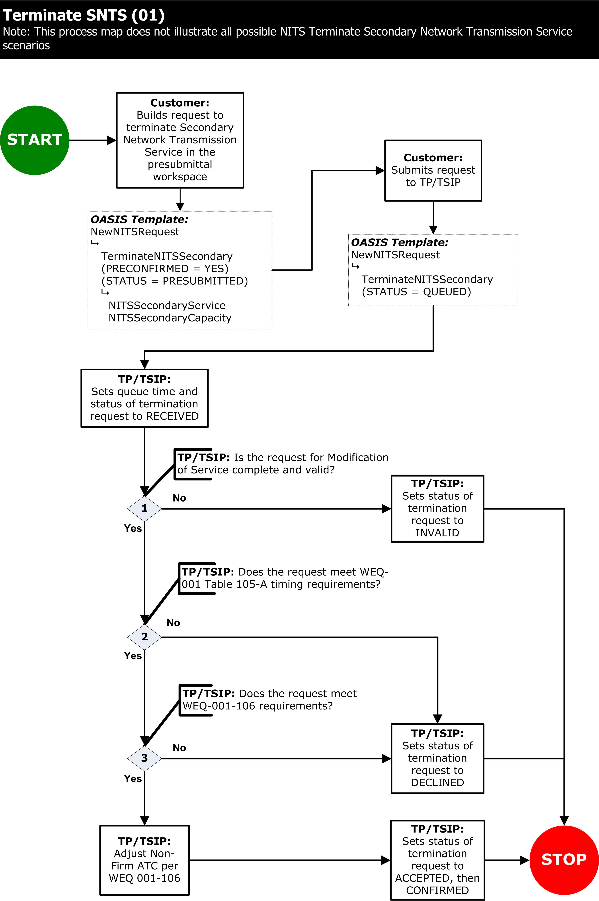
Exhibit 117 – RELEASING SECONDARY NETWORK PROCESS

013-106.1 REQUEST FOR SECONDARY NETWORK TRANSMISSION SERVICE

Secondary Network Transmission Service shall be submitted by the Eligible Customer or Transmission Customer to arrange for new Secondary Network Transmission Service on OASIS. The following are requirements for the Secondary Network Transmission Service request using the NewNITSRequest NITS OASIS INPUT Template.

NewNITSRequest NITS OASIS INPUT Template may be used to begin the process for submitting a new Secondary Network Transmission Service. Along with this NITS OASIS INPUT Template a single NITS OASIS REQUEST Template AddNITSSecondary with the NITS OASIS DATA Templates NITSSecondaryService, NITSSecondaryCapacity, and AuxillaryTransmission must also be submitted for a new Secondary Network Transmission Service.

Data structures for the NITS OASIS INPUT, REQUEST, and DATA Templates are defined in Business Practice Standards WEQ-002-100.

The Eligible Customer or Transmission Customer shall indicate to the Transmission Provider that the request for Secondary Network Transmission Service is ready for Transmission Provider review by submitting the request on OASIS with the STATUS set to QUEUED.

OASIS shall set the queue time for the request for Secondary Network Transmission Service to the time that the Eligible Customer or Transmission Customer submits the request.

Once submitted by the Eligible Customer or Transmission Customer the Transmission Provider shall acknowledge receipt of the Secondary Network Transmission Service by setting the STATUS of the AddNITSSecondary NITS OASIS REQUEST Template request to RECEIVED.

Review of the request for Secondary Network Transmission Service process will be made by the Transmission Provider and shall be made prior to the Secondary Network Transmission Service STATUS being set to CONFIRMED. The following are requirements for Secondary Network Transmission Service request associated with confirming the submitted Secondary Network Transmission Service using the NewNITSRequest NITS OASIS INPUT Template.

UpdateNITSRequest NITS OASIS INPUT Template is used to set the status of the AddNITSSecondary NITS OASIS REQUEST Template. No NITS OASIS DATA Templates are required as the STATUS Data Element being updated is included in the NITS OASIS REQUEST Template Header Record.

if the Transmission Provider determines that the requested service has an invalid field in the request, such as improper POR, POD, SOURCE, SINK, etc. or that the request does not meet minimum information or data requirements, the Transmission Provider shall set the STATUS to INVALID from RECEIVED,.

If the Transmission Provider determines that the Eligible Customer or Transmission Customer has failed to meet any of the terms and conditions for the provision of service (e.g., failure to provide a required deposit, execute a study agreement, etc.), the Transmission Provider shall set the STATUS to DECLINED from RECEIVED.

If the Transmission Provider determines that the requested service cannot be provided due to insufficient transfer capability consistent with the Transmission Provider’s tariff requirements, the Transmission Provider shall set the STATUS to REFUSED from RECEIVED

If the Transmission Provider determines that the requested service which has not been confirmed is preempted by another reservation request, the Transmission Provider shall set the STATUS to SUPERSEDED from RECEIVED.

If the Transmission Provider determines that the Secondary Network Transmission Service is to be granted only in part as requested in the Secondary Network Transmission Service request, the Transmission Provider shall set the STATUS of that request to COUNTEROFFER or CR_COUNTEROFFER from RECEIVED.

If the Transmission Provider determines that a specific request is to be granted in full as specified in the Secondary Network Transmission Service request, the Transmission Provider shall set the STATUS of that request to ACCEPTED or CR_ACCEPTED from RECEIVED.

Once the Secondary Network Transmission Service has been set to the STATUS of ACCEPTED, CR_ACCEPTED, COUNTEROFFER, or CR_COUNTEROFFER the Eligible Customer or Transmission Customer must set the STATUS of the Secondary Network Transmission Service to CONFIRMED or WITHDRAWN according to the timing limits as specified in Business Practice Standard WEQ-001-105.1.5 Table 105-A for Secondary Network Transmission Service using the UpdateNITSRequest NITS OASIS INPUT Template and the AddNITSSecondary NITS OASIS REQUEST Template structure.

If the Eligible Customer or Transmission Customer has not set the STATUS to CONFIRMED or WITHDRAWN according to the timing limits specified in Business Practice Standard WEQ-001-105.1.5 Table 105-A, the Transmission Provider may update the request STATUS to RETRACTED from ACCEPTED, CR_ACCEPTED, COUNTEROFFER, or CR_COUNTEROFFER.

Once the Secondary Network Transmission Service request has been set to the STATUS of CONFIRMED the Secondary Network Transmission Service reservation is incorporated into the NITS Application.

If the Transmission Provider and Transmission Customer mutually agree to void the Secondary Network Transmission Service reservation, the Transmission Provider shall set the status of the Secondary Network Transmission Service reservation from CONFIRMED to ANNULLED and remove the Secondary Network Transmission Service from the NITS Application.

013-106.2 RELEASING SECONDARY NETWORK TRANSMISSION SERVICE

Releasing Secondary Network Transmission Service, as shown in Business Practice Standard WEQ-013-105 Exhibit 117, shall be submitted by the Eligible Customer or Transmission Customer to arrange for termination of Secondary Network Transmission Service on OASIS. The following are requirements for the Secondary Network Transmission Service request using the NewNITSRequest NITS OASIS INPUT Template.

NewNITSRequest NITS OASIS INPUT Template may be used to begin the process for submitting a termination for Secondary Network Transmission Service. Along with this NITS OASIS INPUT Template a single NITS OASIS REQUEST Template TerminateNITSSecondary with the NITS OASIS DATA Templates NITSSecondaryService, and NITSSecondaryCapacity must also be submitted for a termination of Secondary Network Transmission Service.

Data structures for the NITS OASIS INPUT, REQUEST, and DATA Templates are defined in Business Practice Standards WEQ-002-100.

The Eligible Customer or Transmission Customer shall indicate to the Transmission Provider that the request for releasing Secondary Network Transmission Service is ready for Transmission Provider review by submitting the request on OASIS with the STATUS set to QUEUED.

OASIS shall set the queue time for the request for releasing Secondary Network Transmission Service to the time that the Eligible Customer or Transmission Customer submits the request (STATUS = PRECONFIRMED).

Once submitted by the Eligible Customer or Transmission Customer the Transmission Provider shall acknowledge receipt of the releasing Secondary Network Transmission Service by setting the STATUS of the AddNITSSecondary NITS OASIS REQUEST Template request to RECEIVED.

Review of the request for releasing Secondary Network Transmission Service process will be made by the Transmission Provider and shall be made prior to the Secondary Network Transmission Service STATUS being set to CONFIRMED. The following are requirements for releasing Secondary Network Transmission Service request associated with confirming the submitted Secondary Network Transmission Service using the NewNITSRequest NITS OASIS INPUT Template.

UpdateNITSRequest NITS OASIS INPUT Template is used to set the status of the TerminateNITSSecondary NITS OASIS REQUEST Template. No NITS OASIS DATA Templates are required as the STATUS Data Element being updated is included in the NITS OASIS REQUEST Template Header Record.

if the Transmission Provider determines that the requested service has an invalid field in the request, such as improper POR, POD, SOURCE, SINK, etc. or that the request does not meet minimum information or data requirements, the Transmission Provider shall set the STATUS to INVALID from RECEIVED,.

If the Transmission Provider determines that the Eligible Customer or Transmission Customer has failed to meet any of the terms and conditions for the provision of service (e.g., failure to provide a required deposit, execute a study agreement, etc.), the Transmission Provider shall set the STATUS to DECLINED from RECEIVED.

If the Transmission Provider determines that a specific request is to be granted in full as specified in the releasing Secondary Network Transmission Service request, the Transmission Provider shall set the STATUS of that request to ACCEPTED from RECEIVED.

Once the releasing Secondary Network Transmission Service has been set to the STATUS of ACCEPTED the OASIS shall set the STATUS of the releasing Secondary Network Transmission Service to CONFIRMED.

Once the releasing Secondary Network Transmission Service request has been set to the STATUS of CONFIRMED the portion of the Secondary Network Transmission Service reservation is released.

013-107 NETWORK INTEGRATION TRANSMISSION SERVICE – EXTENSION OF NETWORK INTEGRATION TRANSMISSION SERVICE APPLICATION STOP_TIME

Business Practice Standard WEQ-013-101.4 Exhibit 101 should be used as a business process guideline and illustrates the valid changes that may be made to the STATUS value by the Transmission Provider, the Eligible Customer or Transmission Customer during the extension of NITS Application STOP_TIME process; however, individual tariffs may dictate specific actions allowed between statuses that are not reflected in this diagram.

Extension of NITS Application STOP_TIME shall be submitted by the Eligible Customer or Transmission Customer to arrange for the extension of NITS Application STOP_TIME on OASIS. The following are requirements for the extension of NITS Application STOP_TIME request using the NewNITSRequest NITS OASIS INPUT Template.

NewNITSRequest NITS OASIS INPUT Template may be used to begin the process for submitting an extension of NITS Application STOP_TIME. Along with this NITS OASIS INPUT Template a single NITS OASIS REQUEST Template ModifyNITSService with the NITS OASIS DATA Template NITSService must also be submitted for an extension of NITS Application STOP_TIME. The START_TIME in the NITSService NITS OASIS DATA Template must be set to the current STOP_TIME for the NITS Application; the STOP_TIME in the NITSService NITS OASIS DATA Template must be set to the new requested end of term of the NITS Application
Data structures for the NITS OASIS INPUT, REQUEST, and DATA Templates are defined in Business Practice Standards WEQ-002-100.

The Transmission Customer shall indicate to the Transmission Provider that the request for extension of NITS Application STOP_TIME is ready for Transmission Provider review by submitting the request on OASIS with the STATUS set to QUEUED.

OASIS shall set the queue time for the request for extension of NITS Application STOP_TIME to the time that the Transmission Customer submits the request (STATUS = PRECONFIRMED),,.

Once submitted by the Transmission Customer the Transmission Provider shall acknowledge receipt of the extension of NITS Application STOP_TIME by setting the STATUS of the ModfiyNITSService NITS OASIS REQUEST Template request to RECEIVED.

Review of the request for extension of NITS Application STOP_TIME process will be made by the Transmission Provider and shall be made prior to the extension of NITS Application STOP_TIME STATUS being set to CONFIRMED. The following are requirements for extension of NITS Application STOP_TIME request associated with confirming the submitted extension of NITS Application STOP_TIME using the NewNITSRequest NITS OASIS INPUT Template.

if the Transmission Provider determines that the requested extension of time is not valid, the Transmission Provider shall set the STATUS to INVALID from RECEIVED,.

If the Transmission Provider determines that the Transmission Customer has failed to meet any of the terms and conditions for the provision of service (e.g., failure to provide required notice of extension to the term of service, etc.), the Transmission Provider shall set the STATUS to DECLINED from RECEIVED.

If the Transmission Provider determines that the extension to the term of service is to be granted, the Transmission Provider shall set the STATUS of that request to ACCEPTED from RECEIVED.

Once the extension of NITS Application STOP_TIME has been set to the STATUS of ACCEPTED the OASIS will set the STATUS of the extension of NITS Application STOP_TIME to CONFIRMED

Once the overall extension of NITS Application STOP_TIME has been set to the STATUS of CONFIRMED any changes to the extension of NITS Application STOP_TIME will be made in accordance with Business Practice Standard WEQ-013-107.

013-x Appendix x – NITS EXAMPLES
The following examples document the handling of NITS processing.

EXAMPLE xx1 FOR PRE-SUBMITTED NETWORK INTEGRATION TRANSMISSION SERVICE APPLICATION
Example of a request to Transmission Provider (AAA) by Transmission Customer (BBB) to begin a NITS Application in a Pre-submittal Workspace.

INPUT
VERSION=↵
TEMPLATE=↵
OUTPUT_FORMAT=↵
PRIMARY_PROVIDER_CODE=↵
PRIMARY_PROVIDER_DUNS=↵
RETURN_TZ=↵
INPUT=NewNITSRequest↵
REQUEST=NewNITSApplication↵
DATA=NITSService,APPLICATION_NAME,START_TIME,STOP_TIME,SERVICE_DESCRIPTION,FILING_STATUS,TIME_OF_LAST_UPDATE,RECORD_STATUS,ERROR_MESSAGE↵
,20120101000000ES,20201231000000ES,New NITS Application,,,,, ↵
DATA=NITSCustomer,CUSTOMER_CODE,CUSTOMER_DUNS,CUSTOMER_NAME,CUSTOMER_PHONE,CUSTOMER_FAX,CUSTOMER_EMAIL,TRANSMISSION_OWNER,CUSTOMER_STATEMENT,ATTESTOR_NAME,ATTESTATION_SUBMITTER,STATUS_NOTIFICATION,CUSTOMER_COMMENTS,EFFECTIVE_START_TIME,EFFECTIVE_STOP_TIME,AFFILIATE_FLAG,TIME_OF_LAST_UPDATE,RECORD_STATUS,ERROR_MESSAGE↵
BBB,123456789,John Doe,2222222222,3333333333,,AAA,,John Doe VP,John Doe VP,,,20120101000000ES,,,,,, ↵
DATA=NITSAgent,AGENT_CODE,AGENT_DUNS,AGENT_NAME,AGENT_FAX,AGENT_EMAIL,STATUS_NOTIFICATION,AGENT_COMMENTS,EFFECTIVE_START_TIME,EFFECTIVE_STOP_TIME,TIME_OF_LAST_UPDATE,RECORD_STATUS,ERROR_MESSAGE↵
CCC,123456789,John Smith,4444444444,5555555555,,,,20120101000000ES,202012310000ES,,,,

RESPONSE
REQUEST_STATUS=200↵
ERROR_MESSAGE=Success↵
TIME_STAMP=20110706140000ES↵
VERSION=1.6↵
TEMPLATE=↵
OUTPUT_FORMAT=DATA↵
PRIMARY_PROVIDER_CODE=AAA↵
PRIMARY_PROVIDER_DUNS=123456789↵
RETURN_TZ=ES↵
DATA=NITSService,APPLICATION_NAME,START_TIME,STOP_TIME,SERVICE_DESCRIPTION,FILING_STATUS,TIME_OF_LAST_UPDATE,RECORD_STATUS,ERROR_MESSAGE↵
,20120101000000ES,20201231000000ES,New NITS Application,,,,, ↵
DATA=NITSCustomer,CUSTOMER_CODE,CUSTOMER_DUNS,CUSTOMER_NAME,CUSTOMER_PHONE,CUSTOMER_FAX,CUSTOMER_EMAIL,TRANSMISSION_OWNER,CUSTOMER_STATEMENT,ATTESTOR_NAME,ATTESTATION_SUBMITTER,STATUS_NOTIFICATION,CUSTOMER_COMMENTS,EFFECTIVE_START_TIME,EFFECTIVE_STOP_TIME,AFFILIATE_FLAG,TIME_OF_LAST_UPDATE,RECORD_STATUS,ERROR_MESSAGE↵
BBB,123456789,John Doe,2222222222,3333333333,,AAA,,John Doe VP,John Doe VP,,,20120101000000ES,,,,,, ↵
DATA=NITSAgent,AGENT_CODE,AGENT_DUNS,AGENT_NAME,AGENT_FAX,AGENT_EMAIL,STATUS_NOTIFICATION,AGENT_COMMENTS,EFFECTIVE_START_TIME,EFFECTIVE_STOP_TIME,TIME_OF_LAST_UPDATE,RECORD_STATUS,ERROR_MESSAGE↵
CCC,123456789,John Smith,4444444444,5555555555,,,,20120101000000ES,202012310000ES,,,,

Example xx2: Pre-submittal of a NITS Application request through Confirmed Status with Deficiencies (WEQ-013-101.2)

A customer desires to secure NITS with one on-system DNR and one identified Network Load. The customer creates a NITS Application in the OASIS Pre-submittal Workspace and OASIS assigns a unique identifier to the NITS Application. The customer submits application to the Transmission Provider on OASIS and sets the NITS Application queue time. The Transmission Provider evaluates the NITS Application for completeness. During this evaluation, the Transmission Provider discovers deficiencies, thereby determining the NITS Application to be deficient. The Transmission Provider sets the status of the NITS Application to DEFICIENT. The customer corrects the deficiency and sets the NITS Application status to REEVALUATE. The Transmission Provider reviews the re-submitted NITS Application. The provided information remedies the deficiencies, and the Transmission Provider then sets the status to COMPLETED. The Transmission Provider evaluates the COMPLETED NITS Application and determines that it may accommodate the NITS Application request. The Transmission Provider sets the NITS Application status to ACCEPTED. The customer then sets the status to CONFIRMED.

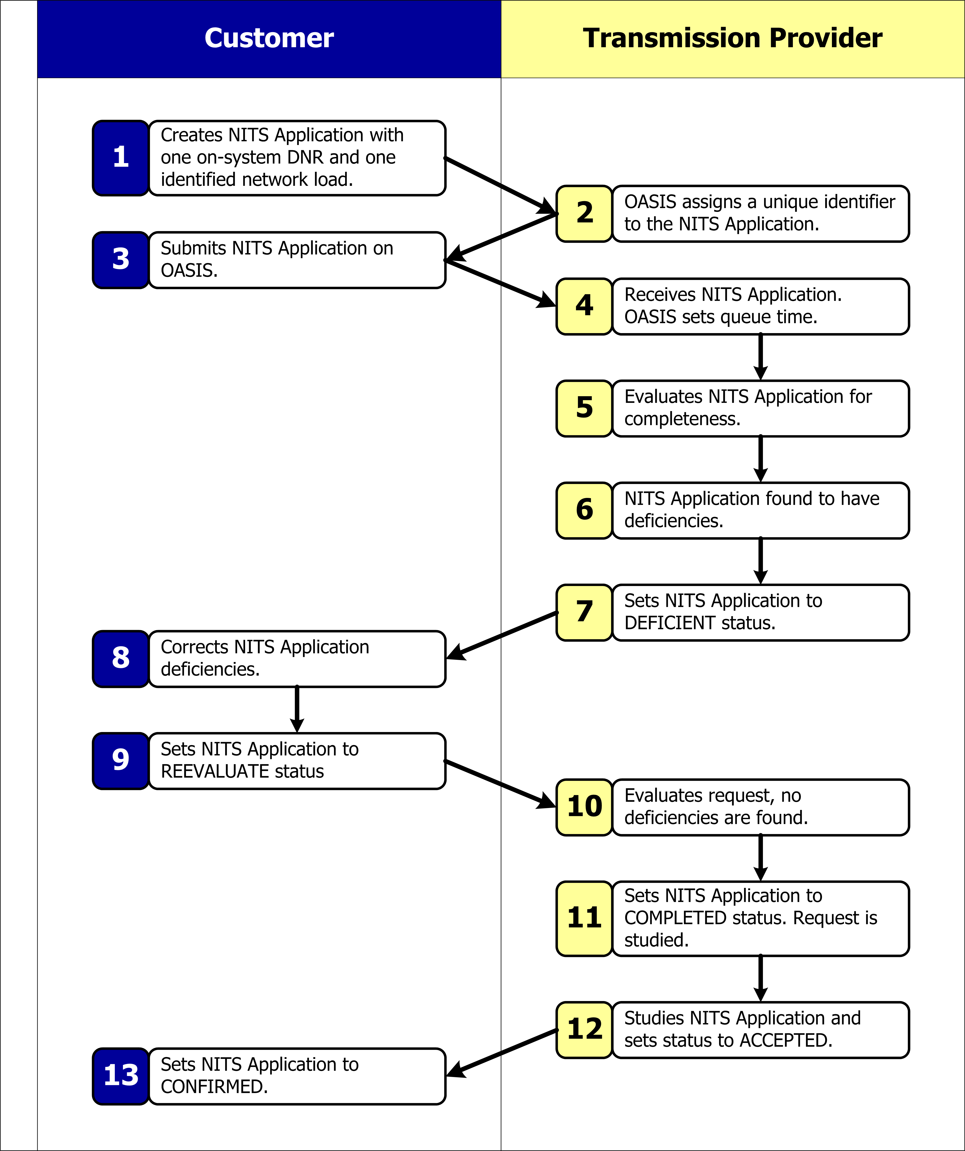

Example xx3: Concomitant Evaluations with a Counteroffer and Rebid (WEQ-013-105.4)

A customer desires to temporarily terminate 100 MW of DNR that it currently holds and request 100 MW of firm PTP transmission service. The customer submits the temporary termination request and the firm PTP transmission service request simultaneously as a Concomitant Evaluation request. The Transmission Provider then evaluates the two requests concomitantly. During the evaluation the Transmission Provider determines that it can only grant 80 MW of firm PTP transmission service. The Transmission Provider then counteroffer the 80 MW of firm PTP transmission service and also sets the status of the temporary termination request to COUNTEROFFER. The customer responds with a re-bid of the temporary termination request to 75 MW and a re-bid of the firm PTP transmission service request to 75 MW. The Transmission Provider evaluates the re-bid requests and accepts the re-bid by setting the status of both requests to ACCEPTED. The customer then sets the status of both requests to CONFIRMED.

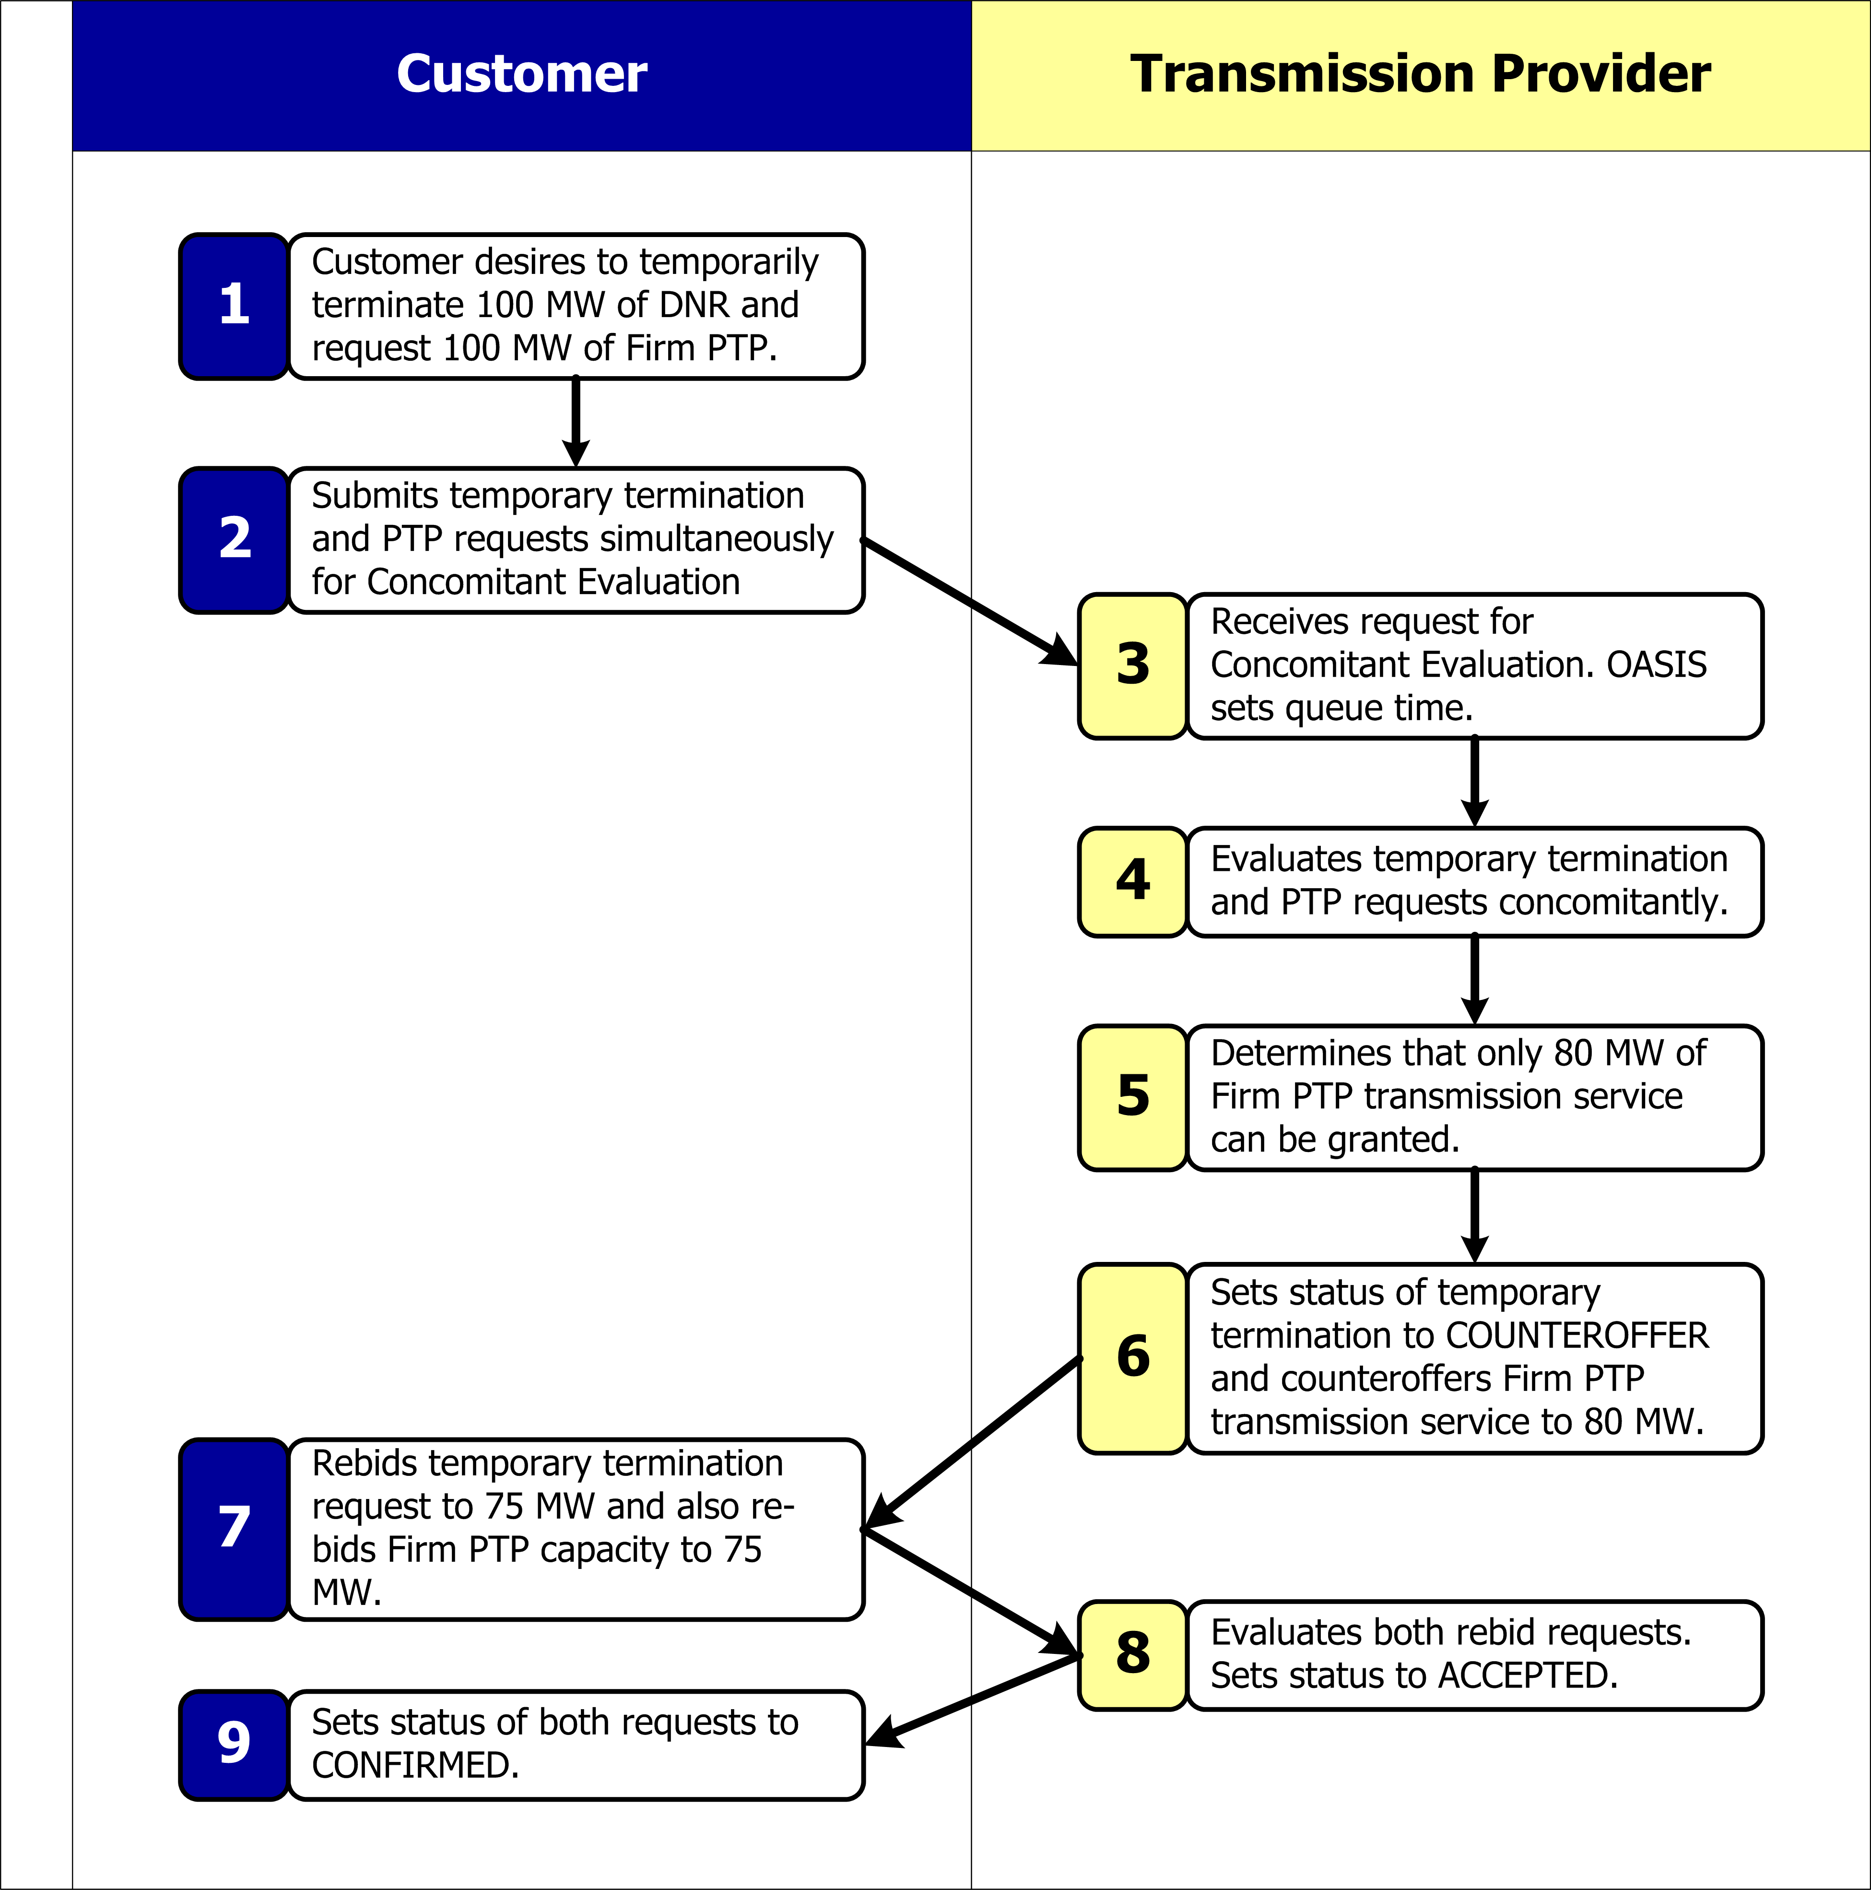

Example xx4: Customer desires to DESIGNATE a Network Resource (WEQ 001-105.1)

A customer requests a modification of service to an existing NITS Application by submitting a request to designate a 500 MW network service from a Network Resource on OASIS. The Transmission Provider acknowledges the queued request by setting the status to RECEIVED. The Transmission Provider reviews the request and finds all required information has been included. The Transmission Provider sets the status of the request to COMPLETED. The Transmission Provider then evaluates the request and determines that the request can be approved and sets the status of the request to ACCEPTED. The customer then sets the status of the request to CONFIRMED.

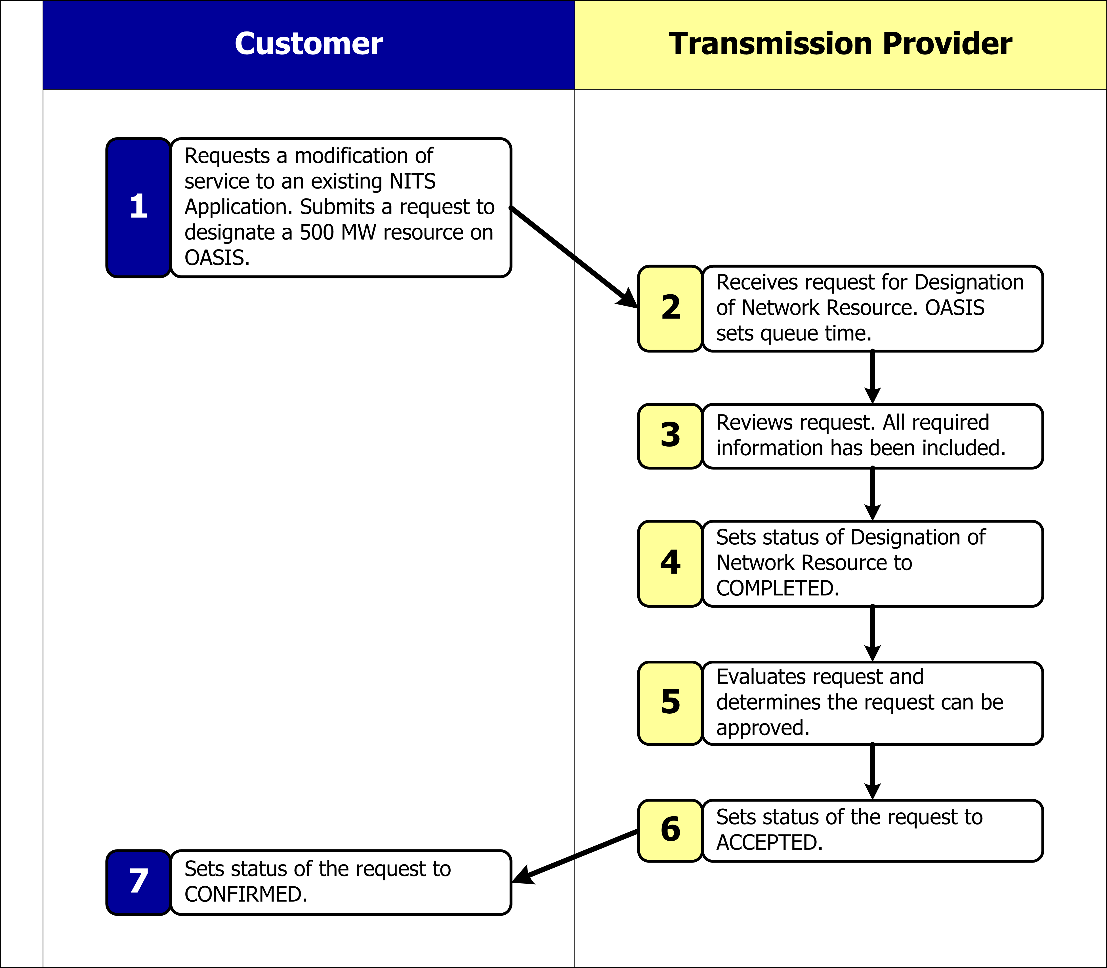

Termination of a Designated Network Resource is also known as “Undesignation” of a Network Resource.

