Date: March 11, 2011

Subject: Late Formal Comments to NAESB concerning the Wholesale Electric Quadrant Draft EE M&V Standard

Dear NAESB Wholesale Electric Quadrant Executive Committee,

KEMA, a firm conducting energy efficiency program design, implementation, evaluation, measurement and verification has reviewed the LATE FORMAL COMMENTS of February 25, 2011, produced by the Regional EM&V Forum with input from stakeholders. We adamantly support the need for meter and other data accuracy standards, however we feel that absolute accuracy requirements must be balanced with the freedom to use data from a variety of sources to help maximize the cost effectiveness and quality of our projects. Many different sources of data can provide valuable insight and useful information but may not all satisfy absolute standards of accuracy. Accordingly, I am therefore recommending the deletion of WEQ.020.3.11.1.9 concerning proxy variable accuracy requirements from the NAESB Wholesale Electric Quadrants Business Practice Standards for Measurement and Verification of Energy Efficiency Products.

With kind regards,
KEMA, Inc.

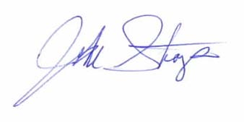

John L. Stoops PhD
Senior Principal Engineer

