March 1, 2011
To: NAESB Wholesale Electric Quadrant Executive Committee
I am a member of the energy efficiency community involved in energy efficiency program evaluation, measurement, and verification. I have reviewed a copy of the LATE FORMAL COMMENTS of February 25, 2011, produced by the Regional EM&V Forum with input from the associated stakeholders. I am writing to convey my support for the recommendation requesting deletion of WEQ.020.3.11.1.9 concerning proxy variable accuracy requirements from the NAESB Wholesale Electric Quadrants Business Practice Standards for Measurement and Verification of Energy Efficiency Products, and my concurrence with the reasons for the recommendation that were noted in the comments.
Please do not hesitate to contact me should you have any questions on this matter.
Sincerely,
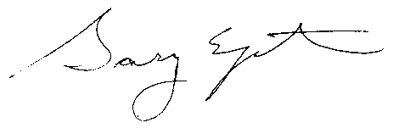
Gary Epstein
President
Energy & Resource Solutions

cc: Elizabeth Titus, Northeast Energy Efficiency Partnerships Regional EM&V Forum; etitus@neep.org

