February 25, 2011

Dear NAESB Executive Committee,
We are a firm engaged in energy efficiency program evaluation, measurement and verification. I have reviewed a copy of the LATE FORMAL COMMENTS of February 25, 2011, produced by the Regional EM&V Forum with input from stakeholders. While we understand the need for meter accuracy standards, we feel that sensor accuracy must be balanced with the ability to use data from a variety of sources. Sources including buildings’ energy management systems can provide vital data for base case measurements. Where the choice is between use of these existing data and using engineering calculations, the existing data can provide better accuracy even if the sensor specifications are difficult to locate or outside of the proposed requirements. I am therefore writing to convey my support for the recommendation requesting deletion of WEQ.020.3.11.1.9 concerning proxy variable accuracy requirements from the NAESB Wholesale Electric Quadrants Business Practice Standards for Measurement and Verification of Energy Efficiency Products, and my concurrence with the reasons for the recommendation that were noted in the comments.

Sincerely,

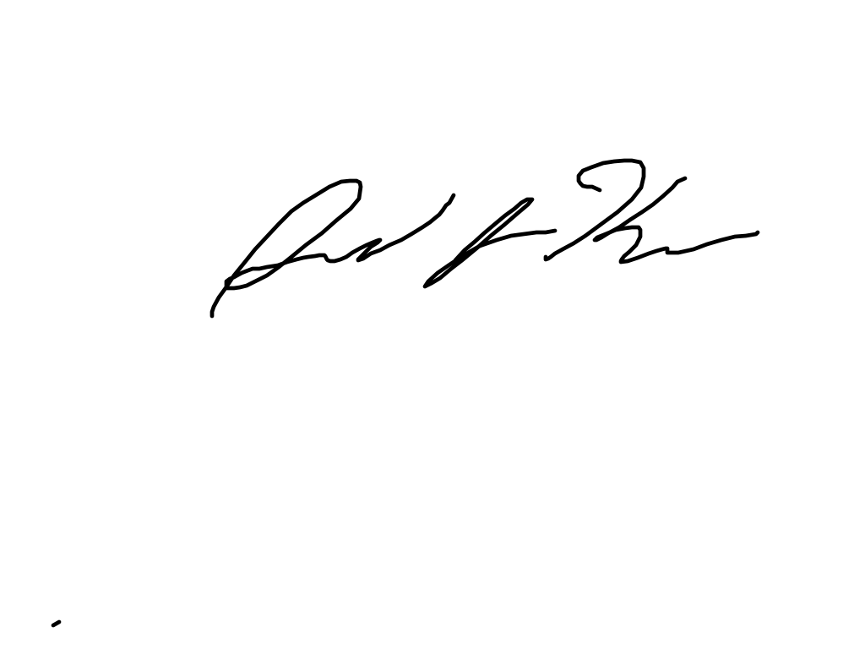
David L. Korn
Principal

