Table of Contents
Executive Summary 3
Submitted By 3
Introduction 3
Parallel Flow Definition 4
NERC IDC Process for the Eastern Interconnection 5
WECC Unscheduled Flow Mitigation Procedure 9
Seams Agreement Definition 11
Minimum Requirements for a Seams Agreement 13
Overview of First To Curtail Examples 15
Firm Transaction Flows 15
On-the-Path 15
Seams Agreement 15
On-the-Path and Seams Agreement 16
Off-the Path and No Seams Agreement 16
Generation to Load 16
With Seams Agreements 16
With No Seams Agreements 17
Review of Pro Forma Open Access Transmission Tariff (OATT) 17
Differences Between Seams Agreement and MOD Standards Coordination Agreement 18
Implementing the Two-Tiered Approach 19
Hybrid Option 19
With Two Tier Firm Curtailments 19
Without Two Tier Firm Curtailments 20
Flowgate Allocation Option 21
With Two Tier Firm Curtailments to Address Seams Agreements and Proportional Curtailment of Firm GTL/PTP 21
With Two Tier Firm Curtailments to Address Proportional of Firm PTP/GTL 23
With No Two Tier 25
With 100 MW of Non-Firm Point-to-point and 509 MWs of Non-Firm GTL available, there is no need for TLR 5 and there are no first-to-curtail curtailments. All entities are assigned a relief obligation that is based on their proportional Non-Firm GTL impacts. 26
Appendix A – WSCC Unscheduled Flow Mitigation Plan 27
Appendix B – First to Curtail – Last to Curtail Examples 40
Appendix C - Pro Forma Extracts 45

Executive Summary

Submitted By
Name Affiliation

Introduction
This paper addresses concerns raised that establishing parallel flow curtailment priorities that may differ from the current TLR process is encroaching on policy issues that are not under the purview of the NAESB BPS. No one questions that the assignment of curtailment priorities in the East during TLR is a commercial issue where NAESB has responsibility. This paper addresses the issue of applying a two-tier firm curtailment process in the East. The proposed two-tier firm curtailment process is based on existing parallel flow curtailment processes in the Eastern and Western Interconnections. In the East, the Weakest Link is the process for assigning curtailment priority to parallel flow transactions. In the West, this process is called Unscheduled Flow Mitigation Procedure. The West is also considering additional changes that would incorporate a two-tier firm priority approach as proposed in the East, and extend it to non-firm parallel flows as well, but it is still early in the process and the final resolution is not known at this time. However, the proposal for the East is limited to application of two tiers to firm parallel flows where no seams agreement exists between the parties. Finally, to address questions raised regarding the appropriateness of the NAESB BPS actions in developing such similar processes, it is noted that any process that WECC develops will be filed at FERC as will the NAESB BPS permanent solution.
In the East, a transaction curtailment priority on a flowgate is that of the transmission segment associated with the Transmission Service Provider (TSP) experiencing the congestion. For on-path transactions (those scheduled on the TSP experiencing the congestion), the determination of the transaction’s curtailment priority is straight forward as a Transmission Service Reservation (TSR) exists on the congested path. However, for off-path transactions without TSR on the congested path, the assignment of curtailment priority is more complex. The Weakest Link is the current process used in the East to assign the curtailment priority of off-path (or parallel flow) transactions. In a nutshell, the Weakest Link method assigns the curtailment priority of a parallel flow transaction to the lowest priority of all transmission segments. The Weakest Link is implicitly applicable to Network and Native Load (NNL) service transactions as well. NNL is deemed on-path when the TSP providing the NNL service is the one experiencing congestion and off-path when the TSP providing the NNL service is other than the one experiencing congestion. Currently, the purchase of firm transmission service on a TSP only guarantees firm curtailment service on the TSP where the firm service has been purchased. If a transaction is off-path and at least one transmission segment is non-firm, the Weakest Link method determines the transaction to be non-firm. The proposed two-tier firm curtailment process attempts to address a unique condition of the Weakest Link method when all transmission segments are firm. In this case, the parallel flow transaction is assigned firm service with the same curtailment rights as other transactions that paid for firm service on the TSP experiencing congestion, even when the contracted path segments is far away from the TSP experiencing the congestion and the congested path has not been studied for capacity by the TSPs that granted the firm transmission service. The two-tier curtailment process only addresses the NNL service transactions, but can be extended to interchange transactions as well. Additional details of the Weakest Link method are described in the sections that follow.
Described below is the application of the two-tier firm priority approach to two options of establishing firm and non-firm use of the transmission system in the Eastern Interconnection that are under consideration by the NAESB BPS. Examples are illustrated to show the options created with the differing implementations. While this work paper addresses the application of a two-tier firm approach in recognizing transmission system usage, the rules for establishing such usage as firm or non-firm are not include.
Implementation of a two-tiered firm priority enables a BA to distinguish and treat its firm and non-firm service while at the same time aids in addressing curtailments when such system use impacts its neighboring BAs. This is accomplished while promoting agreements to consider such parallel flow impacts in a BAs’ determinations of system use.

Parallel Flow Definition
The electricity industry for years has grappled with the fact that electric power does not flow as directed on the grid, but rather as described in Ohm’s law, flows along the path of least resistance. It is the configuration of the electric grid that dictates the resistance that governs the flow of electricity.
This disconnect in the “contract path” between source and sink becomes a reliability concern when an attempt to dispatch scheduled flows negatively impacts the system by creating actual flow patterns that are significantly different from scheduled flows due to the physical reality of the transmission system. These unscheduled flow patterns can load transmission facilities beyond their rated capacity even though these facilities could accommodate the nominal quantity scheduled for transfer had the actual flows matched those scheduled.
Unscheduled flows, also known as loop flows or parallel flows, result from the difference between the energy that is scheduled to flow across an interface connecting two control areas versus the amount of energy that actually flows across the interface between these two control areas. In addition, parallel flows are caused by a control areas’ generation-to-load dispatch when a portion of the resulting flows travel over neighboring systems.
Unscheduled flows appear not only on the interface between control areas but they also appear on the transmission facilities internal to the control areas. Transmission service may be sold on a contract path basis where the transmission customer arranges service from the source control area to the sink control area. When this service is scheduled, it follows the path of least resistance that may flow over the source transmission system and sink transmission system (on-the-path flows) as well as on other transmission systems that are not parties to the transaction (off-the-path flows).
- When a schedule contributes to congestion on a system that sold the transmission service, the Transmission Service Provider (TSP) must honor the priority of the service sold on their system. When TLR is called in the Eastern Interconnection (EI), the IDC uses the constrained path logic to assign a curtailment priority based on the priority of the service sold within that transmission system.
- When a schedule contributes to congestion on other systems that have not sold transmission service, these are considered off-the-path flows or parallel path flows and there is no tariff requirement that TSPs that are off-the-path honor the priority of the transmission service sold by the on-the-path parties. When TLR is called in the EI, the IDC uses the weakest link logic to assign a curtailment priority based on the lowest level of transmission service sold by all TSPs along the path.

NERC IDC Process for the Eastern Interconnection
The NERC IDC has a well-defined method for determining Interchange Transactions priorities on a flowgate in TLR, and it is described in the NAESB WEQ-008 Transmission Loading Relief – Eastern Interconnection Business Practice Standard (These standards are posted at http://www.naesb.org/member_login_form.asp?doc=weq_bklet_031109_mc_thru121409.pdf). This method takes into account the service territory (Transmission Service Provider, or TSP) where the flowgate in TLR is located and the Transmission Service Reservations (“TSR”) purchased by the Transmission Customer in support of the Interchange Transaction and its description on approved eTags. The next paragraphs summarize the method for determining Interchange Transaction priorities on a flowgate in TLR.
An Interchange Transaction eTag (“Tag”) contains many attributes. The ones of relevance to the NERC IDC for the purpose of determining the Tag priority for a flowgate in TLR are:
- Energy Market Profile at a given point in time
- Contracted path of the Tag, including:
  - TSPs on the path
  - TSRs capacity (MW) and priority on each TSP
For the sake of the examples described below, the following Tag transaction will be considered:
Energy: 100 MW
TSPs on path:
TSP-Source: TSR-Source: 100 MW, Priority 7F
TSP-A: TSR-A: 100 MW, Priority 3ND
TSP-B: TSR-B-1: 60 MW, Priority 7F
TSR-B-2: 40 MW, Priority 2NH
TSP-Sink: TSR-Sink: 100 MW, Priority 7F
The figure below depicts the exampled Tag and the surrounding interconnected Transmission Service Providers:
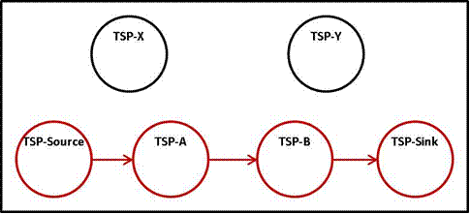

The first step in determining a Tag priority is to identify the relationship between the TSPs on the path of the Tag and the TSP of the flowgate in TLR. When the TSP of the flowgate in TLR is one of those on the path of the Tag, the Tag is considered On-Path. When none of the TSPs on the tag is the one experiencing the TLR, the Tag is considered Off-Path. For instance, if the flowgate in TLR is located in TSP-Source, TSP-A, TSP-B or TSP-Sink, the Tag is regarded as “On-Path”. Otherwise, if the flowgate in TLR is located in either TSP-X or TSP-Y, the Tag is regarded as “Off-Path”.
For On-Path Tags, the IDC uses the Constrained Path Method (“CPM”), whereby the IDC assigns the priority of the Tag on the flowgate in TLR as that of the TSP experiencing the TLR. For example:
- TLR on flowgate in TSP-Source:
  - Tag is considered as Priority 7F for the entire 100 MW amount.
- TLR on flowgate in TSP-A:
  - Tag is considered as Priority 3ND for the entire 100 MW amount.
- TLR on flowgate in TSP-B:
  - Internally to the IDC, the Tag is divided into two distinct transactions, one with 60 MW on Priority 7F, and another with 40 MW on Priority 2NH. In doing so, the Tag is accurately represented and neither the 7F component of the Tag is downgraded to non-firm, nor is the 2NH component of the Tag upgraded to firm.
- TLR on flowgate in TSP-Sink:
  - Tag is considered as Priority 7F for the entire 100 MW amount.
For Off-Path Tags, the IDC uses the Weakest Link (“WL”) Method. The purpose of the WL Method is to assign a priority to a Tag when it is not scheduled through the TSP experiencing the TLR, and a curtailment order cannot be clearly determined. In the Eastern Interconnection (NERC IDC), the WL method assigns priorities to the energy amount of the tag, iteratively, from the lowest to the highest priority of all TSR priorities from all TSPs on the path of the Tag, and until the entire energy amount is assigned a priority. For example, if the flowgate experiencing the TLR is on TSP-X or TSP-Y, the Tag is considered as Off-Path and the priorities would be assigned as follows:
- Step 1: Identify the total energy MW of the Tag:
  - Energy = 100 MW
- Step 2: Beginning from the TSR with the lowest priority, iteratively assign the priority on the Tag by the MW amount of the TSR, up to the total energy MW of the Tag:
  - Iteration 1: TSR-B-2
    - 40 MW in Priority 2NH:
      - Tag has 40 MW in Priority 2NH
      - Tag has 60 MW unassigned
  - Iteration 2: TSR-A
    - 100 MW in Priority 3ND:
      - Tag has 100 MW in Priority 3ND
      - Tag has 0 MW unassigned
- Step 3: Energy is fully assigned priorities:
  - Tag has 40 MW in Priority 2NH
  - Tag has 60 MW in Priority 3ND
The following are some important points to note on CPM and WL methods:
- In this example, although the Tag has many TSRs with firm priority reservations, the flowgate in TLR is Off-Path relative to the tag, so the Tag is assigned to non-firm priorities for curtailment purposes.
- If the tag has firm TSR across its entire path, the tag will be considered firm on the entire Eastern Interconnection by virtue of the WL method process.
- Network and Native Load (NNL) implicitly uses the CPM and WL methods. NNL can be represented as a transaction that sources and sinks in the same TSP and, as such, the priority of the NNL is carried over to the entire Eastern Interconnection. Currently, the IDC implicitly assigns firm priority for NNL transactions.
- The treatment of On-Path and Off-Path transactions is different in Eastern and Western Interconnections. It is important to understand that Western Interconnection curtailment procedure also processes On-Path transactions differently than Off-Path transactions. A summary of the Western Interconnection curtailment procedure is described below:
  - The Western Interconnection utilizes the Unscheduled Flow Mitigation Procedure (UFMP) for curtailment of loop-flow off-path transactions on Qualified Paths (flowgates).
  - The UFMP procedure is a multi-step process (nine steps) that combines the curtailment of On-Path transmission contracts to accommodate a small amount of the Qualified Path’s TTC for off-path loop flows (On-Path Accommodation), with the curtailment of off-path schedules to reduce their impact on the Qualified Path (Off-Path Curtailment). Each UFMP step is equivalent to a TLR level in the Eastern Interconnection.
    - In the On-Path Accommodation steps, on-path schedules are curtailed by an amount that is a function of the Path’s TTC. These curtailments are determined by Contract Path methodologies to increase the Path’s ATC. The purpose of these curtailments is to assure that a percentage of the Path’s TTC is “reserved” for Off-Path schedules. As an example, suppose a Path with 1,000 MW of TTC and the UFMP On-Path Accommodation step calls for accommodation of 5% of the Path’s TTC to Off-Path loop flow.
      - If the sum of all TSRs scheduled on the Path does not exceed 95% of the Path’s TTC, the Path Operator is not required to curtail any On-Path schedule.
      - If the sum of all TSRs scheduled on the Path exceeds 95% of the Path’s TTC, schedules on the Path must be curtailed in a Contract Path basis so that at least 5% of the Path’s TTC is made available to Off-Path transactions. In addition, the Path Operator may curtail schedules according to its tariff.
On-Path Accommodation in the amount that is the greater of 50 MW or 5% of the Path’s TTC occurs in UFMP steps 2-5; 75 MW or 6% of the Path’s TTC in UFMP steps 6 and 7; and 100 MW or 7% of the Path’s TTC in UFMP steps 8 and 9.
As long as the Path is not sold above its accommodation limit, On-Path schedules need not be curtailed. It is also important to note that past results show that the great majority of UFMP requests did not curtail On-Path schedules, indicating that in most cases the Path is not sold above its accommodation limit.
    - Relief from Off-Path schedules is determined as a percentage of the Off-Path schedule impact amount, where the percentage is a function of the TDF of the schedule on the Path, irrespective of the schedules’ TSR priorities. This percentage varies at different UFMP steps. The UFMP determines the relief obligation for each Receiver (LSE on the Off-Path Tag), and it is the responsibility of the Receiver to provide the relief.
The Receiver’s relief obligation is determined according to the rules below:
UFMP Step 4:
      - 20% of MWxTDF for Tags with TDF ≥ 50%
      - 10% of MWxTDF for Tags with 30% ≤ TDF < 50%
UFMP Steps 5 and 6:
      - 25% of MWxTDF for Tags with TDF ≥ 50%
      - 15% of MWxTDF for Tags with 30% ≤ TDF < 50%
      - 10% of MWxTDF for Tags with 20% ≤ TDF < 30%
UFMP Steps 7 and 8:
      - 30% of MWxTDF for Tags with TDF ≥ 50%
      - 20% of MWxTDF for Tags with 30% ≤ TDF < 50%
      - 15% of MWxTDF for Tags with 20% ≤ TDF < 30%
      - 10% of MWxTDF for Tags with 15% ≤ TDF < 20%%
UFMP Step 9:
      - 35% of MWxTDF for Tags with TDF ≥ 50%
      - 25% of MWxTDF for Tags with 30% ≤ TDF < 50%
      - 20% of MWxTDF for Tags with 20% ≤ TDF < 30%
      - 15% of MWxTDF for Tags with 15% ≤ TDF < 20%
      - 10% of MWxTDF for Tags with 10% ≤ TDF < 15%

WECC Unscheduled Flow Mitigation Procedure
The Unscheduled Flow Mitigation Procedure is only used on Qualified Transfer Paths (six) in the west. WECC has the same firm and non-firm transmission service products as the Eastern Interconnection (EI) but they use the rated system path method to review and approve transmission service. This is still a contract path approach in that the reservation is granted over a specific path that establishes its curtailment priority on that path but the schedules may produce actual flows on multiple paths (on those paths where a reservation exits as well as other paths). WECC is similar to the EI in that they have on-the-path flows and off-the-path flows (or parallel path flows). This flow designation is a factor when congestion occurs and steps must be taken to reduce flow impacts.
WECC does not use TLR to manage congestion. They have an unscheduled flow (USF) mitigation procedure that applies to a limited number of paths and all Purchasing/Selling Entities (defined as Receivers in the UFMP) in the West. The East uses the on-the-path (constrained path) and the off-the-path (weakest link) logic to establish curtailment priorities during TLR. In both the constrained path and the weakest link logic, the priority of the transmission service is used to establish the curtailment priority. The West also uses an on-the-path and off-the-path designation to establish curtailment priorities. However, this is not the same as the East in that the priority of the transmission service that was obtained is not a factor when deciding which off –the-path schedules to curtail, only the TDF of the schedules.
Currently, the West requires the transmission operator to provide a level of accommodation on the rated path prior to any off path curtailment. (Accommodation is determined by the amount of energy scheduled on the path compared to that rating of the path. As an example, an accommodation requirement would say that if the path is rated at 1,000 MW then there could only be 950 MWs scheduled on the path. If less than 950 MWs is scheduled, no on path schedules will be curtailed. If more than 950 MWs is scheduled on the path, the path operator should curtail the schedules down to 950 MWs. The procedure does not specify how the path operator must do this, but typically the path operator will curtail non-firm transmission first and firm transmission only if no non-firm transmission is scheduled.) When a curtailment step is called for, all off-the-path schedules (parallel path schedules) with a TDF on the overloaded path above the stated threshold for that step will have a relief requirement associated with it. The off-the-path schedules are assigned this relief requirement without considering the priority of transmission service they have on the parallel path, only the TDF of the schedule. Likewise, there is no requirement to consider the priority of transmission service for the on-the-path schedules when deciding to require relief from off-the-path schedules. Effectively, the current USF mitigation procedure assigns a curtailment priority to parallel path flows at one level below the lowest curtailment priority of the on-the-path flows once the accommodation has been provided. All off-the-path flows with a TDF above the threshold for that step are treated equally in that there is no distinction between off-the-path flows with firm service on another path versus non-firm service on another path.
If a purchasing/selling entity (PSE) schedules power in the West from Oregon to Arizona, the PSE could use a transmission contract path that goes across Path 66 or a path that goes a different route and does not use Path 66. If the PSE uses Path 66 and Path 66 starts getting overloaded, the path operator will look to see what is scheduled versus what the path can handle. If in this case the path is scheduled 3000 MWs of flow and it is capable of handling 4800 MWs of flow, then no on-the-path schedules will be curtailed. Only schedules that are by contract not flowing on Path 66 would be curtailed, regardless of the priority of transmission service purchased by any entity.
This practice is documented in Attachment 1 of the WSCC Unscheduled Flow Mitigation Plan (see Appendix A).

Seams Agreement Definition
As part of the parallel flow visualization (PFV) project, a two-tier curtailment priority for parallel flows using firm transmission service (either PTP or NITS service) is under consideration. There are two reasons why this issue needs to be addressed. A first reason is that the NAESB BPS is developing a mechanism that will establish curtailment priorities of generation-to-load impacts calculated using real-time data in the PFV project. The two options under consideration by the BPS (both the hybrid option and the flowgate allocation option) use the level of transmission service assigned to generators as a starting point when establishing curtailment priorities of the generation-to-load impacts. Because some TSPs may not consider constraints external to their area when granting firm transmission service, there is an issue whether the parallel flow impacts from this firm service should have the same curtailment priority as other firm service that was sold by TSPs honoring external constraints. An example can be used to clarify the issue.
There are three separate BAs (BA-1, BA-2 and BA-3) where BA-1 and BA-2 have agreed to honor external constraints on the other entity’s system when selling transmission service. There is no similar agreement between BA-3 and either BA-1 or BA-2. We will assume the constraint is on BA-1 and is reflected in AFCs computed by BA-1. Even if BA-1 takes into account the impacts of the existing firm service sold by BA-2 and BA-3 when calculating its firm AFCs/ATCs, this does not prevent BA-3 from continuing to sell new firm transmission service that impacts the BA-1 constraint even though BA-1 is posting zero or negative AFCs/ATCs and even though both BA-1 and BA-2 are unable to sell new firm transmission service that impacts the BA-1 constraint. New firm service sold by BA-3 can lead to a situation where the BA-1 constraint is over-subscribed and TLR is needed to manage the congestion. Under a two-tier firm curtailment approach, all non-firm transmission service sold by BA-1, BA-2 and BA-3 is curtailed first. If further reductions are still needed, the TLR is elevated to Level 5 and BA-3 (the TSP that does not consider BA-1 constraints when selling firm transmission service) is asked to curtail its firm service (this can be accomplished by having BA-3 redispatch its system to meet its relief obligation) before BA-1 and BA-2 firm transmission service is curtailed. If further reductions are still needed, BA-1 and BA-2 will be asked to make proportional curtailments by redispatching their systems to meet their relief obligations.
This issue of not honoring external constraints when selling firm transmission service can be addressed by having a two-tier curtailment priority for firm transmission service. Under a two-tier approach, a TSP that has a seams agreement in place to honor external constraints with another TSP, will continue to have the same firm service curtailment priority as the owner of the constraint (last-to-curtail firm curtailment priority). Parallel flow impacts from firm service sold by a TSP that is not part of an agreement will be subject to curtailment prior to that of the owner of the constraint as well as firm service sold by other entities honoring the constraint by seams agreement (first-to-curtail firm curtailment priority).
The two-tier approach will provide an incentive to develop seams agreements requiring TSPs to honor external constraints resulting from service they sell. Having more seams agreements that honor external constraints will reduce the number of TLR events because it avoids congestion caused by selling new firm transmission service that pushes the constraint into TLR. There will still be TLR events caused by forced outages and other unforeseen conditions but they will not be due to a failure to recognize a constraint resulting from selling new firm service.
The section Implementing the Two-Tiered Approach appears later in this work paper and provides numerical examples of applying a two-tier firm curtailment approach for this first usage.
A second reason is that the application of a two-tier firm curtailment approach in the flowgate allocation option would resolve an issue regarding treatment of firm PTP and firm NITS on a comparable basis. Because allocations are based on the entire capacity of the flowgate, a situation can occur where a BA may not receive sufficient allocation to cover all of its firm PTP impacts and firm NITS impacts. When this happens, there are three approaches to address the shortfall:
- Both the firm PTP service and the firm NITS service have a portion of their firm transmission service assigned a non-firm curtailment priority. This approach raises the question what is the benefit of obtaining firm transmission service if it can be degraded to non-firm service every time a shortfall occurs?
- You could use the firm allocation to cover all of the firm PTP service. Any firm allocation that remains would then be used to firm-up the NITS service. Once the firm allocation has been fully used, any remaining firm NITS impacts would be degraded to non-firm service. This approach raises the question why the firm PTP service appears to be given preferential treatment over the firm NITS service?
- You could split the firm allocation on a proportional basis between firm PTP service and firm NITS service. The shortfall for both would be made-up using a first-to-curtail firm curtailment priority. This approach has the benefit of not degrading either the firm PTP service or firm NITS service to a non-firm product but it does require implementing a two-tier firm curtailment approach during TLR.
The section Implementing the Two-Tier Approach appears later in this work paper and provides numerical examples of applying a two-tier firm curtailment approach for this second usage. Please keep in mind that this second usage is completely different than the first usage and is unrelated to whether a seams agreement exists to honor external constraints.

Minimum Requirements for a Seams Agreement
Below are a minimum set of requirements for Seams Agreements
- Will address how the AFC values or ATC calculated by the owning Transmission Service Providers are used when providing transmission service. (The following are considerations when developing a seams agreement.
  - Would use the AFC or ATC calculation results of the owning entity of the limiting facility in approving new requests provided the data meets a certain quality standard defined by the parties
  - Seams agreements can extends beyond the immediate neighbor
  - On-the-path and off-the-path rules when providing transmission service
    - On the path transaction logic – If the transaction is between PJM and Midwest ISO for example, the PJM process would ignore MISO AFC calculated values. This is done with the assumption that the customer would need to submit another transaction on Midwest ISO OASIS in order to complete the transaction path. Therefore, if there are any Midwest ISO constraints they would show up at this time.
    - Off the path transaction logic – If the transaction is between PJM and TVA for example, PJM will honor Midwest ISO AFC calculated values. This is done because Midwest ISO would not see the transaction or have the opportunity to evaluate the transaction between PJM and TVA in the Midwest AFC calculation. Ignoring the Midwest ISO AFC values in the evaluation of the request could potentially over subscribe the Midwest ISO System.
    - To the extent one of the parties has an agreement with another entity that provides comparable treatment among a number of parties, then reciprocal treatment will be provided to that entity by all parties.
    - Data exchange is implemented in support of the timelines of the calculation process.
  - Will address the treatment of existing transmission commitment and other components of AFC or ATC of other parties
- Will address the treatment of firm transmission service and firm generation to load of other parties in congestion management procedures
- Will address both cross border transmission service, internal transmission service and internal generation to load in congestion management procedures
- If any party is jurisdictional the agreement will be filed with FERC
- Will apply to all congestion management processes including TLR and local congestion management procedures
- Parties if requested will pursue seams agreements where they share RCFs. If a party will not agree to a seams agreement unilateral agreements may be filed with FERC.
- Will address the treatment of grandfathered service that was in place pre-OATT.
There are no specific requirements for seams agreements for the Flowgate Allocation Option that would be different from the Hybrid Option.

Overview of First To Curtail Examples
Appendix B First to Curtail – Last to Curtail provides a number of examples in an effort to clarify the circumstances on when the First to Curtail rules would apply during a TLR Level 5 event. First to Curtail only applies to off-the-path Parallel Flows resulting from firm transaction flows either within the Balancing Area (BA) or between BAs or from firm generation to load (GTL) flows within the BA that significantly contribute to the constraints on a third party BA where no direct Seams Agreements are in place between the third party BA and one of the transacting BAs or the Source BA of the firm GTL flows. These examples describe how First to Curtail and Last to Curtail would work for firm transaction flows and firm GTL flows. Note the examples consider that the Firm Transaction Flows and/or Firm GTL Flows have met the minimum IDC threshold in order to be subject to curtailment.

Firm Transaction Flows

On-the-Path
In Example 1 the assumption is that there are no Seams Agreements between the BAs. Firm Transmission Service is purchased between BA-1 and BA-3. Since BA-1 and BA-3 sold firm transmission service on their systems, if there is a constraint on either of their systems, the Firm Transaction Flow is considered on-the-path that is subject to the priority of the service sold in either system, (Last to Curtail firm curtailment priority). In this case, it is not Parallel Flows. If there was a constraint on either BA-2 or BA-4 resulting from scheduling the Firm Transmission Service sold (off-the-path with no Seams Agreement), the Firm Transaction Flows significantly contributing to the constraints on BA-2 and BA-4 would go in the First to Curtail firm curtailment priority.
Example 2 is similar to Example 1 in there are no Seams Agreements. In this example there Firm Transmission Service from BA-1 to BA-4 wheeled through BA-3. In this example, if there is a constraint in BA-1, BA-3 or BA-4 resulting from scheduling the Firm Transmission Service sold between the BAs these Firm Transaction Flows will go in the Last to Curtail. If there was a constraint on BA-2 resulting from scheduling the Firm Transmission Service sold (off-the-path with no Seams Agreement), the Firm Transaction Flows significantly contributing to the constraints on BA-2 would go in the First to Curtail.

Seams Agreement
Example 3 begins to look at the impact of Seams Agreements in determining when First to Curtail and Last to Curtail are considered. In this example, Intra-BA Firm Transmission Service is purchased in BA-2 and there is a Seams Agreement between BA-2 and BA-3. No Seams Agreements exist with BA-1 or BA-4. If the Firm Transaction Flow from the Intra-BA-2 Firm Transmission Service significantly contributing to the constraint on either BA-2 or BA-3, the flow goes into Last to Curtail. If the Firm Transaction Flow from the Intra-BA-2 Firm Transmission Service significantly contributes to the constraint on either BA-1 or BA-4, then the Firm Transaction Flows in BA-1 and BA-4 go into the First to Curtail. BA-2 is considered on-the-path and BA-3 Parallel Flows recognizes the existence of seams agreements.

On-the-Path and Seams Agreement
Example 4 looks at a combination of on-the-path rules and Seams Agreements. In this example, Firm Transmission Service was purchased between BA-1 and BA-2. Additionally, there are Seams Agreement between BA-1 and BA-3 and between BA-2 and BA-3. There are no other Seams Agreements between the BAs. In this example, if there is a constraint in BA-1, BA-2, BA-3 resulting from scheduling the Firm Transmission Service, the Firm Transaction Flows would go into the Last to Curtail. Only if the Firm Transaction Flow from the Firm Transmission Service significantly contributing to the constraint on BA-4 (off-the-path with no Seams Agreement) would the Firm Transaction Flows go into First to Curtail provided the impacts from the Firm Transaction Flow met the minimum IDC Threshold.

Off-the Path and No Seams Agreement
Examples 5 and 6 show the differences in First to Curtail and Last to Curtail, if there were no Seams Agreements in Examples 3 and 4, respectively. In Example 3 there was a Seams Agreement in place in between BA-2 and BA-3. In that example if the Firm Transaction Flow from the Intra-BA 2 Firm Transmission Service significantly contributing to the constraint on either BA-2 or BA-3, the Firm Transaction Flows would go into the Last to Curtail. In Example 5, since there is no Seams Agreement in place between any of the BAs, a constraint which has significant contributions by the Firm Transaction Flow from the Intra-BA-2 Firm Service on neighboring BAs would go into First to Curtail. Only if the constraint was in BA-2 would the Firm Transaction Flow go into the Last to Curtail.
Example 6 has Firm Transmission Service purchased between BA-1 and BA-2. Neither BA-1 nor BA-2 has a Seams Agreement with BA-3 or BA-4. If a constraint is occurs in BA-1 or BA-2, includes significant contributions from Firm Transaction Flows in BA-1 or BA-2,the Firm Transaction Flows will go into Last to Curtail. Unlike Example 4, where there is a Seams Agreement between BA-2 and BA-3, a constraint on BA-3 resulting from scheduling the Firm Transmission Service sold between BA-1 and BA-2, the Firm Transaction Flows will go into First to Curtail if it had significant contributions to the constraint as would a similar constraint on BA-4.

Generation to Load
For the Firm GTL in one BA impacting another BA (Parallel Flows on the other BA), the Firm GLT Flows will go in the First to Curtail in the other BA, unless there is a Seams Agreement between the BA reporting the Firm GTL Flows and the BA experiencing the constraint.

With Seams Agreements
In Example 7, BA-1 has reported its Firm GTL Flows to the IDC and there is a Seams Agreement in place between BA-1 and BA-2 only. In this example, if the Firm GTL Flow significantly contributes to constraint on either BA-1 or BA-2, the Firm GLT Flows would go into the Last to Curtail. Since there were no Seams Agreements in place between BA -1 and BA-3 or BA-4, constraints in BA-3 or BA-4 where there were significant contributions from the Firm GTL Flows from BA1 would go into the First to Curtail.
Example 8 shows how Seams Agreement could be executed between some BAs but not between the BA reporting the Firm GTL Flows and the BA experiencing the constraint. In this example Firm GTL Flow is reported by BA-1 which is significantly contributing to the constraint on BA-4. There are seams agreements between BA-1 and BA-2, BA-1 and BA-3, and BA-3 and BA-4. There is no Seams Agreement between BA-1 and BA-4. In this case if the constraint occurs on BA-4 the Firm GTL Flows from BA-1 goes into First to Curtail. For the other BAs the Firm GTL Flow goes into Last to Curtail, since there are Seams Agreements in place between BA-1 and the other BAs.

With No Seams Agreements
Example 9 shows that if no Seams Agreements are in place and the Firm GTL Flow reported by BA-1 significantly contributes to the constraint on another BA (BA-2, BA-3, and BA-4), the Firm GTL Flows will go into First To Curtail. The Firm GTL Flow will only go to the Last to Curtail for a constraint in BA-1.

Review of Pro Forma Open Access Transmission Tariff (OATT)

The sections of the Pro Forma OATT related to curtailments were reviewed to determine if changes are needed to the Pro Forma OATT when a two-tier curtailment process is used to curtail parallel flows. Sections reviewed included:
- Section 13.6 Curtailment of Firm Transmission Service
- Section 14.7 Curtailment or Interruption of Service
- Section 15.4 Obligation to Provide Transmission Service that Requires Expansion or Modification of the Transmission System, Redispatch or Conditional Curtailment
- Section 30.5 Network Redispatch Obligations
- Section 33 Load Shedding and Curtailments (including subsections)
- Schedule 1 Scheduling, System Control and Dispatch Service
- Attachment C Methodology to Assess Available Transfer Capability
- Attachment J Procedures for Addressing Parallel Flows
Extracts that were reviewed are included in Appendix C – Pro Forma Extracts. From the review, key points are clearly documented in the tariff. First, curtailments must be made on a non-discriminatory basis. Second, Non-Firm Transmission Service shall be subordinate to Firm Transmission Service on the system where service was taken by the transmission service customer. Third, the service to schedule the movement of power through, out of, within, or into a Control Area must be purchased from the Transmission Provider or the Control Operator. Fourth, the Pro Forma OATT does not prescribe a methodology for addressing Parallel Flows. Attachment J provides the flexibility for a Transmission Service Provider to document its process for addressing parallel flows. Considering the Pro Forma OATT includes an Attachment that allows for the creation of a methodology to address Parallel Flow but is silent on what the methodology should be, we do not see how the Pro Forma OATT would have to change if NAESB were to develop a common firm service two-tiered curtailment methodology for the Eastern Interconnection TLR process that addresses parallel flows, so long as the methodology is non-discriminatory and non-firm transmission service is treated as subordinate to firm transmission service on the system where service was taken by the transmission service customer. (See parallel flow procedure being applied by the WECC.)

Differences Between Seams Agreement and MOD Standards Coordination Agreement
Based on information provided by the NERC MOD standard drafting team, the scope of work for development of the NERC MOD standards (01,0 4, 08, 28, 29, 30) included establishment of NERC reliability objectives when calculating ATC. The drafting team intentionally excluded from the scope non-reliability related aspects that exist or are under development in the NAESB business practice standards.
The auditable requirements for the NERC MOD standards do not address or include as evidence any of the aspects of posting or sale of service, TLR, scheduling or curtailment which are specific requirements in the NAESB WEQ-008.
The MOD standards were written to ensure that calculations are performed by Transmission Service Providers to maintain awareness of available transmission system capability on their own systems as well as those of their neighbors. Additionally, the MOD standards focus on increasing consistency and reliability in the development and documentation of Available Transfer Capability calculations performed by entities using one of the three approved methodologies to support analysis and system operations.
The ATC standards make no attempt to standardize requirements for establishing the firm or non-firm priorities of the usage of the transmission system. If this were required of the standards, then a significant shortcoming exists in that the standards do not include specific requirements for honoring a Transmission Service Provider’s neighbors’ system firm and non-firm use. And they do not address methodology(ies) Transmission Service Providers follow to limit the approvals of transmission service reservations if and when granting the service could cause constraints on the neighbors’ transmission system. The standards do not require that Transmission Service Providers respect neighbors’ priorities and system usage.
The rules of assigning firm or non-firm are not addressed. While there are requirements for modeling of neighbors systems, there is no requirement for such modeling or to recognize priority of use of the neighboring system when coordination agreements are not in place. The standard simply specifies how firm and non-firm use will be an input to the calculations and the three methods have differing requirements.
While the NERC MOD standards recognize priorities in the usage of the transmission system, the focus is on the ATC calculation, sharing of information, and performing the calculation at the required frequencies.

Implementing the Two-Tiered Approach

Hybrid Option
The following are two examples of curtailments that could occur under the hybrid option. The examples listed below use the real-time flows from the Flowgate Allocation Process examples in the next section with the assumption that 90% of the GTL flows are Firm and 10% are Non-Firm.

With Two Tier Firm Curtailments
In Example 1, congestion is occurring on a flowgate within Entity A’s footprint. The flowgate limit is 800 MW. Entity A has Seams Agreements with Entities B, C, D, and E. There are no Seams Agreements with Entities F or G. A TLR level 5 is called to remove 400 MWs off the flowgate. 100 MW of Non-Firm Point-to-Point impacts on the flowgate (not shown below) are available to provide some of the relief.
With 100 MW of Non-Firm Point-to-Point and 79 MW of 6NN accounting for 179 MW of the 400 MW needed, 221 MW of additional curtailments are needed. Entities F and G have a total of 299 in the First To Curtail category since they do not have a seams agreement with Entity A. Therefore they will provide the entire 211 MW of relief via the First to Curtail category. This is done on a pro rata basis for both GTL and Point-to-Point.

Without Two Tier Firm Curtailments
Example 2 provides a scenario for the hybrid option without the consideration of seams agreements. This example eliminates the First To Curtail category for Firm GTL and Firm Point-To-Point. Essentially all Firm Transmission Service is placed in the Last to Curtail.
Like the earlier example 179 MWs is achieved through curtailing 100 MW Non-Firm Point-to-Point (not shown) and 79 MW of Non-Firm GTL. Unlike the prior example where Entity F and G had First to Curtail GTL and Point-to-Point to provide the remaining 221 MWs of needed relief, all entities are assigned a relief requirement for both Firm GTL and Firm PTP on a pro rata basis.

Flowgate Allocation Option
The following are three examples of curtailments that could occur under the flowgate allocation option. The examples demonstrate the impact of including two tier firm curtailments where seams agreements do not exist between reciprocal entities and to address the need for proportional curtailments of firm GTL and firm PTP when there is not sufficient firm allocation for both.

With Two Tier Firm Curtailments to Address Seams Agreements and Proportional Curtailment of Firm GTL/PTP
In Example 1, two tier firm curtailments are used where seams agreements do not exist and to address the need for proportional curtailments between firm GTL and firm PTP impacts when there is not enough firm allocation for both. Congestion is occurring on a flowgate within Entity A’s footprint. The flowgate limit is 800 MW. Entity A has Seams Agreements with Entities B, C, D, and E. There are no Seams Agreements with Entities F or G. A TLR level 5 is called to remove 400 MWs off the flowgate. 100 MW of Non-Firm Point-to-Point impacts on the flowgate (not shown below) are available to provide some of the relief.

With 100 MW of Non-Firm Point-to-Point and 88 MW of Non-Firm GTL accounting for 188 MW of the 400 MW needed, 212 MW of additional curtailments are needed. Since there are a total of 507 MWs available in the first-to-curtail category (both Firm GTL and Firm PTP) the TLR 5 will only result in proportional curtailment of first-to-curtail impacts and no curtailment of last-to-curtail impacts. Entities F and G are assigned the largest amount of the first-to-curtail relief obligation and tag curtailment impacts because, lacking a seams agreement with Entity A, all of their GTL and PTP impacts appear as either first-to-curtail firm or non-firm.

With Two Tier Firm Curtailments to Address Proportional of Firm PTP/GTL
In Example 2, two tier firm curtailments are used only to address the need for proportional curtailments between firm GTL and firm PTP impacts when there is not enough firm allocation for both. Congestion is occurring on a flowgate within Entity A’s footprint. The flowgate limit is 800 MW. A TLR level 5 is called to remove 400 MWs off the flowgate. 100 MW of Non-Firm Point-to-Point impacts on the flowgate (not shown below) are available to provide some of the relief.

With 100 MW of Non-Firm Point-to-point and 96 MW of Non-Firm GTL accounting for 196 MW of the 400 MW needed, 204 MW of additional curtailments are needed. Since there are a total of 498 MWs available in the first-to-curtail category (both Firm GTL and Firm PTP) the TLR 5 will only result in proportional curtailment of first-to-curtail impacts and no curtailment of last-to-curtail impacts. All entities are assigned either first-to-curtail relief obligations or tag curtailment impacts where appropriate.

With No Two Tier
In Example 3, there are no two tier firm curtailments. Where there is not enough firm allocation for the firm GTL and the firm PTP, the shortfall is assigned to the firm GTL (the practice followed by the parties with seams agreements). Congestion is occurring on a flowgate within Entity A’s footprint. The flowgate limit is 800 MW. A TLR level 3 is called to remove 400 MWs off the flowgate. 100 MW of Non-Firm Point-to-Point impacts on the flowgate (not shown below) are available to provide some of the relief.

With 100 MW of Non-Firm Point-to-point and 509 MWs of Non-Firm GTL available, there is no need for TLR 5 and there are no first-to-curtail curtailments. All entities are assigned a relief obligation that is based on their proportional Non-Firm GTL impacts.

Appendix A – WSCC Unscheduled Flow Mitigation Plan

The entire WSCC Unscheduled Flow Mitigation Plan is available on the Western Electric Coordinating Council website. Attachment 1 which is referenced in this work paper is included in this Appendix. The completed WSCC Unscheduled Flow Mitigation Plan can be accessed via the following link http://www.wecc.biz/committees/StandingCommittees/OC/UFAS/Shared%20Documents/UFAS%20Mitigation%20Plan.pdf
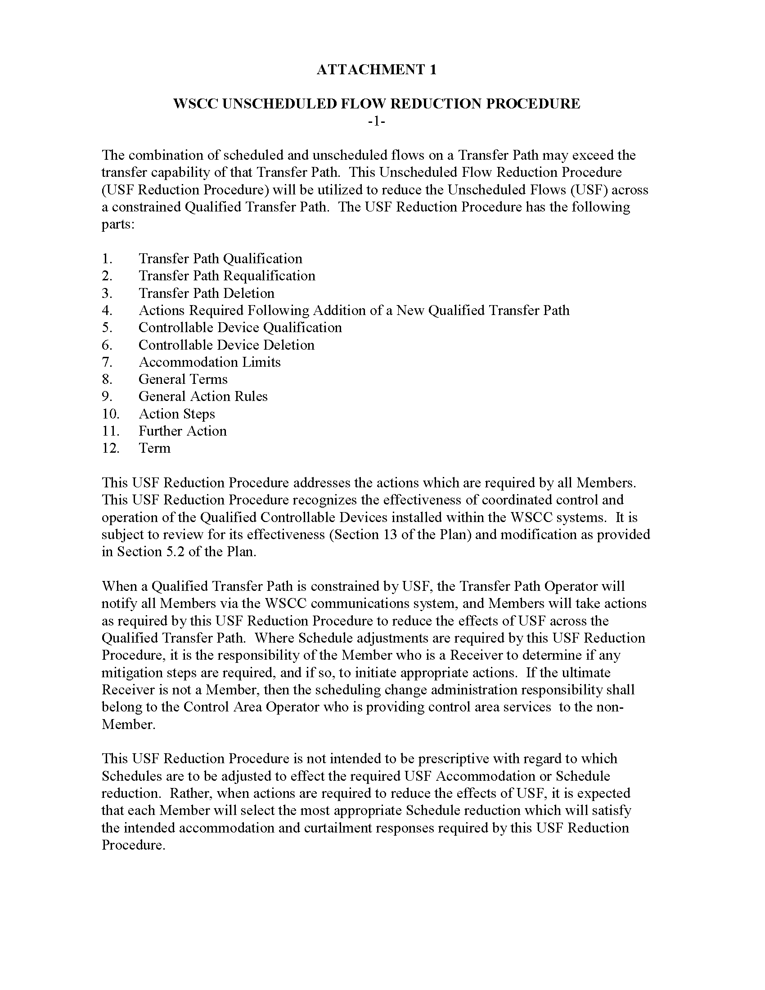
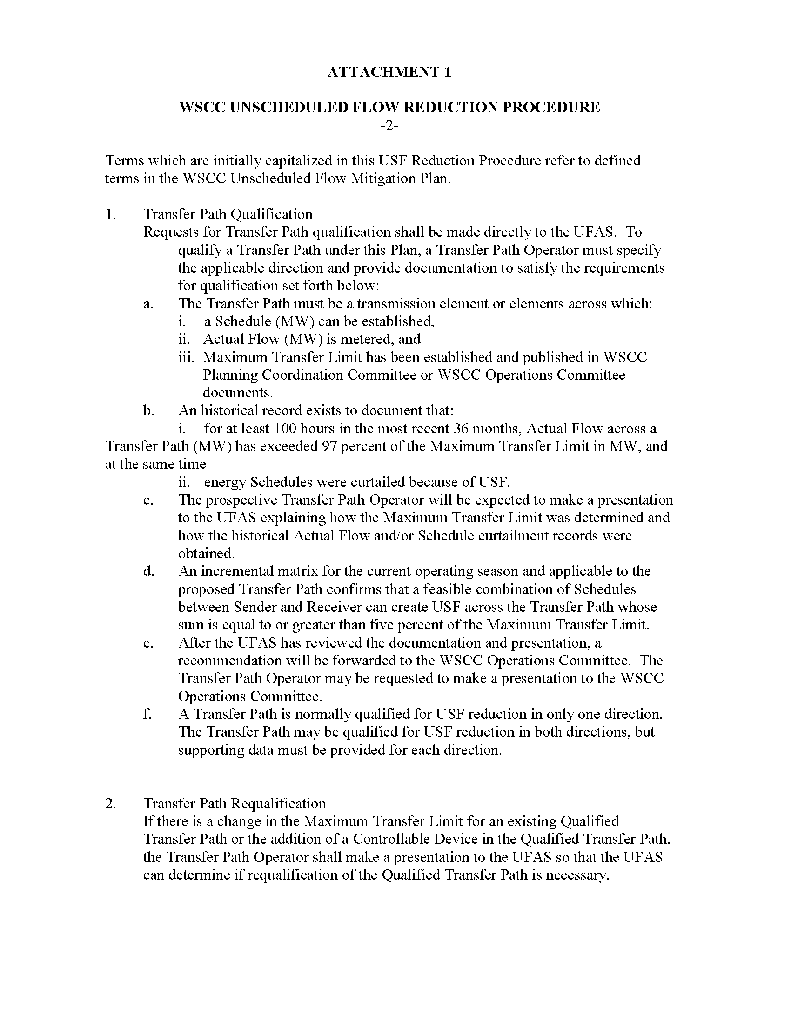
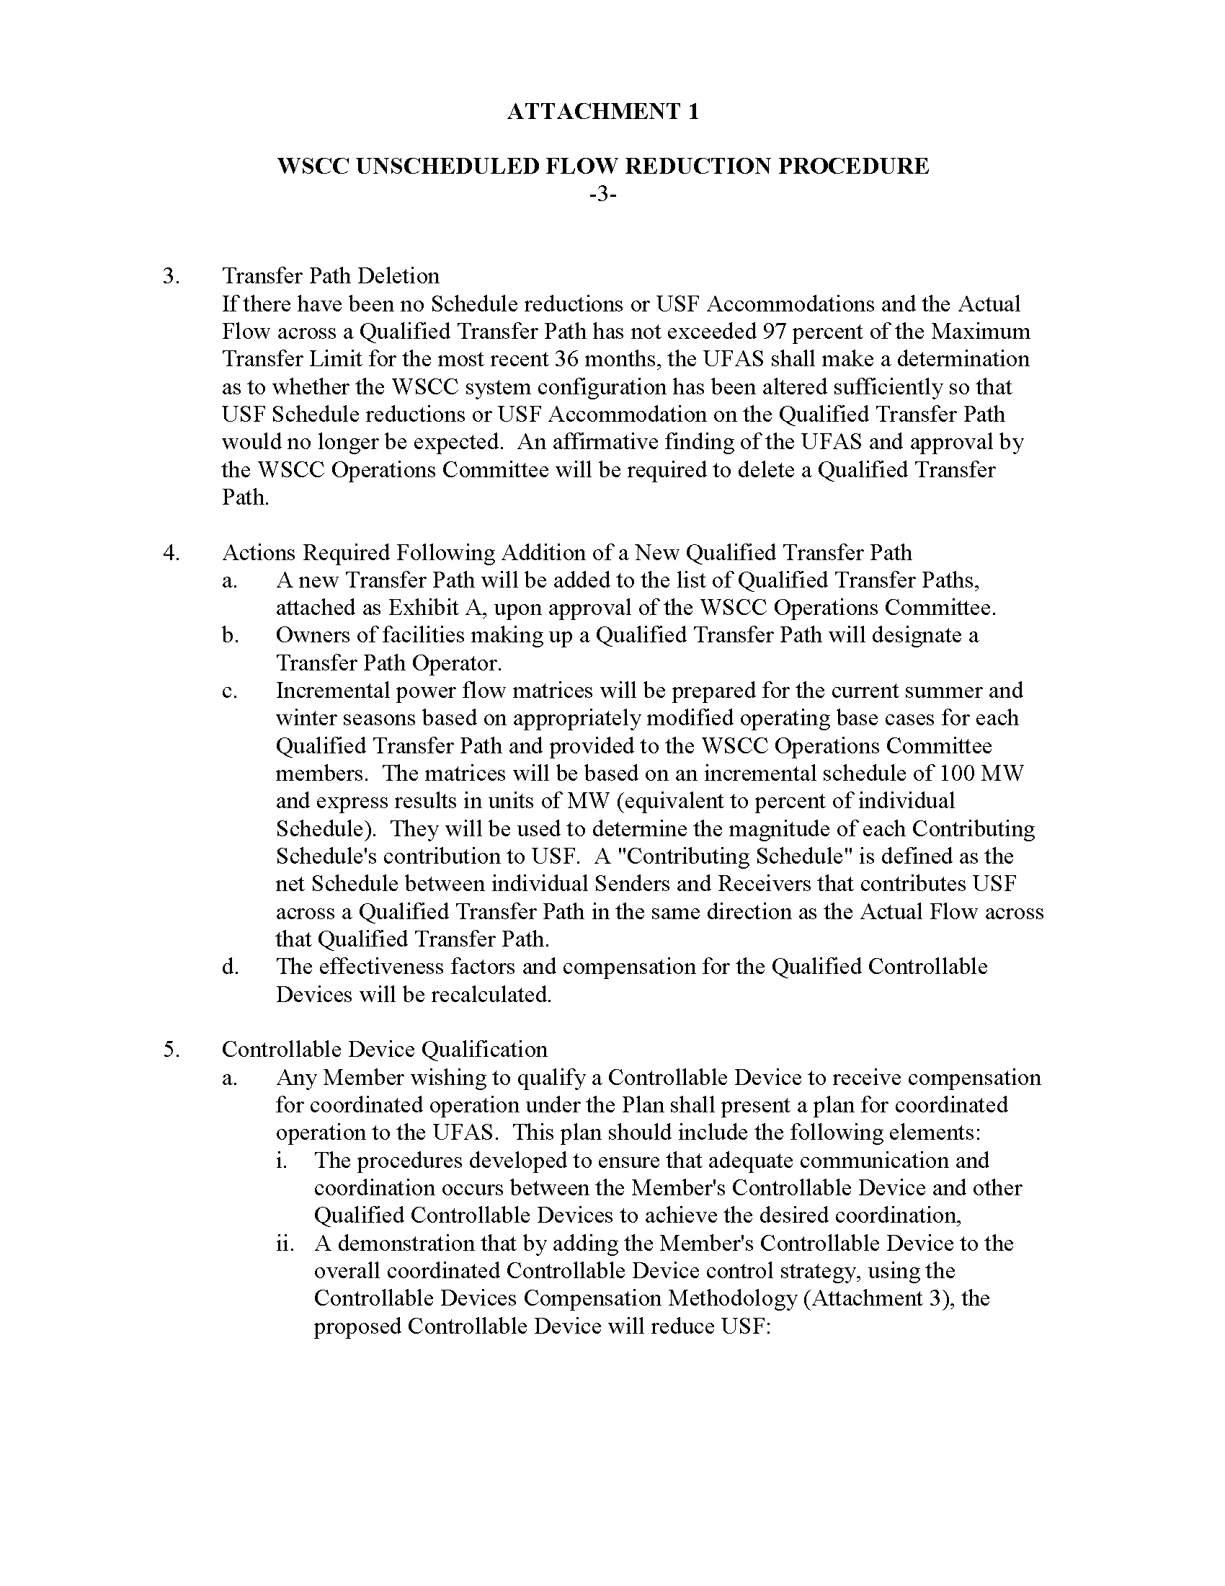
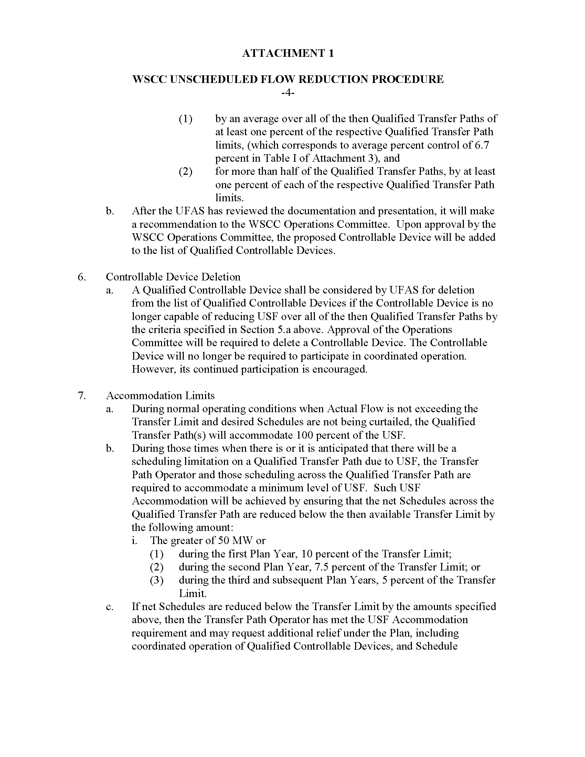
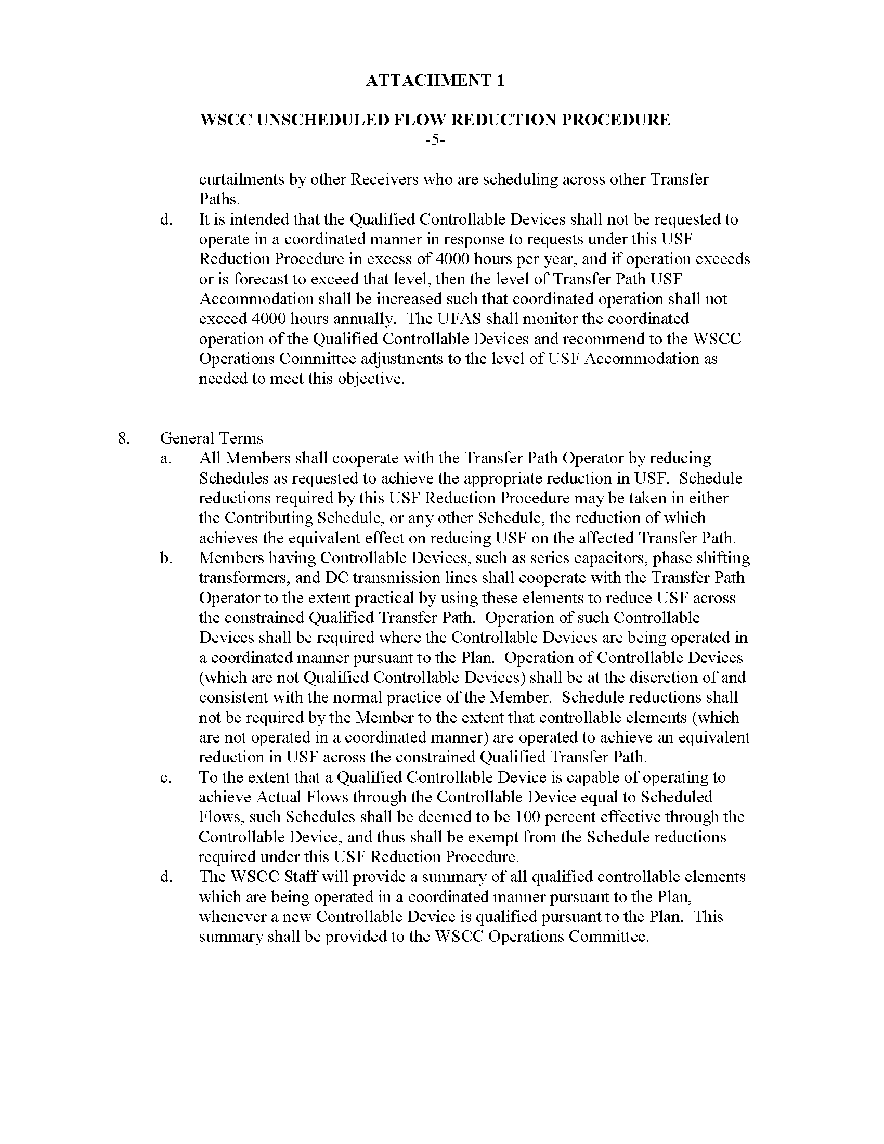
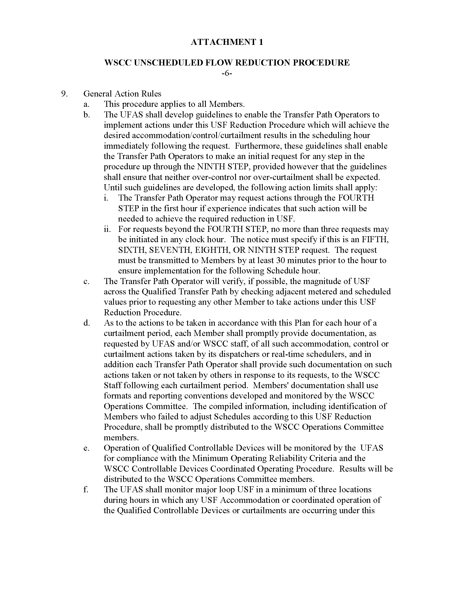
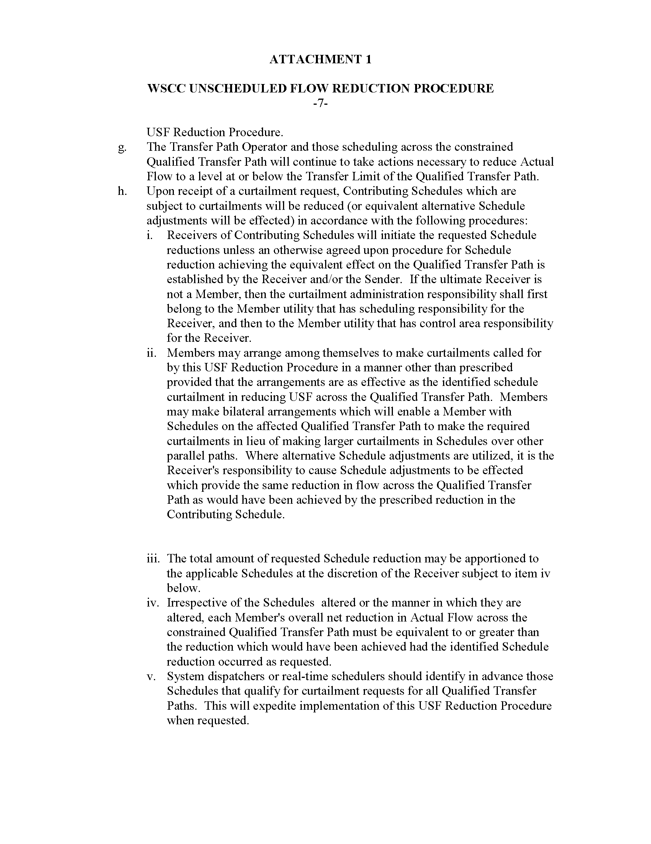
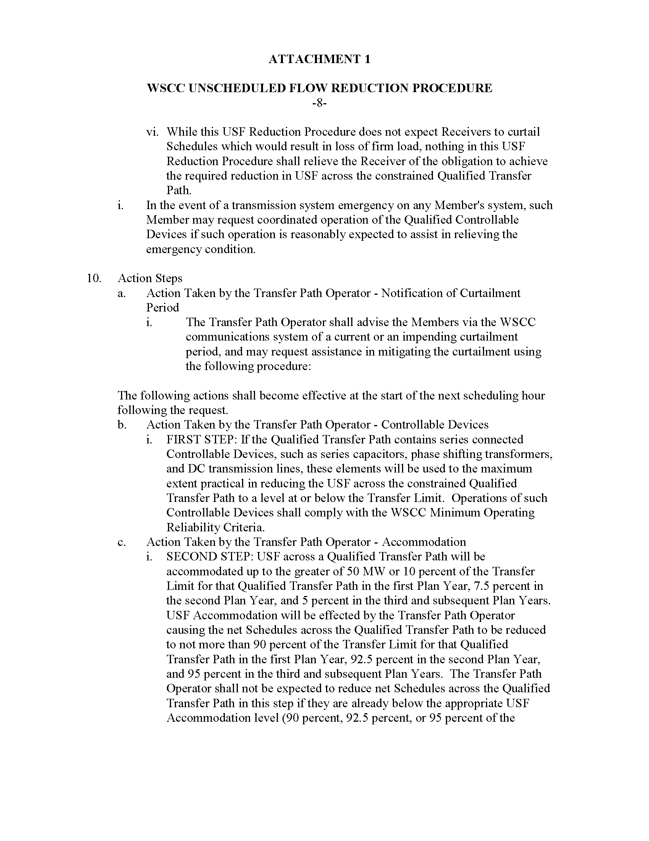
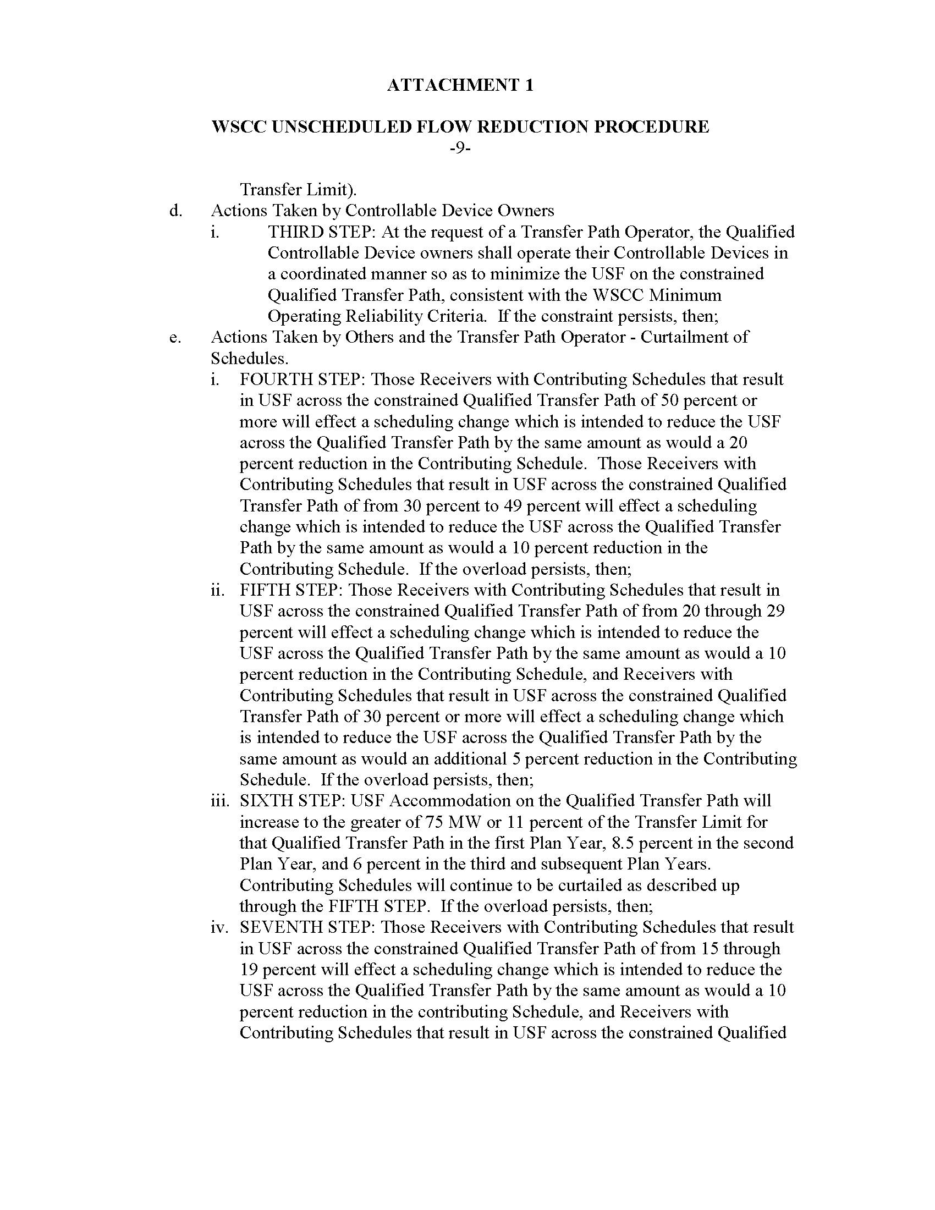
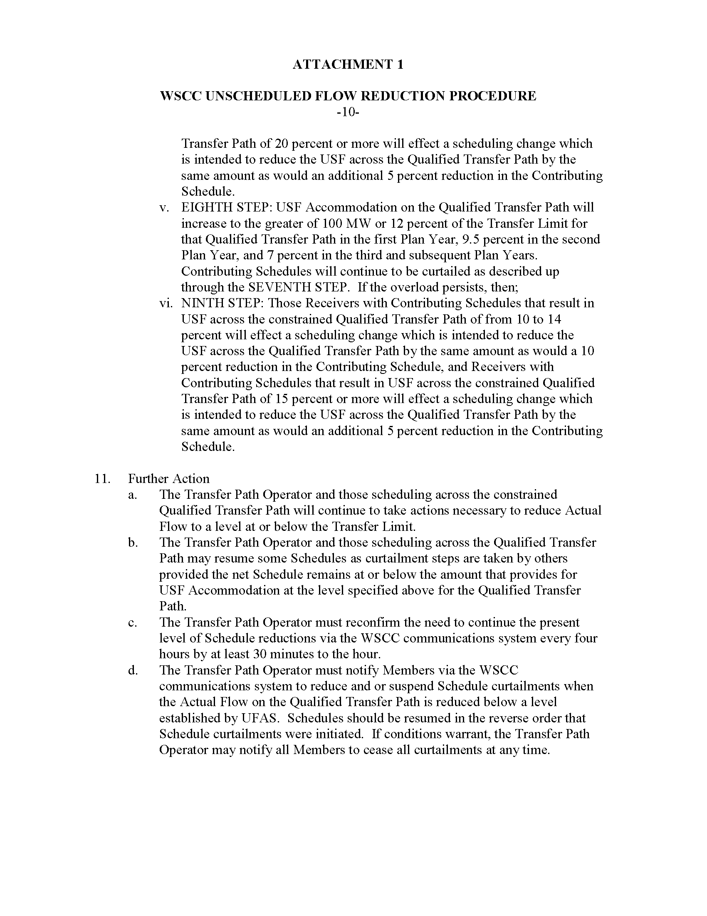

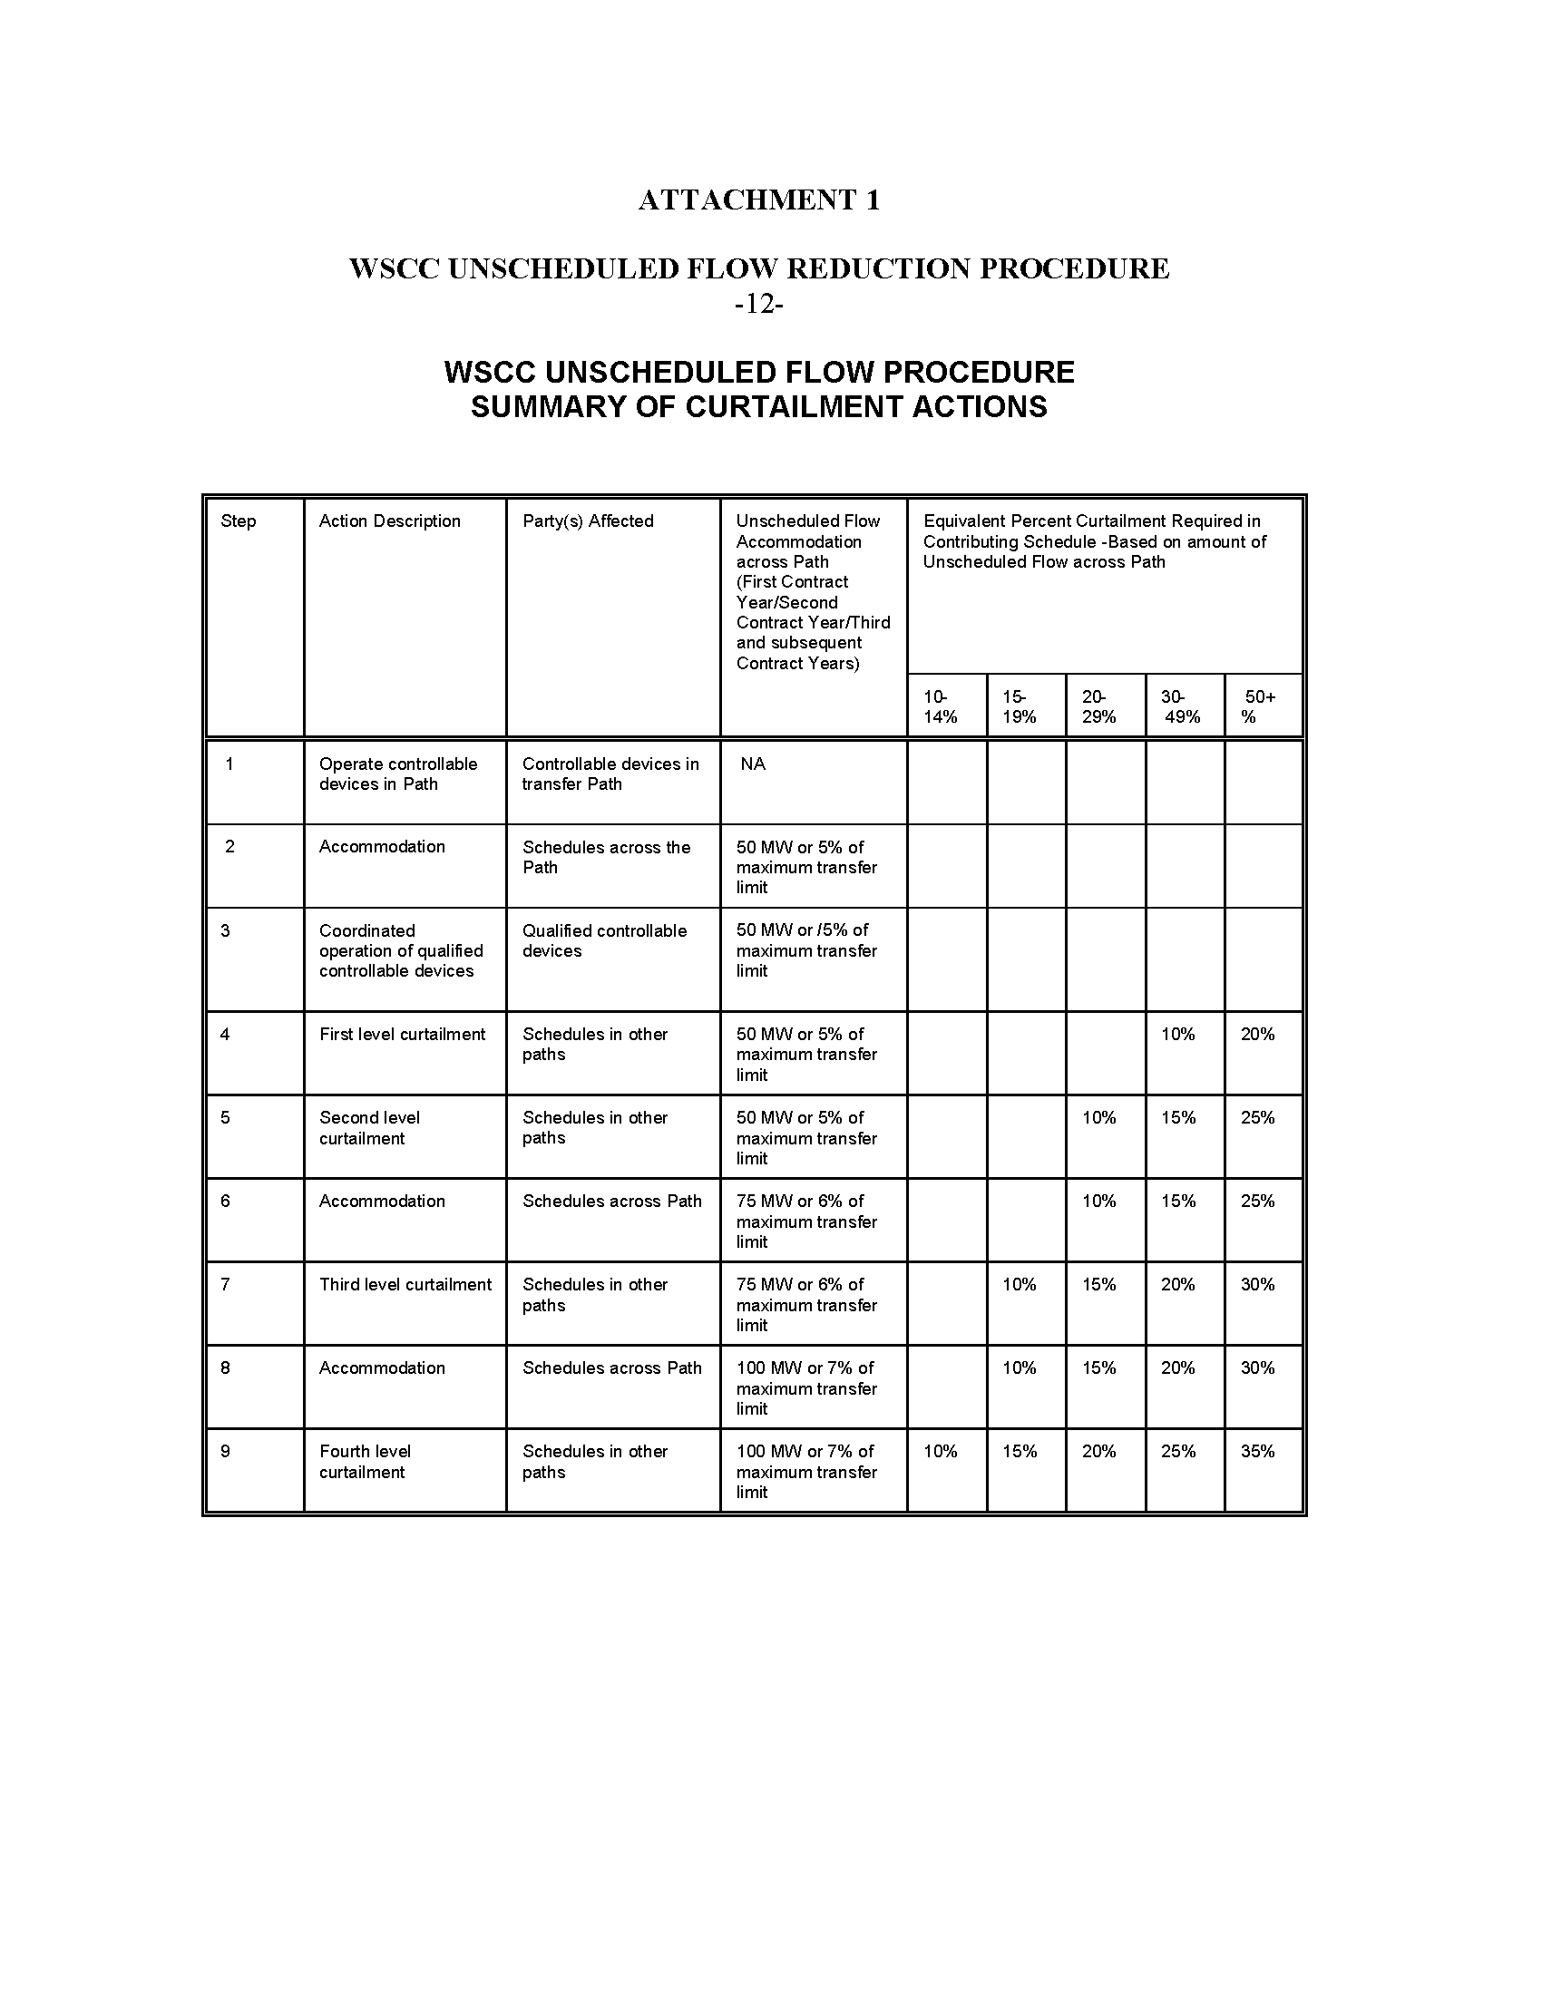

Appendix B – First to Curtail – Last to Curtail Examples

Appendix C - Pro Forma Extracts
- Section 13.6 Curtailment of Firm Transmission Service - In the event that a Curtailment on the Transmission Provider's Transmission System, or a portion thereof, is required to maintain reliable operation of such system and the system directly and indirectly interconnected with Transmission Provider’s Transmission System, Curtailments will be made on a non-discriminatory basis to the transaction(s) that effectively relieve the constraint. Transmission Provider may elect to implement such Curtailments pursuant to the Transmission Loading Relief procedures specified in Attachment J. If multiple transactions require Curtailment, to the extent practicable and consistent with Good Utility Practice, the Transmission Provider will curtail service to Network Customers and Transmission Customers taking Firm Point-To-Point Transmission Service on a basis comparable to the curtailment of service to the Transmission Provider's Native Load Customers. All Curtailments will be made on a non-discriminatory basis, however, Non-Firm Point-To-Point Transmission Service shall be subordinate to Firm Transmission Service. Long-Term Firm Point-to-Point Service subject to conditions described in Section 15.4 shall be curtailed with secondary service in cases where the conditions apply, but otherwise will be curtailed on a pro rata basis with other Firm Transmission Service. When the Transmission Provider determines that an electrical emergency exists on its Transmission System and implements emergency procedures to Curtail Firm Transmission Service, the Transmission Customer shall make the required reductions upon request of the Transmission Provider. However, the Transmission Provider reserves the right to Curtail, in whole or in part, any Firm Transmission Service provided under the Tariff when, in the Transmission Provider's sole discretion, an emergency or other unforeseen condition impairs or degrades the reliability of its Transmission System. The Transmission Provider will notify all affected Transmission Customers in a timely manner of any scheduled Curtailments.
- Section 14.7 Curtailment or Interruption of Service - The Transmission Provider reserves the right to Curtail, in whole or in part, Non-Firm Point-To-Point Transmission Service provided under the Tariff for reliability reasons when an emergency or other unforeseen condition threatens to impair or degrade the reliability of its Transmission System or the systems directly and indirectly interconnected with Transmission Provider’s Transmission System. Transmission Provider may elect to implement such Curtailments pursuant to the Transmission Loading Relief procedures specified in Attachment J. The Transmission Provider reserves the right to Interrupt, in whole or in part, Non-Firm Point-To-Point Transmission Service provided under the Tariff for economic reasons in order to accommodate (1) a request for Firm Transmission Service, (2) a request for Non-Firm Point-To-Point Transmission Service of greater duration, (3) a request for Non-Firm Point-To-Point Transmission Service of equal duration with a higher price, (4) transmission service for Network Customers from non-designated resources, or (5) transmission service for Firm Point-to-Point Transmission Service during conditional curtailment periods as described in Section 15.4. The Transmission Provider also will discontinue or reduce service to the Transmission Customer to the extent that deliveries for transmission are discontinued or reduced at the Point(s) of Receipt. Where required, Curtailments or Interruptions will be made on a non-discriminatory basis to the transaction(s) that effectively relieve the constraint, however, Non-Firm Point-To-Point Transmission Service shall be subordinate to Firm Transmission Service. If multiple transactions require Curtailment or Interruption, to the extent practicable and consistent with Good Utility Practice, Curtailments or Interruptions will be made to transactions of the shortest term (e.g., hourly non-firm transactions will be Curtailed or Interrupted before daily non-firm transactions and daily non-firm transactions will be Curtailed or Interrupted before weekly non-firm transactions). Transmission service for Network Customers from resources other than designated Network Resources will have a higher priority than any Non-Firm Point-To-Point Transmission Service under the Tariff. Non-Firm Point-To-Point Transmission Service over secondary Point(s) of Receipt and Point(s) of Delivery will have a lower priority than any Non-Firm Point-To-Point Transmission Service under the Tariff. The Transmission Provider will provide advance notice of Curtailment or Interruption where such notice can be provided consistent with Good Utility Practice.
- Section 15.4 Obligation to Provide Transmission Service that Requires Expansion or Modification of the Transmission System, Redispatch or Conditional Curtailment –
(a) If the Transmission Provider determines that it cannot accommodate a Completed Application for Firm Point-To-Point Transmission Service because of insufficient capability on its Transmission System, the Transmission Provider will use due diligence to expand or modify its Transmission System to provide the requested Firm Transmission Service, consistent with its planning obligations in Attachment K, provided the Transmission Customer agrees to compensate the Transmission Provider for such costs pursuant to the terms of Section 27. The Transmission Provider will conform to Good Utility Practice and its planning obligations in Attachment K, in determining the need for new facilities and in the design and construction of such facilities. The obligation applies only to those facilities that the Transmission Provider has the right to expand or modify.
(b) If the Transmission Provider determines that it cannot accommodate a Completed Application for Long-Term Firm Point-To-Point Transmission Service because of insufficient capability on its Transmission System, the Transmission Provider will use due diligence to provide redispatch from its own resources until (i) Network Upgrades are completed for the Transmission Customer, (ii) the Transmission Provider determines through a biennial reassessment that it can no longer reliably provide the redispatch, or (iii) the Transmission Customer terminates the service because of redispatch changes resulting from the reassessment. A Transmission Provider shall not unreasonably deny self-provided redispatch or redispatch arranged by the Transmission Customer from a third party resource.
(c) If the Transmission Provider determines that it cannot accommodate a Completed Application for Long-Term Firm Point-To-Point Transmission Service because of insufficient capability on its Transmission System, the Transmission Provider will offer the Firm Transmission Service with the condition that the Transmission Provider may curtail the service prior to the curtailment of other Firm Transmission Service for a specified number of hours per year or during System Condition(s). If the Transmission Customer accepts the service, the Transmission Provider will use due diligence to provide the service until (i) Network Upgrades are completed for the Transmission Customer, (ii) the Transmission Provider determines through a biennial reassessment that it can no longer reliably provide such service, or (iii) the Transmission Customer terminates the service because the reassessment increased the number of hours per year of conditional curtailment or changed the System Conditions.
- Section 30.5 Network Redispatch Obligations - As a condition to receiving Network Integration Transmission Service, the Network Customer agrees to redispatch its Network Resources as requested by the Transmission Provider pursuant to Section 33.2. To the extent practical, the redispatch of resources pursuant to this section shall be on a least cost, non-discriminatory basis between all Network Customers, and the Transmission Provider.
- Section 33.2 Transmission Constraints – During any period when the Transmission Provider determines that a transmission constraint exists on the Transmission System, and such constraint may impair the reliability of the Transmission Provider's system, the Transmission Provider will take whatever actions, consistent with Good Utility Practice, that are reasonably necessary to maintain the reliability of the Transmission Provider's system. To the extent the Transmission Provider determines that the reliability of the Transmission System can be maintained by redispatching resources, the Transmission Provider will initiate procedures pursuant to the Network Operating Agreement to redispatch all Network Resources and the Transmission Provider's own resources on a least-cost basis without regard to the ownership of such resources. Any redispatch under this section may not unduly discriminate between the Transmission Provider's use of the Transmission System on behalf of its Native Load Customers and any Network Customer's use of the Transmission System to serve its designated Network Load.
- Section 33.4 Curtailment of Scheduled Deliveries – If a transmission constraint on the Transmission Provider's Transmission System cannot be relieved through the implementation of least-cost redispatch procedures and the Transmission Provider determines that it is necessary to Curtail scheduled deliveries, the Parties shall Curtail such schedules in accordance with the Network Operating Agreement or pursuant to the Transmission Loading Relief procedures specified in Attachment J.
- Section 33.5 Allocation of Curtailments - The Transmission Provider shall, on a non-discriminatory basis, Curtail the transaction(s) that effectively relieve the constraint. However, to the extent practicable and consistent with Good Utility Practice, any Curtailment will be shared by the Transmission Provider and Network Customer in proportion to their respective Load Ratio Shares. The Transmission Provider shall not direct the Network Customer to Curtail schedules to an extent greater than the Transmission Provider would Curtail the Transmission Provider's schedules under similar circumstances.
- Section 33.7 System Reliability – Notwithstanding any other provisions of this Tariff, the Transmission Provider reserves the right, consistent with Good Utility Practice and on a not unduly discriminatory basis, to Curtail Network Integration Transmission Service without liability on the Transmission Provider's part for the purpose of making necessary adjustments to, changes in, or repairs on its lines, substations and facilities, and in cases where the continuance of Network Integration Transmission Service would endanger persons or property. In the event of any adverse condition(s) or disturbance(s) on the Transmission Provider's Transmission System or on any other system(s) directly or indirectly interconnected with the Transmission Provider's Transmission System, the Transmission Provider, consistent with Good Utility Practice, also may Curtail Network Integration Transmission Service in order to (i) limit the extent or damage of the adverse condition(s) or disturbance(s), (ii) prevent damage to generating or transmission facilities, or (iii) expedite restoration of service. The Transmission Provider will give the Network Customer as much advance notice as is practicable in the event of such Curtailment. Any Curtailment of Network Integration Transmission Service will be not unduly discriminatory relative to the Transmission Provider's use of the Transmission System on behalf of its Native Load Customers. The Transmission Provider shall specify the rate treatment and all related terms and conditions applicable in the event that the Network Customer fails to respond to established Load Shedding and Curtailment procedures.
- Schedule 1 Scheduling, System Control and Dispatch Service – This service is required to schedule the movement of power through, out of, within, or into a Control Area. This service can be provided only by the operator of the Control Area in which the transmission facilities used for transmission service are located. Scheduling, System Control and Dispatch Service is to be provided directly by the Transmission Provider (if the Transmission Provider is the Control Area operator) or indirectly by the Transmission Provider making arrangements with the Control Area operator that performs this service for the Transmission Provider's Transmission System. The Transmission Customer must purchase this service from the Transmission Provider or the Control Area operator. The charges for Scheduling, System Control and Dispatch Service are to be based on the rates set forth below. To the extent the Control Area operator performs this service for the Transmission Provider, charges to the Transmission Customer are to reflect only a pass-through of the costs charged to the Transmission Provider by that Control Area operator.
- Attachment C Methodology To Assess Available Transfer Capability - (extract only) (1) A detailed description of the specific mathematical algorithm used to calculate firm and non-firm ATC (and AFC, if applicable) for its scheduling horizon (same day and real-time), operating horizon (day ahead and pre-schedule) and planning horizon (beyond the operating horizon);
- Attachment J Procedures for Addressing Parallel Flows – To be filed by the Transmission Provider

The WSCC Unscheduled Flow Mitigation Plan was originally approved by FERC prior to Order 890. The Unscheduled Flow Mitigation Plan was also included in the WECC regional standards WECC Standard IRO-STD-006-0 which was approved by FERC under Docket No. RR07-11-000 on June 8, 2007. The Unscheduled Flow Mitigation Plan was also referenced in the NERC Standards IRO-006.4 (Requirement R1.2)which were approved by FERC under Order No. 713-A on March 19, 2009.
The Firm Transaction Flows and/or Firm GTL Flows have met the minimum IDC threshold in order to be subject to curtailment

