Hi Elizabeth,

I see several references to cybersecurity in the document you provided, however the standards are shown as “should”, which means they don’t have to be followed, for example:
RMQ.26.3.1.2 The Utility Service Provider should use this RMQ.26 in conjunction with Utility Service Provider’s application of Cybersecurity Procurement Language for Energy Delivery Systems^{[1]} to develop and specify its chosen OpenFMB Implementation and enforce open standards and interoperability requirements in the Utility Service Provider’s procurement process.

RMQ.26.3.1.3 OpenFMB Implementations should fit within the Utility Service Provider’s overall business procedures. For example, Utility Service Provider-wide security activities such as Electricity Subsector Cybersecurity Risk Management Process^{[2]}, Electricity Subsector Cybersecurity Capability Maturity Model Version 1.1^{[3]}, Energy Sector Cybersecurity Framework Implementation Guidance^{[4]}, and Framework for Improving Critical Infrastructure Cybersecurity Core Mapping to National Institute of Standards and Technology (NIST) Interagency Report (IR) 7628^{[5]} should guide OpenFMB Implementations. Utility Service Provider-wide common governance, risk, and compliance (GRC) requirements and common technical requirements (CTR) from NISTIR 7628 User's Guide^{[6]} and NISTIR 7628 Revision 1 Guidelines for Smart Grid Cybersecurity^{[7]} as well as various NISTIR 7628 unique technical requirements (UTR) may also apply to the OpenFMB Implementation

I don’t see anything prescriptive as to how an OpenFMB shall implement identity and access control, but there are some rather “ambiguous” statements regarding these areas, leaving open the question of “how do I implement “mutual authenticity”, for example:

RMQ.26.3.4.3 OpenFMB Implementations should provide high integrity of the code and parameters that run on an OpenFMB Node and its telecommunications and operational functions to help minimize the degree of any degradation. Approaches include appropriate test scenarios, digital signatures, and hash-based authentication.

RMQ.26.3.4.4 OpenFMB Nodes should have a secure individual identity for any interactions with other OpenFMB Nodes.

RMQ.26.3.4.5 OpenFMB Nodes should mutually authenticate before communicating with each other.

RMQ.26.3.4.6 OpenFMB Nodes should mutually authorize Message Topics before communicating operational data with each other.

RMQ.26.3.4.7 OpenFMB Nodes should provide confidentiality for data in motion and data at rest in accordance with the Utility Service Provider’s risk management process, OpenFMB Node capabilities, and desired OpenFMB Node performance while considering networking best practices, such as Internet Engineering Task Force (IETF)^{[8]} and IPsec^{[9]}.

RMQ.26.3.4.12 OpenFMB Nodes should run with operating system security services.

There is no prescriptive information, that I can see, for vetting identities that will be assigned to OpenFMB devices and assigning credentials to devices to be used as “proof of identity” during authentication and access control events.
I don’t see any requirements as to identity proofing standards and assurance levels, such as what exists in WEQ-012.

There is also reference to a “beta level” standard from OMG for data security, DDS: RMQ.26.7.2.1.1 Data Distribution Service
REF: http://www.omg.org/spec/DDS-SECURITY/1.0/Beta1/PDF/
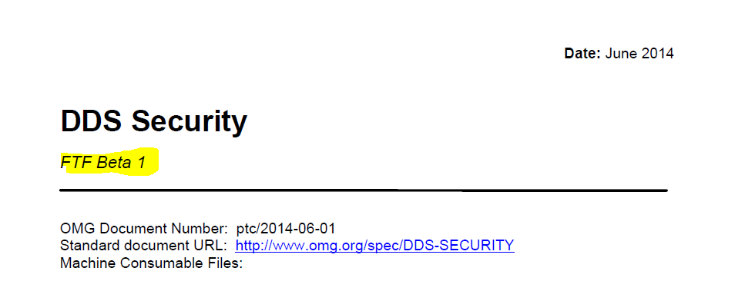
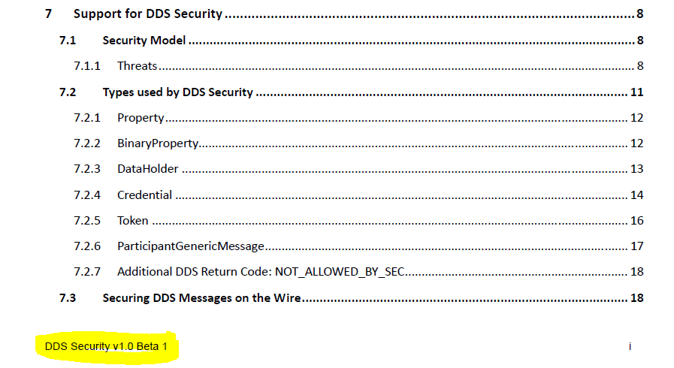

Thanks,
Dick

[1] http://energy.gov/sites/prod/files/2014/04/f15/CybersecProcurementLanguage-EnergyDeliverySystems_040714_fin.pdf
[2] http://energy.gov/sites/prod/files/Cybersecurity Risk Management Process Guideline - Final - May 2012.pdf
[3] http://energy.gov/sites/prod/files/2014/02/f7/ES-C2M2-v1-1-Feb2014.pdf
[4] http://energy.gov/sites/prod/files/2015/01/f19/Energy Sector Cybersecurity Framework Implementation Guidance_FINAL_01-05-15.pdf
[5] http://members.sgip.org/apps/org/workgroup/sgip-mmc/download.php/5472/latest
[6] http://sgip.org/SGIP/files/ccLibraryFiles/Filename/000000000124/NISTIR 7628 Users Guide FINAL-2014-02-27c.pdf
[7] http://nvlpubs.nist.gov/nistpubs/ir/2014/NIST.IR.7628r1.pdf
[8] http://www.ietf.org/rfc/rfc7525.txt.pdf
[9] http://www.ietf.org/rfc/rfc6379.txt.pdf

