August 31, 2009

Jonathan Booe
Staff Attorney
North American Energy Standards Board
1301 Fannin, Suite 2350
Houston, Texas 77002
(713) 356-0060 - office
(281) 642-3912 - cell
jbooe@naesb.org

Dear Mr. Booe,
The Association of Home Appliance Manufacturers (AHAM) Smart Grid Task Force is pleased to have the opportunity to provide NAESB with a framework of the needs of appliance manufacturers and their suppliers in response to your circulation of the document titled ”Measurement & Verification (M&V) Of Demand Response Programs”. The AHAM Smart Grid Task Force was created to allow AHAM members to work collaboratively to ensure that the voice of home appliance manufacturers and their suppliers is heard in regards to the development process of a Smart Grid.

Appliance manufacturers are concerned about the current direction of developments in the Smart Grid arena, specifically in regards to the consumer’s acceptance of, and interaction with, Smart appliances. Consumer approval is absolutely necessary for the success of the Smart Appliance concept.

The following is a list of 5 high level positions the Task Force has agreed upon for an approach to the development of standards for Grid Enabled Smart Appliance Systems.

1) All message protocol definitions from the Smart Grid should exist in an open standards
format to ensure inclusive manufacturer participation and to allow manufacturers to achieve
maximum interoperability.

2) Initially some Smart Appliance systems and corresponding standards may support one-way
communication, while others may support two way communications. Since the utility can
determine responses to commands by monitoring the Smart Meter measurements, this
requirement seems reasonable. A limited number of messages will be used for this
communication.

3) Next generations of Smart Appliance Systems may consider two way communications. This
communication will likely be through an in-home managerial control system. As stated
above, a limited number of standardized messages will be used to support this
communication. This does not preclude additional protocols and messages from being used
for communication with Smart Appliances from the in-home managerial control system.

4) In all cases, the Smart Appliance will retain control of the appliance response. The Smart
Appliance will always allow the consumer the option to override a power reduction
command, if the consumer desires.

5) The Smart Appliance may respond to rate level instructions from the utility in one of the
following ways: 1) shedding load at a limited number of levels (for example, four or five
possible power consumption levels) all under direct control of the appliance, 2) responding
to commands from the in-home managerial control system (which is interpreting or
managing the information from the utility, or 3) presenting the consumer with information
that would encourage the consumer to delay use at that time.

The consumer will always have the option to override these actions and resort to full power
usage or different energy modes.

6) AHAM members are also concerned that the rate structures being considered do not
incentivize or educate consumers. Thus, consumers may not be inclined to utilize smart
products and a large part of the demand response opportunity will be lost.

If you have any questions or issues you would like to discuss, please feel free to contact me.

Sincerely,
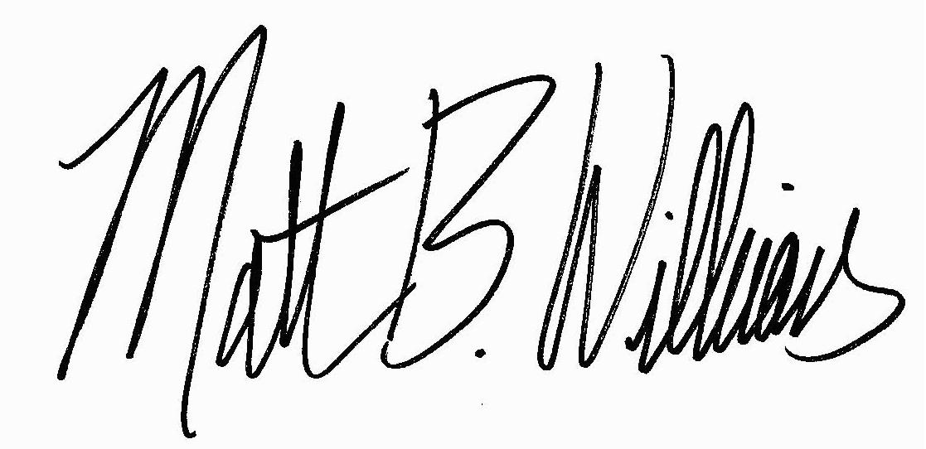
Matthew B. Williams
Director, Standards
202-872-5955 x317
mwilliams@aham.org

