North American Energy Standards Board

Request for Retirement of a NAESB Business Practice Standard, Model Business Practice or Electronic Transaction

Instructions:

1. Please fill out as much of the requested information as possible. It is mandatory to provide a contact name, phone number and fax number to which questions can be directed. If you have an electronic mailing address, please make that available as well.

2. Attach any information you believe is related to the request. The more complete your request is, the less time is required to review it.

3. Once completed, send your request to:
Rae McQuade
NAESB, President
801 Travis, Suite 1675
Houston, TX 77002

Phone: 713-356-0060
Fax: 713-356-0067

by either mail, fax, or to NAESB’s email address, naesb@naesb.org.

Once received, the request will be routed to the appropriate subcommittees for review.

North American Energy Standards Board

Request for Retirement of a NAESB Business Practice Standard, Model Business Practice or Electronic Transaction

Date of Request: February 2, 2016

1. Submitting Entity & Address:
North American Electric Reliability Corporation (NERC)
3353 Peachtree Rd NE
North Tower, Suite 600
Atlanta, GA 30326

2. Contact Person, Phone #, Fax #, Electronic Mailing Address:
Name : Darrel Richardson (primary contact)
Title : Senior Standards Developer, Standards
Phone : 609-613-1848
Fax : 404-446-2595 (please use email)
E-mail : Darrel.Richardson@nerc.net

Name : Howard Gugel
Title : Director, Standards
Phone : 404-446-9693
E-mail : Howard.Gugel@nerc.net

Name : Mark Lauby
Title : Senior Vice President, Chief Reliability Officer
Phone : 404-446-9723
E-mail : Mark.Lauby@nerc.net

- Title and Description of Proposed Standard or Enhancement:

Title:
North American Energy Standard Board (NAESB) WEQ Manual Time Error Correction Business Practice Standards – WEQ-006 (referred to herein as NAESB WEQ-006)

Description:
Interconnection frequency is normally scheduled at 60.00 Hz and controlled to that value. The control is imperfect and over time the frequency will average slightly above or below 60.00 Hz resulting in mechanical electric clocks developing an error relative to true time. Business Practice Standard specifies the procedure to be used for reducing the error to within acceptable limits of true time. NERC requests retirement of (NAESB WEQ-006) to align with NERC’s plan to request retirement of NERC Reliability Standard BAL-004-0, based on industry’s further review of time error correction, as discussed below in response to question 4.

4. Use of Proposed Standard or Enhancement (include how the standard will be used, documentation on the description of the proposed standard, any existing documentation of the proposed standard, and required communication protocols):

The Balancing Authority Reliability-based Controls 2 Periodic Review Team (BARC 2 PRT) was tasked with reviewing certain Reliability Standards and developing recommendations that each Reliability Standard be (1) reaffirmed as is (i.e., no changes needed); (2) revised (which may include revising or retiring one or more requirements); or (3) retired. After an extensive review, the BARC 2 PRT recommended that Reliability Standard BAL-004-0 be retired and that manual Time Error Correction (TEC) be eliminated as a continent-wide NERC Reliability Standard. Then, the Balancing Authority Reliability-based Controls 2.2 Standard Drafting Team (BARC 2.2 SDT) reviewed the findings of the BARC 2 PRT and issued a survey to the industry to gain a better perspective as to any concerns the industry may have if the practice of manual TEC is eliminated. The survey response indicated support for retirement of manual TEC as a Reliability Standard. Upon review, the BARC 2.2 SDT determined that manual TEC does not support the reliability of the Bulk Electric System and that conducting manual TEC in any form contradicts NERC Reliability Principle 2 stating: “The frequency and voltage of interconnected bulk power systems shall be controlled within defined limits through the balancing of real and reactive power supply and demand.” The practice of using manual TEC to place the Interconnection closer to the settings for automatic underfrequency load shedding does not support or enhance reliability. Therefore, BAL-004-0 should be retired.

The BARC 2.2 SDT review and examination of survey results also indicated that the accompanying NAESB WEQ Manual Time Error Correction Business Practice Standard – WEQ-006 (NAESB WEQ-006), should be retired contemporaneously with BAL-004-0. Simultaneous retirement of NAESB WEQ-006 and NERC Reliability Standard BAL-004-0 is necessary to ensure clarity and avoid inadvertent, uncoordinated, manual TEC arising in manner that is inconsistent with Federal Energy Regulatory Commission (FERC) determinations and statements (summarized in response to question 7 below).

Therefore, the BARC 2.2 SDT’s proposed retirement of BAL-004-0 is contingent on simultaneous retirement of NAESB WEQ-006 to ensure clarity and to avoid inadvertent, uncoordinated, manual TEC. The BARC 2.2 SDT has been coordinating with NAESB on this issue. Any filing for government approval for retirement of NERC Reliability Standard BAL-004-0 will highlight that the proposal is conditioned upon retirement of NAESB WEQ-006. Upon retirement of BAL-004-0 and NAESB WEQ-006 the BARC 2.2 SDT believes that the currently or soon to be effective Reliability Standards BAL-003-1 and BAL-001-2 will incent continued adherence to a frequency approximating 60 Hz over long-term averages.

5. Description of Any Tangible or Intangible Benefits to the Use of the Proposed Standard or Enhancement:
N/A (see response to question 4 for analysis of benefits associated with the requested retirement).

6. Estimate of Incremental Specific Costs to Implement Proposed Standard or Enhancement:
N/A

7. Description of Any Specific Legal or Other Considerations:

FERC Order No. 693 and the NOPR in RM09-13-000, reflect the FERC determination that a Reliability Standard on manual TEC is intended to ensure that time error corrections are performed in a manner that does not adversely affect the reliability of the Interconnection.” Order No. 693, at P 383. While manual TEC may not be necessary to ensure reliability, if manual TEC are performed, FERC’s determination clarified that there must be Reliability Standard Requirements in place ensuring performance of manual TEC in a way that does not adversely affect reliability.

If NAESB WEQ-006 for manual TEC were to continue in effect, while Reliability Standard BAL-004-0 was retired, there would be no mandatory Reliability Standard in place to ensure that such manual TEC under NAESB’s Business Practices were performed in a manner that would not adversely affect reliability. Thus, simultaneous, coordinated, retirement of both NERC Reliability Standard BAL-004-0 and NAESB WEQ-006 are necessary to adhere to FERC’s determination.

8. If This Proposed Standard or Enhancement Is Not Tested Yet, List Trading Partners Willing to Test Standard or Enhancement (Corporations and contacts):
N/A (see above regarding the BARC 2 PRT and BARC 2.2 SDT analysis described in response to question 4).

9. If This Proposed Standard or Enhancement Is In Use, Who are the Trading Partners:

The NAESB WEQ-006 applies to Balancing Authorities and Interconnection Time Monitors.

10. Attachments (such as : further detailed proposals, transaction data descriptions, information flows, implementation guides, business process descriptions, examples of ASC ANSI X12 mapped transactions):

Please refer to the Time Error Correction and Reliability White Paper attached as Attachment 1.

Attachment 1
Time Error Correction and Reliability White Paper

Recommendation of the Balancing Authority Reliability-based Controls 2.2 Standard Drafting Team to Retire BAL-004-0 – Time Error Correction

The Balancing Authority Reliability-based Controls 2 Periodic Review Team (BARC 2 PRT) was tasked with reviewing certain Reliability Standards and developing recommendations that each Reliability Standard be (1) reaffirmed as is (i.e., no changes needed); (2) revised (which may include revising or retiring one or more requirements); or (3) retired. After an extensive review, the BARC 2 PRT recommended that Reliability Standard BAL-004-0 be retired and that manual Time Error Correction (TEC) be eliminated as a continent-wide NERC standard. The Balancing Authority Reliability-based Controls 2.2 Standard Drafting Team (BARC 2.2 SDT) reviewed the findings of the BARC 2 PRT and issued a survey to the industry to gain a better perspective as to any concerns the industry may have if the practice of manual TEC was eliminated. The survey response indicated support for retirement of manual TEC as a standard. Upon review, as detailed below, the BARC 2.2 SDT determined that manual TEC would not support the reliability of the BPS. Conducting manual TEC in any form directly contradicts NERC Reliability Principle 2: “The frequency and voltage of interconnected bulk power systems shall be controlled within defined limits through the balancing of real and reactive power supply and demand.” The practice of using manual TEC to place the Interconnection closer to the settings for automatic underfrequency load shedding does not support or enhance reliability. Therefore, BAL-004-0 should be retired.

The survey also indicated that the accompanying North American Energy Standard Board (NAESB) business practice standard, WEQ Manual Time Error Correction Business Practice Standard – WEQ-006, should be retired contemporaneously with BAL-004-0. The BARC 2.2 SDT’s recommendation for retirement of BAL-004-0 is contingent on simultaneous retirement of NAESB WEQ-006 to ensure clarity and to avoid inadvertent, uncoordinated, manual TEC. The BARC 2.2 SDT has been coordinating with NAESB on this issue. As discussed below, upon retirement of BAL-004-0 and NAESB WEQ-006, currently or soon to be effective Reliability Standards BAL-003-1 and BAL-001-2 will incent continued adherence to a frequency approximating 60 Hz over long-term averages.

This white paper reviews the history of manual TEC and BAL-004-0, outlines the key considerations of the BARC 2.2 SDT in developing its recommendation, and assesses whether the use of manual TEC supports the reliability of the Bulk Power System (BPS).

History of Time Error Correction and Reduced Reliance On Manual TEC Today

- Invention of the Synchronous Motor Clock and Market Penetration
In 1916, Henry E. Warren invented the self-starting synchronous motor and three years later the motor was used for the production of the Telechron Clock. The Telechron Clock was a synchronous electric clock, which used alternating current electricity to measure time. Its accuracy depended on the frequency of the power grid. To incentivize electric system operators to regulate frequency in a way that kept the clocks running accurately, the Warren Clock Company, which was manufacturing the Telechron Clock at the time, gave electric clocks to electric system operators. The idea worked and system operators began regulating the frequency as desired by the Warren Clock Company.

During the 1920s, other companies developed synchronous motor clocks and used the same marketing strategy, giving electric clocks to system operators. As the penetration of the synchronous electric clock increased, the incremental electric revenue to utilities from the additional electric clock motors justified the relatively small cost to utilities to regulate system time by modifying system frequency. This additional revenue helped ensure that manual TEC would be an ongoing service provided by the electric utility industry.

- Time Error Correction Practice and Improvements in Clock Accuracy
As the electric system became more interconnected, the service of providing manual TEC was incorporated into the industry’s general operating practice. The current form of manual TEC is a legacy commercial practice that originated in the 1920s as a commercial service and was not related to the reliability of the electric grid. While documentation is available from as late as 1976 that synchronous electric clocks were still being used for important applications, by 1969, alternative methods of keeping accurate time penetrated the market and gradually displaced the electric clock. For example, the introduction of the first mass-produced quartz watch provided a more reliable and less expensive method to keep accurate time. Additionally, 15 years later, the United States made available for free the Global Positioning System, which is a space-based satellite navigation system that provides location and time information.

As discussed below in Section III.e., current Reliability Standards BAL-003-1 and BAL-001-2also ensure adherence to 60 Hz.

History of BAL-004-0
Reliability Standard BAL-004-0 – Time Error Correction became mandatory and enforceable on June 18, 2007. It contains four requirements:

- R1 Only a Reliability Coordinator shall be eligible to act as an Interconnection Time Monitor. A single Reliability Coordinator in each Interconnection shall be designated by the NERC Operating Committee to serve as Interconnection Time Monitor.
- R2 The Interconnection Time Monitor shall monitor Time Error and shall initiate or terminate corrective action orders in accordance with the NAESB Time Error Correction Procedure.
- R3 Each Balancing Authority, when requested, shall participate in a Time Error Correction by one of the following methods:
  - R3.1 The Balancing Authority shall offset its frequency schedule by 0.02 Hertz, leaving the Frequency Bias Setting normal; or
  - R3.2 The Balancing Authority shall offset its Net Interchange Schedule (MW) by an amount equal to the computed bias contribution during a 0.02 Hertz Frequency Deviation (i.e. 20% of the Frequency Bias Setting).
- R4 Any Reliability Coordinator in an Interconnection shall have the authority to request the Interconnection Time Monitor to terminate a Time Error Correction in progress, or a scheduled Time Error Correction that has not begun, for reliability considerations.
  - R4.1 Balancing Authorities that have reliability concerns with the execution of a Time Error Correction shall notify their Reliability Coordinator and request the termination of a Time Error Correction in progress.

On July 11, 2007, a Standard Authorization Request (SAR) was submitted to NERC, proposing to revise BAL-004-0 to:

- Remove inappropriate compliance requirements on Reliability Coordinators who voluntarily agree to serve as Interconnection Time Monitors.
- Remove inappropriate compliance requirements on the NERC Operating Committee (OC), which is not a user, owner, or operator of the BPS.
- Remove inappropriate requirements to follow NAESB business practices.

The revised BAL-004-1 received 94.10% weighted segment approval on December 4, 2007, and was adopted by NERC’s Board of Trustees on March 26, 2008. NERC filed a petition with the Federal Energy Regulatory Commission (FERC) on April 7, 2009, requesting approval for the revised BAL-004-1. In response, FERC issued a Notice of Proposed Rulemaking (NOPR) proposing to remand BAL-004-1 for further consideration. The NOPR requested that NERC:

- Change R2 to indicate that the Interconnection Time Monitor, designated according to a process described in a FERC approved document, is responsible for initiating or terminating a TEC in a reliable manner.
- Explain the circumstances under which the Time Monitor should start or end a TEC.

Between 2010 and 2012, NERC filed a series of petitions to defer action on the BAL-004-1 NOPR as it worked with the NERC Operating Committee (OC) to explore the possibility of eliminating manual TEC, using a field trial. In May and June of 2011, NERC held a webinar and issued a press release laying out a schedule to do a field trial in which manual TEC would have been stopped for a period of time. NERC’s intention was to begin a phased elimination of TEC in ERCOT in August 2011.

After the webinar and issuance of the press release, and in part because NERC received feedback from private citizens, industry, and government entities expressing concern about the field trial, the trial was not conducted. Discussion of the data affecting these issues is included in Appendix I – Discussion of Correspondence attached.

On August 16, 2012, the NERC Board of Trustees withdrew its adoption of BAL-004-1, stating that:

- No Interconnection Time Monitor has ever incurred a violation.
- The NERC OC is not a registered entity, and therefore compliance actions are not a concern. Thus, it is acceptable to keep the OC reference in the Reliability Standard.
- There are no significant issues with the reference to NAESB in R2.

BAL-004-0 remains mandatory and enforceable. Since that time, BAL-004-0 has continued being examined, and the BARC 2.2 SDT has determined that under the current environment and rubric of Reliability Standards (discussed above), BAL-004-0 and NAESB WEQ-006 should be retired.

Key Considerations for BAL-004-0 Retirement
- Manual TEC does not support the reliability of the BPS.
The frequency of an Interconnection is a contributor to the reliability of that Interconnection is. In North America, the system is designed to operate within a specified range, with 60 Hz as the center point of that range. Under and over frequency limits have been established to protect the equipment of both the providers and the users on the Interconnection from failure. As described above, Reliability Standards BAL-003-1 and BAL-001-2 support this by helping to ensure that frequency approximates 60 Hz in addition to modifications made to other standards, such as Interchange and Emergency Operations standards, increasing focus on data accuracy and frequency. As manual TEC is not required for reliability, a Reliability Standard focused on manual TEC is only necessary for ensuring that any manual TEC is implemented consistently across an Interconnection. The BARC 2.2 SDT maintains that elimination of manual TEC will allow each Interconnection to be operated closer to the design frequency of 60 Hz more often, by avoiding the over-corrections that arise in manual TEC accomplished under BAL-004-0 and NAESB WEQ-006.

Industry experts on the OC have stated that the practice of manual TEC does not support reliability, and is instead a strictly commercial service that does require a mandatory and enforceable Reliability Standard. For instance, in an industry survey performed by the Balancing Authority Reliability-based Controls 1 Standard Drafting Team between September 12 and October 13, 2008, approximately 77% of respondents supported the discontinuation of manual TEC. Further, when revisions to BAL-004-0 were developed in the proposed BAL-004-1, “the underlying driver was that it was commonly understood that manual TECs were a commercial task.”

Because there is no additional benefit to reliability from the implementation of manual TEC, the BARC 2.2 SDT recommends the retirement of BAL-004-0.

- Manual TEC is occurring less frequently.
Over the past ten years there has been a drastic decrease of the number of TEC called across all interconnections. There are a number of reasons for these decreases across the interconnections and these include but not limited to the following (see RS Meeting Presentations - January 28-29, 2015 (Coral Gables, FL), slides 50-53; http://www.nerc.com/comm/OC/Resources%20Subcommittee%20RS%202013/RS%20Meeting%20Presentations_January_28-29_2015.pdf):

• Economy (Recession)
• 2005 Energy Policy Act, creation of ERO as reliability enforcer
• The current suite of NERC Reliability Standards
• BAAL field trial participation
• Reduction in number of control areas in the Eastern and Western Interconnections
• Incremental steps in the expansion of PJM and MISO
• Development of Eastern largest Reserve Sharing Group
• Tools that better indicate current performance, such as the Intelligent Alarms
from NERC-CERTS Resource Adequacy Application
• Inadvertent Interchange Tool, which gives BA’s a heads up that their control may require some investigation

There exists no way of determining which of these factors may be the main factor in the decrease of manual TEC, but there has been a marked decrease since the factors listed above have taken place. This indicates that BAL-004-0 (and the NAESB corollary WEQ-006) are not materially assisting entities to maintain frequency at 60 Hz.

- The elimination of manual TEC is not expected to impact Inadvertent Interchange accumulations.
In a FERC Order 693 directive related to BAL-004-0, FERC directed NERC “to perform whatever research it and the industry believe is necessary to provide a sound technical basis for either continuing with the present practice [of TEC] or identifying an alternative practice that is more effective and helps reduce inadvertent interchange.” It should be noted that Time Error and Inadvertent Interchange are not necessarily linked, and therefore, eliminating manual TEC will not have negative impacts on Inadvertent Interchange.

Time Error relates to the accumulated frequency drift of an Interconnection; whereas Inadvertent Interchange is an imbalance of scheduled and actual energy at a Balancing Authority’s boundary in an Interconnection with other Balancing Authorities. Frequency drift is related to an imbalance between load and generation, which may be influenced by factors that include metering error, scheduling error, and the inability to instantaneously match load and generation.

Given the dynamics of load, generation, and Interconnection frequency, it is highly unlikely for any Balancing Authority to have an Area Control Error (ACE) of zero except by chance, so Inadvertent Interchange, positive and negative, is a fact of operation. In addition, the difference between the reliability requirement to ramp Interchange schedules and the business practice to account for Interchange schedules after the fact as “block schedules” (ramp not included) will also result in some amount of Inadvertent Interchange being accumulated each hour, even if the Balancing Authority could perfectly match load and generation throughout an hour. Like frequency drift, Inadvertent Interchange is influenced by the multiple factors that cause an imbalance between load and generation. Eliminating manual TEC will not impact Inadvertent Interchange accumulations.

- Comments from non-electric power industry parties reflect misunderstanding regarding manual TEC.
When NERC and the NERC OC began exploring the possibility of conducting a field trial to eliminate manual TEC, they received feedback from private citizens, industry, and government representatives expressing concern about the impact of eliminating manual TEC. Some of these individuals expressed concern that eliminating manual TEC could affect billing meters or traffic lights that could rely on grid frequency.

However, for the reasons described in Section A of Part III above, such as Reliability Standards BAL-003-1 and BAL-001-2, eliminating manual TEC will not adversely affect frequency. On average, frequency will approximate 60 Hz under these Reliability Standards, and eliminating BAL-004-0 and NAESB WEQ-006 will eliminate the over-corrections that are likely to cause deviation from 60 Hz in today’s environment. [Further comments to address the types of concerns raised by non-electric power industry parties are included at Appendix I.]

Moreover, grid frequency is not the appropriate source for alignment to official time; there are other more appropriate sources available for that service. The National Institute of Standards and Technology and the U.S. Naval Observatory, for instance, maintain a website (www.time.gov) that could be used to correct time periodically, including after power outages. Manual TEC should not be required for the purpose of providing accurate time for synchronous electric clocks. Similarly, commercial or industrial processes dependent upon an exact duration of time could not rely on synchronous electric clocks, as any duration of time determined by such clocks can never be exact, and are negatively affected by each instance of manual TEC.

- Other NERC Reliability Standards already require operation within a reliable frequency range.
NERC’s suite of BAL Reliability Standards is designed to assure safe and reliable Interconnection operation within a defined frequency range, apart from any obligations associated with manual TEC in BAL-004-0. Reliability Standard BAL-003-1 – Frequency Response and Frequency Bias Setting, which became enforceable on April 1, 2015, requires sufficient Frequency Response from the Balancing Authority to maintain Interconnection Frequency within predefined bounds by arresting frequency deviations and supporting frequency until the frequency is restored to its scheduled value. This Reliability Standard ensures that each Interconnection has sufficient Frequency Response to guard against underfrequency load shedding due to a credible event in that Interconnection. It ensures that Balancing Authorities provide the Frequency Response necessary to ensure that frequency does not reach the point where coordinated underfrequency load shedding relays curtail load. BAL-003-1 provides a reliability back stop for N-1-1 contingencies in that the standard requires the Balancing Authority to maintain frequency response to arrest frequency excursions following disturbance on the interconnection. The arresting of frequency allows the interconnection to stabilize and to make adjustments to be ready for the next disturbance.

In addition, the stated purpose of BAL-001-2 – Real Power Balancing Control Performance, which will become effective on July 1, 2016, is to control Interconnection frequency within defined limits. BAL-001 Requirement R1 (CPS1) is the longer term measure of a Balancing Authorities control of frequency in the interconnection. Requirement R1 requires Balancing Authority to consistently over time adjust generation to improve frequency of the interconnection. BAL-001-2 Requirement R2, “Each Balancing Authority shall operate such that its clock-minute average of Reporting ACE does not exceed its clock-minute Balancing Authority ACE Limit (BAAL) for more than 30 consecutive clock-minutes”, is the short term real-time feedback to the system operator of frequency control of the interconnection. Requirement R2 combines frequency versus ACE information to give the operator the immediate feedback to make corrections to move frequency back to within Frequency Trigger Limits.

- Revising BAL-004-0 would not enhance the reliability of the BPS.
In minutes from its March 6-7, 2012 meeting, the NERC OC states that “there is a general consensus that the conduct of manual TECs is a commercial service and does not rise to the level of a reliability standard, with the exception of setting bounds on the magnitude of frequency offset.” But, recognizing that there are other ways to lessen the impact of manual TECs, the NERC OC did not pass a motion to move forward with a field trial to test the impact of eliminating Manual TECs. Further, some have suggested alternative methods of achieving TEC without a TEC Standard. These are discussed in Appendix II – Alternative TEC Methods Suggested.

When considering possible recommendations for BAL-004-0, the BARC 2.2 SDT discussed the option of revising BAL-004-0 to reduce the offset to allow for manual TEC to be implemented for a full load cycle over a consistent time period and lessen the burden on Interconnection Time Monitors. However, the BARC 2.2 SDT determined that would not support the reliability of the BPS. Conducting manual TEC in any form directly contradicts NERC Reliability Principle 2: “The frequency and voltage of interconnected bulk power systems shall be controlled within defined limits through the balancing of real and reactive power supply and demand.” The practice of using manual TEC to place the Interconnection closer to the settings for automatic underfrequency load shedding does not support or enhance reliability. Therefore, in line with NERC’s efforts to eliminate standards that do not promote reliability, BAL-004-0 should be retired.

Summary
Manual TEC is a commercial service that does not support reliability, and accurate time can be obtained from alternative sources. As noted above, other Reliability Standards incent frequency to remain within defined limits. Accordingly, BAL-004-0 – Time Error Correction and the associated NAESB WEQ Manual Time Error Correction Business Practice Standard – WEQ-006 should be retired.

Appendix I – Discussion of Correspondence

Considerable correspondence was received by NERC in response to the announcement of the beginning of a trial to eliminate TEC. In most cases, those commenting on the trial admitted their lack of knowledge of interconnection frequency and its relation to Time Error and TEC. This appendix contains significant information to aid in the understanding of the issues related to time error correction.

Time Error Correction:

The North American Interconnections normally operate with a scheduled frequency of 60 Hz. As load and generation vary, actual frequency of the interconnection varies around this scheduled value. This variation is shown for one-minute average frequencies for the period from the beginning of 2010 through June 2015. This data shows that the one-minute frequency varies from a value of about 59.95 Hz to 60.05 Hz for the great majority of the time, over 99 % of the one-minute intervals. It also shows that the frequency error from 60 Hz is close to a Normal (Gaussian) Distribution.

These normal errors can be put into perspective by looking at the percentage the 0.05 Hz error represents. This is obtained by dividing the 0.05 Hz error by the scheduled frequency of 60 Hz and converting that number to a percentage. This gives an error of 0.083 %. The frequency error that the interconnections experience is less than one tenth of one percent. The elimination of TEC will have no significant effect on these error distributions, although it will move them slightly right or left so that the average error is slightly above or below 60 Hz.

Time error correction has historically been implemented by offsetting the scheduled frequency by 0.02 Hz above or below the normal frequency of 60 Hz. This scheduled offset moves the distribution closer to the relay limits for the interconnection, thus having a detrimental effect on reliability. The history of time error correction has been retained by the interconnections. This history for recent time error corrections is shown below for the Texas, Western, and Eastern Interconnections. This history shows that the total time error accumulated during the year 2014 was 4.2 minutes for the Texas Interconnection, 7.7 minutes for the Western Interconnection, and 2.4 minutes for the Eastern Interconnection. An 8 minute annual error is an error of 0.0015%. When one considers that in most regions of the country, clocks are changed twice per year for Daylight Savings Time, these accumulated time errors are not significant. Although there are no guarantees that this experience will continue, it is expected to do so.

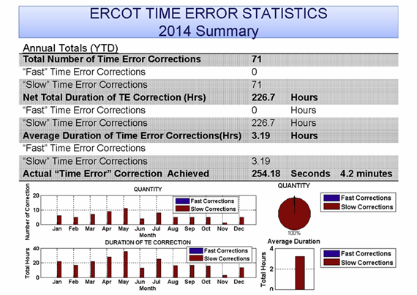

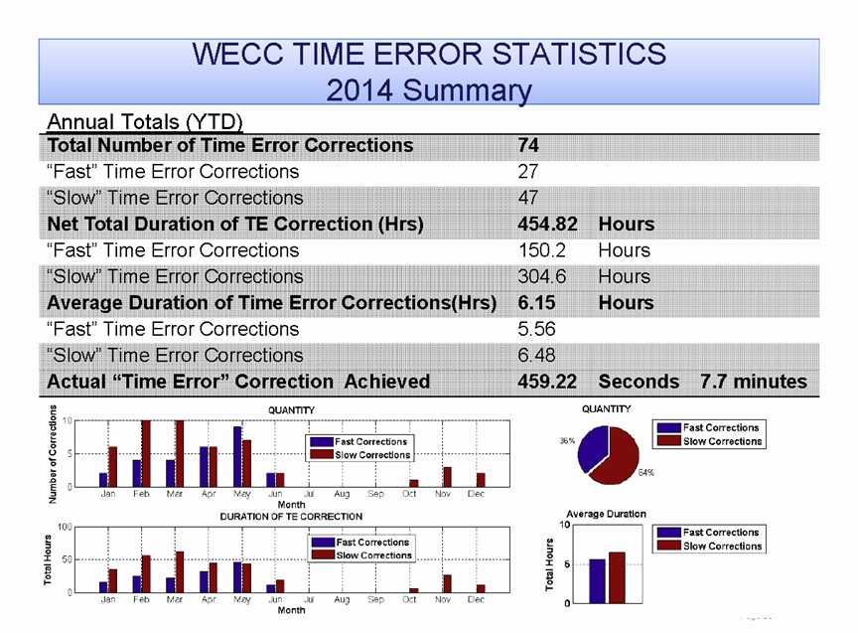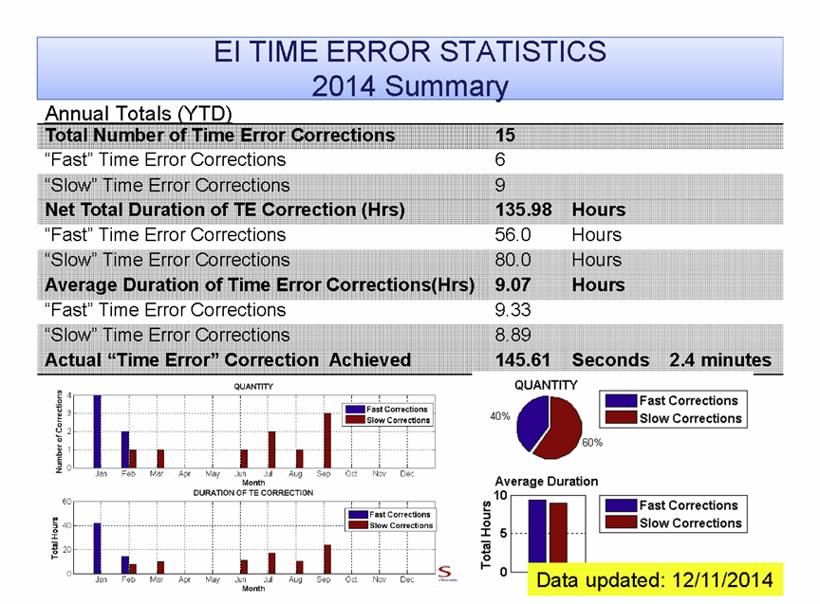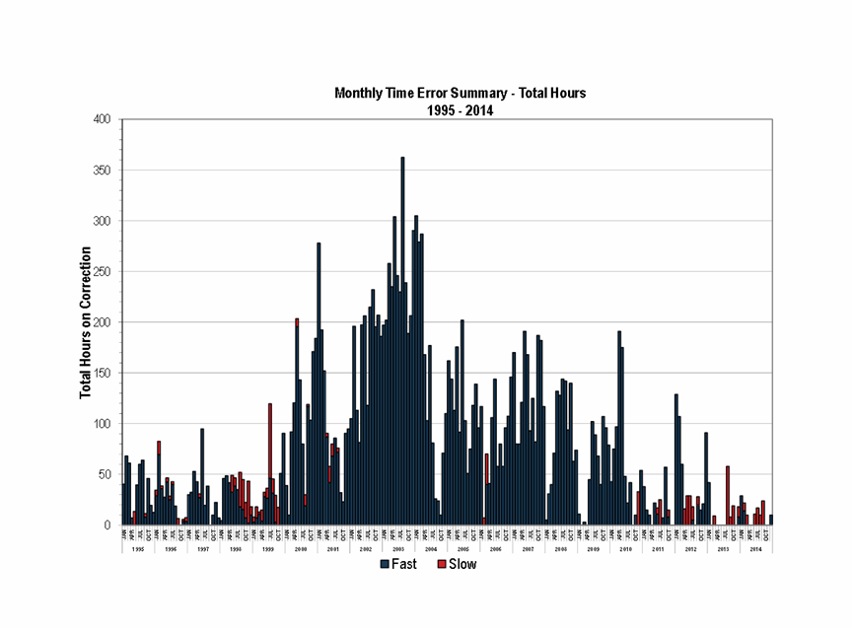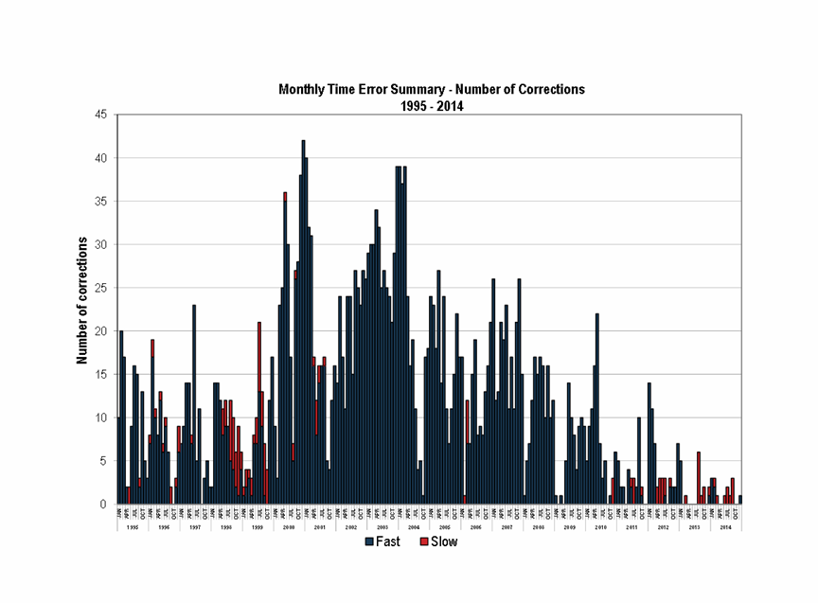

These last two graphs show the history of TEC over the last twenty years. They show that, since NERC was named the Electric Reliability Organization in 2007, TECs have significantly declined to today’s levels. Many feel that this reduction in TEC is a result of improvements in the operation of the North American interconnections resulting from improvements in the NERC Reliability Standards and improvements in best practices as described in the NERC Reliability Guidelines.

Appendix II – Alternative TEC Methods Suggested

Each time the elimination of TEC has been recommended, some in the industry have suggested that alternative methods can be used to achieve TEC without having a reliability standard. Some of the methods suggested are discussed in this appendix.

Allow Uncoordinated Frequency Offset for TEC:

The NERC definition of Reporting ACE requires, “The use of a common Scheduled Frequency (F_{S}) for all areas at all times.” The industry must investigate the effect of not following this part of the definition. When a BA uses a Scheduled Frequency different from the Scheduled Frequency in use by the remainder of the interconnection BAs, the use of this Scheduled Frequency affects the value of ACE. For example, if a BA offsets it Scheduled Frequency by +0.02 Hz when the remainder of the interconnection is using a Scheduled Frequency of 60 Hz, that BAs Reporting ACE will be reduced by an amount equal to its Frequency Bias times 0.02 Hz. This is relatively small effect, but there is an additional effect that most fail to consider.

When CPS1 and BAAL are calculated the value of Reporting ACE is multiplied by the value of the Frequency Error. The Frequency Error value also depends on the Scheduled Frequency. As a result, simply using a different Scheduled Frequency from the remainder of the interconnection will not only cause a small MW offset to Reporting ACE, but it may also cause a large change in CPS1 and BAAL measured performance. These large changes in performance measurement are the concern, causing its CPS1 and BAAL measure to change by more than just the change in the value of ACE. An example of this effect is provided as follows:

Example 1: Effect of Uncoordinated Frequency Offset
Assume that Time Error is fast indicating that a lower Scheduled Frequency will help to correct Time Error.
Assume that Actual Frequency of the interconnection is 59.990 Hz and Scheduled Frequency is 60 Hz.
Assume that a BA with a Frequency Bias Setting of 100 MW/0.1 Hz has a Tie Error of -290 MW. Using the Scheduled Frequency of 60 Hz, this BA will have the following performance measurements:

ACE = Tie Error (10B)(F_{A} – F_{S}) = -290 -10 x -100 x (59.990 – 60.000) = -300 MW
CPS1 = (2 – ((-300 /-10(-100)) x -0.010) / ε₁² x 100% = 2-(0.003 / 0.000324) x 100% = -725%
BAAL_{Low} = -10 (-100) x (FTL_{Low} – F_{S})² / (F_{A} – F_{S}) = 1000 x (3 x ε₁)² / (-0.01) = 1000 x 9 x ε₁²/ (-0.01) = -291.6

If an uncoordinated frequency offset is allowed, then this BA could offset its Scheduled Frequency -.02 Hz. Using this new scheduled frequency in the above measures will yield the following performance measurements:
ACE = Tie Error – 10(B)(F_{A} – F_{S}) = -290 -10 x -100 x (59.990 – 59.980) = -280 MW
CPS1 = (2 – ((-280 /-10(-100)) x 0.010) / ε₁² x 100% = 2-(-0.0028 / 0.000324) x 100% = 964%
BAAL_{Low} = -10 (-100) x (FTL_{Low} – F_{S})² / (F_{A} – F_{S}) = 1000 x (3 x ε₁)² / (-0.01) = 1000 x 9 x ε₁² / (-0.01) = -291.6

By making this simple change in Scheduled Frequency, the BA reduces its ACE by 20 MW, the BA improves its CPS1 performance by 1,689 %, and it improves its BAAL performance enough to avoid a BAAL non-compliance. Although on first look, it would appear that allowing uncoordinated frequency offsets to enable TEC is beneficial, allowing this practice would make all of the current performance measurements that rely on ACE unreliable.

Allow Unilateral Inadvertent Payback for TEC:

Another suggestion that has been made is that unilateral inadvertent payback be included in Reporting ACE allowing up to 5 MW or 10% of the Frequency Bias Setting in the direction to correct time error. This practice is also addressed in the Reporting ACE definition, “The algebraic sum of all area Net Interchange Schedules and all Net Interchange actual values is equal to zero at all times.” It has further been suggested that enabling a unilateral inadvertent payback of this magnitude would have little effect on the current performance measures. As with the previous analysis for uncoordinated frequency offset, the effect of including a unilateral inadvertent payback term in Reporting ACE is evaluated in the following Example 2:

Example 2: Effect of Unilateral Inadvertent Payback
Assume that Time Error is fast indicating that a lower Scheduled Frequency will help to correct Time Error.
Assume that Actual Frequency of the interconnection is 59.990 Hz and Scheduled Frequency is 60 Hz.
Assume that a BA with a Frequency Bias Setting of 100 MW/0.1 Hz has a Tie Error of -290 MW.
Using the Scheduled Frequency of 60 Hz, this BA will have the following performance measurements:

ACE = Tie Error – 10(B)(F_{A} – F_{S}) = -290 -10 x -100 x (59.990 – 60.000) = -300 MW
CPS1 = (2 – ((-300 /-10(-100)) x -0.010) / ε₁² x 100% = 2-(0.003 / 0.000324) x 100% = -725%
BAAL_{Low} = -10 (-100) x (FTL_{Low} – F_{S})² / (F_{A} – F_{S}) = 1000 x (3 x ε₁)² / (-0.01) = 1000 x 9 x ε₁² / (-0.01) = -291.6

If a unilateral inadvertent payback term is allowed, then this BA could modify its Reporting ACE by 10 MW in the above calculation of performance measures. The performance calculations would change as follows:

ACE = Tie Error – 10(B)(F_{A} – F_{S}) = -290 -10 x -100 x (59.990 – 60.000) + 10 = -290 MW
CPS1 = (2 – ((-290 /-10(-100)) x 0.010) / ε₁² x 100% = 2-(0.0029 / 0.000324) x 100% = -695%
BAAL_{Low} = -10 (-100) x (FTL_{Low} – F_{S})² / (F_{A} – F_{S}) = 1000 x (3 x ε₁)² / (-0.01) = 1000 x 9 x ε₁² / (-0.01) = -291.6
By making this simple change by adding 10 MW of unilateral inadvertent payback, the BA reduces its ACE by 10 MW, the BA improves its CPS1 performance by 30 %, and it improves its BAAL performance enough to avoid a BAAL non-compliance. Although on first look, it would appear that allowing unilateral inadvertent payback to enable TEC causes only small changes in performance, and it therefore, should be enabled to address TEC. This position has been supported by a study that implemented unilateral inadvertent payback on a continuous basis at 10% of the Frequency Bias Setting would cause a change of less than 1% in CPS1 performance.

The problem with the above analysis is that unilateral inadvertent payback would only need to be implemented a small percentage of the time. Under these conditions, it is important to consider the factors that could influence when to implement a unilateral payback schedule. One factor is the Actual Frequency at the time the unilateral inadvertent payback schedule is implemented.

Example 3: Effect of Unilateral Inadvertent Payback
Assume that Time Error is fast indicating that a lower Scheduled Frequency will help to correct Time Error.
Assume that Actual Frequency of the interconnection is 59.940 Hz and Scheduled Frequency is 60 Hz.
Assume that a BA with a Frequency Bias Setting of 100 MW/0.1 Hz has a Tie Error of 10 MW.
Using the Scheduled Frequency of 60 Hz, this BA will have the following performance measurements:

ACE = Tie Error – 10(B)(F_{A} – F_{S}) = 10 -10 x -100 x (59.940 – 60.000) = -50 MW
CPS1 = (2 – ((-50 /-10(-100)) x -0.060) / ε₁² x 100% = 2-(0.003 / 0.000324) x 100% = -726%
BAAL_{Low} = -10 (-100) x (FTL_{Low} – F_{S})² / (F_{A} – F_{S}) = 1000 x (3 x ε₁)² / (-0.01) = 1000 x 9 x ε₁²/ (-0.06) = -48.6

If a unilateral inadvertent payback term is allowed, then this BA could modify its Reporting ACE by 10 MW in the above calculation of performance measures. The performance calculations would change as follows:

ACE = Tie Error – 10(B)(F_{A} – F_{S}) = 10 -10 x -100 x (59.940 – 60.000) + 10 = -40 MW
CPS1 = (2 – ((-40 /-10(-100)) x 0.060) / ε₁² x 100% = 2-(0.0024 / 0.000324) x 100% = -541%
BAAL_{Low} = -10 (-100) x (FTL_{Low} – F_{S})² / (F_{A} – F_{S}) = 1000 x (3 x ε₁)² / (-0.01) = 1000 x 9 x ε₁² / (-0.06) = -48.6

By making this simple change of adding 10 MW of unilateral inadvertent payback, the BA reduces its ACE by 10 MW, the BA improves its CPS1 performance by 185 %, and easily meets its BAAL limit. Since the suggested change when implemented across all time has very little effect on CPS1 and BAAL, it would make sense to require unilateral inadvertent payback to be excluded from Reporting ACE to encourage that unilateral inadvertent payback to be implemented at times when it will have little to no effect on the CPS1 and BAAL performance measures. In other words, unilateral inadvertent payback should only be implemented when it will benefit the interconnection by moving Actual Frequency toward 60 Hz or when Actual Frequency is near 60 Hz and it will not contribute to reliability problems. Under these conditions, unilateral inadvertent payback will be able to be implemented almost 50% of the time.

Minutes from the March 6-7, 2012 meeting of the Operating Committee. Posted at: http://www.nerc.com/comm/OC/Agendas%20Highlights%20and%20Minutes%20DL/Agendas,%20Highlights,%20and%20Minutes%20-%202012/Operating_Committee_Meeting_Minutes_Mar_6-7_2011_R1.pdf
Minutes from the March 6-7, 2012 meeting of the Operating Committee.
Frequency Response is a measure of an Interconnection’s ability to stabilize frequency immediately following the sudden loss of generation or load. Power system operators manage or control frequency primarily through adjustments to the output of generators with the goal of restoring balance between generation and load. Failure to maintain frequency can disrupt the operation of equipment and initiate disconnection of power plant equipment to prevent them from being damaged, which could lead to wide-spread blackouts.
Minutes from the March 6-7, 2012 meeting of the Operating Committee.

