North American Energy Standards Board

Request for Initiation of a NAESB Business Practice Standard, Model Business Practice or Electronic Transaction
or
Enhancement of an Existing NAESB Business Practice Standard, Model Business Practice or Electronic Transaction

Instructions:

1. Please fill out as much of the requested information as possible. It is mandatory to provide a contact name, phone number and fax number to which questions can be directed. If you have an electronic mailing address, please make that available as well.

2. Attach any information you believe is related to the request. The more complete your request is, the less time is required to review it.

3. Once completed, send your request to:
Rae McQuade
NAESB, President
801 Travis, Suite 1675
Houston, TX 77002

Phone: 713-356-0060
Fax: 713-356-0067

by either mail, fax, or to NAESB’s email address, naesb@naesb.org.

Once received, the request will be routed to the appropriate subcommittees for review.

Please note that submitters should provide the requests to the NAESB office in sufficient time so that the NAESB Triage Subcommittee may fully consider the request prior to taking action on it. It is preferable that the request be submitted a minimum of 3 business days prior to the Triage Subcommittee meetings. Those meeting schedules are posted on the NAESB web site at http://www.naesb.org/monthly_calendar.asp.

North American Energy Standards Board

Request for Initiation of a NAESB Business Practice Standard, Model Business Practice or Electronic Transaction
or
Enhancement of an Existing NAESB Business Practice Standard, Model Business Practice or Electronic Transaction

Date of Request: 11/20/2014

1. Submitting Entity & Address:

Duke Energy Business Services
c/o Emerging Technology Office
400 South Tryon Street
Mailbox ST17E
Charlotte, NC 28285

2. Contact Person, Phone #, Fax #, Electronic Mailing Address:

Name : Stuart Laval
Title : Manager, Technology Development
Phone : 980-373-2580
Fax :
E-mail : Stuart.Laval@duke-energy.com

- Title and Description of Proposed Standard or Enhancement:

Title:
Open Field Message Bus (OpenFMB) Architecture for Interoperable Data Exchange between Distributed Power Systems Devices on the Electric Grid’s Field Area Networks.

Description:

OpenFMB is a specification for power systems field devices to leverage a non-proprietary and standards-based reference architecture platform, which consists of internet protocol (IP) networking, Internet of Things (IoT) messaging protocols, and standardized common semantic models, to enable the secure, reliable, and scalable communications and peer-to-peer information exchange between devices on the electric grid.

Since there is not a “one-size-fits-all” software or hardware technology that can adequately enable true interoperability between the new Distributed Energy Resource (DER) systems and the existing grid automation infrastructure, an OpenFMB specification is needed to assemble and document a blueprint for a nodal reference architecture (see Figure 1) that leverages modular, plug ‘n play components with clearly-defined interfaces (e.g. at the application layer) and platform-independent semantic data models, to enable the seamless translation and contextualization of information on a field message bus (see Figure 2), which is shared between field devices in an open and distributed fashion that allows for remote processing of local decisions without the need to round-trip the data to/from the back-office.
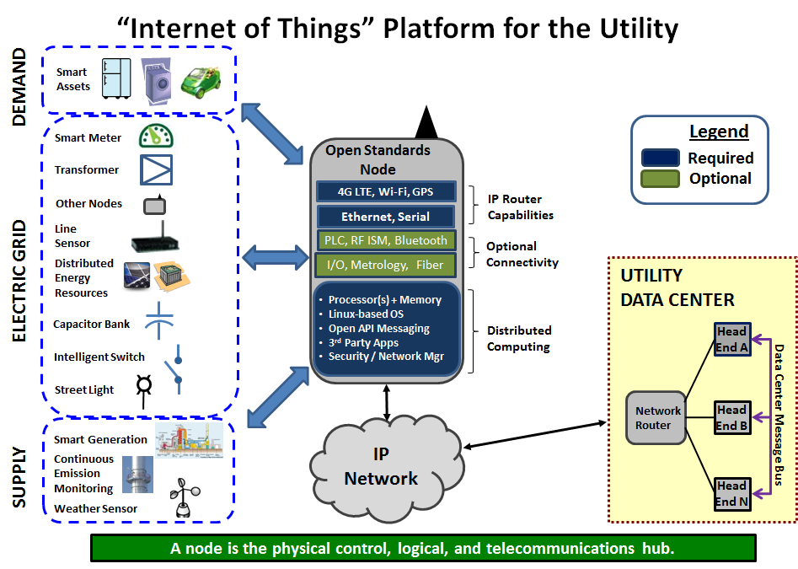
Figure 1: Open Standard, Nodal Reference Architecture Platform

Another outcome of the OpenFMB standard initiative will be to identify and deliver a set of initial business use-cases for field device intelligence and local decision-making, including ancillary implementation specifications and conformance guidelines, that demonstrate the feasibility of this flexible distributed platform that is agnostic to IoT messaging protocol and common semantic model.

The representative IoT protocols to be considered for messaging include:
- Data Distribution Service (DDS): OMG standard for Publish/Subscribe (pub/sub) protocol
- Message Queue Telemetry Transport (MQTT): OASIS standard for pub/sub protocol
- Advanced Message Queue Protocol (AMQP): OASIS standard for pub/sub protocol
- Constrained Application Protocol (CoAP): IETF RESTful client/server protocol
- Extensible Messaging and Presence Protocol (XMPP): IETF RESTful client/server protocol

The representative common semantic model standards to be considered for mapping include:
- Common Information Model (CIM) defined by IEC 61968/61970
- Substation Configuration Language (SCL) defined by as IEC 61850
- SunSpec Alliance data models

- Use of Proposed Standard or Enhancement (include how the standard will be used, documentation on the description of the proposed standard, any existing documentation of the proposed standard, and required communication protocols):

Today, many of the electric grid devices support different features and functionality within substations and along the transmission and distribution lines. In addition, these devices use different means of communication and different protocol standards, in many cases proprietary in nature, which have prevented most of these devices from being capable of communicating with other devices in the field, let alone exchange data and information for local intelligence and decision making.

The proposed OpenFMB standard will be used by device vendors and/or utilities to develop the technical requirements to be implemented on field devices that will be able to communicate with each other via a field message bus (see figure 2) without much additional effort of integration.

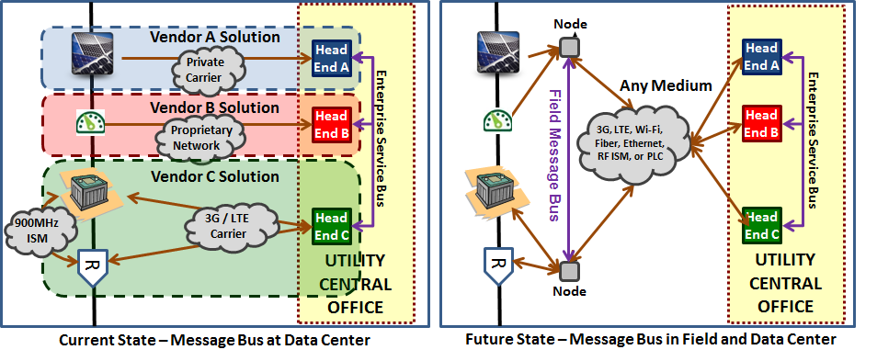
Figure 2: Peer-to-Peer Data Exchanges between Nodes Enabled by an Open Field Message Bus (OpenFMB)

With the implementation of the OpenFMB requirements that support IoT protocol interfaces and embrace common semantic models, devices from different vendors and from utilities can, in fact, interoperate directly or through gateway technologies that act as a bridge, translator, or adapter for legacy protocols. The following diagram (see Figure 3) illustrates some of the building blocks that consist of device types, utility legacy protocols (DNP3, Modbus, IEC 61850 MMS/GOOSE, C12, etc.), IoT protocols, and use-case application logic that may be involved in this reference architecture.

A critical component of the proposed OpenFMB standard is the development of the common semantic layer to serve as the basis for the “system contextualized message” to be exchanged between field devices, collectively known as the “Field Message Bus”. The platform-independent data model of the common semantic layer will expand upon the initial work that has been based upon the IEC CIM with additional references and/or mappings to other key standards such as IEC 61850 and SunSpec.

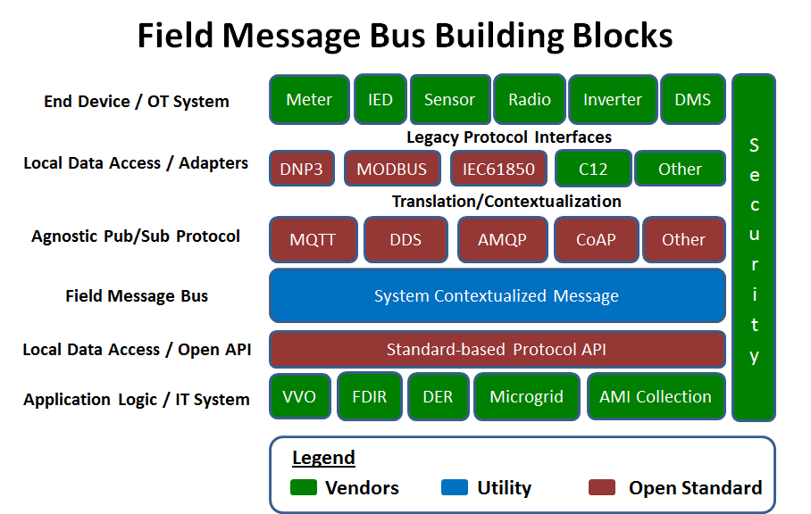

Figure 3: Example Building Blocks in the Open Field Message Bus (OpenFMB) Architecture

An initial set of use cases that have been developed (available at http://www.opengridstandards.org) used IEC CIM as the basis for common semantics and OMG DDS as the IoT protocol for data exchange.

5. Description of Any Tangible or Intangible Benefits to the Use of the Proposed Standard or Enhancement:

There are many benefits to the industry, utilities, and end customers. Among them are the following:

- Enabling devices to communicate quickly with each other in an open, secure, and scalable fashion, which will foster new and innovative utility grid control and management features and functionality that were not feasible before. The could create a more resilient, reliable, and robust grid that is integrated with the supply-side operations and demand planning.
- Enabling open competition of grid field devices and reduce proprietary technologies dependence. This will fuel innovation in the marketplace and reduce supply chain risk.
- Enabling the capability to leverage existing sensors and communications infrastructure of current smart grid investment by unlocking the data those devices are already collecting.
- Enabling better integration of grid devices and services to end-use customer, especially in the wake of the fast growth of Distributed Energy Resources and the advent of transactive energy.

6. Estimate of Incremental Specific Costs to Implement Proposed Standard or Enhancement:

Cost of implementation will vary depending on device type and level of functionality.

7. Description of Any Specific Legal or Other Considerations:

The work that has been developed and published under the “Field Message Bus” initiative led by Duke Energy, found at http://www.opengridstandards.org , will be contributed to this effort. There are dependences and/or mapping to other standards such as IEC 61968/61970/62325 (CIM) and IEC 61850, DNP3, C12, Modbus, openADR, DDS, CoAP, XMPP, MQTT, AMQP, etc.

8. If This Proposed Standard or Enhancement Is Not Tested Yet, List Trading Partners Willing to Test Standard or Enhancement (Corporations and contacts):

The list of initial trading partners that will be involved in the development, testing and implementation of the proposed standard are:

- Duke Energy / Stuart Laval
- CPS Energy / Raiford Smith
- Electric Power Research Institute (EPRI) / Matt Wakefield
- Xtensible Solutions / Joe Zhou
- National Rural Electric Cooperative Association (NRECA) / Craig Miller

9. If This Proposed Standard or Enhancement Is In Use, Who are the Trading Partners :

N/A. This is a new standard.

10. Attachments (such as : further detailed proposals, transaction data descriptions, information flows, implementation guides, business process descriptions, examples of ASC ANSI X12 mapped transactions):

TBD

