R13003
North American Energy Standards Board

Request for Initiation of a NAESB Business Practice Standard, Model Business Practice or Electronic Transaction
or
Enhancement of an Existing NAESB Business Practice Standard, Model Business Practice or Electronic Transaction

Instructions:

1. Please fill out as much of the requested information as possible. It is mandatory to provide a contact name, phone number and fax number to which questions can be directed. If you have an electronic mailing address, please make that available as well.

2. Attach any information you believe is related to the request. The more complete your request is, the less time is required to review it.

3. Once completed, send your request to:
Rae McQuade
NAESB, President
801 Travis, Suite 1675
Houston, TX 77002

Phone: 713-356-0060
Fax: 713-356-0067

by either mail, fax, or to NAESB’s email address, naesb@naesb.org.

Once received, the request will be routed to the appropriate subcommittees for review.

Please note that submitters should provide the requests to the NAESB office in sufficient time so that the NAESB Triage Subcommittee may fully consider the request prior to taking action on it. It is preferable that the request be submitted a minimum of 3 business days prior to the Triage Subcommittee meetings. Those meeting schedules are posted on the NAESB web site at http://www.naesb.org/monthly_calendar.asp.

R13003
North American Energy Standards Board

Request for Initiation of a NAESB Business Practice Standard, Model Business Practice or Electronic Transaction
or
Enhancement of an Existing NAESB Business Practice Standard, Model Business Practice or Electronic Transaction

Date of Request: 2/6/2013

1. Submitting Entity & Address:
Quorum Business Solutions
811 Main St, Suite 2000
Houston, TX 77002

2. Contact Person, Phone #, Fax #, Electronic Mailing Address:
Name : Seth Peters
Title : QPTM Product Architect
Phone : 713.430.8171
Fax :
E-mail : seth_peters@qbsol.com

- Title and Description of Proposed Standard or Enhancement:

Title:

Modify WGQ Business Practice Standards Matrix to include additional fields

Description:

Please add additional informational columns to the standards matrix that would be used to reference when viewing standards. The Version Cross Reference in the back of Business Practice Standards Book 1 of 2 provides some of these fields, but would be beneficial to have the fields in one place and in Excel format for members.
Fields from Version Cross Reference:
Adopted – used to display when the standard was first introduced.
Revised – used to display all versions when the standard was modified.

Additional Fields for reference:
Latest Revision – used to display only the most recent version when the standard was modified.

Implementation Booklet – used to document the primary standards booklet the standard appears. Example values would include Nominations, Flowing Gas, and QEDM

Type – used to distinguish classification of standards. Example values would include “Definition”, “Principle”, “Standard”, “Interpretation”, “Dataset”, and “Model”

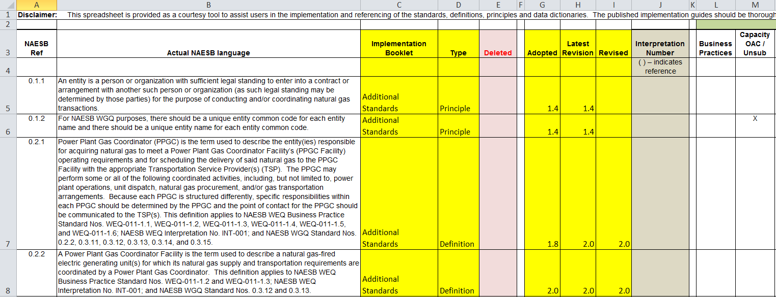
4. Use of Proposed Standard or Enhancement (include how the standard will be used, documentation on the description of the proposed standard, any existing documentation of the proposed standard, and required communication protocols):

The enhancement would provide additional information in the matrix and provide a centralized place for viewing and filtering version information for each standard. Currently version information is spread out between the Version Cross Reference section in the Additional Standards booklet, the Version Notes section of the individual booklets and actual standards in the individual booklets

5. Description of Any Tangible or Intangible Benefits to the Use of the Proposed Standard or Enhancement:

6. Estimate of Incremental Specific Costs to Implement Proposed Standard or Enhancement:

7. Description of Any Specific Legal or Other Considerations:
Disclaimer is already provided in the matrix.

8. If This Proposed Standard or Enhancement Is Not Tested Yet, List Trading Partners Willing to Test Standard or Enhancement (Corporations and contacts):
N/A

9. If This Proposed Standard or Enhancement Is In Use, Who are the Trading Partners :
N/A

10. Attachments (such as : further detailed proposals, transaction data descriptions, information flows, implementation guides, business process descriptions, examples of ASC ANSI X12 mapped transactions):

Excel Attachment:
NAESB Request - WGQ Business Practice Standards Matrix - Attachment 1.xlsx

