Instructions:

1. Please fill out as much of the requested information as possible. It is mandatory to provide a contact name, phone number, fax number, and an email address to which questions can be directed.

2. Attach any information you believe is related to the request. The more complete your request is, the less time is required to review it.

3. Once completed, please electronically submit your request to naesb@naesb.org with the subject line Request for Enhancement to a NAESB EIR.

Please note the request should be submitted to the NAESB office to allow an appropriate amount of time for implementation of the request before expiration of any associated deadlines of the requesting entity.

Date of Request: ______July 26, 2018____________

1. Submitting Entity & Address:
__Southwest Power Pool__________________________________
__201 Worthen Dr_______________________________________
__Little Rock, AR 72223 _________________________________
______________________________________________________

2. Contact Person, Phone Number, Fax Number, and Email Address:
Name : __Julie Gerush_______________________
Title : __Sr. Operations Analyst_______________
Phone : __501-688-1622______________________
Fax : ___501-482-2009 ________________
E-mail : __jgerush@spp.org __________________

- Title and Description of Proposed Enhancement:

Title:
_webRegistry (EIR)_Pseudo-Tie Registration Form________________________________________
_______________________________________________________________________
_______________________________________________________________________
_______________________________________________________________________

Description:
Pseudo-ties are required to be registered by NERC. (INT-006-4 says: Each BA shall only implement or operate a pseudo-tie that is included in the NAESB EIR in order to support congestion management procedures.)

When an entity registers a pseudo-tie, they do so by completing a Pseudo-Tie Entry Form in OATI webRegistry (EIR). The EIR routes the information to the appropriate parties for review and provides the opportunity to approve or deny the registration.

There are several fields in the Entry Form for the proposed pseudo-tie’s details, as shown in this screenshot.

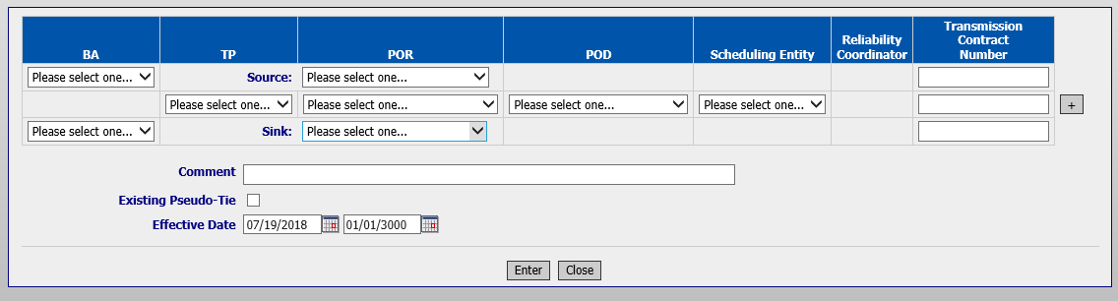

The content of most of those fields is available in the EIR Pseudo-Tie listing.
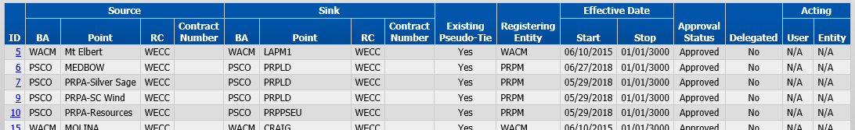

There is no place in the Entry Form to designate whether the pseudo-tie is for generation or load. This is basic information about the pseudo-tie that should be documented in the Entry Form and then appear in the EIR Pseudo-Tie listing.

This information is relevant because you must first know whether the pseudo-tie is for generation or load before you can determine the pseudo tie direction.

The path on the Pseudo-Tie Entry Form mirrors the direction of the generation.

Example:
This Pseudo-Tie Entry Form could represent pseudo-tied generation into SWPP or pseudo-tied load out of SWPP.
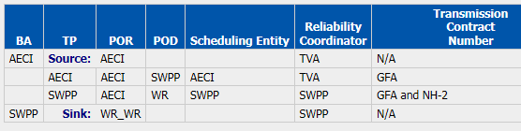

For Pseudo-Tied Gen In (PSGI) to the Sink BA shown on the form, the generation is going to the Attaining BA from the Native BA.

For Pseudo-Tied Load Out (PSLO) of the Sink BA shown on the form, the load is going from the Native BA to the Attaining BA.

Without an indicator of Load or Generation, there’s no way to identify whether or not this entry is for PSLI, PSLO, PSGI, or PSGO.

EIR users, and especially entities that receive Pseudo-Tie Entry Forms for the purpose of approving or denying the registration, should have all of the information about the pseudo-tie available to them in the EIR.

Currently, the submitter of the Entry Form could use the Comments field to designate generation or load, but that is rarely done. Furthermore, there is no way to make generation or load a required entry in that field and the field’s contents are not searchable, nor do the contents appear in the EIR Pseudo-Tie listing.

4. How Enhancement Will Be Implemented
__ SPP is requesting the following enhancements to webRegistry:
- Add a Load or Generation designation (could be a dropdown field) to the Pseudo-Tie Entry Form.
- Make the contents of that field visible on the EIR Pseudo-Tie listing. (It could take the place of the Existing Pseudo-Tie box which is being deleted.)

5. Perceived Benefits the Functionality Will Add to the Tool
___The benefits are:
- The basic information of whether the pseudo tie is for generation or load and the direction of the pseudo-tie would be clear by looking at the form or the EIR Pseudo-Tie listing.

- During the approval process, all of the approval entities would have all of the required information at the same time.

- Will expedite the approval process since “Generation” or “Load” is clearly stated, and approvers would know whether or not the submitter has filled the form out correctly. Approvers would not have to place follow-up calls for clarification.

- All of the basic information about existing pseudo-ties would be available in the EIR; BAs would not have to document the designation separately (which cannot be enforced).

- With the generation or load information available on the Pseudo-Tie listing, EIR users would be able to query pseudo-ties by generation or load (by either sorting the information on the screen or exporting the information into Excel).

6. Beneficiaries of Enhancement
___All entities who use EIR to submit pseudo-tie registrations, review pseudo-tie registrations for approval/denial, and/or view pending/approved pseudo-tie registrations.

SPP reached out to others in the industry to see if they would support this change:
PJM – Would support change
MISO – Would support change
DUKE – Would support change
CAISO – would abstain. All of their pseudo-ties are gen, so no designation is needed
BPA – has no need for the distinction
_______________________________________________________________________

7. Any Associated Deadlines and Rationale
_______________________________________________________________________
_______________________________________________________________________
_______________________________________________________________________

8. Description of Any Specific Legal or Other Considerations
_______________________________________________________________________
_______________________________________________________________________
_______________________________________________________________________
9. Identification of Testing Issues and Contacts for Volunteers for Testing
_______________________________________________________________________
_______________________________________________________________________
_______________________________________________________________________

10. Attachments Included in Request

The Pseudo-Tie Entry Form.

EIR Pseudo-Tie listing shows all approved/pending Pseudo-Ties and their status. If this proposed enhancement is implemented, the Existing Pseudo-Tie column could be replaced with a column that displays GEN or LOAD.

A completed Pseudo-Tie Entry Form
