Date of Request: July 11, 2017

1. Submitting Entity & Address:
Alan Pritchard
Duke Energy
Mail Code EC02A
PO Box 1006
Charlotte, NC 28201-1006

2. Contact Person, Phone Number, Fax Number, and Email Address:
Name : Alan Pritchard
Title : Lead Engineer
Phone : 704-382-7463
Fax :
E-mail : alan.pritchard@duke-energy.com

- Title and Description of Proposed Enhancement:

Title: Accommodate multiple reservation numbers in the Transmission Contract Number field for pseudo-tie registration

Description:
Duke Energy is an intermediate BA in a pseudo-tie between the TVA BA and the PJM BA. The pseudo-tie is for numerous years and it will use four reservations on the Duke system over those years. WebRegistry has a 32 character limit to the Transmission Contract Number field which is too short to accommodate the entry of the four reservation numbers. Since NERC requires registration of pseudo-ties in the EIR, we find ourselves in a dilemma because the registration information is incomplete.

4. How Enhancement Will Be Implemented
Duke proposes two stages to the implementation.

First, since there is a need for a pseudo-tie to be registered and implemented by July 25, 2017. To accommodate that need, Duke requests that the field length be expanded to 60 characters as soon as possible and assure that the full field length is viewable in the approval window. Also, make provisions to modify this field over time, if the functionality doesn’t exist now.

Second, Duke asks that the field be modified to accommodate continuation lines for each reservation/transmission contract, with each contract number listed on each line.

5. Perceived Benefits the Functionality Will Add to the Tool

6. Beneficiaries of Enhancement
These changes will permit full documentation of pseudo-ties that use multiple transmission reservations.

The second change, adding lines for each reservation associated with a pseudo-tie, will make it easier for the NAESB WEQ OASIS subcommittee to address 2017 API 3.a. Requirements for OASIS to use data in the Electric Industry Registry (R12001).

7. Any Associated Deadlines and Rationale
- Expand field length (first part of the requested implementation to be completed in July, hopefully prior to July 24, 2017.
- Modify to have line for each reservation (second change requested) to be completed by the end of 2017, if possible.
8. Description of Any Specific Legal or Other Considerations
_______________________________________________________________________
_______________________________________________________________________
_______________________________________________________________________
_______________________________________________________________________
_______________________________________________________________________
_______________________________________________________________________
_______________________________________________________________________
_______________________________________________________________________

9. Identification of Testing Issues and Contacts for Volunteers for Testing
_______________________________________________________________________
_______________________________________________________________________
_______________________________________________________________________
_______________________________________________________________________
_______________________________________________________________________
_______________________________________________________________________
_______________________________________________________________________
_______________________________________________________________________

10. Attachments Included in Request

Here is the view when I open up the approval window. The reservations for SMT and DUK are being truncated.

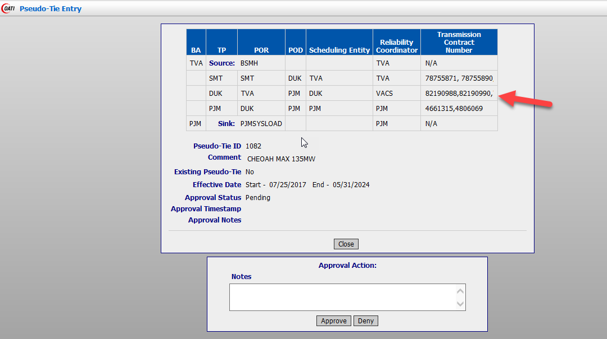

Here is the view when I open up the Pseudo-Tie Object window. The reservations for SMT and DUK are being truncated.

