Application for NAESB Certification of energy efficiency
measurement and verification services or products
Please return this form along with payment to the North American Energy Standards Board (“NAESB”) offices at the above address. Upon receipt of the documentation outlined in the NAESB Energy Efficiency Measurement and Verification Services or Products Board Certification Process and reviewed for completeness, a certification mark` will be sent to the Officer listed below for use during a one-year certification period.

Full Legal Name of Company (Company):
Officer Name (Officer):
Officer Title:
Full Address of Primary Place of Business (Street Address, Bldg/Suite, City, State/Province and Postal Code):

Phone: Fax:
E-mail: Web Site:
Payment Information:
NAESB Member Price Per Certification $ 1,000
Non-Member Price Per Certification $15,000
Total Amount Enclosed or to Be Charged: ______
Form of Payment:
□ Check Enclosed Made Payable to “NAESB”
□ Credit Card Charge (see attached payment form)
ATTACHED PAYMENT FORM MUST ACCOMPANY THIS FORM FOR CREDIT CARD PAYMENTS

NAESB Certification – Credit Card Payment Form
(Submit with Application for NAESB Certification of energy efficiency
measurement and verification products and services)
Name as it appears
on Credit Card:
Credit Card
Billing Address:
City/State/
Zip Code:
 | Phone: |  |  |  |  |  |  |  |  |  |  | Fax Number:
E-mail:
Payment Method: |  |  |  |  |  | VISA |  |  | Account Number:
 |  |  |  |  |  | MASTERCARD |  | Amount to be Charged: |  |  |  |  | Expiration Date:
 |  |  |  |  |  | AMER. EXPRESS |  | Security Code²:
 |  |  |  |  |  |  |  |  | Authorized Signature:

²Credit Card Security Code
For your security, we require your credit card's security code. This greatly improves the security of using your credit card online.
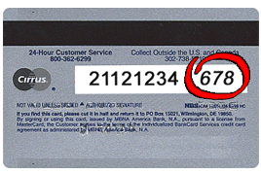
If you are using a Visa, MasterCard or Discover, please provide the 3-digit verification number found on the back of your card.
This is a non-embossed number printed on the signature panel on the back, immediately following the account number.
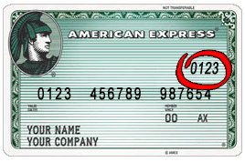
The card security code for your American Express card is a four-digit number located on the front of your credit card, to the right or left above your main credit card number.
This code is a 4-digit, non-embossed number

