1. RECOMMENDED ACTION: EFFECT OF EC VOTE TO ACCEPT RECOMMENDED ACTION:
 | Accept as requested | X | Change to Existing Practice
X | Accept as modified below |  | Status Quo
 | Decline
2. TYPE OF DEVELOPMENT/MAINTENANCE
Per Request: |  | Per Recommendation:
 | Initiation | X | Initiation
X | Modification | X | Modification
 | Interpretation |  | Interpretation
 | Withdrawal |  | Withdrawal
X | Principle | X | Principle
X | Definition | X | Definition
X | Business Practice Standard | X | Business Practice Standard
X | Document | X | Document
 | Data Element |  | Data Element
 | Code Value |  | Code Value
 | X12 Implementation Guide |  | X12 Implementation Guide
X | Business Process Documentation | X | Business Process Documentation

3. RECOMMENDATION

SUMMARY:
The standards support the measurement and verification characteristics of Demand Response products and services administered for application in the wholesale market and may be the subject of individual tariffs filed with and approved by the Federal Energy Regulatory Commission.

Recommended Standards:
DISCLAIMER: This document contains draft information on standards for wholesale electricity Demand Response products and services in markets administered by Independent System Operators and Regional Transmission Organizations (hereinafter referred to as “System Operator”). The information contained within this draft is not intended to replace applicable tariff, governing documents, operating procedures, protocols or manuals, for wholesale Demand Response, and in the event of a conflict, the latter documents shall have precedence over these standards.

Contact information: Eric Winkler, Ph.D., ISO New England, 413-540-4513, ewinkler@iso-ne.com
WEQ-015 Business Practices for Wholesale Electricity Demand Response Programs - Please see attached documentation.

4. SUPPORTING DOCUMENTATION

a. Description of Request:

Develop business practices to support demand side management and energy efficiency programs in the wholesale and retail electric markets.

b. Description of Recommendation:

For the second phase, develop business practices to provide more clarity and granularity for the measurement and verification aspects of the wholesale market demand response programs.

c. Business Purpose:

The business practices may be used by the administrators of wholesale demand response programs to add market transparency and understanding in the application of the measurement and verification characteristics of those programs.

d. Commentary/Rationale of Subcommittee(s)/Task Force(s):
- April 11, 2007: Several representatives of the NAESB WEQ, REQ, and RGQ as well as representatives of the US Department of Energy, US Environmental Protection Agency, FERC, and other industry experts met at the Department of Energy offices in Washington, D.C. to discuss the NAESB effort to draft business practices for Demand Side Management and Energy Efficiency. Ongoing Energy Efficiency and DSM projects and programs by other groups (such as NAPEE) were reviewed by the meeting attendees. The following resolution outlines the scope of the initial effort by NAESB to draft business practice standards for these topics: It was decided that NAESB should begin its standards development focus on measurement and verification of energy savings and peak demand reduction from both a wholesale and retail electric market perspective. A future schedule of meetings for DSM and Energy Efficiency should be posted on the NAESB website shortly.
- May 24, 2007: 75 NAESB members, FERC, DOE, EEI, ISO and State regulatory personnel, experts in DSM and energy markets participants (22% more than the first meeting) met in person and by conference telephone at NAESB headquarters in Houston to refine the scope of Phase 1 activities, agreeing on a specific list of tasks and assigning subgroups of volunteers to work on each task. At this meeting, no less than 28 individuals spoke to the group.
- June 18, 2007: 51 NAESB members, FERC, DOE, EEI, ISO and State regulatory personnel, experts in DSM and energy markets participants met in person and by conference telephone at BGE offices in Baltimore to further refine the scope of Phase 1 activities by reviewing the initial task list and revising it with more detailed deliverable requirements and dates, and with identification of base documents to support completing each task.
- July 26, 2007: 46 NAESB members, FERC, DOE, EEI, ISO and State regulatory personnel, experts in DSM and energy markets participants met in person and by conference telephone at AGA offices in Washington DC to present deliverables of existing demand response measurement and verification protocols and a list of 41 possible topics and subtopics for NAESB model business practices. The task force reviewed all 41 possibilities, deciding whether to draft MBPs and which ones can be grouped together.
- September 14, 2007: The results of the meeting including possible standards text were sent out for comment including notes, considerations and possible standards text. Comments were requested on each of the nine standards development areas including whether the remarks were directed to wholesale or retail markets, pre program evaluation or post implementation evaluation, or to DSM or EE projects.
- September 25, 2007: A DSM-EE meeting was held in Austin, Texas hosted by ERCOT. The purpose of the meeting was to review the comments, determine the level of progress made towards the task list and determine if adjustments to the task, focus or schedule were needed. When reviewing the comments it was determined to focus in five areas specific to demand response programs, and develop business practice standards that would prove helpful – (1) DR programs administered by ISOs and RTOS in the wholesale markets, (2) DR programs administered by utilities in wholesale markets, (3) DR programs administered by utilities in the retail markets, (4) a glossary to support the DR programs, and (5) a preamble to put the business practice standards in context. To focus on the DR programs, each of the three areas outlined will develop a matrix that describes the aspects of the DR programs in effect today, planned, or has been in effect in the past.
- November 6, 2007: Several of the NAESB leadership met with Commissioners Kerr and Ervin of NC to gain further understanding of expectations for DSM-EE NAESB activity for electricity for the retail markets.
- November 11, 2007: NAESB participated in a panel on DSM-EE at the NARUC Annual Meeting in Anaheim.
- November 30, 2007: Meeting hosted by Dominion in Richmond. During the meeting, each of the five groups described the progress made and plans to date. Drafts of the three matrices were reviewed, as was a draft glossary and outline for the preamble. It is possible that the two wholesale matrices will be combined. The calendar for 2008 was also set. The next meeting is scheduled for January 23 in Baltimore hosted by BGE.
- December 3, 2007: A meeting was held with Commissioner Mason of Ohio to gain further understanding of expectations for DSM-EE NAESB activity for natural gas for the retail markets.
- January 23, 2008: The group met in Baltimore to review progress on the two matrices, the preamble and the glossary. The wholesale matrix for DR programs administered by ISOs and RTOs was reviewed. Data is being placed in five separate categories -Initial Testing and Auditing, Ongoing Testing and Auditing, Triggering; Construction, Statistical Analysis, Performance and Baselines. The matrix for retail DR programs is lagging but several companies have provided or agreed to provide data – including BGE, Dominion, ConEd, Alabama Power and ComVerge. Procedures for how to collect the data was discussed with both interviews online and distributed surveys discussed. Both the preamble and glossary while first drafts are available are dependent on the work of the matrices and cannot be further developed until after more progress has been made on the matrices.
- March 28, 2008: The group met in Houston to review progress on the two matrices. The wholesale matrix for DR programs administered by ISOs and RTOs was reviewed. The matrix had expanded significantly to provide for more comparability for responses. 45 DR programs have been identified and the data is now being verified. A template for the type of standards to be expected from this effort was reviewed. The retail matrix now has additional data and several interviews were conducted online, with the conclusion that it is the preferred way to gather data. The retail group is to set up a face-to-face meeting in May to review the matrix and make changes before sending it out to utilities for interviews.
- May 30, 2008: The group met in Holyoke to continue review progress on the two matrices. The wholesale matrix for DR programs administered by ISOs and RTOs was reviewed. The matrix had expanded significantly to provide for more comparability for responses. With the 45 DR programs identified, the group is now consolidating the data to higher levels from the more specific items collected. With the consolidation, the business practices should be drafted. The outline for the business practices has been prepared. The retail matrix now has contributions from 11 DR programs and the matrix structure is being validated against flow charts of the programs. Once the matrix structure is validated, online interviews will be held. It was determined to concentrate on dispatchable DR programs first.
- July 30, 2008: The group met in Carmel, Indiana hosted by ACES Power to review the progress made in the two efforts. With the 45 DR programs identified, the wholesale group has consolidated the data to higher levels and draft language is being developed around four product types, energy, capacity, regulation and reserves which incorporate information from various ISO/RTOs, as well as other entities. For the retail effort, the group is relying on work from AEIC regarding process flow and applying that flow to DR programs in place. From the flows, draft standards are being prepared. Once the draft standards are prepared, efforts will being to collect through interviews information from other utilities, geographically diverse and administering programs different from those already documented. Through the interviews it is expected that we would validate both the matrix and the draft standards. The retail group is initially focusing on dispatchable DR programs. Coordination is also underway with NERC on the development of a DR survey and with the AEIC. Work will soon begin with both groups to include the glossary and the preamble text.
- October 3, 2008: The group met in Austin, Texas hosted by ERCOT to review progress made in development of M&V standards for retail and wholesale DR programs. A recommendation of business practice standards for the wholesale market was reviewed by the group. After discussion, it was the intent that the recommendation be distributed for a two week informal comment period. The comments would be discussed at the December meeting including any suggested changes. After discussion on December 2, the recommendation will either be voted out of subcommittee and would proceed to a formal comment period and Executive Committee consideration, or the recommendation would continue to be modified by the subcommittee through another round of informal comments. For retail, the subgroup has collected detailed data on some DR programs underway. After review of the wholesale effort, it was discussed that the retail subgroup would hold a two day session to determine whether to proceed at the level defined in the wholesale recommendation, or proceed to define more prescriptive standards.
- December 2, 2008: The group met in Birmingham hosted by Alabama Power to review comments and vote on the recommendation for Wholesale Electric Quadrant standards for M&V characteristics for DR products and services. After considerable discussion, and several votes to amend the recommendation the recommendation with the amendments put forward by the ISOs and RTOs and three separate amendments addressing titling, applicability, and additional specificity for the definition of Baseline, the motion to adopt the revised recommendation was approved with significant support.with 86.5 percent approval by balanced vote. All WEQ segments were present and voting. The revised recommendation will go out for a thirty day comment period and is now considered a work product of the WEQ EC. The abbreviated update report was given for the Retail market effort. The Retail group plans to use the WEQ revised recommendation as a foundation for their work.
e. Additional Background documentation
- DSM-EE NAESB page for meetings and materials: http://www.naesb.org/dsm-ee.asp
- Presentation of the wholesale recommendation given on October 3: ISO presentation - http://www.naesb.org/pdf3/dsmee100308w7.pdf
- Presentation on the NAESB process to be used – given on October 3: http://www.naesb.org/pdf3/dsmee100308w8.pdf
[At a later time a supporting document with clarifying information will be provided as a Technical Implementation Business Practice]

Business Practices for Measurement and Verification of Wholesale Electricity Demand Response
Introduction
- Measurement and Verification Standards
These Measurement and Verification (M&V) standards are intended to facilitate Demand Response in wholesale electricity markets by providing a common framework for the following:
- Transparency: accessible and understandable M&V requirements for Demand Response products;
- Accountability: criteria that will enable the System Operator to accurately measure performance of Demand Response resources; and
- Consistency: standards applicable across all wholesale electricity markets.
- Applicability of Measurement and Verification Standards:
ISO/RTO Administered Markets
These standards are applicable only to Independent System Operator-Regional Transmission Organization administered markets in North America. The standards reflect business practices applicable to measurement and verification of wholesale market Demand Response services including the following four product/service categories:

Energy Service
A type of Demand Response service in which Demand Resources delivers a quantity of electricity measured in MWhs.

Capacity Service
A type of Demand Response service in which Demand Resources are obligated to control Demand over a defined period of time measured in MW.

Reserve Service
A type of Demand Response service in which Demand Resources are obligated to be available to provide Demand reduction upon deployment by the System Operator, based on reserve capacity requirements that are established to meet applicable reliability standards.

Regulation Service
A type of Demand Response service in which a Demand Resource increases and decreases Load in response to real-time signals from the System Operator. Demand Resources providing Regulation Service are subject to dispatch continuously during a commitment period. Provision of Regulation Service does not correlate to the time periods, deadlines and transitions in the Demand Response Event definition.
These standards establish Demand Response M&V criteria. They do not establish requirements related to the compensation, design, operation, or use of Demand Response services. In these regards, System Operators are not required to offer these Services and may not currently offer each of these Services. Terms that are capitalized in these standards have the meanings ascribed to them in the Definitions of Terms section.
For purposes of these Measurement and Verification standards, Demand Response does not include Measurement and Verification of energy efficiency or permanent Load reduction.
Tariff Conflict and NERC Standards:
In the event of a conflict between these business practices and the System Operator’s Tariffs, operating procedures, protocols or manuals, the Tariff, operating procedures, protocols or manuals shall have precedence. Terms defined in the Definition of Terms do not modify or supersede market rule or tariff definitions that apply to the compensation, design, operation, or use of Demand Response services. Additionally, all entities supplying Demand Response Services shall comply with applicable NERC reliability standards.
Non-ISO/RTO Markets:
These standards do not apply in markets administered by non-ISO/RTOs. Wholesale Demand Response standards applicable to non- ISO/RTO markets will be developed when required.
- Overview of the Standards
These M&V standards establish criteria for the use of equipment, technology, and procedures to quantify the Demand Reduction Value delivered. Standards developed may include commonalities among product types. The following outline of standards is applicable to the four Demand Response product categories.
General | Advance Notification
General | Deployment Time
General | Reduction Deadline
General | Release/Recall
General | Normal Operations
General | Demand Resource Availability Measurement
General | Aggregation
General | Transparency of Requirements
Telemetry | Telemetry Requirement
Telemetry | Telemetry Accuracy
Telemetry | Telemetry Interval
Telemetry | Other Telemetry Measurements
Telemetry | Communication Protocol
Telemetry | Governor Control Equivalent
Telemetry | On-Site Generation Telemetry Requirement
After-The-Fact  Metering | After-the-Fact Metering Requirement
After-The-Fact  Metering | Meter Accuracy
After-The-Fact  Metering | Details of Meter/Equipment Standards
After-The-Fact  Metering | Meter Data Reporting Deadline
After-The-Fact  Metering | Meter Data Reporting Interval
After-The-Fact  Metering | Clock / Time Accuracy
After-The-Fact  Metering | Validating, Editing & Estimating (VEE) Method
After-The-Fact  Metering | On-Site Generation Meter Requirement
Performance  Evaluation | Rules for Performance Evaluation
Performance Evaluation Methodology
For each Demand Response service, a performance evaluation methodology is used to determine the Demand Reduction Value provided by a Demand Resource. The standards include descriptions of acceptable Baselines and alternative performance measurements that are appropriate for each of the four types of Demand Response services. The table below provides an outline of the applicable criteria for performance evaluation methodologies.
Baseline Information | Baseline Window
Baseline Information | Calculation Type
Baseline Information | Sampling Precision and Accuracy
Baseline Information | Exclusion Rules
Baseline Information | Baseline Adjustments
Baseline Information | Adjustment Window
Event Information | Use of Real-Time Telemetry
Event Information | Use of After-The-Fact Metering
Event Information | Performance Window
Event Information | Measurement Type
Special Processing | Highly-Variable Load Logic
Special Processing | On-Site Generation Requirements
These standards do not specify detailed characteristics of performance evaluation methodologies, but rather provide a framework that may be used to develop performance evaluation methodologies for specific Demand Response services. The System Operator may offer multiple performance evaluation models and may assign a Demand Resource to a model based on the characteristics of the Demand Resource’s Load or allow the Demand Resource to choose a performance evaluation model consistent with its load characteristics from a predefined list. The following methodology types are applicable to wholesale Demand Response Services:
Maximum Base Load: A performance evaluation methodology based solely on a Demand Resource’s ability to maintain its electricity usage at or below a specified level during a Demand Response Event.
Meter Before / Meter After: A performance evaluation methodology where electricity Demand over a prescribed period of time prior to Deployment is compared to similar readings during the Sustained Response Period.
Baseline Type-I: A Baseline performance evaluation methodology based on a Demand Resource’s historical interval meter data which may also include other variables such as weather and calendar data.
Baseline Type-II: A Baseline performance evaluation methodology that uses statistical sampling to estimate the electricity usage of an Aggregated Demand Resource where interval metering is not available on the entire population.
Metering Generator Output: A performance evaluation methodology in which the Demand Reduction Value is based on the output of a generator located behind the Demand Resource’s revenue meter.

Performance  Evaluation Type | Valid For Service Type
Performance  Evaluation Type | Energy | Capacity | Reserves | Regulation
Maximum Base Load | ✓ | ✓ | ✓
Meter Before / Meter After | ✓ | ✓ | ✓ | ✓
Baseline Type-I | ✓ | ✓ | ✓
Baseline Type-II | ✓ | ✓ | ✓
Metering Generator Output | ✓ | ✓ | ✓ | ✓

WEQ.0.3. Definition of Terms

WEQ.0.3.1. Adjustment Window: The period of time prior to a Demand Response Event used for calculating a Baseline adjustment.

WEQ.0.3.2. Advance Notification(s): One or more communications to Demand Resources of an impending Demand Response Event in advance of the actual event.

WEQ.0.3.3. After-the-Fact Metering: Interval meter data used to measure Demand Response. May not apply to Demand Resources under Baseline Type II (Non-Interval Meter).

WEQ.0.3.4. Aggregated Demand Resource: A group of independent Load facilities that provide Demand Response services as a single Demand Resource.

WEQ.0.3.5. Reserved

WEQ.0.3.6. Baseline: A method of estimating the electricity that would have been used by a Customer or Demand Resource in the absence of a Demand Response Event. It may be calculated using interval metering (BaselineType 1) and/or statistical sampling (Baseline type II). The figure below illustrates the concept of Baseline relative to a Demand Response Event.
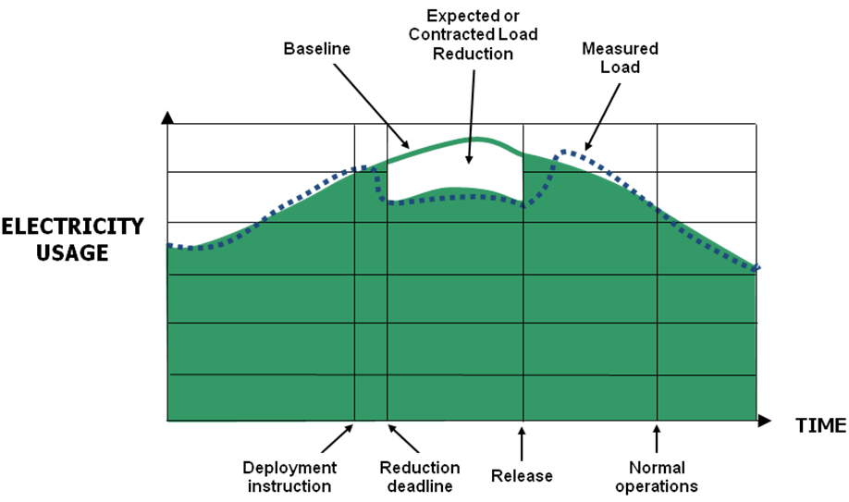
WEQ.0.3.7.

WEQ.0.3.8. Baseline Adjustment: A modification to the Baseline to reflect actual conditions immediately prior to or during a Demand Response Event to provide a better estimate of the energy the Demand Resource would have used but for the Demand Response Event. The adjustments may include but are not limited to weather conditions, near real time event facility Load, current Demand Resource operational information, or other parameters based on the System Operator’s requirements.

WEQ.0.3.9. Baseline Type-I (Interval Metered): A Baseline performance evaluation methodology based on a Demand Resource’s historical interval meter data which may also include other variables such as weather and calendar data.

WEQ.0.3.10. Baseline Type-II (Non-Interval Metered): A Baseline performance evaluation methodology that uses statistical sampling to estimate the electricity usage of an Aggregated Demand Resource where interval metering is not available on the entire population.

WEQ.0.3.11. Baseline Window: A period of time preceding and optionally following a Demand Response Event over which the electricity usage data is collected for the purpose of establishing a Baseline. The applicability of this term is limited to Meter Before/Meter After, and Baseline Type-I and Type-II.

WEQ.0.3.12. Capacity Service: A type of Demand Response service in which Demand Resources are obligated to control demand over a defined period of time measured in MW.

WEQ.0.3.13. Reserved

WEQ.0.3.14. Reserved

WEQ.0.3.15. Demand: The rate at which electric energy is delivered to or by a system or part of a system, generally expressed in kilowatts or megawatts, at a given instant or averaged over any designated interval of time; and the rate at which energy is being used by the customer (NERC Definition).

WEQ.0.3.16. Demand Reduction Value: Measurement of reduced electricity usage by a Demand Resource during a Demand Response Event.

WEQ.0.3.17. Demand Resource: A Load or aggregation of Loads capable of providing measureable and verifiable Demand Response.

WEQ.0.3.18. Demand Resource Availability: The potential Demand Reduction Value available to be dispatched for a Demand Response Event.

WEQ.0.3.19. Demand Response: A temporary change in electricity usage by a Demand Resource in response to market or reliability conditions. For purposes of these standards, Demand Response does not include energy efficiency or permanent Load reduction.

WEQ.0.3.20. Demand Response Event: A period of time defined by the System Operator, including notifications, deadlines, and transitions, during which Demand Resources provide Demand Response. All notifications, deadlines, and transitions may not be not applicable to all Demand Response products or services.

WEQ.0.3.21.

WEQ.0.3.22. Demand Response Provider: The entity that is responsible for delivering Demand Response.

WEQ.0.3.23. Deployment: The time at which a Demand Resource begins reducing Demand on the system in response to an instruction.

WEQ.0.3.24. Deployment Period: The time in a Demand Response Event beginning with the Deployment and ending with the Release/Recall.

WEQ.0.3.25. Reserved

WEQ.0.3.26. Reserved

WEQ.0.3.27. Reserved

WEQ.0.3.28. Energy Service: A type of Demand Response service in which a Demand Resource provides a quantity of electricity measured in MWhs.

WEQ.0.3.29. Reserved

WEQ.0.3.30. Reserved

WEQ.0.3.31. Governing Documents: Documents that determine the interactions between a System Operator and other parties, including but not limited to, applicable law, regulatory documents (e.g., tariffs, rules, regulations), contractual agreements, operational manuals, and other relevant models and operational procedures.

WEQ.0.3.32. Reserved

WEQ.0.3.33. Highly-Variable Load: A Load with a fluctuating or unpredictable electricity usage pattern.

WEQ.0.3.34. Load: An end-use device or customer that receives power from the electric system (NERC Definition).

WEQ.0.3.35. Maximum Base Load: A performance evaluation methodology based solely on a Demand Resource’s ability to maintain its electricity usage at or below a specified level during a Demand Response Event.

WEQ.0.3.36.

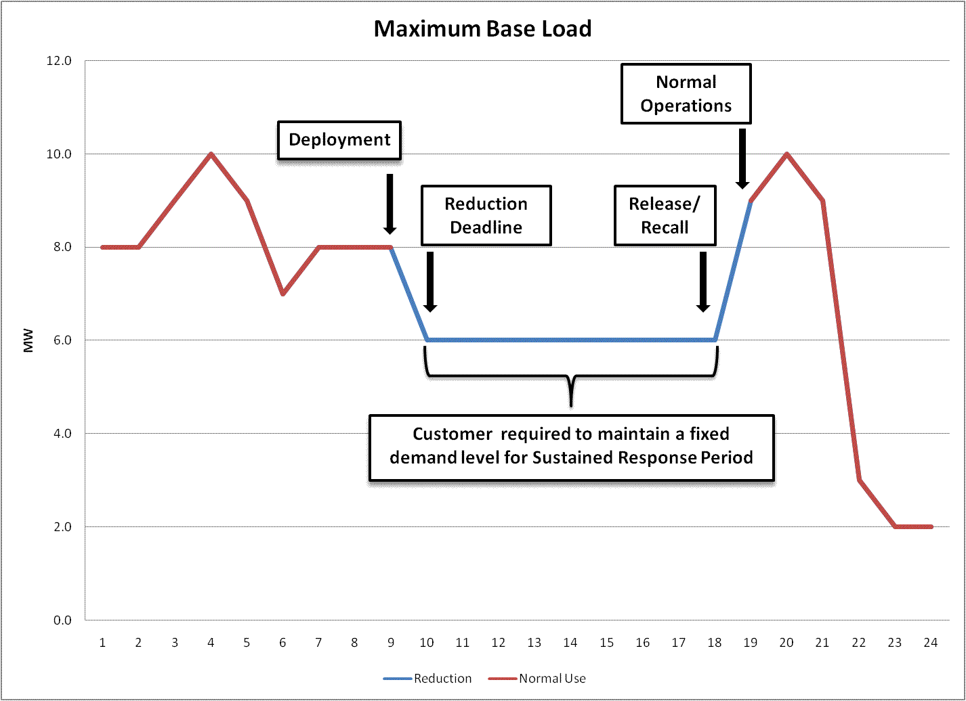

WEQ.0.3.37. Meter Before / Meter After: A performance evaluation methodology where electricity Demand over a prescribed period of time prior to Deployment is compared to similar readings during the Sustained Response Period.

WEQ.0.3.38.

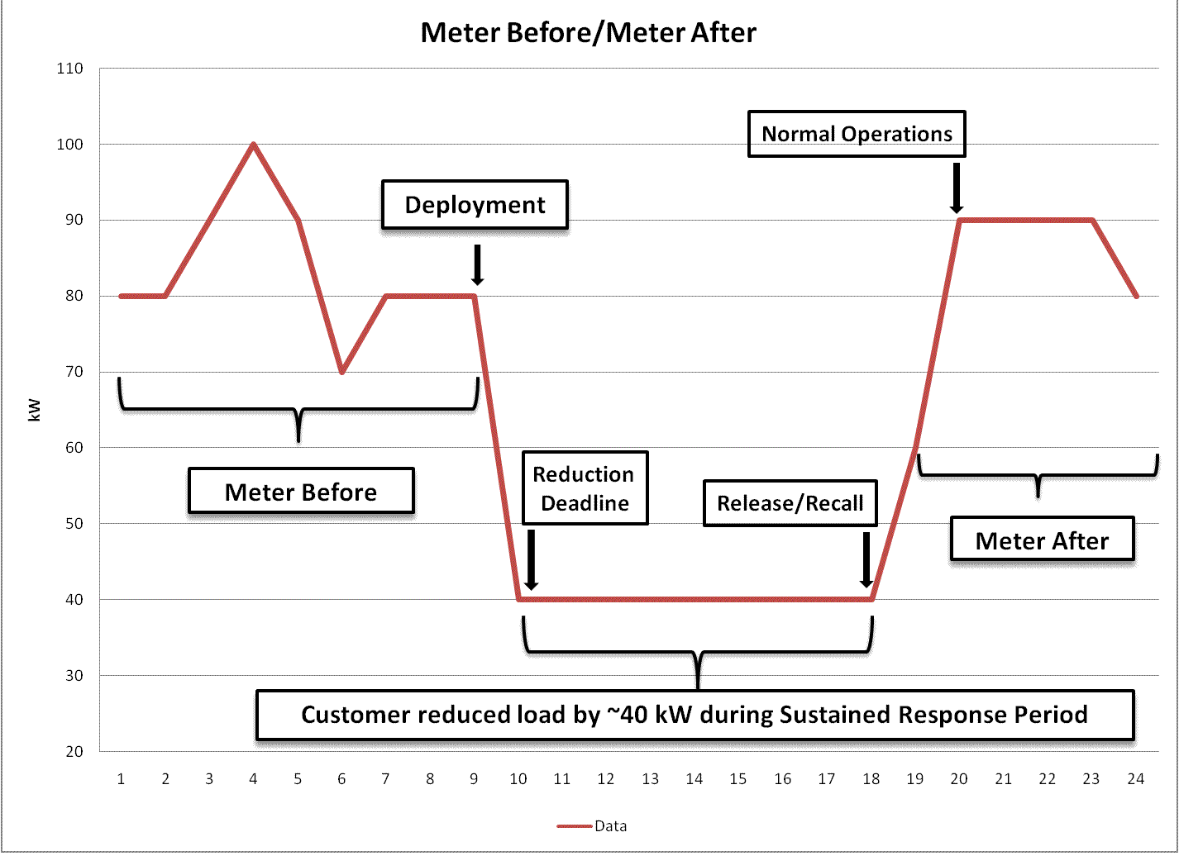

WEQ.0.3.39. Meter Data Recording Interval: The time between electricity meter usage recordings.

WEQ.0.3.40. Meter Data Reporting Deadline: The maximum allowed time from the end of a Demand Response Event (Normal Operations) to the time when meter data is required to be submitted for performance evaluation and settlement. The Meter Data Reporting Deadline may be either relative (a number of hours/days after Normal Operations) or fixed (a fixed calendar time, such as end-of-month).

WEQ.0.3.41. Metering Generator Output: A performance evaluation methodology in which the Demand Reduction Value is based on the output of a generator located behind the Demand Resource’s revenue meter.

WEQ.0.3.42. Reserved

WEQ.0.3.43. Reserved

WEQ.0.3.44. Normal Operations: The time following Release/Recall at which a System Operator may require a Demand Resource to have returned its Load usage to normal levels, and to be available again for Deployment.

WEQ.0.3.45. Reserved

WEQ.0.3.46. Performance Window: The period of time in a Demand Response Event analyzed by the System Operator to measure and verify the Demand Reduction Value for a Demand Resource.

WEQ.0.3.47. Reserved

WEQ.0.3.48. Ramp Period: The time between Deployment and Reduction Deadline, representing the period of time over which a Demand Resource is expected to achieve its change in Demand.

WEQ.0.3.49. Ramp Rate: The rate, expressed in megawatts per minute, that a generator changes its output or a Demand Resource changes its Load.

WEQ.0.3.50. Reserved

WEQ.0.3.51. Recovery Period: The time between Release/Recall and Normal Operations, representing the window over which Demand Resources are required to return to their normal Load.

WEQ.0.3.52. Reduction Deadline: The time at the end of the Ramp Period when a Demand Resource is required to have met its Demand Reduction Value obligation.

WEQ.0.3.53. Regulation Service: A type of Demand Response service in which a Demand Resource increases and decreases Load in response to real-time signals from the System Operator. Demand Resources providing Regulation Service are subject to dispatch continuously during a commitment period. Provision of Regulation Service does not correlate to the time periods, deadlines and transitions in the Demand Response Event definition.

WEQ.0.3.54. Release/Recall: The time when the System Operator specifies a Deployment Period has ended or will end.

WEQ.0.3.55. Reserve Service: A type of Demand Response service in which Demand Resources are obligated to be available to provide Demand reduction upon deployment by the System Operator, based on reserve capacity requirements that are established to meet applicable reliability standards.

WEQ.0.3.56. Reserved

WEQ.0.3.57. Sustained Response Period: The period of time between Reduction Deadline and Release/Recall over which a Demand Resource is required to deliver its obligated Demand Reduction Value.

WEQ.0.3.58. System Operator: A System Operator is a Balancing Authority, Transmission Operator, or Reliability Coordinator responsible for monitoring and controlling an electric system in real time. (Based on NERC definitions)

WEQ.0.3.59. Telemetry: Equipment for measuring a quantity and transmitting the result to a remote location for measurement, monitoring, display or recording.

WEQ.0.3.60. Telemetry Interval: The unit of time between communications of telemetered data.

WEQ.0.3.61. Reserved

WEQ.0.3.62. Validation, Editing and Estimation: The process of confirming the accuracy of raw meter data and, if necessary, replacing corrupt or missing data. VEE guidelines are published in the Edison Electric Institute’s Uniform Business Practices for Unbundled Electricity Metering.

Business Practice Requirements:
Provision of Wholesale Electric Demand Response Energy Products
Applicability
The Standard applies to any entity that administers wholesale Demand Response Energy Products.
Purpose
The purpose of this Standard is to ensure that participants in wholesale electric markets in which these Products are administered receive uniform access to information that will enable them to participate in said markets.
  - GENERAL
- Advance Notification
The governing documents shall specify any requirements for the Advance Notification instruction.
- Deployment Time
The governing documents shall specify the time at which Demand Resources must begin reducing Demand on the system.
- Reduction Deadline
The governing documents shall specify the Reduction Deadline.
- Release/Recall
The governing documents shall specify the time at which Demand Resources shall be instructed to begin restoring Load.
- Normal Operations
The governing documents shall specify Normal Operations.
- Demand Resource Availability Measurement
Not applicable to Energy Service unless otherwise specified by the Governing documents .
- Aggregation
The governing documents shall specify any requirements for aggregated Demand.
- Transparency of Requirements
Any specific requirements shall be defined in a regional market’s governing documents and shall be posted in a publicly accessible location.
  - TELEMETRY
- Telemetry Requirement
The Governing Documents shall specify any requirements for real-time Telemetry, including, but not limited to: the use of real-time Telemetry, the entity or entities responsible for installing and maintaining Telemetry equipment and collecting and communicating Telemetry data. For purposes of these standards Telemetry refers to equipment providing communication signals between a Demand Resource or Demand Response Provider and the System Operator.
- On-Site Generation Telemetry
If on-site generation is present behind the primary Telemetry point, real-time Telemetry data shall be required to measure performance of the generator unless otherwise specified by the governing documents.
- Telemetry Accuracy
The governing documents shall specify the accuracy of the real-time Demand measurement to be expressed as a percentage of full scale, not to exceed 5.0%.
- Telemetry Interval
The governing documents shall specify the Telemetry Interval at a value not to exceed 5 minutes.
- Other Telemetry Measurements
The governing documents shall specify any additional Telemetry data requirements.
- Communication Protocol
The governing documents shall specify the Telemetry communication protocol.
- Governor Control Equivalent
Not applicable to Energy Service unless otherwise specified by the governing documents.
  - AFTER-THE-FACT METERING
- After-the-Fact Metering Requirement
After-the-Fact Metering is required unless otherwise specified by the governing documents.
- Meter Accuracy
The governing documents shall specify the accuracy of the After-the-Fact Metering not to exceed 2% of full scale, except where state jurisdictional requirements apply.

- Details of Meter/Equipment Standards
Meter/Equipment standards shall meet or exceed industry standards equivalent to ANSI C12 unless otherwise specified by the governing documents.
- Meter Data Reporting Deadline
The governing documents shall specify the Meter Data Reporting Deadline.
- Meter Data Reporting Interval
The governing documents shall specify the Meter Data Reporting Interval at a value not to exceed 1 hour.
- Clock / Time Accuracy
The governing documents shall specify the clock and time accuracy. Clock and time meter/equipment standards shall meet or exceed industry standards equivalent to ANSI C12 unless otherwise specified by the governing documents.
- Validating, Editing & Estimating (VEE) Method
The governing documents shall specify VEE requirements.
- On-Site Generation Meter Requirement
The governing documents shall specify additional metering requirements if on-site generation is present behind the primary metering point.
  - PERFORMANCE EVALUATION
- Rules for Performance Evaluation
Performance shall be evaluated through the use of one of the following methods unless otherwise specified by the governing documents:
- Maximum Base Load
- Meter Before / Meter After
- Baseline Type-I
- Baseline Type-II
- Metering Generator Output

Business Practice Requirements:
Provision of Wholesale Electric Demand Response Capacity Products
Applicability
The Standard applies to any entity that administers the wholesale Demand Response Capacity Products.

Purpose
The purpose of this Standard is to ensure that participants in wholesale electric markets in which these Products are administered receive uniform access to information that will enable them to participate in said markets.
  - GENERAL
- Advance Notification
The governing documents shall specify any requirements for the Advance Notification instruction. Advance Notification has a minimum of no advance notice and a maximum of a day-ahead advance notice.
- Deployment Time
The governing documents shall specify the time at which Demand Resources must begin reducing Demand on the system.
- Reduction Deadline
The governing documents shall specify the Reduction Deadline. The minimum Reduction Deadline is instandtaneous and the maximum Reduction Deadline is two hours.
- Release/Recall
The governing documents shall specify the time at which Demand Resources shall be instructed to begin restoring Load.
- Normal Operations
The governing documents shall specify Normal Operations.
- Demand Resource Availability Measurement
The governing documents shall specify any requirements for measuring the capability of a Demand Resource to meet its obligation.
- Aggregation
The governing documents allow for Aggregation of Demand Resources to meet the minimum eligibility resource size. The governing documents shall specify any requirements for aggregated Demand Resources for the purposes of Measurement and Verification.
- Transparency of Requirements
Any specific requirements shall be defined in a regional market’s governing documents and shall be posted in a publicly accessible location.
  - TELEMETRY
- Telemetry Requirement
The governing documents shall specify any requirements for real-time Telemetry, including, but not limited to: the use of real-time Telemetry, the entity or entities responsible for installing and maintaining Telemetry equipment and collecting and communicating Telemetry data.
- On-Site Generation Telemetry
If on-site generation is present behind the primary Telemetry point, real-time Telemetry data shall be required to measure performance of the generator unless otherwise specified by the governing documents.
- Telemetry Accuracy
The governing documents shall specify the accuracy of the real-time Demand measurement to be expressed as a percentage of full scale, not to exceed 3.0%.
- Telemetry Interval
The governing documents shall specify the Telemetry Interval at a value not to exceed 5 minutes.
- Other Telemetry Measurements
The governing documents shall specify any additional Telemetry data requirements.
- Communication Protocol
The governing documents shall specify the Telemetry communication protocol.
- Governor Control Equivalent
Not applicable to Capacity Service unless otherwise specified by the governing documents.
  - AFTER-THE-FACT METERING
- After-the-Fact Metering Requirement
After-the-fact Metering is required unless otherwise specified by the governing documents.
- Meter Accuracy
The governing documents shall specify the accuracy of the After-the-Fact Metering to be expressed as a percentage of full scale, not to exceed 3%.
- Details of Meter/Equipment Standards
Meter/Equipment standards shall meet or exceed industry standards equivalent to ANSI C12 unless otherwise specified by the governing documents.
- Meter Data Reporting Deadline
The governing documents shall specify the Meter Data Reporting Deadline. The Meter Data Reporting Deadline rules has a minimum of daily reporting and a maximum reporting deadline of 103 days after a Demand Response Event.
- Meter Data Reporting Interval
The governing documents shall specify the Meter Data Reporting Interval. The Meter Data Reporting Interval has a minimum interval reporting of 5 minutes and a maximum of 1 hour.

- Clock / Time Accuracy
The governing documents shall specify the clock and time accuracy. Clock and time meter/equipment standards shall meet or exceed industry standards equivalent to ANSI C12 unless otherwise specified by the governing documents.
- Validating, Editing & Estimating (VEE) Method
The governing documents shall specify VEE requirements, if applicable.
- On-Site Generation Meter Requirement
The governing documents shall specify additional metering requirements if on-site generation is present behind the primary metering point.
  - PERFORMANCE EVALUATION
- Rules for Performance Evaluation
Performance shall be evaluated through the use of one of the following methods unless otherwise specified by the governing documents:
- Maximum Base Load
- Meter Before / Meter After
- Baseline Type-I
- Baseline Type-II
- Metering Generator Output

Business Practice Requirements:
Provision of Wholesale Electric Demand Response Reserve Products
Applicability
The Standard applies to any entity that administers the wholesale Demand Response Reserve Products.
Purpose
The purpose of this Standard is to ensure that participants in wholesale electric markets in which these Products are administered receive uniform access to information that will enable them to participate in said markets.

  - GENERAL
- Advance Notification
The governing documents shall specify any requirements for the Advance Notification instruction.
- Deployment Time
The governing documents shall specify the time at which Demand Resources must begin reducing Demand on the system.
- Reduction Deadline
The governing documents shall specify the Reduction Deadline.
- Release/Recall
The governing documents shall specify the time at which Demand Resources shall be instructed to begin restoring Load.
- Normal Operations
The governing documents shall specify Normal Operations.
- Demand Resource Availability Measurement
The governing documents shall specify any requirements for measuring the capability of a Demand Resource to meet its obligation.
- Aggregation
The governing documents shall specify any requirements for Aggregated Demand Resources.
- Transparency of Requirements
Any specific requirements shall be defined in a regional market’s governing documents and shall be posted in a publicly accessible location.
  - TELEMETRY
- Telemetry Requirement
The governing documents shall specify any requirements for real-time Telemetry, including, but not limited to: the use of real-time Telemetry, the entity or entities responsible for installing and maintaining Telemetry equipment and collecting and communicating Telemetry data.
- .On-Site Generation Telemetry
If on-site generation is present behind the primary telemetry point, real-time Telemetry data shall be required to measure performance of the generator unless otherwise specified by the governing documents.

- Telemetry Accuracy
The governing documents shall specify the accuracy of the real-time Demand measurement to be expressed as a percentage of full scale, not to exceed 5.0%.
- Telemetry Interval
The governing documents shall specify the Telemetry Interval at a value not to exceed 5 minutes.
- Other Telemetry Measurements
The governing documents shall specify any additional Telemetry data requirements.
- Communication Protocol
The governing documents shall specify the Telemetry communication protocol.
- Governor Control Equivalent
Not applicable to Reserve Service unless otherwise specified by the governing documents.
  - AFTER-THE-FACT METERING
- After-the-Fact Metering Requirement
After-the-fact Metering is required unless otherwise specified by the governing documents.
- Meter Accuracy
The governing documents shall specify the accuracy of the After-the-Fact Metering not to exceed 2% of full scale, except where state jurisdictional requirements apply.
- Details of Meter/Equipment Standards
Meter/Equipment standards shall meet or exceed industry standards equivalent to ANSI C12 unless otherwise specified by the governing documents.
- Meter Data Reporting Deadline
The governing documents shall specify the Meter Data Reporting Deadline.
- Meter Data Reporting Interval
The governing documents shall specify the Meter Data Reporting Interval at a value not to exceed 1 hour.
- Clock / Time Accuracy
The governing documents shall specify the clock and time accuracy. Clock and time meter/equipment standards shall meet or exceed industry standards equivalent to ANSI C12 unless otherwise specified by the governing documents.
- Validating, Editing & Estimating (VEE) Method
The governing documents shall specify VEE requirements.

- On-Site Generation Meter Requirement
The governing documents shall specify additional metering requirements if on-site generation is present behind the primary metering point.
  - PERFORMANCE EVALUATION
- Rules for Performance Evaluation
Performance shall be evaluated through the use of one of the following methods unless otherwise specified by the governing documents:
- Maximum Base Load
- Meter Before / Meter After
- Baseline Type-I
- Baseline Type-II
- Metering Generator Output

Business Practice Requirements:
Provision of Wholesale Electric Demand Response Regulation Products
Applicability
The Standard applies to any entity that administers the wholesale Demand Response Regulation Products.
Purpose
The purpose of this Standard is to ensure that participants in wholesale electric markets in which these Products are administered receive uniform access to information that will enable them to participate in said markets.
  - GENERAL
- Advance Notification
Not applicable to Regulation Service unless otherwise specified by the governing documents.
- Deployment Time
Not applicable to Regulation Service unless otherwise specified by the governing documents.
- Reduction Deadline
Not applicable to Regulation Service unless otherwise specified by the governing documents.
- Release/Recall
Not applicable to Regulation Service unless otherwise specified by the governing documents.

- Normal Operations
Not applicable to Regulation Service unless otherwise specified by the governing documents.
- Demand Resource Availability Measurement
Not applicable to Regulation Service unless otherwise specified by the governing documents.
- Aggregation
The governing documents shall specify any requirements for aggregated Demand Resources.
- Transparency of Requirements
Any specific requirements shall be defined in the regional market’s governing documents and shall be posted in a publicly accessible location.
  - TELEMETRY
- Telemetry Requirement
The governing documents shall specify any requirements for real-time Telemetry, including, but not limited to: the use of real-time Telemetry, the entity or entities responsible for installing and maintaining Telemetry equipment and collecting and communicating Telemetry data.
- On-Site Generation Telemetry
If on-site generation is present behind the primary Telemetry point, real-time Telemetry data shall be required to measure performance of the generator unless otherwise specified by the governing documents.
- Telemetry Accuracy
The governing documents shall specify the accuracy of the real-time Demand measurement to be expressed as a percentage of full scale, not to exceed 5.0%.
- Telemetry Interval
In accordance with NERC Reliability Standards, the governing documents shall specify the Telemetry Interval at a value not to exceed 5 minutes.
- Other Telemetry Measurements
The governing documents shall specify any additional Telemetry data requirements.
- Communication Protocol
The governing documents shall specify the Telemetry communication protocol.
- Governor Control Equivalent
Demand Resources providing Regulation Service shall respond to grid frequency deviations, either by dispatch instruction or automated response, similar to governor action provided by generation resources, unless otherwise specified by the governing documents.
  - AFTER-THE-FACT METERING
- After-the-Fact Metering Requirement
After-the-fact Metering is not required unless otherwise specified by the governing documents.
- Meter Accuracy
The governing documents shall specify the accuracy of the After-the-Fact Metering to be expressed as a percentage of full scale, not to exceed 2.0%.
- Details of Meter/Equipment Standards
Meter/Equipment standards shall meet or exceed industry standards equivalent to ANSI C12 unless otherwise specified by the governing documents.
- Meter Data Reporting Deadline
The governing documents shall specify the Meter Data Reporting Deadline.
- Meter Data Reporting Interval
The governing documents shall specify the Meter Data Reporting Interval at a value not to exceed 1 hour.
- Clock / Time Accuracy
In accordance with NERC Reliability Standards, the governing documents shall specify the clock and time accuracy. Clock and time meter/equipment standards shall meet or exceed industry standards equivalent to ANSI C12 unless otherwise specified by the governing documents.
- Validating, Editing & Estimating (VEE) Method
The governing documents shall specify VEE requirements, if applicable.
- On-Site Generation Meter Requirement
The governing documents shall specify additional metering requirements if on-site generation is present behind the primary metering point.
  - PERFORMANCE EVALUATION
- Rules for Performance Evaluation
Performance shall be evaluated using telemetry data and additionally through the use of one of the following methods unless otherwise specified by the governing documents:
- Meter Before / Meter After
- Metering Generator Output

Business Practice Requirements
Maximum Base Load Evaluation
  - BASELINE INFORMATION
There are no Baseline calculations defined for Maximum Base Load evaluations. The Maximum Base Load Evaluation methodology shall be associated with a demand reduction obligation compared to the Demand Resource’s average Load or as specified by the governing documents.
  - EVENT INFORMATION
    - Use of Real-Time Telemetry
The governing documents shall specify if real-time Telemetry data is to be used to measure performance.
    - Use of After-The-Fact Metering
After-the-fact metering shall be used to measure performance, unless otherwise specified by the governing documents.
    - Performance Window
The Performance Window shall be the Sustained Response Period (Reduction Deadline through Release/Recall) unless otherwise specified by the governing documents.
    - Measurement Type
During the Performance Window, the Demand Resource must maintain its electricity consumption at or below the Maximum Base Load. The criteria used to evaluate performance shall be one of the following unless otherwise specified by the governing documents:
    - Peak Demand
    - Average Demand - over a period of from 5 minutes to the entire Performance Window
  - SPECIAL PROCESSING
The governing documents shall specify any special processing rules.

Business Practice Requirements
Meter Before / Meter After
  - BASELINE INFORMATION
    - Baseline Window
The governing documents shall specify the time interval associated with the meter read, prior to deployment, used to establish the Baseline Window.

    - Calculation Type
During the Baseline Window, the energy consumption or Demand of the Demand Resource shall be evaluated using one of the following measurements unless otherwise specified by the governing documents:
- Instantaneous
- Maximum
- Average
    - Sampling Precision and Accuracy
Sampling is not permitted for this performance evaluation type, unless otherwise specified by the governing documents.
    - Exclusion Rules
The governing documents shall specify any exclusion rules.
    - Baseline Adjustments
Baseline Adjustments are not permitted for this performance evaluation type, unless specified by the governing documents.
    - Adjustment Window
No Adjustment Window is used for this model unless otherwise specified by the governing documents.
  - EVENT INFORMATION
    - Use of real-time Telemetry
The governing documents specify that real-time Telemetry data may or may not be utilized to measure performance.
    - Use of After-The-Fact Metering
After-the-fact metering shall be used to measure performance, unless otherwise specified by the governing documents.
    - Performance Window
The Performance Window shall be the Sustained Response Period (Reduction Deadline through Release/Recall) unless otherwise specified by the governing documents.
    - Measurement Type
During the Performance Window, the Demand Resource shall be evaluated using one of the following measurements unless otherwise specified by the governing documents:
- Instantaneous
- Maximum
- Average

  - SPECIAL PROCESSING
    - Highly-Variable Load Logic
The governing documents shall specify any performance evaluation requirements for Highly-Variable Loads.
    - On-Site Generation Requirements
The governing documents shall specify any performance evaluation requirements for on-site generation.

Business Practice Requirements
Baseline Type-I (Interval Meter)
  - BASELINE INFORMATION
    - Baseline Window
The governing documents shall specify the Baseline Window.
    - Calculation Type
The governing documents shall specify the method of developing the Baseline value using, but not limited to, the following calculation types:
- Maximum
- Average
- Regression
    - Sampling Precision and Accuracy
Sampling is not permitted for this Performance Evaluation type, unless otherwise specified by the governing documents.
    - Exclusion Rules
The governing documents shall specify any rules for excluding data from the Baseline Window. Exclusion rules may be based on, but are not limited to the following:
- Historical Demand Response Events
- Testing/Audit Periods
- Calendar data
- Outages
- Weather emergencies or force majeure events
- Usage threshold
- Known, discrete load additions or reductions that have occurred during the Baseline Window

    - Baseline Adjustments
The governing documents shall specify any rules for Baseline Adjustments. Adjustment rules may be based on, but are not limited to the following:
- Temperature
- Humidity
- Calendar data
- Sunrise/Sunset time
- Event day operating conditions
    - Adjustment Window
The minimum Adjustment Window is the last SCADA reading and the maximum Adjustment Window is three hours after deployment. Other Adjustment Windows shall be specified by the governing documents.
  - EVENT INFORMATION
    - Use of Real-Time Telemetry
The governing documents specify that real-time Telemetry data may or may not be required to measure performance.
    - Use of After-The-Fact Metering
The use of After-the-fact metering is allowed but may be optional to measure performance, unless otherwise specified by the governing documents.
    - Performance Window
The governing documents shall specify the Performance Window.
    - Measurement Type
During the Performance Window, the Demand Resource shall be evaluated using one of the following measurements unless otherwise specified by the governing documents:
- Maximum
- Average
- Regression
  - SPECIAL PROCESSING
    - Highly-Variable Load Logic
The governing documents may specify performance evaluation requirements for Highly-Variable Loads.
    - On-Site Generation Requirements
The governing documents may specify performance evaluation requirements for on-site generation.

Business Practice Requirements
Baseline Type-II (Non-Interval Meter)
  - BASELINE INFORMATION
    - Baseline Window
The governing documents shall specify the Baseline Window.
    - Calculation Type
The governing documents shall specify the method of developing the Baseline value using, but not limited to, the following calculation types:
- Maximum
- Average
- Regression
    - Sampling Precision and Accuracy
The governing documents shall specify sampling precision and accuracy requirements.
    - Exclusion Rules
The governing documents shall specify any rules for excluding data from the Baseline Window. Exclusion rules may be based on, but are not limited to the following:
- Historical Demand Response Events
- Testing/Audit Periods
- Calendar data
- Outages
- Weather emergencies or force majeure events
- Usage threshold
- Known, discrete load additions or reductions that have occurred during the Baseline Window
    - Baseline Adjustments
The governing documents shall specify any rules for Baseline Adjustments. Adjustment rules may be based on, but are not limited to the following:
- Temperature
- Humidity
- Calendar data
- Sunrise/Sunset time
- Event day operating conditions
    - Adjustment Window
The governing documents shall specify the Adjustment Window.

  - EVENT INFORMATION
    - Use of Real-Time Telemetry
The governing documents shall specify if real-time Telemetry data is to be used to measure performance.
    - Use of After-The-Fact Metering
After-the-fact metering or other energy measurement technology shall be used to measure performance, as a supplement to real-time Telemetry (if real-time Telemetry is specified) unless otherwise specified by the governing documents.

    - Performance Window
The governing documents shall specify the Performance Window.
    - Measurement Type
During the Performance Window, the Demand Resource shall be evaluated using one of the following measurements unless otherwise specified by the governing documents:
- Maximum
- Average
- Regression
- Statistical equivalent of 5 Minute or hourly metering
  - SPECIAL PROCESSING
The governing documents shall specify any special processing rules.

Business Practice Requirements
Metering Generator Output
  - BASELINE INFORMATION
The governing documents shall specify Baseline calculations for Metering Generator Output.
  - EVENT INFORMATION
    - Use of Real-Time Telemetry
The governing documents shall specify if real-time Telemetry data is to be used to measure performance.
    - Use of After-The-Fact Metering
After-the-fact metering on the generator and optionally on the associated Load shall be used to measure performance unless otherwise specified by the governing documents.

    - Performance Window
The governing documents shall specify the Performance Window.
    - Measurement Type
During the Performance Window, the Demand Resource shall be evaluated using the total measured generation output unless otherwise specified by the governing documents.
  - SPECIAL PROCESSING
The governing documents shall specify any special processing rules.
Revision History
Business Practice Sub-Working Group

Date | Revision Decription | Categories Changed | Approved
3/12/2010 | Removed “System Operator” and replaced it with “Market Rules pertaining to demand response” to more accurately reflect that rules are developed by markets not the System Operator. | 015-1.0 through 015-1.10
06/11/2010 | Modified language to provide additional enhancement. | 015-1.12 through 015-1.14
06/18/2010 | Changed the Telemetry Accuracy and Meter Accuracy per the IRC Matrix update. | 015-1.1 through 015-1.2 and 015-1.9 through 015-1.10
06/23/2010 | Modified language to include parameters in IRC Matrix. | 015-1.4 through 015-1.6.
7/23/2010 | Added definition for “Governing documents” and modified text accordingly throughout business practice standards. | Definition section addition and modified all applicable locations in document.
7/30/2010 | In Regulation, under Telemetry Accuracy, changes to 5% from 3%. | 015-1.13 Telemetry
8/13/2010 | Removed “Market Rules” and replaced it with “governing documents.” | Throughout document.
9/16/2010 | Replaced glossary with glossary approved in May 2010. | Glossary

Revision History
Performance Evaluation Sub-Working Group

Date | Revision Decription | Categories Changed | Approved
3/12/2010 | Removed “System Operator” and replaced it with “governing documents pertaining to demand response” to more accurately reflect that rules are developed by markets not the System Operator. | 015-1.11 through 015-1.30
7/17/2010 | Added clarifications in Use of ATF Metering and inserted additional Measurement Type. | 015-1.26
7/23/2010 | Modified language to provide additional enhancement | 015-1.19, 015-1.20, 015-1.22 and 015-1.23
7/30/2010 | In Max Base Load, under Measurement Type, added clarification phrase to “b) Average Demand” | 015-1.17 Event Information
8/13/2010 | Removed “Market Rules” and replaced it with “governing documents.” | Throughout document.

The terms Product(s) or Service(s) may be used interchangeably in these standards.

