1. RECOMMENDED ACTION: EFFECT OF EC VOTE TO ACCEPT RECOMMENDED ACTION:
X | Accept as requested | X | Change to Existing Practice
 | Accept as modified below |  | Status Quo
 | Decline
2. TYPE OF DEVELOPMENT/MAINTENANCE
Per Request: |  | Per Recommendation:
 | Initiation |  | Initiation
X | Modification | X | Modification
 | Interpretation |  | Interpretation
 | Withdrawal |  | Withdrawal
X | Principle | X | Principle
 | Definition |  | Definition
X | Business Practice Standard | X | Business Practice Standard
 | Document |  | Document
 | Data Element |  | Data Element
 | Code Value |  | Code Value
 | X12 Implementation Guide |  | X12 Implementation Guide
 | Business Process Documentation |  | Business Process Documentation
3. RECOMMENDATION
SUMMARY:
The DSM-EE Subcommittee submits this Recommendation for 2010 Retail Annual Plan Item No. 3.c to support phase 2, retail development of Model Business Practices for Measurement & Verification (M&V) for Demand Response programs.
Recommended Standards:
MEASUREMENT & VERIFICATION (M&V) OF DEMAND RESPONSE PROGRAMS
Table of Contents
Executive Summary
Introduction
Business Processes and Practices
REQ.13 Overview
REQ.13.1 Principles
REQ.13.2 Definitions
REQ.13.2.A Business Definitions
REQ.13.3 Model Business Practices
REQ.13.3.1 General Characteristices of a Demand Response Event
REQ.13.3.2 Measurement of Load
REQ.13.3.3 Statistical Sampling
REQ.13.3.4 Performance Evaluation Methods
REQ.13.3.4.1 Maximum Base Load Evaluation
REQ.13.3.4.2 Meter Before / Meter After Evaluation
REQ.13.3.4.3 Baseline Evaluation
REQ.13.3.4.4 Metering Generator Output Evaluation
Executive Summary
This section provides a common framework of the Model Business Practices for Measurement and Verification (M&V) of Demand Response programs in retail electric markets. The purpose of these Model Business Practices is to provide:
- Transparency: accessible and understandable M&V protocols for Demand Response programs
- Accountability: criteria that will enable the Program Administrator to accurately estimate load impacts of Demand Response Resources; and
- Consistency: a process or protocol that will allow Program Administrators, Applicable Regulatory Authorities, or program participants to agree on the required steps to take to verify demand reductions resulting from Demand Response programs in retail energy markets.
- Comprehensive: strives to cover all forms of Demand Response
The purpose of this Standard is to ensure that regulatory commissions and participants in retail electric markets in which dispatchable Demand Response products are administered have access to uniform Measurement and Verification protocols that will enable them to develop consistent values for the load impact estimates of the programs.
These Model Business Practices were designed in concert with Wholesale Electric Quadrant Standards covering Demand Response programs operating in wholesale electric markets. In the event of a conflict between these business practices and business practices developed by the Wholesale Electric Quadrant for products that are bid into wholesale markets, the Wholesale Electric Quadrant Standard should have precedence. Additionally, all Entities supplying Demand Response Services should comply with applicable North American Electric Reliability Corporation(NERC) reliability standards.
Introduction
The North American Energy Standards Board (NAESB) is a voluntary non-profit organization comprised of members from all aspects of the natural gas and electric industries. Within NAESB, the Retail Electric Quadrant (REQ) and the Retail Gas Quadrant (RGQ) focus on issues impacting the retail sale of energy to end-use customers. REQ / RGQ Model Business Practices are intended to provide guidance to Distribution Companies, Suppliers, and other Market Participants involved in providing energy service to end-use Customers. The focus of these Model Business Practices is performing M&V for Demand Response programs and is not intended to address Demand Response program design. These Model Business Practices are intended to be consistent with the Wholesale Electric Standards, but also acknowledge differences in product and program types between the two markets.
These Model Business Practices are voluntary and do not address policy issues that are the subject of state legislation or regulatory decisions. These Model Business Practices have been adopted with the realization that as the industry evolves, additional and amended Model Business Practices may be necessary. Any industry participant seeking additional or amended Model Business Practices (including principles, definitions, data elements, process descriptions, and technical implementation instructions) should submit a request to the NAESB office, detailing the change, so that the appropriate process may take place to amend the Model Business Practice.
Business Processes and Practices
MEASUREMENT & VERIFICATION (M&V) OF DEMAND RESPONSE PROGRAMS
REQ.13 Overview
These M&V Model Business Practices establish criteria for the use of equipment, technology, and procedures to quantify the Demand Reduction Value delivered from retail demand response programs (product types). Model Business Practices developed may include commonalities among product types. The following outline of Model Business Practices is applicable to the Demand Response products.
General | Advance Notification
General | Deployment Time
General | Reduction Deadline
General | Release/Recall
General | Normal Operations
General | Demand Resource Availability Measurement
General | Aggregation
General | Transparency of Requirements
Telemetry | Telemetry Requirement
Telemetry | Telemetry Accuracy
Telemetry | Telemetry Interval
Telemetry | Other Telemetry Measurements
Telemetry | Communication Protocol
Telemetry | Governor Control Equivalent
Telemetry | On-Site Generation Telemetry Requirement
After-The-Fact  Metering | After-the-Fact Metering Requirement
After-The-Fact  Metering | Meter Accuracy
After-The-Fact  Metering | Details of Meter/Equipment Standards
After-The-Fact  Metering | Meter Data Reporting Deadline
After-The-Fact  Metering | Meter Data Reporting Interval
After-The-Fact  Metering | Clock / Time Accuracy
After-The-Fact  Metering | Validating, Editing & Estimating (VEE) Method
After-The-Fact  Metering | On-Site Generation Meter Requirement
Performance  Evaluation | Rules for Performance Evaluation
For Demand Response products, a performance evaluation methodology is used to determine the Demand Reduction Value provided by a Demand Resource. The Model Business Practices include descriptions of acceptable Baselines and alternative performance measurements that are appropriate for each type of Demand Response products. The table below provides an outline of the applicable criteria for performance evaluation methodologies.
Baseline Information | Baseline Window
Baseline Information | Calculation Type
Baseline Information | Sampling Precision and Accuracy
Baseline Information | Exclusion Rules
Baseline Information | Baseline Adjustments
Baseline Information | Adjustment Window
Event Information | Use of Real-Time Telemetry
Event Information | Use of After-The-Fact Metering
Event Information | Performance Window
Event Information | Measurement Type
Special Processing | Highly-Variable Load Logic
Special Processing | On-Site Generation Requirements
These Model Business Practices do not specify detailed characteristics of performance evaluation methodologies, but rather provide a framework that may be used to develop performance evaluation methodologies for specific Demand Response services. This approach is believed to be most appropriate at this time as development of performance evaluation methodologies and baseline calculations continues to mature. The following methodology types are applicable to retail Demand Response products:
- Maximum Base Load
- Meter Before / Meter After
- Baseline
- Metering Generator Output
REQ.13.1 Principles
REQ.13.1.1 The processes for M&V of Demand Response programs should be efficient to minimize the time and effort needed to accomplish these operational details.
REQ.13.1.2 The processes for M&V of Demand Response programs should be consistent with the requirements set forth by the Applicable Regulatory Authority.
REQ.13.1.3 The processes for M&V of Demand Response programs should minimize the occurrence of unauthorized activity in the marketplace.
REQ.13.1.4 A contract or agreement between participants may establish different processes, timeframes, or operational requirements. Any conflict between these recommended processes and an applicable contract is resolved according to the provisions of the contract.
REQ.13.1.5 These processes do not address contractual obligations between participants and their Customers, but because they are intended to be business practices, entities may incorporate them into contractual arrangements.
REQ.13.1.6 All Customer specific data must remain confidential unless the parties otherwise agree.
REQ.13.2 Definitions
REQ.13.2.A Business Definitions

REQ.0.2.145 Adjustment Window: The period of time prior to a Demand Response Event used for calculating a Baseline Adjustment.

REQ.0.2.146 Advance Notification(s): One or more communications to Demand Resources of an impending Demand Response Event in advance of the actual event.

REQ.0.2.147 After-the-Fact Metering: Interval meter data separate from Telemetry that is used to measure Demand Response. May not apply to Demand Resources under Baseline using statisitical sampling.
RXQ.0.2.1 Applicable Regulatory Authority: The state regulatory agency or other local governing body that provides oversight, policy guidance, and direction to any parties involved in the process of providing energy to Retail Customers through regulation and orders.
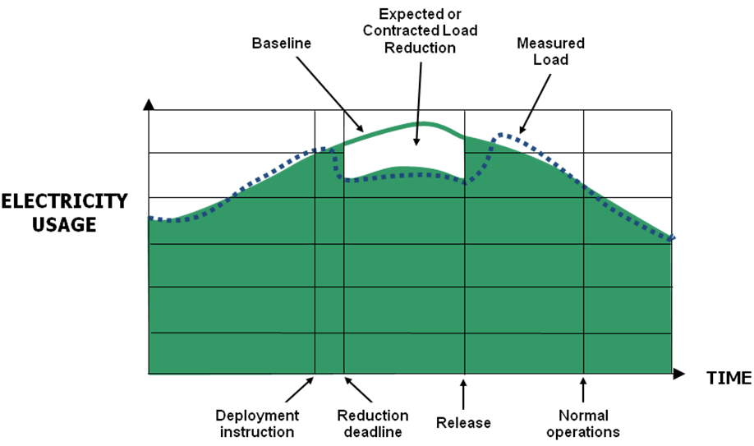
REQ.0.2.148 Baseline: A method of estimating the electricity that would have been consumed by a Customer or Demand Resource in the absence of a Demand Response Event. It may be calculated using interval metering and/or statistical sampling techniques. The figure below illustrates the concept of Baseline relative to a Demand Response Event.
Figure 1. Illustration of Baseline Concept.

REQ.0.2.149 Baseline Adjustment: A modification to the Baseline to account for conditions immediately prior to or during a Demand Response Event to provide a better estimate of the energy the Demand Resource would have used but for the Demand Response Event. The adjustments may include but are not limited to weather conditions, near real time event facility Load, current Demand Resource operational information, or other parameters based on the Program Administrator’s requirements.

REQ.0.2.150 Baseline Window: A period of time preceding and optionally following a Demand Response Event over which the electricity usage data is collected for the purpose of establishing a Baseline.

REQ.0.2.151 Capacity Service: A type of Demand Response service in which Demand Resources are obligated to control demand over a defined period of time measured in MW.
REQ.0.2.152 Critical Peak Pricing: A pricing structure in which the Customer receives notification identifying a time interval, (“critical hours”) during which special higher prices apply over and above whatever other rate they may be charged. Critical hours generally represent a small percentage of the hours in the year.
RXQ.0.2.16 Customer: Any Entity that takes gas and/or electric service for its ownusage.

REQ.0.2.153 Demand: The rate at which electric energy is delivered to or by a system or part of a system, generally expressed in kilowatts or megawatts, at a given instant or averaged over any designated interval of time; and the rate at which energy is being used by the Retail customer.

REQ.0.2.154 Demand Reduction Value: Measurement of reduced electricity usage by a Demand Resource during a Demand Response Event.

REQ.0.2.155 Demand Resource: A Load or aggregation of Loads capable of providing measurable and verifiable Demand Response.
REQ.0.2.156 Demand Resource Availability Measurement: The potential Demand Reduction Value available to be dispatched for a Demand Response Event.

REQ.0.2.157 Demand Response: A temporary change in electricity usage by a Demand Resource in response to market or reliability conditions. For purposes of these Model Business Practices, Demand Response does not include energy efficiency or permanent Load reduction.
For purposes of these Model Business Practices, this definition does not include energy efficiency or permanent Load reduction.
REQ.0.2.158 Demand Response Event: A period of time defined by the Program Administrator, including notifications, deadlines, and transitions, during which Demand Resources provide Demand Response. All notifications, deadlines, and transitions may not be applicable to all Demand Response products or services.
The figure below represents the terms for timing events and time durations applicable to the characteristics of a dispatchable Demand Response Event. The definitions of the ten elements in the figure are the basis for describing the Timing of a Demand Response Event.
Figure 2. Timing of a Demand Response Event

REQ.0.2.159 Demand Response Provider: The Entity that is responsible for delivering Demand reductions from Demand Resources.

REQ.0.2.160 Deployment: The time at which a Demand Resource begins reducing Demand on the system in response to an instruction.

REQ.0.2.161 Deployment Period: The time in a Demand Response Event beginning with the Deployment and ending with the Release/Recall.
REQ.0.2.162 Direct Load Control: A Demand Response activity by which the program sponsor remotely shuts down or cycles a Customer’s electrical equipment (e.g. air conditioner, water heater). Direct Load Control programs are primarily offered to residential or small commercial Customers.
REQ.0.2.163 Dispatchable Programs: Programs that allow a Program Administrator to declare a Demand Response Event that has a specific start time and end time.
RXQ.0.2.17 Distribution Company: A regulated Entity which provides distribution services and may provide energy and/or transmission / transportation services in a given area.
REQ.0.2.164 Energy Service: A type of Demand Response service in which a Demand Resource provides a quantity of electricity measured in MWhs. .
RXQ.0.2.47 Entity: A person or organization with sufficient legal standing to enter into a contract or arrangement with another such person or organization (as such legal standing may be determined by those parties) for the purpose of conducting and/or coordinating energy transactions.
REQ.0.2.165 Firm Service Level: Demand level that a Customer must not exceed during a Demand Response Event.
RXQ.0.2.22 Governing Documents: Documents that determine the interactions among parties, including but not limited to: applicable law, regulatory documents (e.g., tariffs, rules, regulations), contractual agreements,Distribution Company Operational Manuals, and other relevant models and operational procedures.
REQ.0.2.166 Guaranteed Load Drop: Reduction of a specified amount of Load.
REQ.0.2.167 Highly-Variable Load: A Load with a fluctuating or unpredictable electricity usage pattern.

REQ.0.2.168 Load: An end-use device or customer that receives power from the electric system.

REQ.0.2.169 Maximum Base Load: A performance evaluation methodology based solely on a Demand Resource’s ability to maintain its electricity usage at or below a specified level during a Demand Response Event.
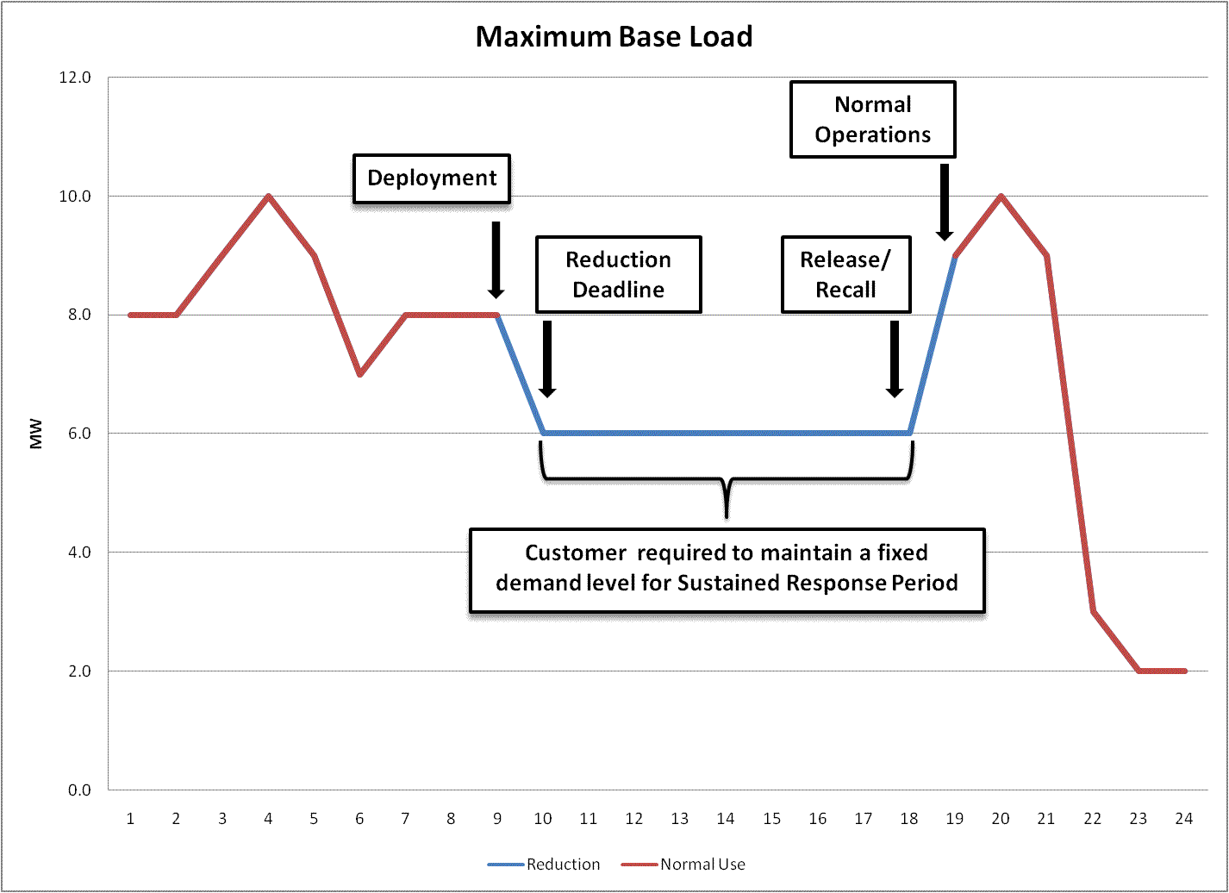

Figure 3. Maximum Base Load Illustration
REQ.0.2.170 Meter Before / Meter After: A performance evaluation methodology where electricity Demand over a prescribed period of time prior to Deployment is compared to similar readings during the Sustained Response Period.
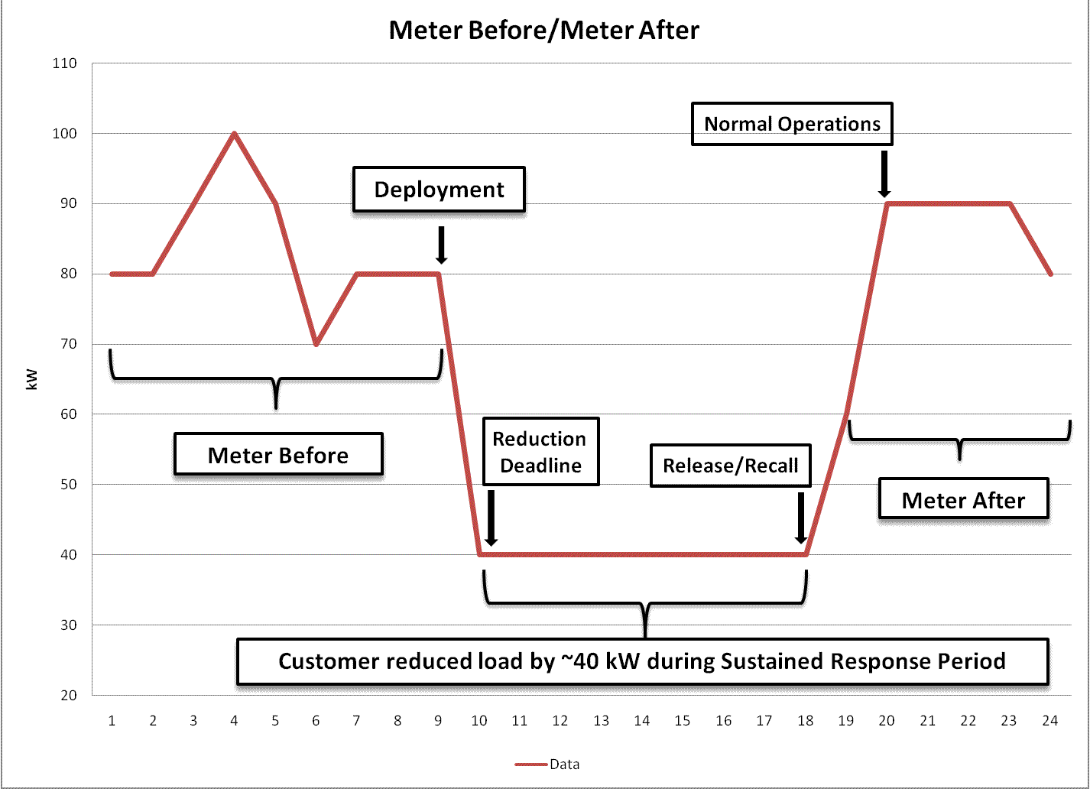

Figure 4. Meter Before/Meter After Illustration

REQ.0.2.171 Meter Data Recording Interval: The time between electricity meter usage recordings.

REQ.0.2.172 Meter Data Reporting Deadline: The maximum allowed time from the end of a Demand Response Event (Normal Operations) to the time when meter data is required to be submitted for performance evaluation and settlement. The Meter Data Reporting Deadline may be either relative (a number of hours/days after Normal Operations) or fixed (a fixed calendar time, such as end-of-month).
REQ.0.2.173 Metering Generator Output: A performance evaluation methodology in which the Demand Reduction Value is based on the output of a generator located behind the Demand Resource’s revenue meter.
REQ.0.2.174 Non-Dispatchable Programs: Programs in which Demand Resources curtail according to tariff structure, not in response to instructions from a Program Administrator.
REQ.0.2.175 Non-Spinning Reserve: Operating reserves that can be started, synchronized and loaded within a specified time period.

REQ.0.2.176 Normal Operations: The time following Release/Recall at which a Program Administrator may require a Demand Resource to have returned its Load usage to normal levels, and to be available again for Deployment.

REQ.0.2.177 Operability Factor: A net-to-gross percentage applied to the Demand Resource Availability Measurement, developed using a defined and documented testing protocol to verify both signal reception and device operation of the units in a retail Demand Response program, specific to a time period.

REQ.0.2.178 Performance Window: The period of time in a Demand Response Event analyzed by the Program Administrator to measure and verify the Demand Reduction Value for a Demand Resource.
REQ.0.2.179 Program Administrator: An investor-owned, governmental or cooperative utility with the responsibility for developing and operating Demand Response programs.
REQ.0.2.180 Ramp Period: The time between Deployment and Reduction Deadline, representing the period of time over which a Demand Resource is expected to achieve its change in Demand.

REQ.0.2.181 Ramp Rate: The rate, expressed in megawatts per minute, that a generator changes its output or a Demand Resource changes its Load.

REQ.0.2.182 Real Time Pricing: A retail rate in which the price for electricity fluctuates reflecting changes in the wholesale price of electricity.

REQ.0.2.183 Recovery Period: The time between Release/Recall and Normal Operations, representing the window over which Demand Resources are required to return to their normal Load.

REQ.0.2.184 Reduction Deadline: The time at the end of the Ramp Period when a Demand Resource is required to have met its Demand Reduction Value obligation.

REQ.0.2.185 Regulation Service: A type of Demand Response service in which a Demand Resource increases and decreases Load in response to real-time signals from the Program Administrator. Demand Resources providing Regulation Service are subject to dispatch continuously during a commitment period. Provision of Regulation Service does not correlate to time periods, deadlines and transitions in the Demand Response Event definition.

REQ.0.2.186 Release/Recall: The time when the Program Administrator specifies a Deployment Period has ended or will end.
REQ.0.2.187 Spinning Reserve: Operating reserves from resources that are synchronized to the grid and can respond to instructions from the Program Administrator.

REQ.0.2.188 Sustained Response Period: The period of time between Reduction Deadline and Release/Recall over which a Demand Resource is required to deliver its obligated Demand Reduction Value.

REQ.0.2.189 Telemetry: Equipment for measuring a quantity and transmitting the result to a remote location for measurement, monitoring, display or recording.

REQ.0.2.190 Telemetry Interval: The unit of time between communications of telemetered data.
REQ.0.2.191 Time-of-Use Rates: Rates where usage unit prices vary by more than one time period within a 24-hour day to reflect the average cost of generating and delivering power during those time periods. Daily pricing blocks may include, but are not limited to, an on-peak, partial-peak, and an off-peak price for non-holiday weekdays, with the on-peak price as the highest price, and the off-peak price as the lowest price.

REQ.0.2.192 Validation, Editing and Estimation: The process of confirming the accuracy of raw meter data and, if necessary, replacing corrupt or missing data. VEE guidelines are published in the Edison Electric Institute’s Uniform Business Practices for Unbundled Electricity Metering.

REQ.13.3 Model Business Practices
REQ.13.3.1 General Characteristics of a Demand Response Event
REQ.13.3.1.1 All actions taken in a Demand Response Event should be in accordance with the Governing Documents.
REQ.13.3.1.2 Advance Notification: The Program Administrator should specify any requirements for the Advance Notification.
REQ.13.3.1.3 The Program Administrator should initiate Deployment of the Demand Resource(s) depending on the specific circumstance(s) of the Demand Response Event.
REQ.13.3.1.4 The Reduction Deadline will depend on the specific circumstance(s) of the Demand Response Event and should be specified by the Program Administrator.
REQ.13.3.1.5 Any requirement(s) for a Ramp Period or a specified Ramp Rate will depend on the specific circumstance(s) of the Demand Response Event and should be specified by the Program Administrator.
REQ.13.3.1.6 The Release / Recall will depend on the specific circumstance(s) of the Demand Response Event and should be specified by the Program Administrator.
REQ.13.3.1.7 Any requirement for a return to Normal Operations will depend on the specific circumstance(s) of the Demand Response Event and the Recovery Period should be specified by the Program Administrator.
REQ.13.3.2 Measurement of Load
REQ.13.3.2.1 Demand Response resource value may be estimated via Telemetry or After-the-Fact Metering or both.
REQ.13.3.2.2 After-the-fact measurement is required either by metering each individual site or by statistical sampling.
REQ.13.3.2.3 Meter accuracy should meet or exceed industry standards or as specified by the Applicable Regulatory Authority.
REQ.13.3.2.4 Meters and other equipment should meet or exceed industry standards equivalent to ANSI C12 or as specified by the Applicable Regulatory Authority.
REQ.13.3.2.5 The Meter Data Reporting Deadline should be specified in the Governing Documents.
REQ.13.3.2.6 The Meter Data Recording Interval should be specified in the Governing Documents.
REQ.13.3.2.7 The meter clock / time accuracy should meet or exceed industry standards equivalent to ANSI C12 or as specified by the Applicable Regulatory Authority.
REQ.13.3.2.8 The method of Validating, Editing and Estimation should conform to an accepted methodology (such as the guidelines published in the current edition of the Edison Electric Institute’s Uniform Business Practices for Unbundled Electricity Metering), and should be specified in the Governing Documents.
REQ.13.3.3 Statistical Sampling
REQ.13.3.3.1 The method of statistical sampling used should conform to an accepted methodology and should be specified in the Governing Documents. The following list provides examples of currently accepted methodologies:
- The Association of Edison Illuminating Companies (AEIC) Load Research Manual
      - Chapter 4 – Sample Design and Selection
      - Chapter 5 – Sample Implementation
- The Federal Energy Management Program M&V Guidelines: Measurement and Verification for Federal Energy Projects – Appendix B;
- The California Energy Efficiency Evaluation Protocols;
- The California Evaluation Framework – Chapter 13; or
- The Independent System Operator (ISO)-New England Manual for Measurement and Verification of Demand Reduction Value from Demand Resources, Section 7.
REQ.13.3.3.2 The general steps to be taken in statistical sampling are, but are not limited to:
- Define the population
- Design the sample to meet program objectives.

- Specify the listing of units available to be sampled which is sometimes called the sampling frame
- Identify design (auxiliary) variables
- Choose the sampling technique
- Choose stratification variable(s)
- Select allocation procedure
- Estimate means and variances of loads
- Examine sample size requirements
- Select sampling techniques and design
- Determine the sample size
- Identify those units to be in the sample
- Identify the criteria for selecting those units to be substituted for sample units who decline
- Select sample and alternates
- Validate sample
- Contacting and enroll the Customers to be in the sample, and install the metering devices, if needed
- Collect interval meter data.
REQ.13.3.3.3 The sample drawn should comport to a level of statistical signifigance that supports the goals of the program
REQ.13.3.4 Performance Evaluation Methods
Performance is evaluated through the use of one of the following methods unless otherwise specified by the Program Administrator:
- Maximum Base Load
- Meter Before / Meter After
- Baseline
- Metering Generator Output
REQ.13.3.4.1 Maximum Base Load Evaluation
REQ.13.3.4.1.1 Any requirement for real-time Telemetry data to be used to measure performance should be specified by the Program Administrator.
REQ.13.3.4.1.2 Any requirement for After-The-Fact Metering should be specified by the Program Administrator.
REQ.13.3.4.1.3 The Performance Window is the Sustained Response Period (Reduction Deadline through Release/Recall) unless otherwise specified by the Program Administrator.
REQ.13.3.4.1.4 During the Performance Window, the Demand Resource must maintain its electricity consumption at or below the Maximum Base Load. The criteria used to evaluate performance is one of the following unless otherwise specified by the Program Administrator:
- Average Demand
- Peak Demand
REQ.13.3.4.2 Meter Before / Meter After Evaluation
REQ.13.3.4.2.1 The Program Administrator should specify the Baseline Window.
REQ.13.3.4.2.2 During the Baseline Window, the Demand Reduction Value of the Demand Resource is evaluated using one of the following measurements as specified by the Program Administrator:
- Average Demand
- Instantaneous Demand
- Maximum Demand

REQ.13.3.4.2.3 Statistical sampling is not used for this performance evaluation method, unless otherwise specified by the Program Administrator.
REQ.13.3.4.2.4 The Program Administrator should specify any time periods to be excluded from Baseline Window.
REQ.13.3.4.2.5 The Program Administrator should specify any Baseline Adjustments.
REQ.13.3.4.2.6 No Adjustment Window is used for this model unless otherwise specified by the Program Administrator.
REQ.13.3.4.2.7 The Program Administrator should specify if real-time Telemetry data is to be used to measure performance.
REQ.13.3.4.2.8 After-The-Fact Metering should be used to measure performance, unless otherwise specified by the Program Administrator.
REQ.13.3.4.2.9 The Performance Window is the Sustained Response Period (Reduction Deadline through Release/Recall) unless otherwise specified by the Program Administrator.
REQ.13.3.4.2.10 During the Performance Window, the Demand Resource is evaluated using the same method of development of the Demand Reduction Value as identified in REQ.13.3.4.2.2.

REQ.13.3.4.2.11 The Program Administrator should specify any performance evaluation requirements for Highly-Variable Loads.
REQ.13.3.4.2.12 The Program Administrator should specify any performance evaluation requirements for on-site generation.
REQ.13.3.4.3 Baseline Evaluation
REQ.13.3.4.3.1 The Program Administrator should specify the Baseline Window.
REQ.13.3.4.3.2 The Program Administrator should specify the method of developing the Baseline value using, but not limited to, the following calculation types:
- Average kW over a specified interval
- Maximum kW over a specified interval

- Regression
REQ.13.3.4.3.3 Statistical sampling is generally permitted for this performance pvaluation method, unless otherwise specified by the Program Administrator.
REQ.13.3.4.3.4 The Program Administrator should specify any rules for excluding data from the Baseline Window. Exclusion rules may be based on, but are not limited to the following:
- Historical Demand Response Events
- Testing/Audit Periods
- Calendar data
- Outages
- Weather emergencies or force majeure events
- Usage threshold
- Known, discrete load additions or reductions that have occurred during the Baseline Window
REQ.13.3.4.3.5 The Program Administrator should specify any rules for Baseline Adjustments. Adjustment rules may be based on, but are not limited to the following:
- Temperature
- Humidity
- Calendar data
- Sunrise/Sunset time
- Event day operating conditions
REQ.13.3.4.3.6 The Program Administrator should specify the Adjustment Window.
REQ.13.3.4.3.7 The Program Administrator should specify if real-time Telemetry data is to be used to measure performance.
REQ.13.3.4.3.8 After-The-Fact Metering is used to measure performance, unless otherwise specified by the Program Administrator.
REQ.13.3.4.3.9 The Program Administrator should specify the Performance Window.
REQ.13.3.4.3.10 During the Performance Window, the Demand Resource is evaluated using the same method of development of the Baseline value as identified in REQ.13.3.4.3.2

REQ.13.3.4.3.11 The Program Administrator may specify performance evaluation requirements for Highly-Variable Loads.
REQ.13.3.4.3.12 The Program Administrator may specify performance evaluation requirements for on-site generation.
REQ.13.3.4.3.13 The Program Administrator should specify the testing protocol if an Operability Factor will be applied to the Demand Resource Availability Measurement.
REQ.13.3.4.4 Metering Generator Output Evaluation
REQ.13.3.4.4.1 The Program Administrator should specify Baseline calculations for Metering Generator Output.
REQ.13.3.4.4.2 The Program Administrator should specify if real-time Telemetry data is to be used to measure performance.
REQ.13.3.4.4.3 After-The-Fact Metering on the generator and optionally on the associated Load is used to measure performance unless otherwise specified by the Program Administrator.
REQ.13.3.4.4.4 The Program Administrator should specify the Performance Window.
REQ.13.3.4.4.5 During the Performance Window, the Demand Resource is evaluated using the total measured generation output unless otherwise specified by the Program Administrator.
REQ.13.3.4.4.6 The Program Administrator should specify any special processing rules.

4. SUPPORTING DOCUMENTATION

a. Description of Request:

b. Description of Recommendation:
The DSM-EE Subcommittee submits this Recommendation for 2010 Retail Annual Plan Item No. 3.c to support phase 2, retail development of Model Business Practices for Measurement & Verification (M&V) for Demand Response programs.

c. Business Purpose:

d. Commentary/Rationale of Subcommittee(s)/Task Force(s):

Association of Edison Illuminating Companies (AEIC), Load Research Manual,2nd ed., Birmingham, AL, 2001, www.aeic.org
US Department of Energy. M&V Guidelines: Measurement and Verification for Federal Energy Management Projects Version 3.0. 2008. (or current version).
California Public Utilities Commission, California Energy Efficiency Evaluation Protocols: Technical, Methodological, and Reporting Requirements for Evaluation Professionals, 2006. (http://www.cpuc.ca.gov/PUC/)
California Public Utilities Commission, The California Evaluation Framework, current version. (http://www.cpuc.ca.gov/PUC/).
ISO-New England, Manual for Measurement and Verification of Demand Resources, (M-MVDR), current version. (http://www.iso-ne.com/rules_proceds/isone_mnls/index.html).

