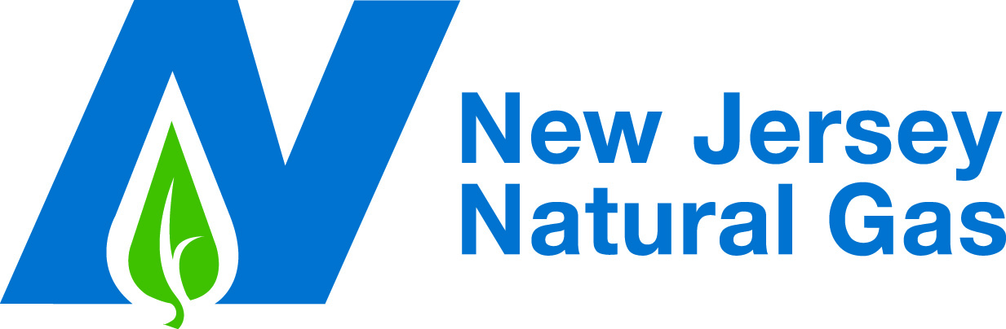

Date: July 2, 2008

To: NAESB WGQ Executive Committee

From: New Jersey Natural Gas Company

Subject: Comments in Support of Recommendation to Maintain the Status Quo By Declining to Adopt a Modified Gas Nomination Timeline – 2007 WGQ Annual Plan Item 7c and 2008 WGQ Annual Plan Item 4c – Consider Whether Changes to Existing Intra-day Schedules Would Benefit All Shippers, and Provide Better Coordination Between Gas and Electric Scheduling (FERC Order No. 698 issued 6-25-07, Docket Nos. RM05-5-001 and RM96-1-027 as related to the NAESB reports submitted in Docket No. RM05-28-000)____________________________

Overview

Maintaining the status quo by declining to adopt a modified NAESB gas nomination timeline is the right course of action for the NAESB WGQ Executive Committee to take in this circumstance. Over a 10 month period (August 2007 through May 2008) the Business Practice Subcommittee of the WGQ vetted no fewer than 12 proposals to change the current NAESB gas nomination timeline while considering the issue of whether changes to existing intra-day schedules would benefit all shippers and provide better coordination between gas and electric scheduling. The lack of consensus on any of these proposals and the fact that each of the three proposals put to a vote failed by a wide margin underscores the concerns that gas industry participants have with proposed changes to the current NAESB gas nomination timeline. The member companies of the Business Practice Subcommittee have done their job. Significant resources were expended by the active participants throughout the process to ensure that the many sides of this complicated issue were fully and meaningfully considered. New Jersey Natural Gas Company (“New Jersey Natural”) was an active participant in that process and encourages the NAESB WGQ Executive Committee to respect the outcome that emerged from it by maintaining the status quo.

Discussion

Consistent with the Federal Energy Regulatory Commission’s (“FERC” or the “Commission”) directive to NAESB in Order No. 698 to “consider whether changes to existing intra-day schedules would benefit all shippers and provide better coordination between gas and electric scheduling”, the Business Practice Subcommittee of the WGQ discussed no fewer than 12 proposals to modify the existing NAESB gas nomination timeline to inter alia add additional intraday cycles with an additional bump cycle. Throughout the 10 month vetting process no consensus emerged in support of any of the proposals. The lack of consensus is reflective of the diverse requirements of the different segments within the WGQ as well as the individual participants within each segment, who do not necessarily have common interests. As a result, it soon became evident to most participants that although not ideal for some, the current NAESB gas nomination timeline remains a functional compromise that continues to adequately serve most participants in the industry relatively well. Furthermore, because of the diverse requirements among industry participants, any revisions to the status quo will benefit some, but disadvantage others. In effect, realizing that any revisions to the existing NAESB gas nomination timeline would be an imperfect compromise, much the same as the existing NAESB gas nomination timeline, maintaining the status quo emerged as the best option for most industry participants.

Without Standardized Electric Schedules, Revising the Gas Nomination Timeline Alone Will Not Achieve the Goals of Order No. 698

Competing gas scheduling requirements among electric generating companies arising from the varying electric scheduling timelines that they are subject to is illustrative of the difficulty faced by the Business Practice Subcommittee in achieving consensus in this area. One of the Commission’s primary goals in Order No. 698 was to encourage both the gas and electric industry to work toward affording electric generators greater flexibility in responding to daily weather-induced and other changes in electricity demand. Clearly one factor in achieving that goal is the level of synchronization between the gas nomination schedule and electric schedules. However, currently no level of gas/electric synchronization will achieve the intended goal alone because the electric schedules themselves are not standardized. Unlike the gas nomination schedule, electric scheduling timelines are not standardized and, therefore, there is no one-size-fits-all revision to the gas nomination timeline that electric generating companies can embrace. The concerns over accommodating all the time zones in which companies operate and the current electric market schedules are but a few of the challenges that must be met. The electric industry stakeholders must work together and invest the time and resources as did the Wholesale Gas Quadrant Business Practice Subcommittee to consider adopting a uniform timeline and shift electric market clearing times in order to harmonize the gas and electric supply schedules. The New York and New England ISOs have implemented these enhancements to their market structures. However, divergent interests among the electric generating companies are evident as in the two competing proposals put forth by FPL and APS/TVA.

Apart from the discord among the electric generating companies themselves over which set of proposed revisions to the NAESB gas nomination timeline to support, even if electric schedules were standardized and gas/electric timelines harmonized, that alone would not assure electric generators of reliable peak period supplies. To the extent that electric generators, particularly peakers, are willing to roll the dice by relying on interruptible transportation to meet their gas supply requirements, there will always be supply risk. Furthermore, solving the firm/interruptible risk calculus is dependent in part on the scheduling priority of firm vis a vis interruptible transportation with the number of bumpable cycles and no-bump cycles in the gas nomination timeline being an important factor. However, this issue is no less problematic than the number and timing of nomination cycles because any change to bumping rights necessarily affects the value of firm versus interruptible service. Clearly, the gas nomination timeline should not be addressed in isolation of the electric market schedule. To do so would preclude the possibility of creating a workable solution that would benefit all industry stakeholders. New Jersey Natural believes this course of action would be premature at best as much work needs to be done on the electric side of the equation. As such, no changes to the gas nomination timeline are warranted at this time.

Without a Compelling Reason to Change the Status Quo, the Significant Cost of Revising the Gas Nomination Timeline Should Not Be Overlooked

Quite simply, there is no compelling basis for adopting any particular modifications to the NAESB gas nomination timeline at this time and certainly not before electric schedules themselves are harmonized. But there are several concerns that would arise with any change in the status quo, all of which underscore why the best course of action in this circumstance is not to adopt a modified NAESB gas nomination timeline, as follows:

- Problems persist with pipeline confirmations under the current gas nomination timeline. Increasing the number of nomination cycles or shortening confirmation windows is likely to exacerbate those problems;

- Modifying the intraday nomination timeline to increase and/or add to the number of bumpable cycles will further reduce the time to react to a cut in interruptible service;

- If the number of bumpable nomination cycles is increased and/or delayed until later in the day, the number of available counter-parties to transact with in the event of a cut is likely to decrease, particularly if these cycles occur outside of normal business hours; and

- Changes to the intraday nomination timeline that increase and/or add to the number of bumpable cycles will cause staffing issues for LDCs, pipelines and gas marketers resulting in increased costs with no assurance of commensurate benefits.

Each of the three proposals put to a vote largely overlooked these concerns and the associated costs with implementing a revised gas nomination timeline. For example, the APS/TVA proposal over-simplifies the significance of a changed timeline and fails to consider the following:

- Currently, nominations for most pipelines are firm only in the Timely Cycle. There is no guarantee a shipper can make an intraday nomination after the Timely Cycle. This is because a shipper could be “sealed” (unable to increase scheduled quantity) or if secondary nominations had been scheduled in the Timely Cycle, then a shipper could be unable to increase quantity intraday;

- There is rarely any Interruptible Transportation flowing during the winter and summer peaks;

- There is no automatic match-up of nominations; currently much of the process is still performed manually and is not an EDI process for many pipelines. Pipelines must match up contract numbers on all pipelines, which can be particularly problematic when there are multiple segments;

- Pipelines must confirm multiple interconnects. Although technology is improving, the volume and complexity of transactions has also increased so problems persist;

- Pipelines have different EBBs and many have different requirements further necessitating a sufficient amount of time to schedule and make confirmations. This is not an automated process;

- APS/TVA proposals contained ID Cycles that would be bumpable as late as 7:30 pm or 8 pm (Eastern Time), but there are insufficient pipeline representatives at that time to fix problems. These late bumping cycles are well outside reasonable business hours;

- APS/TVA proposals contained very compressed timelines whereby there would be only one hour between cut/bump and nomination, e.g., an 8 pm (Eastern Time) cut/bump and the proposed nomination deadline of 9 pm (Eastern Time). One hour is not enough time for parties to react to a cut/bump and get rescheduled, if it is even possible.

- APS/TVA proposals, and others, contained early morning cycles. Here the shipper would not be matching physical flows, but more likely working with storage. Basically the shipper likely would not be dealing with major changes at interconnects, but instead this is its last chance to get things fixed. This is a frequently used time period, but does not need to be as early as suggested to be useful. Pipelines that already allow morning cycles have deadlines in the 8 am - 9 am (Eastern Time) window.

Recommendation

New Jersey Natural encourages the WGQ Executive Committee to decline to adopt a modified NAESB gas nomination timeline and thereby maintain the status quo. Revisions to the NAESB gas nomination timeline alone will not achieve the goals of Order No. 698 and plainly there is no consensus among industry participants as to what if any revisions should be adopted. At this juncture, without any compelling benefits, a change in the gas nomination timeline would be little more than a change for change’s sake. However, a change in the timeline would impose a real cost on the industry in the form of modifying existing systems and adding additional staff.

Standards for Business Practices for Interstate Natural Gas Pipelines; Standards for Business Practices for Public Utilities, Order No. 698, 72 FR 38757 (July 16, 2007), III FERC Stats. & Regs. ¶ 31,251, at P 69 (June 25, 2007) (“Order No. 698”).

