1. RECOMMENDED ACTION: EFFECT OF EC VOTE TO ACCEPT RECOMMENDED ACTION:
Accept as requested x Change to Existing Practice
x Accept as modified below Status Quo
Decline

2. TYPE OF DEVELOPMENT/MAINTENANCE

Per Request: Per Recommendation:

Initiation Initiation
Modification Modification
Interpretation Interpretation
Withdrawal Withdrawal

Principle Principle
Definition Definition
x Business Practice Standard Business Practice Standard
Document Document
Data Element Data Element
Code Value Code Value
X12 Implementation Guide X12 Implementation Guide
Business Process Documentation Business Process Documentation

3. RECOMMENDATION

SUMMARY: To address Request R07007, e-Tag timing tables, the JISWG worked with the requestor to simplify and enhance the clarity of the tables. The Timing Table Interchange Timeline with Minimum Reliability-Related Response Times in Appendix D of WEQ 004 Coordinate Interchange ratified under change request R05001 (with Minor Corrections Applied March 20, 2007) will be split into two tables. One table will be applicable to all interconnections other than WECC. The second table will be specific to WECC. These two tables have differences due to the difference in ramp durations and ramp start between the WECC and other interconnections. The tables now also contain a timeline diagram which various industry participants requested. The timing tables, if approved, should replace the timing tables in the existing Coordinate Interchange standard. The revised timing tables are included below.

Recommended Standards:
Timing Requirements for all Interconnections except WECC

 |  | A | B | C | D
If Actual Arranged Interchange (RFI) is Submitted | IA Assigns Initial Status of | IA Makes Initial Distribution of Arranged Interchange | BA and TSP Conduct Reliability Assessments  IA Verifies Reliability Data Complete | IA Compiles and Distributes Status | BA Prepares Confirmed Interchange for Implementation | Minimum Total Reliability Period  (Columns A through D)
>1 hour after the start time | ATF | < 1minute from RFI submission | < 2 hours from Arranged Interchange receipt from IA | < 1minute from receipt of all Reliability Assessments | NA | NA
<15 minutes prior to ramp start and <1 hour after the start time | Late | < 1minute from RFI submission | < 10 minutes from Arranged Interchange receipt from IA | < 1minute from receipt of all Reliability Assessments | < 3 minutes after receipt of confirmed RFI | 15 minutes
<1 hour and > 15 minutes prior to ramp start | On-time | < 1minute from RFI submission | < 10 minutes from Arranged Interchange receipt from IA | <1 minute from receipt of all Reliability Assessments | >3 minutes prior to ramp start | 15 minutes
>1 hour and < 4 hours prior to ramp start | On-time | < 1minute from RFI submission | < 20 minutes from Arranged Interchange receipt from IA | < 1minute from receipt of all Reliability Assessments | > 39 minutes prior to ramp start | 1 hour plus 1 minute
> 4 hours prior to ramp start | On-time | < 1minute from RFI submission | < 2 hours from Arranged Interchange receipt from IA | < 1minute from receipt of all Reliability Assessments | > 1 hour 58 minutes prior to ramp start | 4 hours

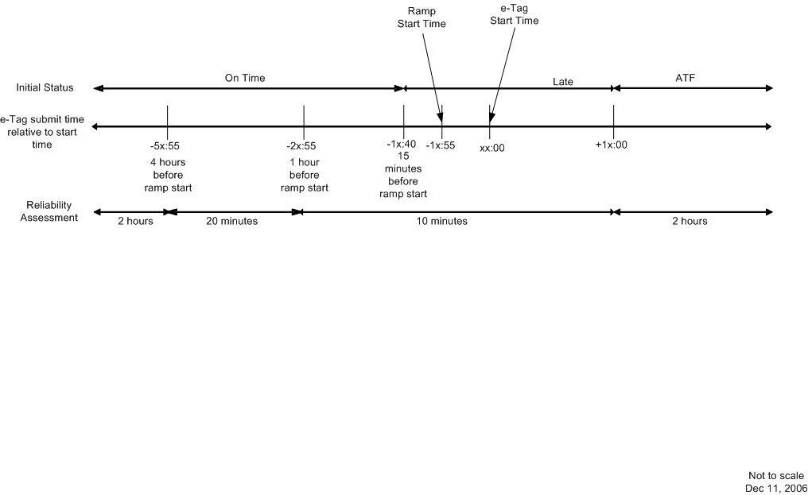

Timing Requirements for WECC

 |  | A | B | C | D
If Actual Arranged Interchange (RFI) is Submitted | IA Assigns Initial Status of | IA Makes Initial Distribution of Arranged Interchange | BA and TSP Conduct Reliability Assessments  IA Verifies Reliability Data Complete | IA Compiles and Distributes Status | BA Prepares Confirmed Interchange for Implementation | Minimum Total Reliability Period  (Columns A through D)
>1 hour after the start time | ATF | < 1minute from RFI submission | < 2 hours from Arranged Interchange receipt from IA | < 1minute from receipt of all Reliability Assessments | NA | NA
<10 minutes prior to ramp start and <1 hour after the start time | Late | < 1minute from RFI submission | < 10 minutes from Arranged Interchange receipt from IA | < 1minute from receipt of all Reliability Assessments | < 3 minutes after receipt of confirmed RFI | 15 minutes
<1 hour and > 10 minutes prior to ramp start | On-time | < 1minute from RFI submission | < 10 minutes from Arranged Interchange receipt from IA and > 4 minutes prior to ramp start | < 1minute from receipt of all Reliability Assessments | > 3 minutes prior to ramp start | 10-15 minutes
>1 hour and < 4 hours prior to ramp start | On-time | < 1minute from RFI submission | < 20 minutes from Arranged Interchange receipt from IA | < 1minute from receipt of all Reliability Assessments | > 39 minutes prior to ramp start | 1 hour plus 1 minute
> 4 hours prior to ramp start | On-time | < 1minute from RFI submission | < 2 hours from Arranged Interchange receipt from IA | < 1minute from receipt of all Reliability Assessments | > 1 hour 58 minutes prior to ramp start | 4 hours
Submitted before 10:00 PPT with start time > 00:00 PPT of following day | On-time | < 1minute from RFI submission | By 12:00 PPT of day the Arranged Interchange was received by the IA | < 1minute from receipt of all Reliability Assessments | > 1 hour 58 minutes prior to ramp start | Min 4 hours

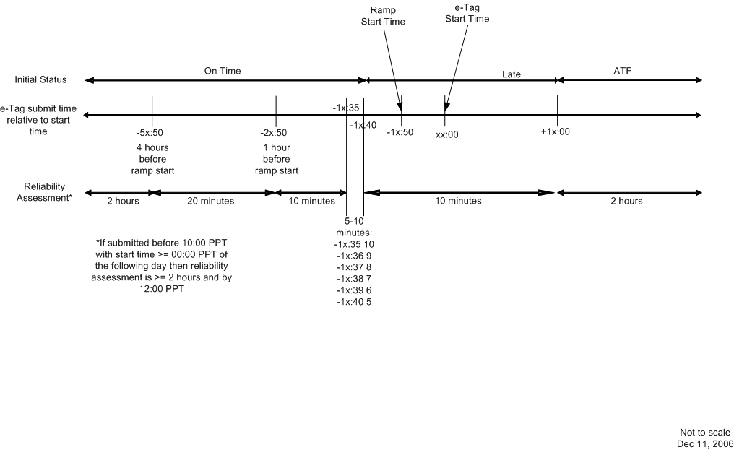

4. SUPPORTING DOCUMENTATION

- Description of Request:
Update the Timing Table to Reflect the Categories (On-time, Late, After-the-fact, and Pre-late) used in the latest E-Tag Specification with respect to receipt of an Arranged Interchange (RFI):
- Include designation of request status based on start and submittal times.
- Include assess times for After-The-Fact (ATF) requests.
Include a WECC preschedule late (Pre-Late) submittal definition
b. Description of Recommendation:
After review of this Request and in consultation with the WECC, the JISWG recommends that the Pre-late category is not necessary. The JISWG recommends that the tables set forth in this recommendation be adopted to replace the existing timing tables in the Timing Table Interchange Timeline with Minimum Reliability-Related Response Times in Appendix D of WEQ 004 Coordinate Interchange ratified under change request R05001 (with Minor Corrections Applied March 20, 2007)..

c. Business Purpose:
Clear definition of what RFIs are assigned on their initial status: On Time, Late, or After the Fact

d. Commentary/Rationale of Subcommittee(s)/Task Force(s): Simplify timing rules, clarify the effects of the timing tables on each entity, incorporate desired changes from industry participants, and provide a clear definition of the initial status that should be assigned to an RFI as per the request.
JISWG Meeting, May 15-18, 2007: Draft Minutes
JISWG Conference Call, June 6, 2007
ESS/ITS Conference Call, June 14, 2007
JISWG Conference Call, June 25, 2007: Draft Minutes
ESS/ITS Meeting, June 26-27, 2007

