North American Energy Standards Board

Request for Initiation of a NAESB Business Practice Standard, Model Business Practice or Electronic Transaction
or
Enhancement of an Existing NAESB Business Practice Standard, Model Business Practice or Electronic Transaction

Instructions:

1. Please fill out as much of the requested information as possible. It is mandatory to provide a contact name, phone number and fax number to which questions can be directed. If you have an electronic mailing address, please make that available as well.

2. Attach any information you believe is related to the request. The more complete your request is, the less time is required to review it.

3. Once completed, send your request to:
Rae McQuade
NAESB, Executive Director
1301 Fannin, Suite 2350
Houston, TX 77002

Phone: 713-356-0060
Fax: 713-356-0067

by either mail, fax, or to NAESB’s email address, naesb@naesb.org.

Once received, the request will be routed to the appropriate subcommittees for review.

Please note that submitters should provide the requests to the NAESB office in sufficient time so that the NAESB Triage Subcommittee may fully consider the request prior to taking action on it. It is preferable that the request be submitted a minimum of 3 business days prior to the Triage Subcommittee meetings. Those meeting schedules are posted on the NAESB web site at http://www.naesb.org/monthly_calendar.asp.

North American Energy Standards Board

Request for Initiation of a NAESB Business Practice Standard, Model Business Practice or Electronic Transaction
or
Enhancement of an Existing NAESB Business Practice Standard, Model Business Practice or Electronic Transaction

Date of Request: November 16, 2005

1. Submitting Entity & Address:
El Paso Natural Gas Company
2 N. Nevada
Colorado Springs, Colorado 80903

2. Contact Person, Phone #, Fax #, Electronic Mailing Address:
Name : Sally Turley and Michael Stender
719-520-4509 719-667-7613
Title : Manager Consultant
E-mail: sally.turley@elpaso.com/mike.stender@elpaso.com

3. Description of Proposed Standard or Enhancement:

Offer Upload
Offer Download
Bid Upload
Bid Download
Award Download

Modify the above transaction sets to allow for variable monthly release quantities, variable monthly bid quantities and variable monthly award quantities, subject to variable monthly minimum offer quantities. Awards will be determined based on variable monthly bid quantity, variable monthly minimum acceptable award at the Receipt/Delivery point level, variable monthly minimum acceptable award at the Contract level, and variable minimum acceptable award at all of the Contract levels over the bid term.

- Use of Proposed Standard or Enhancement (include how the standard will be used, documentation on the description of the proposed standard, any existing documentation of the proposed standard, and required communication protocols):

This proposed change will give EPNG’s customers the flexibility to post offers and bid on capacity from contracts that have variable monthly receipt/delivery contract entitlements in a single offer and will eliminate the need to post separate offers each month.

5. Description of Any Tangible or Intangible Benefits to the Use of the Proposed Standard or Enhancement:

The proposed change will make the capacity release program more user friendly, more flexible and give the customers certainty of securing capacity for long term transactions.

- Estimate of Incremental Specific Costs to Implement Proposed Standard or Enhancement:

This is a Business Conditional option and there is no additional cost to any parties that do not implement this Business Conditional proposal.

7. Description of Any Specific Legal or Other Considerations:
None.

8. If This Proposed Standard or Enhancement Is Not Tested Yet, List Trading Partners Willing to Test Standard or Enhancement (Corporations and contacts):
None.

9. If This Proposed Standard or Enhancement Is In Use, Who are the Trading Partners :
None.

- Attachments (such as : further detailed proposals, transaction data descriptions, information flows, implementation guides, business process descriptions, examples of ASC ANSI X12 mapped transactions):

Offer:
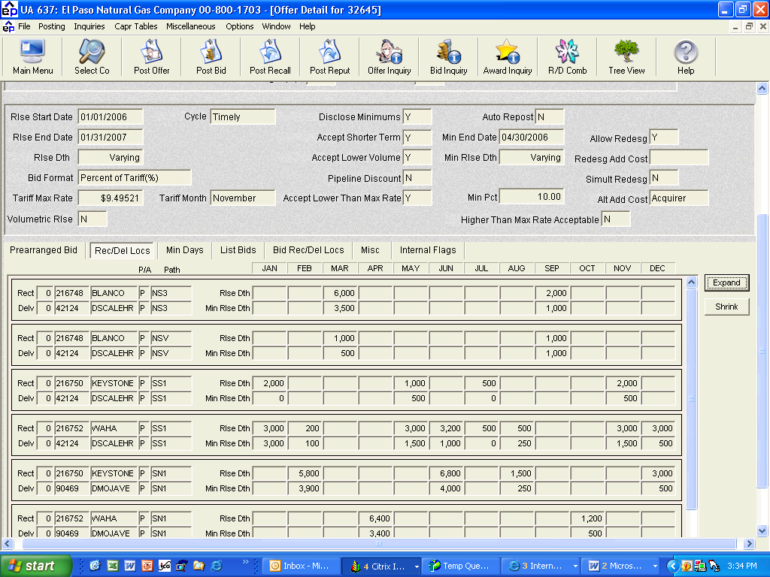

Bid:
