Application for NAESB Certification
Please return this form along with payment to the North American Energy Standards Board (“NAESB”) offices at the above address. Upon approval, you will be sent the appropriate self-certification check list(s) and certification mark license agreement. Once a completed check list(s) and executed license agreement are received, and reviewed for completeness, a certification mark will be sent the below company representative for use during a two-year certification period.

Name of Company:
Company Representative:
Address, City, State and Postal Code:

Phone: Fax:
E-mail: Web Site:
Name and Version of Software Product or Software Solution Being Certified:
1.
2.
3.
4.
NAESB Standard or Model Business Practices Being Certified (“Standards Certified”):
□ Wholesale Gas Quadrant, Version 1.4, 1.5, 1.6, 1.7, 1.8, 1.9, 2.0, 3.0, 3.1, 3.2, or 4.0 (circle one)
□ Wholesale Electric Quadrant, OASIS SC&P Version 0, 1, 2.0, 2.1 or 2.2 (circle one)
Scope of Certification (select all that apply):
□ Data/Information Requirements
□ Web Site Requirements (Informational Postings and Customer Activities)
□ EDI/EDM Requirements
Payment Information:
NAESB Member Price Per Certification $ 1,000
Non-Member Price Per Certification $15,000
Number of Software Products and Solutions Being Certified __________
Number of Versions of Standards the Above Software Is Being Certified __________
Total Amount Enclosed or to Be Charged: __________
Form of Payment:
□ Check Enclosed Made Payable to “NAESB”
□ Credit Card Charge (see attached payment form)

ATTACHED PAYMENT FORM MUST ACCOMPANY THIS FORM FOR CREDIT CARD PAYMENTS

NAESB Certification – Credit Card Payment Form
(Submit with Application for NAESB Certification)
Name as it appears
on Credit Card:
Credit Card
Billing Address:
City/State/
Zip Code:
 | Phone: |  |  |  |  |  |  |  |  |  |  | Fax Number:
E-mail:
Payment Method: |  |  |  |  |  | VISA |  |  | Account Number:
 |  |  |  |  |  | MASTERCARD |  | Amount to be Charged: |  |  |  |  | Expiration Date:
 |  |  |  |  |  | AMER. EXPRESS |  | Security Code²:
 |  |  |  |  |  |  |  |  | Authorized Signature:

²Credit Card Security Code
For your security, we require your credit card's security code. This greatly improves the security of using your credit card online.
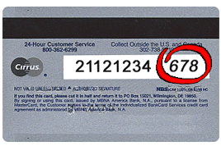
If you are using a Visa, MasterCard or Discover, please provide the 3-digit verification number found on the back of your card.
This is a non-embossed number printed on the signature panel on the back, immediately following the account number.
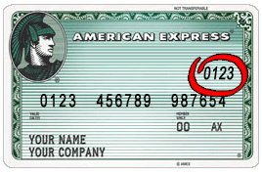
The card security code for your American Express card is a four-digit number located on the front of your credit card, to the right or left above your main credit card number.
This code is a 4-digit, non-embossed number

